Eden Geothermal Limited

The Eden Project

Bodelva

Par

PL24 2SG

Tel: +44 (0)1726 806540

E: [tenders@edengeothermal.com](mailto:tenders@edengeothermal.com)

Date: 13th March 2020

**INVITATION TO TENDER**

Dear Sir/Madam

|  |  |
| --- | --- |
| **Project** | **Eden Geothermal Project**  Drilling rig and associated equipment for the drilling of the geothermal exploration well |
| **Tender reference** | EGL- ITT- CO35 |

You are invited to submit a competitive tender for the supply of a drilling rig and associated equipment for a project co-funded by the European Regional Development Fund.

Please submit your proposal in full no later than:

**16:00** hours on **20th April 2020**

Except under exceptional circumstances, no extension of time and date by which the tender must be submitted will be granted. Late submissions will not be accepted.

Any query in connection with this tender or the invitation to tender shall be submitted in writing to the mailbox by 12:00 hours on 2nd April 2020.

Email for submission of queries and completed tenders: [tenders@edengeothermal.com](mailto:tenders@edengeothermal.com)

We look forward to receiving your submission.

Yours faithfully

Augusta Grand

Executive Director

|  |
| --- |
| **Invitation to Tender:**  **Drilling rig and associated equipment for the Eden Geothermal Project.** |
|  |

|  |  |
| --- | --- |
| **Project** | **Eden Geothermal Project** |
| **Tender reference** | EGL-ITT-CO35 |
| **Version** | 1 |
| **Release Date** | 13th March 2020 |
| **Issuer** | Eden Geothermal Limited (“EGL”) |
| **Supplier Response Date** | 16:00 hours 20th April 2020 |

**Contents**

|  |  |
| --- | --- |
| **PART A: INSTRUCTIONS TO TENDERERS** |  |
| **1 Instructions for Completion** | **6** |
| 1.1 Submission Details | 6 |
| 1.2 Enquiries and Tender Queries | 7 |
| 1.3 Format of Tender Submission | 7 |
| 1.4 Project Description | 7 |
| 1.5 Outline Scope of Works | 8 |
| 1.6 Validity Period | 8 |
| 1.7 Form of Contract | 8 |
|  |  |
| **2 Timetable** | **9** |
|  |  |
| **PART B: RETURN OF TENDER** |  |
| **3 Tender Completion Documentation** | **10** |
| 3.1 Company Information | 10 |
| 3.2 Technical Submission | 11 |
| 3.3 Commercial Submission | 12 |
|  |  |
| **PART C: EVALUATION** |  |
| **4 Evaluation Process** | **13** |
| 4.1 Company Information | 13 |
| 4.2 Technical Evaluation | 14 |
| 4.3 Commercial Evaluation | 15 |
| 4.4 Total Score | 15 |
| 4.5 Clarification | 15 |
| 4.6 Sub-contracting arrangements | 16 |
| 4.7 Award and notification | 16 |
|  |  |
| **PART D: CONDITIONS**  **5 Conditions** | **17** |
| 5.1 Confidentiality and Freedom of Information | 17 |
| 5.2 Language | 17 |
| 5.3 Applicable Law | 17 |
| 5.4 Additional costs | 17 |
| 5.5 Costs | 18 |
| 5.6 Right to cancel or vary the process | 18 |
| 5.7 Inducements | 18 |
| 5.8 Performance Bond | 18 |
| 5.9 Disclaimer | 18 |

|  |  |
| --- | --- |
| **Contents (continued)** |  |
|  |  |
| **SCHEDULES** |  |
| Schedule 1a: Company Details | 20 |
| Schedule 1b: Equality and Diversity | 21 |
| Schedule 1c: Insurance Cover | 22 |
| Schedule 1d: Legal Matters and Disputes | 23 |
| Schedule 1e: Grounds for Mandatory Exclusion | 25 |
| Schedule 1f: Other Grounds for Exclusion | 27 |
| Schedule 1g: Economic and Financial Standing | 29 |
| Schedule 1h: Health and Safety | 30 |
| Schedule 1i: Quality Assurance and Environmental Management Systems | 31 |
| Schedule 2: Declarations | 32 |
| Schedule 3: Relevant Experience and Contract Examples | 33 |
|  |  |
| Schedule 4: Commercial Offer | 35 |
| Schedule 5: Commercially Sensitive Information | 37 |
|  |  |
| Schedule 6a: Project Background Information | 38 |
| Schedule 6b: Well Summary | 41 |
| Schedule 6c: Location and Site Layout | 42 |
| Schedule 6d: Geology  Schedule 6e: Basis of Well Design | 47  50 |
| Schedule 7: Equipment and Services to be Provided  Schedule 8: Drilling Bid Contract Form  Schedule 9: Drilling Bid Contract Form: Contractor’s Bid | 52  54  66 |
|  |  |
|  |  |
| **APPENDICES** |  |
| Appendix A: Site Regulations | 68 |
| Appendix B: Draft Drilling Rig Contract | 70 |
|  |  |

|  |
| --- |
| **PART A: INSTRUCTIONS TO TENDERERS** |

**1 Instructions for Completion**

**1.1 Submission Details**

Eden Geothermal Limited is issuing this Invitation to Tender (ITT) for a drilling rig and associated equipment for the purpose of drilling a geothermal exploration well at the Eden Geothermal Project, near St Austell in Cornwall.

The Tender submission must arrive at Eden Geothermal Ltd no later than **16.00 on 20th April 2020**. Applicants must submit their Tenders in two separate documents, comprising (see section 3):

1. Company Information (including responses to Schedules 1 and 2) and

Technical Submission (including response to Schedule 3)

1. Commercial submission

The Applicant will be required to submit a written proposal as part of the response, in the form set out. The Applicant should submit (i) one signed hard copy set of the two documents, inclusive of any relevant appendices, quoting the contract title at the front of this document; and (ii) an electronic copy of these documents in PDF or read-only format, by email. Envelopes and packages, must bear no reference to the tenderer by name; franking machines which automatically print the company’s name should not be used.

The documents must be submitted to the Authorised Officer at Eden Geothermal Ltd:

1. By email to [tenders@edengeothermal.com](mailto:tenders@edengeothermal.com)
2. By post to the following address: Eden Geothermal Limited, Foundation Building, Eden Project, Bodelva, Par, Cornwall PL24 2SG

Tenders will be received up to the time and date stated. Those received before the due date will be retained unopened until then. It is the responsibility of the tenderer to ensure that their tender is delivered not later than the appointed time. EGL reserves the right to not consider any tenders received after the deadline, in which event late bids will be returned, unopened, to the Applicant.

Applicants may request extensions to this date with a valid reason, which may be accepted at the discretion of the Evaluation Panel of Eden Geothermal Limited. All other Applicants will be notified of any extension that is granted.

Applicants are advised that Eden Geothermal Ltd is not bound to accept the lowest price submitted, and will not reimburse any expense incurred by Applicants during the tendering process.

Any information relating to Eden Geothermal Ltd and supplied by Eden Geothermal Ltd in relation to this project shall be retained by the Applicant in strictest confidence.

**1.2 Enquiries and Tender Queries**

Please register your interest by emailing the address below, quoting the tender reference number.

Send all enquiries in writing by email, by the deadline stated at Section 2, quoting the contract title printed at the front of this document:

[tenders@edengeothermal.com](mailto:tenders@edengeothermal.com)

Bidders shall provide a single point of contact in their organisation. Eden Geothermal Ltd shall not be responsible for contacting the bidder through any route other than the nominated contact. The bidder must therefore undertake to notify Eden Geothermal Ltd of any changes relating to the point of contact.

Applicants are advised that, where Eden Geothermal Ltd considers appropriate, a copy of any such enquiries will be distributed to all Applicants along with the written response, although the original Applicant’s identity will remain confidential. Applicants will only receive the written response if they have registered their interest.

**1.3 Format of Tender Submission**

Applicants must provide the following:

1. Company Information – Schedules 1a to 1i inclusive
2. Declarations – Schedule 2
3. Technical submission - Schedule 3
4. Commercial submission – Schedule 4 (to be submitted as a separate document)

## 1.4 Project Description

The Eden Geothermal Project is being run by Eden Geothermal Ltd (EGL), which is an SPV set-up to manage and implement the development of a deep geothermal energy plant at the Eden Project, Bodelva, Par, Cornwall PL24 2SG. Funding is in place and planning permission has been obtained.

The ultimate aim of EGL is to develop a two-well deep geothermal system that will produce both direct heat and power, some of which will provide direct supply to the Eden Project, with the remainder being exported. This 3-year Project forms the first stage of this development and is co-financed by the European Regional Development Fund, Cornwall Council and private investment.

The project will comprise (i) the construction of a suitably sized drilling site; (ii) the drilling of one well to a nominal depth of 4,500 metres; and (iii) the testing and heat production demonstration from this well. It is anticipated that the drilling of the first deep well will commence in Q4 2020, subject to procurement, and that the project will be completed by October2022. Based on the success of this project, it will form the precursor to the next stage of development for a two-well deep geothermal heat and power plant.

There is current planning consent for the project on this site.

## 1.5 Scope of Works

The project will engage services for a for a drilling rig and associated equipment for the drilling of a geothermal exploration well at the Eden Geothermal Project, near St Austell.

It is anticipated that the contract will start on or around 4th June 2020.

Background information to the project is included in Schedule 6.

The full technical specification and Scope of Works are included in Schedules 7 and 8.

**1.6 Validity Period**

Tenders must remain valid for acceptance for a period of 90 days from the Tender Return Date.

**1.7 Form of Contract**

The form of contract is attached as Appendix B.

**2 Timetable**

This procurement will follow a clear, structured and transparent process at all times, to ensure that all Applicants are treated equally. The key dates for this procurement (timetable) are as follows:

|  |  |
| --- | --- |
| **Process** | **Date** |
| Issue of Tender | 13th March 2020 |
| Closing date for clarification questions | 12:00 hrs 2nd April 2020 |
| EGL to respond to clarification questions | 9th April 2020 |
| Tender return date | 16:00 hrs 20th April 2020 |
| Award decision communicated to the winning tenderer | 4th May 2020 |
| Notify unsuccessful tenderers | 4th May 2020 |
| Expected contract award date | 14th May 2020 |
| Expected contract start date | 4th June 2020 |
| Expected programme start | November 2020 |
| Expected contract completion date | 15th July 2021 |

**Date set for the receipt of bids at Eden Geothermal Ltd: 20th April 2020 at 16.00**

|  |
| --- |
| **PART B: RETURN OF TENDER** |

# 3 Tender Completion Documentation

This Section provides information to help Tenderers prepare their tenders. Applicants are advised to read all the documentation carefully to ensure that they are familiar with the nature and extent of their obligations should their tender be accepted.

The Applicant must complete and return all relevant documents as part of their Tender response:

1. Company Information – Schedules 1a to 1i inclusive
2. Declarations – Schedule 2
3. Technical submission - Schedule 3
4. Commercial submission – Schedule 4 (to be submitted as a separate document)

Applicants must ensure that all questions are completed in full, in English, and in the format requested. Failure to do so may result in the submission being disqualified. Applicants are expected to supply all required information, or clearly state the reason for being unable to do so. Where the question does not apply, please state clearly ‘N/A’. Where the answer is a statement of fact, it must be accurate. It is the Applicant’s responsibility to ensure that EGL is not misled.

Any appropriate supporting documents (e.g.; maps, brochures, organisation charts, etc.) should be included as additional information. Please supply them as an Appendix. They should be numbered clearly and listed as part of your declaration. PDF is the only acceptable file format. Any additional documents provided by the Applicant must refer to a specific item within the ITT and be easily identifiable as the answer to a particular question or set of questions.

Should the Applicant wish to propose a deviation from the specification please ensure that this is clearly identified where appropriate in the response.

## 3.1 Company Information

It is the responsibility of the Applicant to inform EGL of any matter that may affect the Applicant’s qualification. All Applicants must complete **Schedules 1, 2, 3** and **4.**

3.1.1 Company Details

The Applicant must complete the details required in **Schedule 1a**. Where the Applicant is a consortium or partnership bidder, Schedule 1a must be completed by each member of the consortium or partnership.

3.1.2 Financial Matters

The Applicant is required to provide the information requested in **Schedule 1g**. In the case of a consortium or partnership bid, all members of the consortium or partnership should complete this information. This section may be used, in conjunction with credit reference agency checks if necessary, to gain a basic indication of the financial stability of the Applicant. The determination of the appropriate risk level will be proportionate and relevant to the size, value and nature of the specific contract being tendered. EGL reserves the right to undertake further independent financial checks, if it feels it important to do so. Financial responsibility cannot be shared. Consortium or partnership bids must state one of the members of the partnership as the Lead Applicant, which will be the financially responsible party.

3.1.3 Health &, Safety, Quality Assurance and Environment

The Applicant must supply a copy of all relevant Health and Safety and Environmental Management policies as requested in **Schedules 1h & i**. In the case of a consortium or partnership bid, the Health and Safety, Quality Assurance and Environment policies of the lead Applicant shall be submitted with the proposal and shall prevail.

3.1.4 Equality and Diversity

The Lead Organisation must complete **Schedule 1b** confirming that their organisation and any partner or sub-contract organisation complies with its legal obligations under European law relating to equality and diversity.

3.1.5 Insurances

For any Applicant to be successful, adequate insurance cover will be required. The minimum levels are indicated in Schedule 1c. The Lead Organisation, and any partners or consortium members, must complete **Schedule 1c** with the relevant information and confirm that the details entered are correct. If the Applicant does not currently have the required level of insurance, please confirm that it will have the cover required should it be awarded the contract. If the policy held is in the aggregate, the remaining cover must exceed the minimum requirements shown.

3.1.6 Legal Matters, Disputes and Conflicts

The Lead Organisation and its partner organisations must complete answers to all the questions in **Schedule 1d** relating to legal matters. If the answer to any of the questions (a) to (i) is ‘yes’, please provide full details and the steps taken as a consequence.

EGL is obliged to consider certain legal and conflict matters that could affect the ability of the Lead Applicant, or its partners, to deliver the works or services required for this contract. Some of these matters would lead to a mandatory exclusion. The Lead Organisation and its partner organisations must complete answers to all the questions in **Schedule 1e and 1f**.

3.1.7 Declaration

The Applicant (or each partner or member organisation in the case of a consortium bid) must complete the Declaration in **Schedule 2**.

## 3.2 Technical Submission

The background information and the detailed scope of works are provided in Schedules 6 and 7. The Applicant’s submission should take into account all relevant factors contained within this information, although EGL does not accept any responsibility for the accuracy or completeness of this information. Applicants must submit their bid based on the scope of works described in Schedules 6 and 7.

The Applicant must complete **Schedule 3**, providing evidence to demonstrate the expertise and experience of the lead Applicant and any proposed partners or sub-contractors in relation to this scope of works. A proposed programme and time schedule for the works must also be provided.

## 3.3 Commercial Submission

The Applicant should provide a detailed price structure for the works and services. All prices will be quoted in pounds sterling and should exclude VAT.

Where appropriate the Applicant is required to provide a detailed breakdown to show the prices (excluding VAT) of the main elements. If some prices are only estimated at this stage, please make it clear which these are (excluding VAT).

Where applicable, EGL will pay any VAT incurred at the prevailing rate (currently 20%). If the VAT rate changes EGL will pay any VAT incurred at the new rate. It is the responsibility of the Applicant to check their VAT position with HMRC before submitting a bid.

Please outline in **Schedule 5** any items that the Lead Organisation or its partners consider to be genuinely Confidential and/or Commercially Sensitive which should not be disclosed in respect of your Tender**.**

|  |
| --- |
| **PART C: EVALUATION** |

**4 Evaluation Process**

This Section specifies the criteria to be used to determine the successful applicant and the requirements for the tenderer’s qualification to perform the contract.

**All applicants must prepare separate technical and commercial bid documents.**

**Technical and commercial bids must be received by Eden Geothermal Ltd**

**in separate PDF files and hard copy documents, each quoting the tender number in the title.**

**All bids will be impartially evaluated against the same criteria by an ‘Evaluation Panel’ on behalf of Eden Geothermal Limited.**

The evaluation process will be conducted in a manner that ensures tenders are evaluated fairly to ascertain the most technically and economically advantageous tender. Each tender submission will be evaluated only on the information that is provided by the Applicant. Tenders may be rejected if the information asked for in the ITT and Specification is not given at the time of tendering.

Technical documents and bids will be restricted to the members of the Evaluation Panel, which has full power to make decisions on behalf of Eden Geothermal Limited. The evaluation will be carried out by the Evaluation Panel in two sections, with weightings applied where appropriate:

|  |  |
| --- | --- |
| **Title** | **Evaluation Method** |
| Company Information (Schedules 1a-1i) | Pass / Fail |
| Technical Criteria (Schedule 3) | Scored. 60% weighting |
| Commercial Criteria (Schedule 4) | Scored. 40% weighting |

## 4.1 Company Information

The Company Information will be evaluated first and Applicants will be required to pass this stage before their Tenders are evaluated on the basis of their technical and commercial submission.

Eight criteria will be used to evaluate Applicants, each being scored on a pass or fail basis. Applicants must pass all criteria to proceed to the remainder of the evaluation. The eight criteria are:

* 1. Equality & Diversity
  2. Insurances
  3. Legal Matters & Disputes
  4. Grounds for Mandatory Exclusion
  5. Other Grounds for Exclusion
  6. Economic & Financial Standing
  7. Health & Safety
  8. Quality Assurance and Environmental Management Systems

If the Applicant is made up of a Lead Organisation and other organisations who have jointly entered into a consortium, joint venture or other contracting arrangement, each of the organisations must pass all the criteria in order for the Tender to proceed to the remainder of the evaluation.

4.1.1 Grounds for mandatory exclusion

EGL will exclude any Applicant who answers ‘Yes’ in any of the situations in Schedule 1e. This includes evidence of convictions relating to specific criminal offences including, but not limited to, bribery, corruption, conspiracy, terrorism, fraud and money laundering, or if you have been the subject of a binding legal decision which found a breach of legal obligations to pay tax or social security obligations (except where this is disproportionate, e.g. only minor amounts involved).

## 4.2 Technical evaluation

Only Applicants that have passed the evaluation of Company Information will have their technical bids evaluated by the Evaluation Panel.

The technical submission should demonstrate the Applicant’s expertise, experience and capability to carry out the work in accordance with the technical requirements and the project programme.

The Applicant should provide details in Schedule 3 of up to three contracts, in any combination from either the public or private sector, that are relevant to EGL’s requirements for this tender. In the case of a partnership or consortium bid, each partner or member of the bidding consortium may provide evidence of up to 3 contracts each. Responses to the questions in Schedule 3 will be scored on the basis of the information provided. Where (i) references are not considered to be relevant, or (ii) a satisfactory number of references have not been provided, EGL will take this into account during evaluation.

The quality of the technical submission will be scored in accordance with the Scoring Matrix shown below:

**5** Excellent Extremely good demonstration of relevant ability, understanding, experience, skills, resources and quality measures required to provide the services, with full evidence provided to support this.

**4** Good Above average demonstration of the relevant ability, understanding, experience, skills, resource and quality measures required to provide the services, with a majority of evidence provided to support this.

**3** Acceptable Satisfactory demonstration of the relevant ability, understanding, experience, skills, resources and quality measures required to provide the services, with some evidence to support this.

**2**  Minor Reservations Some reservations regarding the relevant ability, understanding, experience, skills, resources or quality measures required to provide the services, and/or with little or no evidence to support this.

**1** Major Reservations Serious reservations regarding the relevant ability, understanding, experience, skills, resources or quality measures required to provide the services, and/or with no evidence to support this.

**0** Unacceptable Non-compliance and/or insufficient information provided to demonstrate that there is the ability, understanding, experience, skills, resource and quality measures required to provide the services.

## 4.3 Commercial evaluation

The Commercial Evaluation will only be carried out for submissions that achieve a Technical Evaluation score of at least 3. Commercial submissions from the unaccepted parties will be destroyed unopened.

The commercial offer will be judged by taking the tendered total cost. The totalled cost will be used to assess the tenders on the basis of cost.

The mean average price of all the tender prices will be calculated and this will be judged to equal 50% of the available commercial marks. The individual tenders will then be awarded points above and below the average percentage relative to their tender price.

## 4.4 Total score

The final ‘Total Score’ will be calculated by converting the Technical Evaluation score and the Commercial Evaluation score into a percentage which is then combined according to the weighting stated in Section 4. The selected Applicant will be the one with the highest Total Score and this will be the award decision.

The Evaluation Panel will have the authority to send out a Letter of Intent to the proposed awardee, which should state that a contract will be awarded.

## 4.5 Clarification

During the evaluation process, EGL may need to seek clarification on aspects of an Applicant’s submission. If required, EGL will contact the Applicant using the contact details provided. Clarification may require further submission or supplementation or clarification to complete the relevant information or documentation within an appropriate time limit. The purpose of any such clarification will be only to provide EGL with the information required to evaluate and score the submission; it will not be an opportunity for the Applicant to improve or substantially change the information that has already been submitted.

## 4.6 Sub-contracting arrangements

Where the Applicant proposes to use one or more sub-contractors to deliver some or all of the requirements, a separate appendix for Schedule 1a should be used to provide details that includes the members of the supply chain, the percentage of work being delivered by each subcontractor and the key deliverables each sub-contractor will be responsible for. If the Applicant proposes to use sub-contractors, the Applicant will be the ultimate responsible party for all the sub-contractors’ obligations. Where information provided to EGL indicates that sub-contractors are to play a significant role in delivering key requirements, any changes to those sub-contracting arrangements may affect the ability of the Applicant to proceed with the procurement process or to provide the supplies and/or services.

## 4.7 Award and Notification

Once EGL has completed the evaluation and has identified the successful tenderer(s), EGL will inform the winning Applicant in writing by email of the ’award decision’.

The unsuccessful Applicants will be informed in writing of the fact on the same day after the closure of the evaluation procedure. EGL will offer feedback to every Bidder submitting an unsuccessful proposal.

Ten days after the evaluation has been completed and all parties have been informed of the outcome, the contract will be awarded.

|  |
| --- |
| **PART D: CONDITIONS** |

**5 Conditions**

## 5.1 Confidentiality and Freedom of Information

This document is proprietary to EGL and the information contained herein is confidential.

EGL confirms that it will keep confidential and will not disclose to any third parties any information obtained from a named Applicant contact, other than to the EU Managing Authority, to its funders, and under EGL’s commitment to meeting its responsibilities under the Freedom of Information Act (FOI) 2000 or the Environmental Information Regulations (EIR) 2004. All information submitted to EGL may need to be disclosed in response to a request under these regulations.

The Applicant must treat all information supplied to it by EGL in confidence and must not disclose it to third parties other than to obtain sureties or quotations for submitting its response as part of the tendering process.

The Applicant must identify any parts of its tender submission which it designates as confidential and would not want published; such information may include technical or trade secrets or other confidential information in **Schedule 5**. The Applicant should explain (in broad terms) what harm may result from disclosure if a request is received, and the time period applicable to that sensitivity. However, the Applicant should be aware that, even where information has been categorised as being commercially sensitive, EGL may still be required to disclose it under the FOI or EIR if a request is received.

Without prejudice to EGL’s obligation to disclose information in accordance with the FOI or EIR, EGL shall, acting reasonably, at its absolute discretion and notwithstanding any other provision in this Tender or otherwise seek to apply the commercial interests exemption to the information/documents listed in this Schedule.

## 5.2 Language

The completed tender and all accompanying documents must be in English.

## 5.3 Applicable Law

Any contract concluded as a result of this ITT will be governed by the law of England & Wales.

## 5.4 Additional costs

Once the contract has been awarded, EGL will not pay any additional costs incurred which are not reflected in the tender submission.

## 5.5 Costs

Unless otherwise stated in this ITT, all costs associated with taking part in this process remain the Applicant’s responsibility. The Applicant will not be entitled to claim from EGL any costs or expenses which may have been incurred in preparing the tender, whether or not the tender is successful. EGL will not return any part of the completed tender.

## 5.6 Right to cancel or vary the process

EGL reserves the right to cancel or withdraw from the tendering process at any stage. Cancellation of the procurement process (at any-time) under any circumstances will not render Eden Geothermal Ltd liable for any costs or expenses incurred by bidders during the procurement process.

## 5.7 Inducements

Offering an inducement of any kind in relation to obtaining this or any other contract with EGL will disqualify the Applicant from being considered and may constitute a criminal offence.

**5.8** **Performance Bond**

## A performance bond of 500,000 GBP is requested from the Contractor. This bond is issued to guarantee the proper performance of the contract as well as the exact and timely compliance of all legal and contractual obligations.

The Bond can be issued as:

Cash Deposit

Bank Guarantee

Surety Insurance

## 5.9 Disclaimer

The issue of the information and the tender does not commit Eden Geothermal Ltd to award any contract pursuant to the bid process or enter into a contractual relationship with any provider of the service. Nothing in the tender or in any other communications made between Eden Geothermal Ltd or its agents and any other party, or any part thereof, shall be taken as constituting a contract, agreement or representation between Eden Geothermal Ltd and any other party (save for a formal award of contract made in writing by or on behalf of Eden Geothermal Ltd).

While the information in this ITT and supporting documents has been prepared in good faith by EGL, it may not be comprehensive, and nor has it been independently verified. Neither EGL nor their advisors, nor their respective directors, officers, members, partners, employees, other staff or agents:

* makes any representation or warranty (express or implied) as to the accuracy, reasonableness or completeness of this ITT; or
* accepts any responsibility for the information contained in the ITT or for the accuracy or completeness of that information; or
* shall be liable for any loss or damage (other than in respect of fraudulent misrepresentation) arising as a result of relying on such information or any subsequent communication.

|  |
| --- |
| **SCHEDULES** |

# Schedule 1a - Company Details. To be completed by each partner organisation/ consortium member.

|  |  |  |  |
| --- | --- | --- | --- |
| **Applicant details** | | **Answer** | |
| Full name of the Applicant completing the ITT | |  | |
| Registered company address | |  | |
| Registered company number | |  | |
| Registered charity number | |  | |
| Registered VAT number | |  | |
| Name of immediate parent company | |  | |
| Name of ultimate parent company | |  | |
| Type of company (please tick relevant boxes) | | Public limited company |  |
| Limited company |  |
| Limited liability partnership |  |
| Other partnership |  |
| Sole trader |  |
| Other |  |
| Small or medium enterprise |  |
| Tendering model (please tick relevant box) | | Bidding as a Prime Contractor and will deliver 100% of the key contract deliverables |  |
| Bidding as a Prime Contractor and will use third parties to deliver some of the services |  |
| Bidding as Prime Contractor but will operate as a Managing Agent and will use third parties to deliver all of the services |  |
| Other (please specify) |  |
| **Contact details** | | | |
| Name |  | | |
| Position |  | | |
| Postal address |  | | |
| Country |  | | |
| Phone number |  | | |
| Email |  | | |

# Schedule 1b - Equality and Diversity

The Lead Organisation and all other organisations must confirm that their organisation complies with its legal obligations under European law relating to the following:

|  |  |
| --- | --- |
| **Item** | **Confirm Yes / No** |
| a) Race |  |
| b) Sexual Orientation |  |
| c) Gender Reassignment |  |
| d) Disability |  |
| e) Age |  |
| f) Religion or Belief |  |
| g) Sex |  |
| h) Marriage & Civil Partnership |  |
| i) Pregnancy & Maternity |  |

In order to pass this criterion, all organisations must answer ‘yes’ to all items.

# Schedule 1c - Insurance Cover

|  |  |
| --- | --- |
| **Insurance** |  |
| **Employer’s Liability** (minimum £5m cover)  Employers' Liability insurance shall cover all employees engaged in the performance of the Contractor's services.  Insurer  Policy Number  Amount of cover £  Renewal Date |  |
| **Public Liability** (minimum £5m cover)  General Third Party Liability insurance for any incident or series of incidents covering the operations of the Contractor and its Sub-Contractors in the performance of the Contract.  Insurer  Policy Number  Amount of cover £  Renewal Date  The policy shall include, but not be limited to, coverage of (i) damage to third party property, (ii) bodily and personal injury (iii) premises and operations, (iv) independent contractors, (v) completed operations, (vi) contractual liability (or their equivalents). |  |
| **Professional Indemnity** (minimum £5m cover)  Insurer  Policy Number  Amount of cover £  Renewal Date |  |

# Schedule 1d - Legal Matters and Disputes

|  |  |
| --- | --- |
| **Has the Applicant, or any of its proposed partners, in the last three years:** | **Yes/no If yes, please provide details including details of any unresolved disputes, or outstanding claims or litigation.** |
| 1. been prosecuted or had any Court judgements awarded against it? |  |
| (b) had penalties, default notices or liquidated damages awarded against it? |  |
| (c) had a contract terminated or not had a contract renewed due to a failure to meet its obligations? |  |
| (d) been prosecuted for breaking any UK or EU, or equivalent national legislation relating to the environment or Health and Safety? |  |
| (e) had any notice served upon it by an environmental regulator or authority? |  |
| (f) had any finding of unlawful discrimination made against it by any court of law or industrial or employment tribunal? |  |
| (g) been the subject of a formal investigation on grounds of alleged unlawful discrimination? |  |
| (h) been convicted for failure to prevent corruption or bribery under section 7 of the Bribery Act 2010? |  |
| (i) been the subject of any health / safety on-the-job citations, violations or demands from any employees? |  |

EGL will decide whether an answer ‘Yes’ to any of the questions listed above and its consequential details constitutes an acceptable risk. Where the Applicant (including the Lead Organisation and all other organisations) answers ‘No’ to all of the above the Applicant will pass.

# Schedule 1e - Grounds for Mandatory Exclusion

Within the past five years, has your organisation (or any member of your proposed consortium, if applicable), Directors or partner or any other person who has powers of representation, decision or control been convicted of any of the following offences? Please indicate your answer by marking ‘**X**’ in the relevant box.

|  | **Yes** | **No** |
| --- | --- | --- |
| (a) conspiracy within the meaning of section 1 or 1A of the Criminal Law Act 1977 or article 9 or 9A of the Criminal Attempts and Conspiracy (Northern Ireland) Order 1983 where that conspiracy relates to participation in a criminal organisation as defined in Article 2 of Council Framework Decision 2008/841/JHA on the fight against organised crime; |  |  |
| (b) corruption within the meaning of section 1(2) of the Public Bodies Corrupt Practices Act 1889 or section 1 of the Prevention of Corruption Act 1906; |  |  |
| (c) the common law offence of bribery; |  |  |
| (d) bribery within the meaning of sections 1, 2 or 6 of the Bribery Act 2010; or section 113 of the Representation of the People Act 1983; |  |  |
| (e) any of the following offences, where the offence relates to fraud affecting the European Communities’ financial interests as defined by Article 1 of the Convention on the protection of the financial interests of the European Communities:  (i) the offence of cheating the Revenue;  (ii) the offence of conspiracy to defraud;  (iii) fraud or theft within the meaning of the Theft Act 1968, the Theft Act (Northern Ireland) 1969, the Theft Act 1978 or the Theft (Northern Ireland) Order 1978;  (iv) fraudulent trading within the meaning of section 458 of the Companies Act 1985, article 451 of the Companies (Northern Ireland) Order 1986 or section 993 of the Companies Act 2006;  (v) fraudulent evasion within the meaning of section 170 of the Customs and Excise Management Act 1979 or section 72 of the Value Added Tax Act 1994;  (vi) an offence in connection with taxation in the European Union within the meaning of section 71 of the Criminal Justice Act 1993;  (vii) destroying, defacing or concealing of documents or procuring the execution of a valuable security within the meaning of section 20 of the Theft Act 1968 or section 19 of the Theft Act (Northern Ireland) 1969;  (viii) fraud within the meaning of section 2, 3 or 4 of the Fraud Act 2006; or  (ix) the possession of articles for use in frauds within the meaning of section 6 of the Fraud Act 2006, or the making, adapting, supplying or offering to supply articles for use in frauds within the meaning of section 7 of that Act;  (x) disproportionate history of personnel and technical safety violations |  |  |
| (f) any offence listed in (i) in section 41 of the Counter Terrorism Act 2008; or (ii) in Schedule 2 to that Act where the court has determined that there is a terrorist connection; |  |  |
| (g) any offence under sections 44 to 46 of the Serious Crime Act 2007 which relates to an offence covered by subparagraph (f); |  |  |
| (h) money laundering within the meaning of sections 340(11) and 415 of the Proceeds of Crime Act 2002; |  |  |
| (i) an offence in connection with the proceeds of criminal conduct within the meaning of section 93A, 93B or 93C of the Criminal Justice Act 1988 or article 45, 46 or 47 of the Proceeds of Crime (Northern Ireland) Order 1996; |  |  |
| (j) an offence under section 4 of the Asylum and Immigration (Treatment of Claimants etc.) Act 2004; |  |  |
| (k) an offence under section 59A of the Sexual Offences Act 2003; |  |  |
| (l) an offence under section 71 of the Coroners and Justice Act 2009; |  |  |
| (m) an offence in connection with the proceeds of drug trafficking within the meaning of section 49, 50 or 51 of the Drug Trafficking Act 1994; or |  |  |
| (n) any other offence within the meaning of Article 57(1) of the Public Contracts Directive—  (i) as defined by the law of any jurisdiction outside England and Wales and Northern Ireland; or  (ii) created, after the day on which these Regulations were made, in the law of England and Wales or Northern Ireland. |  |  |
| (o) Non-payment of taxes - has it been established by a judicial or administrative decision having final and binding effect in accordance with the legal provisions of any part of the United Kingdom or the legal provisions of the country in which your organisation is established (if outside the UK), that your organisation is in breach of obligations related to the payment of tax or social security contributions? |  |  |

# Schedule 1f - Other Grounds for Exclusion

Within the past three years, please indicate if any of the following situations have applied, or currently apply, to your organisation (or any member of your proposed consortium, if applicable). Please indicate your answer by marking ‘**X**’ in the relevant box.

|  |  |  |
| --- | --- | --- |
|  | **Yes** | **No** |
| (a) your organisation has violated applicable obligations referred to in regulation 56 (2) of the Public Contracts Regulations 2015 in the fields of environmental, social and labour law established by EU law, national law, collective agreements or by the international environmental, social and labour law provisions listed in Annex X to the Public Contracts Directive as amended from time to time; |  |  |
| (b) your organisation is bankrupt or is the subject of insolvency or winding-up proceedings, where your assets are being administered by a liquidator or by the court, where it is in an arrangement with creditors, where its business activities are suspended or it is in any analogous situation arising from a similar procedure under the laws and regulations of any State; |  |  |
| (c) your organisation is guilty of grave professional misconduct, which renders its integrity questionable; |  |  |
| (d) your organisation has entered into agreements with other economic operators aimed at distorting competition; |  |  |
| (e) your organisation has a Conflict of Interest (CoI) within the meaning of regulation 24 of the Public Contracts Regulations 2015 that cannot be effectively remedied by other, less intrusive, measures; (**\***) |  |  |
| (f) the prior involvement of your organisation in the preparation of the procurement procedure has resulted in a distortion of competition, as referred to in regulation 41, that cannot be remedied by other, less intrusive, measures; |  |  |
| (g) your organisation has shown significant or persistent deficiencies in the performance of a substantive requirement under a prior public contract, a prior contract with a contracting entity, or a prior concession contract, which led to early termination of that prior contract, damages or other comparable sanctions; |  |  |
| (j) your organisation has negligently provided misleading information that may have a material influence on decisions concerning exclusion, selection or award. |  |  |
| (k) your organisation has committed an offence under the Modern Slavery Act 2015. |  |  |

**(*) Conflicts of interest**

*EGL may exclude the Applicant if there is a conflict of interest which cannot be effectively remedied. The concept of a conflict of interest includes any situation where relevant staff members have, directly or indirectly, a financial, economic or other personal interest which might be perceived to compromise their impartiality and independence in the context of the procurement procedure. Where there is any indication that a conflict of interest exists or may arise then it is the responsibility of the Applicant to inform EGL, detailing the conflict in a separate Appendix. Provided that it has been carried out in a transparent manner, routine pre-market engagement carried out by EGL should not represent a conflict of interest for the Applicant.*

**If you have answered ‘Yes’ to any of the above question, please use a separate Appendix to provide further details.**

**Schedule 1g -Economic and Financial Standing**

This section should be filled out by each partner or member of proposed consortium, where applicable.

|  |  |  |
| --- | --- | --- |
|  | **Enclosed** | **Not Applicable** |
| (a) Please state the name and title of the person in your business responsible for financial matters. |  |  |
| (b) Please enclose copies of the business’ audited accounts of the past two years, to include:   * Balance Sheet * Profit and Loss Account * Full notes to the Accounts * Director’s Report * Auditor’s Report |  |  |
| (c) If the accounts submitted for section (b) above are for an accounting year ended more than 10 months ago, please confirm that the business is still trading and provide the latest summary of management accounts. |  |  |
| (d) Has there been any event since the last audited accounts that could affect the going concern status of the company? |  |  |
| (e) Please confirm that we may obtain references from your bankers and provide their name and address. |  |  |
| (f) Has your business been in breach of any contracts or had any contract terminated for breach within the last three years?  (If yes, please provide details). |  |  |

**Schedule 1h - Health and Safety**

This section should be filled out by the lead Applicant on behalf of partners/other consortium members. The lead Applicant’s policies should be provided and shall prevail for all partners/consortium members.

|  |  |  |
| --- | --- | --- |
|  | **Enclosed** | **Not Applicable** |
| (a) State the total number of Employees |  |  |
| (b) Please enclose a signed copy of your Health and Safety Policy indicating when it was last reviewed and by whose authority it was published. |  |  |
|  | **None** | **Enclosed** |
| (c) Please provide evidence of all RIDDOR (the Reporting of Injuries, Diseases and Dangerous Occurrences Regulations 1999) reportable events for the last three years. This should include a system for reviewing all incidents, and recording the action taken as a result. |  |  |
| (d) Please enclose details of prosecutions or notices served on your company under the Health and Safety at Work Act 1974, or other health and safety legislation, in the last five years and the action which you have taken to remedy matters subject to enforcement action. |  |  |

**Schedule 1i -Quality Assurance, Environmental Management and Corporate Social Responsibility**

This section should be filled out by each partner or member of proposed consortium, where applicable.

|  |  |  |
| --- | --- | --- |
| (a) Name of Director, Partner or persons responsible for the implementation of the company’s Environmental and Quality Assurance Policies. |  | |
|  | **Enclosed** | **Not Applicable** |
| (b) Have you acquired any recognised Quality Assurance accreditation relevant to this contract? If yes, please provide details.  If no accreditation is held, please attach an outline of your Quality Assurance Policy or, if you have no policy, give reasons why. |  |  |
| (c) Please provide details of any Environmental Management System certification that your company holds, e.g. ISO 14001 or equivalent standard which is pending. Please include a copy of any certificate.  If no accreditation is held, please attach an outline of your Environmental Policy or, if you have no policy, give reasons why. |  |  |
| (d) Please enclose a copy of your Corporate Social Responsibility Policy, or other equivalent policy document (if available) |  |  |

**Schedule 2 - Declarations**

I/We understand that the information provided in this document and any supporting information provided by us will be relied upon and taken to be true and accurate. Should it subsequently be determined that any information supplied by us was inaccurate, I/we understand and accept that Eden Geothermal Limited reserves the right to exclude our offer to supply (if still under evaluation) or if the Contract has been awarded and the information that was inaccurately supplied had a significant influence on the award, that Eden Geothermal Limited shall be at liberty to terminate the Contract.

I/We understand that Eden Geothermal Limited is not bound to accept the lowest price or any tender that may be received.

|  |  |
| --- | --- |
| **Name of organisation** |  |
| **Name of person applying on behalf of organisation** |  |
| **Signature** |  |
| **Title / position of person** |  |
| **Date** |  |
| **Contact telephone** |  |
| **Contact e-mail** |  |
| **Address and post code** |  |
| **Registered office if different from above** |  |
| **Organisation VAT registration number** |  |

**Schedule 3 – Relevant Experience and Contract Examples (60%)**

**Part 1** Relevant Company Experience (15% of the available technical marks)

Please provide details of up to five contracts, in any combination from either the public or private sector, that are relevant to EGL’s requirement. Contracts should be from within the previous five years, and VCSEs may include samples of grant funded work.

The following details should be provided for each contract:

* Name of customer organisation
* Point of contact in customer organisation & position in the organisation
* Contract estimated and final completion date
* Scope of works
* Estimated Contract Value

In no more than 300 words, please provide a brief description of the contract delivered, including evidence of your technical capability and links to your staff and key personnel. If the participation is in association with another company, indicate the percentage of responsibility that was provided by your organisation.

If you cannot provide at least one example contract, in no more than 300 words please provide an explanation (e.g. your organisation is a new start-up).

**Part 2** Relevant Key Personnel Experience (15% of the available technical marks)

Please provide a maximum of five named individuals with job titles and summary CV. The individuals proposed should be shown in an organogram and dedicated to this contract if you are successful. Each CV should provide details of the business background and expertise of the above staff and key personnel relevant to this contract.

As part of the five CVs, we expect to receive CVs for the following personnel:

* Senior Driller
* Tool Pusher
* H&S Advisor (with knowledge of relevant legislation)

Each CV should be no more than two sides of A4.

**Part 3** Availability (20% ofavailable technical marks)

The programmed start date for the commencement of mobilisation on site is the 1st November 2020 and drilling is expected to take 5 months. Please confirm the date your proposed rig will be available to commence on site.

Note this part will be marked as follows:

* Available to start between 1st November to 31st December 2020 – 5 marks
* Available to start between 1st to 31st Jan 2021 – 3 marks
* Available to start between 1st to 28th Feb 2021 – 2 marks
* Available to start between 1st to 31st March 2021 – 1 mark
* Beyond 31st March 2021 – 0 marks

Please also confirm if the proposed rig is currently in use and if so when its current contract is due to complete.

**Part 4** Rig Details (50% of the available technical marks)

Please provide information with respect to your proposed drill rig, demonstrating how it meets the specification detailed Section 7. The basic requirements of the rig are:

* Based on current drilling technology
* Fit for purpose and properly maintained
* Meets all appropriate codes, certification and standards
* CE marked and meets statutory UK onshore drilling requirements

Note is it essential that the rig can achieve the required hook load capacity and is less than 55m in mast height. Information to be provided should include details on:

* Hook load
* Mast and sub-base height set-back
* Set-back capacity (if not hydraulic rig)
* Tripping Capacity
* Iron Roughneck
* Pipe handling unit
* Mud pumps & tanks
* Solid control system
* Power supply & back up
* Noise
* Top drive

This section should not be longer than four sides of A4.

**Schedule 4 - Commercial Offer (40%)**

**Please note this Schedule is to be returned as a separate document.**

Sir/Madam,

We ………………………………………………………have inspected this Tender Document and accompanying information relating to the Eden Geothermal Ltd Tender and hereby offer to carry out the Services as set out in the Scope of Works to your entire satisfaction for the following fees.

|  |  |
| --- | --- |
| Item | Tendered Price |
| Cost to Mobilise the rig (lump sum) | £ |
| Cost to Demobilise the rig (lump sum) | £ |
| Operating day rate with drill in use  (note 152 days will be assumed for the evaluation) | £/day |
| Standby day rate including crew  (note 15 days will be assumed for the evaluation) | £/day |
| Standby day rate including watchman  (note 15 days will be assumed for the evaluation) | £/day |
| Force majeure  (lump sum, excluded from evaluation) |  |

The above fees shall include allowances for the general obligations, management obligations and project requirements as defined by the Scope of Works. The above rates shall include for all reasonable disbursements but should exclude VAT.

The staff rates associated with the commission (including reasonable disbursements but excluding VAT) are:

|  |  |  |
| --- | --- | --- |
| **Staff Designation** | | **Daily Rate £/day** |
| Company | Member of Staff and Grade |
|  |  |  |
|  |  |  |
|  |  |  |
|  |  |  |
|  |  |  |
|  |  |  |

We understand that you do not bind yourselves to accept the lowest or any tender. We accept the contract conditions for this contract and this tender remains open for acceptance for 90 days.

|  |  |
| --- | --- |
| **Name of organisation** |  |
| **Name of person signing** |  |
| **Capacity in which signed** |  |
| **Signature** |  |
| **Date** |  |

# Schedule 5 - Commercially Sensitive Information

Eden Geothermal Limited may be obliged to disclose information in or relating to this Tender following a request for information under the FOIA or EIR. Please outline in the table below items that you consider to be genuinely Confidential and/or Commercially Sensitive which should not be disclosed in respect of your Tender (see Section 5.1)

|  |  |  |  |
| --- | --- | --- | --- |
| **Information** | **Reference / page** | **Reason for non-**  **disclosure** | **Duration of confidentiality** |
|  |  |  |  |
|  |  |  |  |
|  |  |  |  |
|  |  |  |  |
|  |  |  |  |

This schedule will be kept with the Tender documents for consideration should a request for information under the Freedom of Information Act 2000 or Environmental Information Regulations 2004 be received. This document will be destroyed in line with the retention and destruction policy of Eden Geothermal Limited.

**Schedule 6a - Project Background Information**



# 

Eden Geothermal Limited (“EGL”) is investigating the potential for building a geothermal power plant generating both heat and electricity in Southwest England. As a result of development work undertaken since 2009, EGL now intends to construct a deep geothermal plant at the Eden Project at Bodelva, Par, Cornwall, UK.

The Eden Geothermal plant will be made up of two boreholes, a production and an injection well, both drilled approximately to 4.5 km vertical depth in a known fault into the granite beneath Eden. The temperature at that depth is expected to be in the range of 170 - 190°C. Superheated water produced from this depth through the first well will be used to generate electricity and provide heat, and then, being cooled off, will be returned to the fault via an injection borehole.

With an anticipated gross electric capacity of around 7 MWe and the ability to generate around 90 % of the time, the Eden Geothermal Plant could produce enough electricity to supply the Eden Project and around four to five thousand households, as well as heating for the Biomes and green houses at the Eden Project - and potentially some district or industrial heating.

The project will be completed in two independent project phases, whereby the first well and the associated test programme represent a self-contained project phase with an emphasis on exploration. This first stage is a 40 month project comprising (i) finalisation of design; (ii) site preparation and installation of infrastructure; (iii) drilling the first deep well; (iv) well/fault permeability testing; and (v) heat demonstration over a period of 12 months to satisfy ERDF outputs.

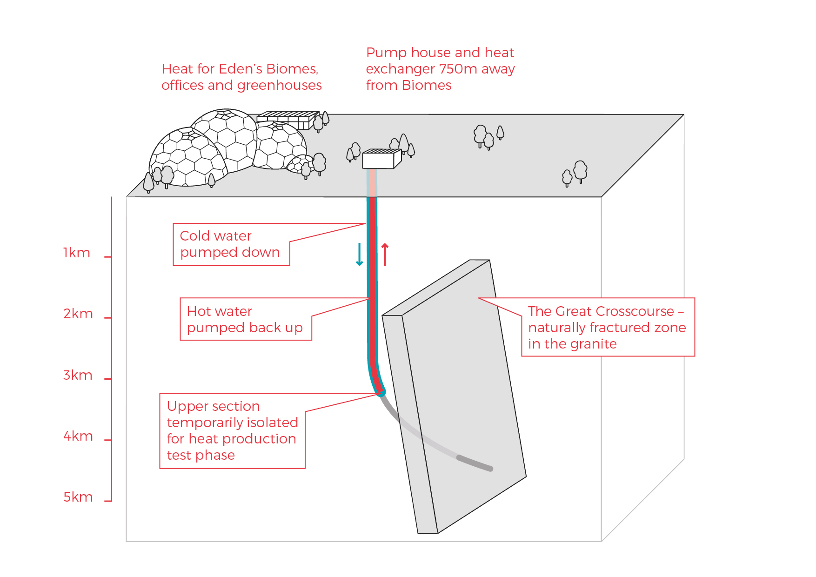

*Phase 1 of the deep geothermal concept at the Eden Project*

Eden Geothermal Limited is a special purpose vehicle which was set up to develop the geothermal project at the Eden site. The project combines the famous Eden Project site with EGS Energy Ltd’s and BESTEC (UK) Ltd’s technical expertise and experience in the geothermal sector.

EGS Energy Ltd is a UK private limited company, incorporated in 2008 and established by Roy Baria and Guy Macpherson Grant to develop deep geothermal energy solutions in the UK. BESTEC (UK) Ltd is a UK private limited company incorporated in June 2012 and established by Jörg Baumgärtner to perform deep geothermal work in the UK in cooperation with BESTEC GmbH, an established specialist company in geothermal project development. Eden Project Limited is a wholly owned subsidiary of the Eden Trust, a registered charity in the UK.

Eden Geothermal Limited has been allocated funding from the European Regional Development Fund and from Cornwall Council, together with private investment match funding, to undertake the first phase as an Industrial Research Project.

**Project Timeline**

|  |  |  |  |
| --- | --- | --- | --- |
| **Item** | **Activity** | **Duration**  **(months)** | **Date** |
| Milestone | Project commencement |  | 01/10/2019 |
| 1 | Pre-preparation, recruitment, tenders for main contractors  Preparations - finalise design, procurement and documentation | 9 |  |
| 2 | Site enabling works, procurement | 4 |  |
| 3 | Drill and complete the first well: | 5 |  |
| Milestone | Completion of drilling |  | 15/04/2021 |
| 4 | Well testing | 2 |  |
| Milestone | Evaluation of target hydrogeology |  | 15/06/2021 |
| 6 | Reporting - evaluation, reporting and dissemination | 4 |  |
| 7 | Deploy single-well heat system and heat main |  |  |

**Schedule 6b - Well Summary**

|  |  |  |
| --- | --- | --- |
|  | **Item** |  |
| 1 | Well location | Eden Project, Bodelva, Par, Cornwall UK |
| 2 | Well name | EG-1 |
| 3 | Expected well total depth | Nominal 4,700 m MD [4,500 m TVD BGL] |
| 4 | Co-ordinate location | 204399E 055652N [British National Grid]  (elevation ~130 ma OD) |
| 5 | Well classification | Geothermal |
| 6 | Borehole type | Directional |
| 7 | Well completion | Barefoot, allowing hydraulic injection/production tests |
| 8 | Expected open hole length | Maximum 1,000 m |
| 9 | Geology | Biotite – lithium granite with kaolonised sections |
| 10 | Target structure | The Great Crosscourse - steeply inclined fault structure striking NNW - SSE |
| 11 | Est. reservoir pressure | Hydrostatic (0.43psi/ft.) 9 726 m-2 kg s-2 |
| 12 | Est. BH temperature | ~ 170 - 190°C |
| +13 | Expected formation fluids | Saline water |
| 14 | Expected hydrology | Low porosity/fracture permeability |
| 15 | Estimated spud date | On or about Q4 2020 |
| 16 | Anticipated duration | 150 days (excluding rig mob/demob) |

# Schedule 6c - Location and Site Layout

The Eden Project is Cornwall’s largest visitor attraction with a footfall of approximately 1 million visitors per year. It is located about 2 - 3 km north-east of the town of St Austell in the southern part of Cornwall. Many tourists are drawn to this area because of the [Eden Project](http://www.edenproject.com), a large-scale complex that emulates various natural environments, houses plant species from around the world and hosts special events using high profile entertainers (www.edenproject.com). The area surrounding the Eden Project is also the centre of the Cornish china-clay industry.

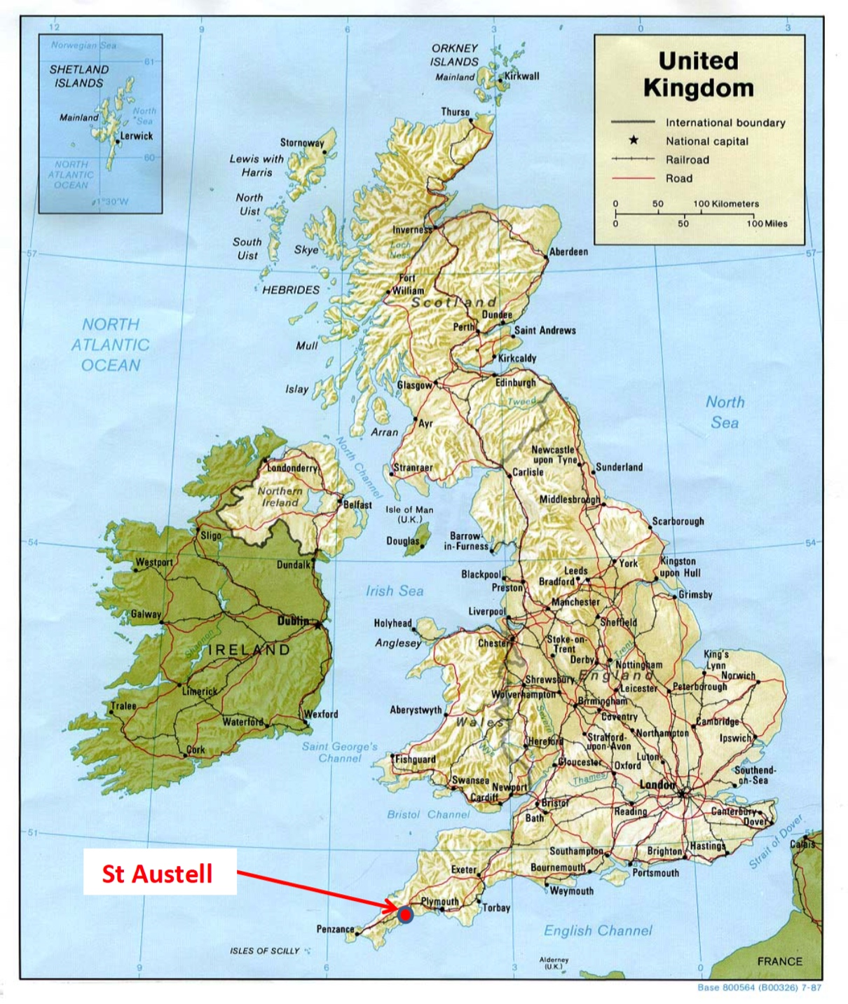

*Map of the UK showing the site of the Eden Project near St Austell*

Access by car/van

The main route into Cornwall is via the M5 motorway to Exeter and either the A30 or the A38 trunk roads through Cornwall. The majority of the A30 is dual carriageway. The Eden Project is signed from the A30.

The Eden Project is well connected by road, either (i) from the A30, via the A391; (ii) from Truro by the A390 (eastbound); and (iii) from Plymouth by the A38 and A390 (westbound). The road distance from Plymouth to St Austell is 26 miles or 42 km.

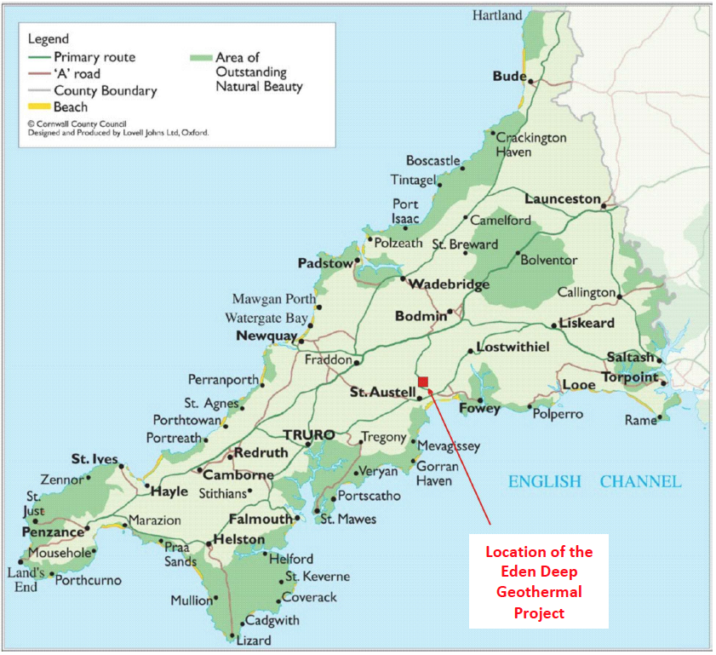

*Location of the Eden Project in Cornwall*

Access by truck/HGV

The recommended transport route for HGVs to and from the Eden Project is either:

1. from the Innis Downs junction on the A30, taking the A391 through Bugle, Stenalees and Carluddon and on to the Eden Project; or
2. from the Victoria Interchange on the A30, taking the B3274 through Roche and Trezaise to Stenalees, then the A391 to Carluddon and on to the Eden Project.

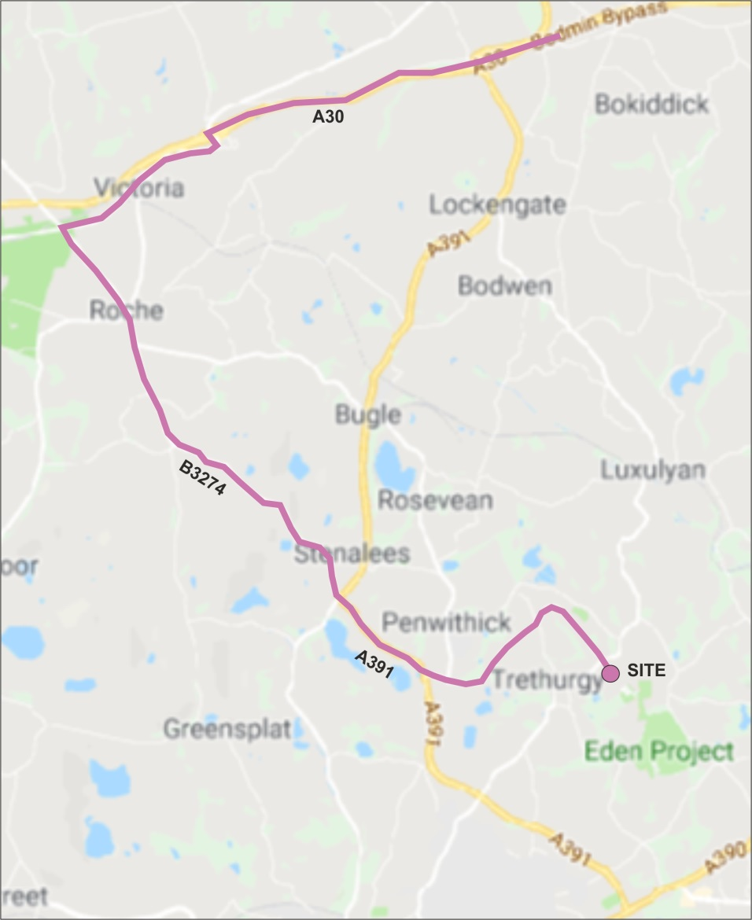

*HGV road route to the Eden Project*

Access by plane:

Newquay International Airport is located approximately 30 km from the Eden Project, around half an hour by car, via the A3059, A39, A30 and A391.

Access by train from London:

From Paddington Station, First Great Western runs trains to Cornwall which stop at all the principal stations throughout Cornwall including: **St Austell** and **Par**.

Access by boat to Plymouth:

Brittany Ferries maintains a route from Roscoff in Brittany, France to Plymouth (approximately 6 ‑ 8 hrs sailing time).

## Layout of the deep geothermal drilling site

The geothermal site is located adjacent to the north entrance of the Eden Project and is easily accessible from the road.

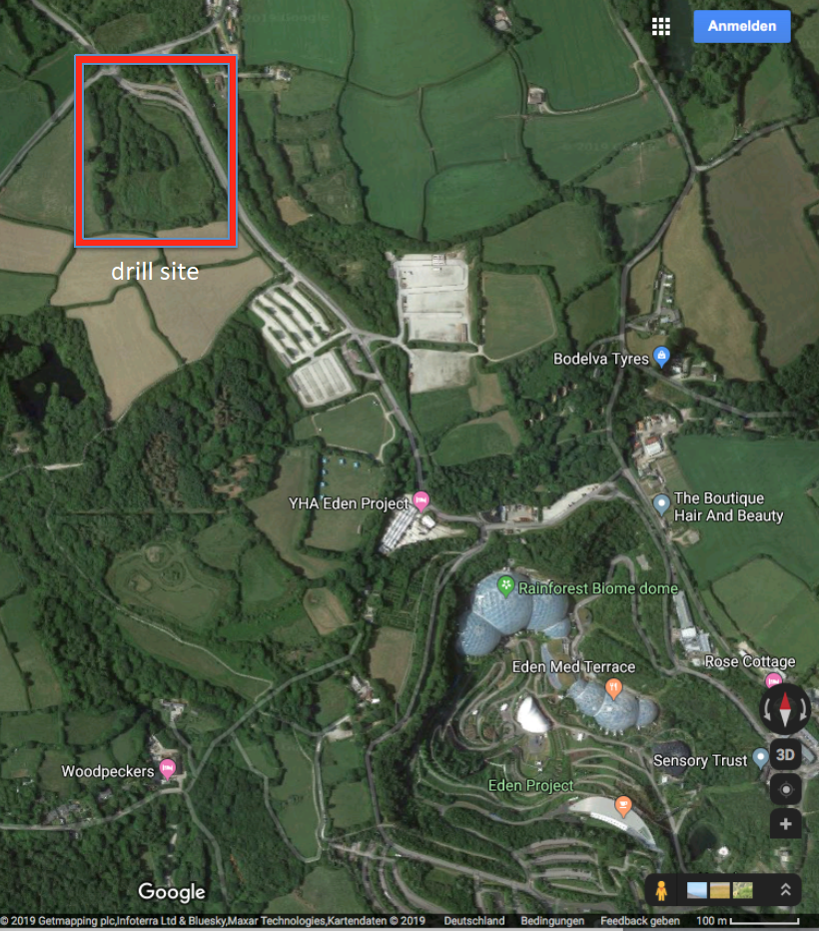

*Aerial view of the deep geothermal drilling site at the Eden Project*

The site is a relatively large, level area situated in the base of a shallow valley at an elevation of approximately 130 ma OD. The proposed layout of the drilling site is shown below, but the precise site layout and design is still to be finalised and is dependent on the specifications of the selected drilling rig.

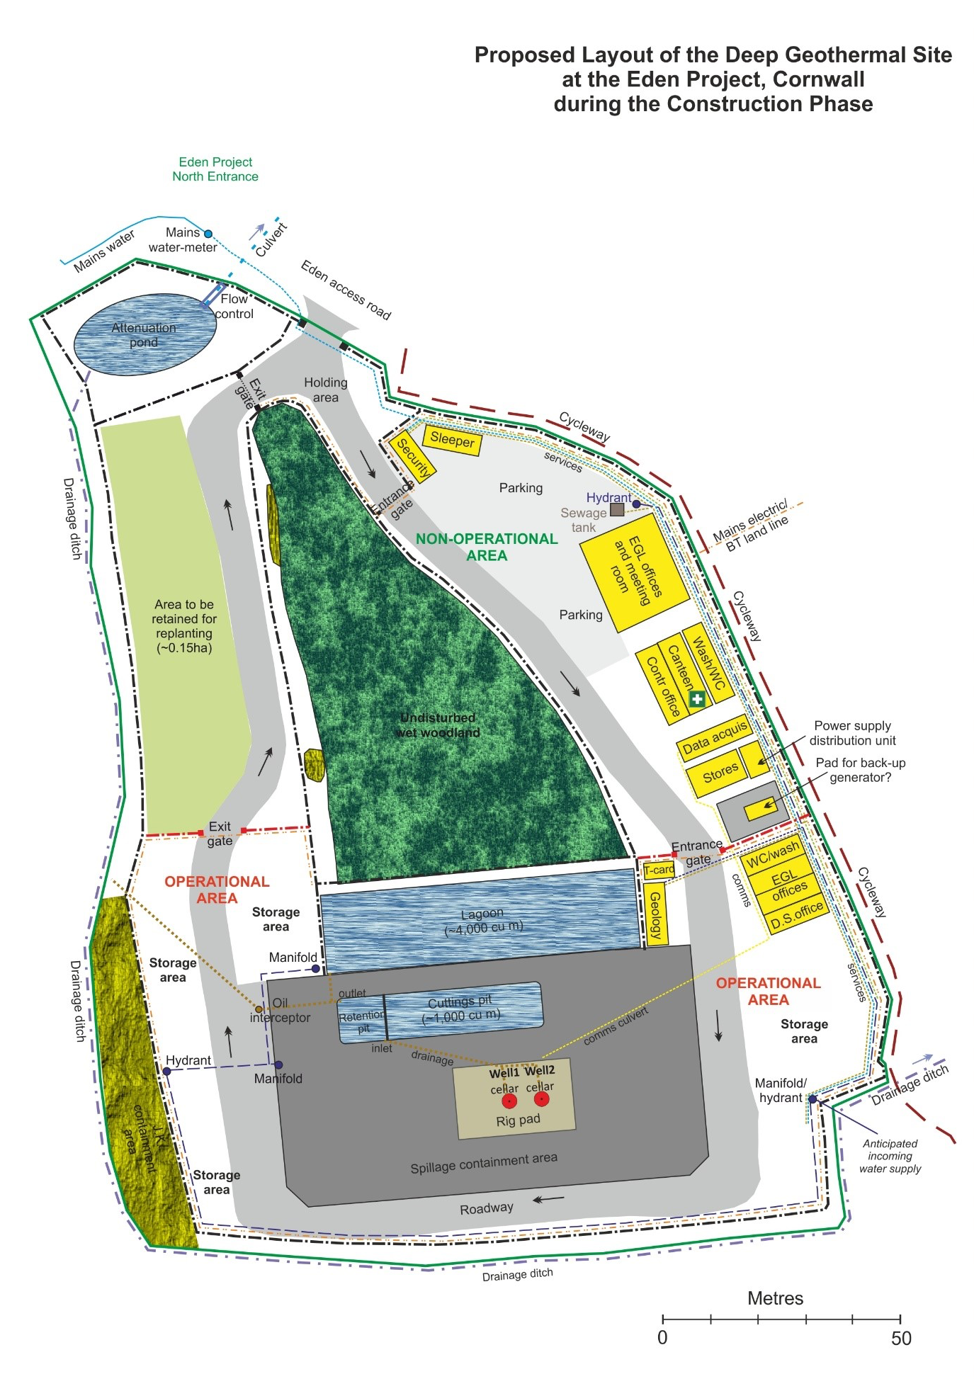

# Schedule 6d - Geology

The drilling site at the Eden Project is located on the southeast flank of the St Austell granite mass, which forms part of the Cornubian Batholith that runs under the spine of Cornwall. The St Austell Granite comprises lithium-mica granite in the west, mecoarse-grained biotite granite in the east and in the vicinity of the site is medium to coarse grained (megacrystic) biotite granite. The depth of the batholith has not been confirmed, but based on gravity modelling and processing of seismic reflection data, the base of the St Austell Granite in the vicinity of the site is inferred to lie at a depth > 7,000 m.

|  |  |
| --- | --- |
| **Eden Project geothermal site** | Geology cross-section |
| *Geological plan, with The Great Crosscourse superimposed, and an inferred section* | |

From the Geological Survey of Great Britain, (1:50,000 Geological Map of Bodmin, Sheet 347) the site is shown to be underlain (in sequence) by alluvium comprising silty clays, sands, gravels and peat overlying the St Austell Granite.

The granite in the vicinity of the site is medium to coarse grained (megacrystic) biotite granite. The granite is expected to contain feldspar megacrysts (15 - 20 mm size) in a coarse-grained matrix of alkali feldspar, plagioclase, biotite, quartz and white mica. The main component of the granite, from near surface data, at the Eden Project is quartz (~ 34 %), alkali-feldspar (~ 32 %), plagioclase (~ 22 %), biotite (~ 6 %), muscovite mica (~ 4 %) and primary tourmaline (1 %) and other minerals (1 %). With depth there are likely to be changes in grain size and mineral composition, perhaps with the granite becoming finer grained with depth. Surface mapping in the wider region shows variations in the composition of the granites which probably reflect a multi-phase intrusion history.

The Eden Project is centred in a former china clay pit. A characteristic of the St Austell Granite is the extensive ‘kaolinisation’ that occurs, principally in the lithium-mica granite to the west, which is less prevalent in the biotite granite. Kaolinisation is the alteration and degradation of the granite comprising a process of hydrolysis accompanied by removal of alkalis and silica. Ground investigations to a depth of 50m have proven highly weathered (kaolinised – Grade V) and saturated granite between surface and a depth of 25 m beneath the drill site. The formation is expected to become more competent below this depth, but further zones of weathering beneath this are likely.

The groundwater aquifer appears to be in hydraulic connection with the overlying superficial deposits, with groundwater levels at the site recorded between 2 and 4m below ground level.

Several types of veins containing varying assemblages of quartz, tourmaline and other minerals occur in the St Austell Granite, of which greisen bordered quartz-tourmaline veins are the most common type. The veins, often 1 ‑ 2 m in width, occur in clusters, usually parallel to subparallel, with a dominant ENE - WSW strike and steeply dipping between 60 - 90°. Dip directions towards the north seem to be slightly more common than those to the south. Some relatively minor deposits of metalliferous minerals, chiefly iron and tin, have been mined underground to shallow depth only. The nearest recorded mine is a shallow tin working approximately 500 m to the south of the site.

It is suggested that the main kaolin deposits may be associated with near vertical faults (locally named crosscourses) that strike through the granite in a NNW - SSE direction. These crosscourses are likely to have formed the fluid pathways for the downward migration of meteoric water and subsequent granite alteration. Some of the crosscourses are historic wrench faults, several 10s of metres wide, whereas many of the minor crosscourses are only 1 to 2 metres in width with a relatively short length. It is anticipated that such structures will extend to great depth and will form the target zone for the development of the EGS ‘reservoir’ at a depth of 4 to 5 km.

The compressive strength of the granite varies from location to location and is dependent on a number of geological factors, such as modal composition, degree of weathering and density. The uniaxial compressive strength of the granite at the Rosemanowes site (at a depth of 2.0 - 2.5 km) was found to be 135 MPa. A recent study has shown values for Grade 2 St Austell Granite (with a density of 2,640 kg/m3) of 120 ‑ 180 MPa; for Grade 3 granite (density of 2,450 kg/m3) of 40 ‑ 60 MPa; and for Grade 4 granite (with a density of 2,200 kg/m3) of 10 ‑ 20 MPa. However, the unconfined compressive strength values of 257 MPa were found in fine-grained granite at Geevor Mine, near Land’s End.

**Temperature and stress regime**

Heat flow values on or close to the Cornish granite are typically 120 mW/m2, whereas away from the granite the values are approximately 60 mW/m2. The modelling indicates the geothermal gradient in the vicinity of the Eden Project to be 35 - 40°C/km. This equates to a rock temperature of approximately 90°C at a depth of 2,000 m (TVD); approximately 160°C at 4,000 m (casing shoe); and 170 - 190°C at a depth of 4,500 m (target zone).

Evidence has shown that deep wells in the Cornish granite are exposed to hydrostatic conditions, with no zones of overpressure. Typical hydrostatic gradients for water lie in the range of 1.00 ‑ 1.15 g/cm3 (0.433 ‑ 0.500 psi/ft). At shallow depth the fracture gradient (the pressure required to induce fractures in rock at a given depth) relates to the vertical stress, but below a depth of approximately 300 m it is governed by the components of in-situ horizontal stress. Stress measurements in the 2,500 m deep geothermal wells at the former Hot Dry Rock Project, situated approximately 30 km to the southwest of Eden, and at other shallower sites in Cornwall, provide data that enables prediction of the in-situ stress regime at a depth of 5 km with a relative degree of confidence. It is anticipated that the granite will be fractured at depth and that the fluid encountered within the granite could be saline.

**Target structure**

The target for the first well is a NNW-SSE coursing fault, named The Great Crosscourse, within the southeast periphery of the exposed St Austell Granite mass. This type of large crosscourse structure is a major wrench fault with a strike length of several 10s of kilometres, traversing the granite pluton. There is considerable uncertainty about the precise location and characteristics of The Great Crosscourse at a target depth of 4,500 m. The main structure is likely to be characterised by ramifying networks of intense microfractures and quartz veins. The fault zone is likely to contain a number of discrete and complex fault planes with splay faults some of which may be oriented at a low or even high angle to the main fault zone trend. The dip angle of the fault is expected to be near vertical, i.e. about 80 - 85° down to the ENE. The width of the fault is not well recorded; at one location the main structure is recorded to be ~ 45 meters wide. Generally fault structures of this type can comprise a zone of disturbed ground >100 meters wide, but this zonal width is likely to become narrower with increasing depth.

Observations and mapping of joints and strucutres from wells up to 2500 m depth at the Rosemanowes site showed that major faults/structures were dipping around 80° east.

**Schedule 6e - Basis of Well Design**

**Schematic well plan: EG-1**

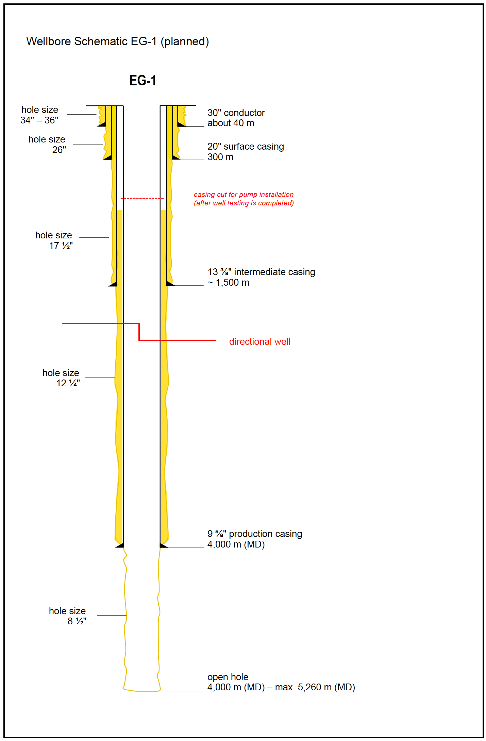

*Schematic well plan for the well EG-1: The precise well design is still under preparation and will incorporate the results of the ongoing geological investigations.*

**Drilling programme**

The entire programme, including mobilisation and demobilisation is estimated to take 8 months, with the drilling programme taking approximately 150 days from spud to completion. Planning consent has been given for 24 hour per day, 7 days per week working times during the drilling and well testing operations.

**Schedule 7 - Equipment and Services to be Provided**

The following equipment and services are required:

1. A drilling unit with the minimum specifications as detailed in the Technical Specifications (Schedule 8) mobilised to the drilling site and capable of drilling the two wells as specified in the Well Design (Schedule 6e).
2. Personnel as required to perform operations 24 hrs / 7 days as specified in the attached example contract (Schedule 8).
3. Equipment and services as specified in the attached example contract (Schedule 8 and 9 and Appendix B).
4. All equipment, materials and consumables necessary to operate the rig for the purpose and duration required;
5. Management, maintenance, servicing and repairs to the rig;
6. All relevant certification for the rig to operate onshore in the UK;
7. Welfare and mess facilities for the Contractor’s toolpusher, rig crew and other Contractor personnel, service company personnel and Company drilling supervisors;
8. Arrangement of accommodation (off-site) and travel for the rig crew;
9. Overnight/welfare accommodation on site for Contractor toolpusher;
10. Sufficient office facilities for the occasional use of service personnel (e.g. directional driller, mud engineer);
11. Basic first aid facility in case of an accident

As part of the submission the tenderer must supply the following:

1. A diagram showing how the rig and equipment will fit on to the site
2. The degree of levelling required for the area around the substructure
3. Detailed information on the rig footprint and loadings to verify the rig paramters match the local ground conditions and to enable the design of the drilling pad to be finalised
4. A transport load list with load sizes and weights
5. An estimate of rig fuel usage while drilling
6. Details of:

* sub-structure type (box-on-box/slingshot, etc.)
* method of mast erection (cantilever/telescopic, etc.)
* pipe handling system (laydown/stacking) and estimated tripping speeds
* rig skidding system

**Constraints**

Noise

The geothermal site is situated in a quiet rural area with nearby residencies, and specific conditions apply to the abatement of noise due to the proximity of residences and to environmental regulations. There are strict noise limits in the Planning Consent for drilling and continuous noise monitoring will be carried out around the site and at nearby properties throughout the drilling programme. The night time limit is 40db at LAeq, 1 hour as measured 1 m from the façade of any noise-sensitive receptor. The nearest receptor is a residential property situated approximately 200 m ENE of the well site. The drilling contractor will be required to comply with the Noise Management Plan agreed with the Local Authority (in preparation).

The tenderer must provide an up to date noise report and map for the proposed drilling unit and ancillary plant and equipment. Noise levels & structural vibration from the rig and proposed mitigation will be important criteria in selecting the successful Contractor.

Rig mast height

The height to the top of the drilling rig mast must be no more than 55.0 m above ground level (Clause 4 of the planning consent PA10/04671, dated 16th December 2010).

Safety compliance

If the drilling rig is brought in from outside the UK, it must be compliant with UK requirements. This will be checked by the Client carrying out a detailed rig audit prior to mobilisation and by ensuring compliance prior to spud.

Experience

Applicants are required to demonstrate their expertise and experience in (i) the operation of drilling contracts for deep (> 3,000 m) high temperature (> 120°C) wells; and (ii) working onshore in Europe and/or UK. Please provide documented evidence of the rig use during the past 5 years.

**Schedule 8 - Drilling Bid Contract Form**

**Bid contract for the drilling of the geothermal production & exploration well EG-1**

**to:**

Eden Geothermal Limited (EGL) invites you to submit a quote on this Drilling Bid Contract form for performing the drilling of the well outlined below and under the terms, conditions, and in accordance with the provisions of the Drilling Contract heretofore executed by your organization in conjunction with Eden Geothermal Limited (EGL).

If your bid, as submitted, is accepted by Eden Geothermal Limited (EGL), this document will become part of the contract between you and Eden Geothermal Limited (EGL).

**The proposed programme is:**

1. Mobilise rig, drill, log and complete Well EG-1
2. Test Well EG-1
3. Demobilise rig

The maximum depth (measured) is expected to be around 4,500 to 5,000 meters with an open hole diameter of 8.5”.

**Basic Conditions:**

* Be based on current drilling technology
* Fit for purpose and properly maintained
* Meet all appropriate codes, certification and standards
* Be CE marked and meet statutory UK onshore drilling requirements

**Specifications:**

Capability:Drilling to a depth of 5,500 m using 5½” drillpipe.

Hook Load: Have a maximum hook load capacity in the range between 770,000 pounds (minimum) and 925.000 pounds (350 to 420 metric tons).

Mast height: The height to the top of the mast must not exceed 55 m above ground level (permission requirement).

Racking capacity: If the rig is a conventional rig, the racking capacity should be at least 5,500m with 5" drill pipe.

Top Drive: Max. load exceeding 350 metric tons or 390 sh.ton (short tons).

Tripping Capacity: Doubles or Triples.

Iron Roughneck: Max. Joint OD 9.5” or larger.

Pumps: Triplex mud pumps capable of delivering at least 950 gpm (3600 l/min) and 3000 psi (200 bars).

Tanks: Mud tanks with a capacity of 180 m3 or more plus reserve tank.

Mud Cooler: Mud Cooler (on request), mud temperature reduction 15 – 20°C (note the noise limitations) designed for max. mud flow 180 m3/hr, water based mud, max. density 1.20 SG.

Fresh Water: Fresh water tanks with a capacity of 50 m3 or more.

Solid Control: Solid Control System with at least two Linear / Elliptical Motion Shakers, Desander, Desilter and one Centrifuge.

Optional: Solid Control System with additional Centrifuges.

Optional: Solid Control System with Flocculation Unit.

Power Supply: Electricity through generators. Sufficient Generator capacity to supply the rig & contracor’s site buildings is required; at least one back-up generator. There is no gas supply on site.

Noise: Specific conditions apply to the abatement of noise due to the proximity of residences and to environmental regulations: < 40 dB at 200 m. Contractor needs to supply a noise survey report and profile for the rig.

**Along with the equipment specified in the attached contractor-supplied inventory, the following will be provided at the expense of:**

(No exceptions allowed to specifications)

| **Distribution of Inventory and Responsibilities between Contractor and Operator** | | |
| --- | --- | --- |
| **Item** | **Operator** | **Contractor** |
| Provide foundation pad and hardstanding for the rig units | x |  |
| Maintenance of roads and location | x |  |
| Construct and remove reserve pit | x |  |
| Provide cellar | x |  |
| Restore property to original condition | x |  |
| Dig rathole and mousehole (if required) |  | x |
| Subcontract trucks for moving |  | x |
| Rig up, rig down including cranage |  | x |
| Casing and wellhead equipment | x |  |
| Supply high-pressure welder for SOW casing head | x |  |
| DSA's to nipple up on wellhead |  | x |
| Welding for rigging up, repair or modification of Contractor’s equipment including labour, materials and equipment |  |  |
| Handling of Operator’s drilling and well testing materials at the well site |  | x |
| Labour to handle Operator’s drilling supplies, materials and equipment etc. at the drilling location |  | x |
| Labour, loaders for rigging uo, rigging down, lunload and load of thrid arty drilling services equipment during rig shifts |  | x |
| Clean-up Contractor’s supplies and all rubbish (including 3rd party) on site |  | x |
| Cleaning out of cellar and drains during and on completion of drilling |  | x |
| Fresh water (about 10 l/s) | x |  |
| Mud and cuttings waste disposal | x |  |
| Communication: Hard wire telephone | x |  |
| Communication: Radio telephone |  | x |
| Electricity or electric generator (sound-proofed) |  | x |
| Back-up generator |  | x |
| Air compressor (for rig needs) |  | x |
| Double-skin fuel tanks (minimum 20.000 l) |  | x |
| Mark-up for fuel for contractor’s equipment |  | x |
| Self-contained toilets and showers |  | x |
| Fishing tools for contractor's tools |  | x |
| Bits, jars, hole openers, stabilizers, reamers | x |  |
| Drilling data recording device |  | x |
| Tong torque gauges |  | x |
| 2 x linear / eliptical motion shale shaker |  | x |
| Desander: 1000 GPM capacity or larger |  | x |
| Desilter: 600 GPM capacity or larger |  | x |
| Degasser |  | x |
| Top Drive rated for max. load |  | x |
| Iron roughneck, power slips, power tongs (c/w tong torque gauges) |  | x |
| PVT |  | x |
| Flow-show (paddle) |  | x |
| 20-3/4“ 3000 # double ram preventer with BOP pressure accumulator unit with remote controls and hydraulic control lines |  | x |
| 20-3/4“ 3000 # annular preventer with BOP pressure accumulator unit with remote controls and hydraulic control lines |  | x |
| 13-5/8" 5000 # or 10000 # double ram preventer with BOP pressure accumulator unit with remote controls and hydraulic control lines |  | x |
| 13-5/8" 5000 # or 10000 # annular preventer with BOP pressure accumulator unit with remote controls and hydraulic control lines |  | x |
| All required BOP spools and adapters for preventers, **especially:**   * spacer spool 20 ¾” 3000 x 20 ¾” 3000 with kill and choke line connections and valves, height about 800 mm * spacer spool 20 ¾” 3000 x 20 ¾” 3000 height about  2.700 mm – 3000 mm * DSA 13 5/8” 10000 x 13 5/8” 5000 * spacer spool 13 5/8” 5000 psi x 13 5/8” 5000, height about 1500 mm * spacer spool 13 5/8” 5000 psi x 13 5/8” 5000, height about 2300 mm |  | x |
| 5000 # choke manifold |  | x |
| 180 m3 mud tank system w. mixing equipment |  | x |
| Min 50 m3 fresh water tank |  | x |
| 15 - 16 m3 trip tank |  | x |
| Minimum 80 m3 water storage tank |  | x |
| Shale shaker screens |  | x |
| Mud Cooler (day rate, on request), mud temperature reduction 15 – 20°C (note the noise limitations) designed for max. mud flow max. 180 m3/hr, water based mud, max. density 1.20 SG, |  | x |
| Additional mud logging equipment (if required) | x | optional |
| BOP test pump |  | x |
| Wear bushing |  | x |
| Upper & lower kelly valve, kelly saver sub, inside BOP valve |  | x |
| Corrosion indicator rings for drill pipe |  | x |
| Pipe rams with high-temperature rated rubber seals for drill string |  | x |
| Pipe rams for casing (see schematic well design) |  | x |
| Float valves and float subs |  | x |
| Lubes and greases for contractor’s equipment |  | x |
| Casing thread lubricants | x |  |
| Casing drifts for 20”, 13 3/8” and 9 5/8” casing |  | x |
| Pipe dope for drill string |  | x |
| Mud and related chemicals | x |  |
| Cement and pumping equipment | x |  |
| Completion fluid | x |  |
| Well logging equipment | x |  |
| Well test equipment | x |  |
| Welding service for equipment |  | x |
| **Either** 5000 meters 5” premium class drill pipe S-135 hard banded (*) |  | x |
| **or** 4000 meters 5-1/2” premium class drill pipe S-135 hard banded (*) and 1000 meters of 5” premium class drill pipe S-135 hard banded (*) |  | x |
| 30 6-1/2” drill collars |  | x |
| 20 8-1/4” drill collars |  | x |
| 9 9-1/2” drill collars |  | x |
| Either 20 jts HWDP 5 ½”, hard banded |  | X |
| or 20 jts HWDP 5” hard banded |  |  |
| Related x-over subs and kellys for above |  | x |
| Forklift for location (min 10 to) |  | x |
| Equipment storage units, workshops and other ancillary units |  | x |
| Fishing tools for all Contractor-supplied equipment and tools |  | x |
| Arrange delivery of and purchase all necessary fuel, to be reimbursed by the Operator. |  | x |

(*) Contractor to specify which of these drill pipe sizes will be supplied with the rig

**Additionally, the Contractor shall be expected to supply the following documents, facilities, services, and accommodation:**

* A detailed rig inventory
* Responsible for ensuring that sufficient fuel levels are maintained to enable the rig to operate for its required purposes throughout the drilling and testing programme.
* At least 10 suitably zoned communication units (or similar approved).
* Telephone/fax and broadband cabling from the Operator’s central point to the Contractor’s cabins /rig and usage thereof.
* Rest room, toilet and washroom, canteen, laundry, lockers, and canteen/mess room, complete with First Aid facilities, to accommodate the Contractor’s personnel and the rig-based service contractors, with responsibility for installing/connecting all power, telephone, water and sewage requirements.
* Office accommodation for drilling contractor’s staff (Toolpusher, Manager, HSE Advisor, etc). Offices to be equipped with telephone and 240V power connections.
* Sleepers for Contractor’s tool pusher and Operator’s supervisor
* Ensure all their personnel are equipped with regulatory PPE that is fit for purpose.
* Any tanks used but not located within the spillage containment area of the site bunded area are required to have a “zero discharge” drainage.
* All diesel and oil tanks and vessels have a double skin or integrally bunded.
* Delineated ATEX zones.
* First aid facilities and emergency wash and eye stations located adjacent to any chemical mixing locations.
* Red warning light on top of the mast. Mast lighting to be shrouded to minimise light pollution.
* The mud programme will be directed by the Operator. Cutting samples will be obtained by the Contractor at the direction of the geologist in charge and/or mud logger.

**Reporting**

The Contractor shall provide the following reports to the Drilling Supervisor:

* IADC type daily report
* Five (or more) channel recording unit recording at least: hook weight, pump pressure, pump strokes, PVT, torque and RPM
* BHA and drillstring reports (including a tally of all drillstring and casing run downhole)
* Other reports as may be required by the Drilling Supervisor

The Day Toolpusher will be expected to attend every daily morning meeting.

**Optional equipment, which may be offered by the Contractor**

* Casing tools to run 13 3/8” casing string
* Power tongs to run 13 3/8” casing
* Casing tools to run 9 5/8” casing string
* Power tongs to run 9 5/8” casing
* Power unit for tongs
* Rig data unit (mud logging unit)
* Additional office units
* Additional welfare and changing (shower/wash/toilet) units for service personnel

**Personnel**

|  |  |  |  |
| --- | --- | --- | --- |
| **Position** | **Day shift** | **Night shift** | **Total personnel per 24 hours** |
| Senior Toolpusher |  |  |  |
| Night Toolpusher |  |  |  |
| Driller |  |  |  |
| Assistant Driller |  |  |  |
| Derrickman |  |  |  |
| Roughnecks |  |  |  |
| Mechanic |  |  |  |
| Electrician |  |  |  |
| Health & Safety Advisor |  |  |  |

Please supply documentation on the professional experience of the key personnel associated with the drilling rig.

**General provisions**

1. **If your bid is accepted by Eden Geothermal Limited (EGL), this document will be attached to and made a part of the Drilling Rig Contract between the Contractor and Eden Geothermal Limited (EGL) therein also referred to as the “Operator”.**
2. Eden Geothermal Limited (EGL) will reimburse the Contractor for the actual cost plus 5% for all those materials and services additionally furnished by the Contractor (aside of the equipment listed above) at the special request of Eden Geothermal Limited.
3. The Contractor will furnish 24 (twenty-four) hour supervision in the form of two (2) tool pushers on duty 12 (twelve) hours per day each during the drilling operations pertaining to this contract. Tool pushers and drillers are to be well qualified in all phases of geothermal drilling operations and well control procedures and will be required to have up-to-date certificates in well control and first aid training. Drilling operations may be suspended by Eden Geothermal Limited at the Contractor’s sole time and expense if the crew size is not adequate to conduct the tour of activity safely and without serious loss in efficiency. Eden Geothermal Limited’s opinion as to the competence and adequacy of crew and tool pushers shall prevail.
4. NO SMOKING will be permitted within 50 (fifty) meters of the well bore and pit area. This distance may be increased by Eden Geothermal Limited or the Contractor at any time. The Contractor will provide receptacles for deposit of all smoking materials.
5. The Contractor will be required to furnish Premium drill pipe as specified by API RP7G/2. The Contractor must furnish suitable weight and grade drill pipe to maintain 150,000 lbs overpull based on Class II rating.
6. The Contractor must provide a valid inspection according to DS1 Cat 5 of the drill pipes with a full strap of all pipe joints before it is placed in service on this job. Eden Geothermal Limited will perform on site an initial random picking inspection (according to DS1 Cat 5) of about 5 - 10% of the drill pipe as soon as it is delivered on location. This initial random picking inspection will be at the discretion and expense of Eden Geothermal Limited. During this initial random picking inspection on site all drill pipes must qualify as double white band service. If this is not the case - at the Contractor's expense - all drill pipes must be inspected again on site according to DS1 Cat 5.
7. Re-inspection of the drill string during operation will be at the discretion and expense of Eden Geothermal Limited. Replacement or repair of pipe due to normal wear or damage by the Contractor’s personnel will be at the Contractor's expense, including transportation and handling fees.

Final inspection according to API RP7G/2 of all used drill pipes and drill collars will be at the expense of Eden Geothermal Limited.

1. For the purpose of this Contract it is assumed that drill pipe loses value linearly within the premium class specification for the OD of pipe joints. Normal wear of drill pipe is defined at two point five percent (2.5%) of the difference between top premium class and top II class range per month from the time the drill pipe was put into continuous service at the EG-1 drilling location. **If pipe is run to top of the line class 2 pipe, for the purpose of pipe wear calculations, its value is set to ............... £ per meter.**

For the purpose of lost in hole and replacement compensation, drill pipe and string element values are listed below and in the drilling bid contract form:

DP 5 ½” S premium, LIH per joint: ................

DP 5” G S premium, LIH per joint: ................

HWDP 5” premium, LIH value per joint: ................

HWDP 5 1/2” premium, LIH value per joint: ................

6-1/2” drill collar, LIH value per joint: ................

8-1/4” drill collar, LIH value per joint: ................

9-1/2” drill collar, LIH value per joint: ................

Lost in hole, abnormal wear elements have to be replaced during drilling operations. The Operator will pay for transport costs.

The amount of compensation due to abnormal wear shall be the additional depreciation experienced in percentage applied to the replacement cost. In addition, the Operator shall bear the cost of any hard banding of tool joints and drill collars rendered necessary by abnormal wear (as defined above) during the course of the contract.

1. The Contractor must provide a valid inspection report/document of API RP-7G all tool joints of drill collars, subs and lift subs which are furnished by the Contractor. Eden Geothermal Limited will perform on site an initial random picking inspection of tool joints of drill collars, subs and lift subs as soon as they are delivered on site at the Eden Project, St Austell, Cornwall. This initial random picking inspection will be at Eden Geothermal Limited’s discretion and expense. During this initial random picking inspection on site all tool joints of drill collars, subs and lift subs must qualify as double white band service. If this is not the case - at the Operator's discretion and Contractor’s expense - all tool joints of drill collars, subs and lift subs must be inspected again on site. Re-inspection of the drill collars during operation will be at Eden Geothermal Limited’s discretion and expense. Replacement or repair of drill collars rejected due to normal wear or damage by the Contractor's personnel will be at the Contractor's expense, including transportation and handling fees.
2. In order to perform the inspection mentioned in Art. 6 and Art. 7, all drill pipes and drill collars will have to be mobilised ahead of the rig itself, stocked and inspected at the drilling site in the Eden Project, St Austell, Cornwall. Unloading and stockage of the drill pipes and collars at the drilling platform will be at the Contractor’s care and expense.
3. Hard banded drill pipe tool joints must be sufficiently smooth so that damage to casing strings does not occur. The judgment of Eden Geothermal Limited’s supervisor as to suitability of hard banded pipe will prevail.
4. The Contractor will make up all rotary-shouldered connections per torque specifications as set forth in the IADC Drilling Manual or in API RP7G/2.
5. Prior to beginning the operations, the Contractor will furnish a master strap acceptable to Eden Geothermal Limited of the Contractor's drill pipe and drill collars on location. Drill pipes and drill collars rejected by inspection or unusable will be promptly removed from the location at the Contractor’s expense and replaced by Contractor.
6. Eden Geothermal Limited will pay only the first (24) twenty-four hours rig time at day rates without drill pipe to nipple up and test blowout preventer on each casing string. This period to start after the appropriate wellhead is installed.
7. Re-testing of blowout preventer equipment will be at the discretion and expense of Eden Geothermal Limited. Repairs to blowout preventers and associated equipment will be considered as rig repairs, and payment for such repairs will be per the Drilling Contract.
8. BOP equipment will be re-tested as required by governmental regulatory agencies.
9. The Contractor will require its crews to conduct a blowout control drill once per week. This is to insure that all crews are fully trained in blowout control and that blowout preventer equipment is in good operating condition. Annular preventers operated for a drill will not be completely closed. All drills will be noted on tour sheets.
10. Replacement of blowout preventer rubber elements will be at the Contractor's expense if such replacement is due to normal wear. Eden Geothermal Limited will replace elements damaged because of abnormal conditions such as stripping drill pipe.
11. The Contractor will furnish adequate illumination at the accumulator.
12. In the event that a crew is shorthanded, Eden Geothermal Limited will deduct the wages of missing crew member or members from invoice. For the purpose of determining this deduction, the Contractor's applicable rate for those particular missing positions will be used. The rates paid for each crewman position is to be provided to Eden Geothermal Limited by the Contractor.
13. An explosion-proof heating system for the doghouse may be operated only with the permission of the Eden Geothermal Limited’s supervisor. Other types of heating devices will not be allowed.
14. The Contractor will furnish all liners, swabs, and pistons required to operate its pumps at the maximum rated efficiency.
15. There is no electrical supply from the grid, and no mains gas supply, on site. The Contractor must provide adequate generating capacity to support its and service companies’ ancillary requirements, mud logger facility, and other usual support equipment.
16. The Contractor will furnish suitable wiper rubbers for all tools in use. Same will be used on all trips in and out of hole, and the hole will be covered at all times when the drill pipe is out of the hole.
17. On site personnel are required to wear hard hat, steel toed safety shoes, and appropriate protective clothing and goggles. The Contractor is expected to provide equipment that makes it easy to identify the role of the wearer at a distance.
18. Rig day work ceases when mud tanks are jetted and cleaned.
19. The Contractor will be responsible for the disposal of all waste material and containers that are supplied by the Contractor.
20. The Contractor, at its sole cost, shall be responsible for qualifying, licensing or registering its drilling rig and associated equipment to operate in Cornwall. The Contractor will present all documentation required to operate a drilling rig in Cornwall to the Operator before the signature of this Contract.
21. Before accepting the rig, a delegate from EGL will perform a rig inspection either at its base or during a drilling operation in order to assess the details in the bid document and verify the state of the rig.
22. The rig must be compliant with UK regulations. If it is imported into the UK, EGL will arrange an independenty safety compliance audit prior to mobilisation. Any modifications required to ensure compliance would be at the Contractor’s expense.
23. The Contractor will be required to arrange fuel deliveries as necessary throughout the drilling programme. The Contractor will supply the Operator with a pre-agreed mark-up.
24. **This Drilling Bid Contract will be followed in the offer with an attachment that fully depicts the equipment that is being supplied by the Contractor for use on the Eden EG-1 well (the Contractor's Equipment Description). This document will then be made a part of the overall Drilling Contract Agreement.**

**Read and accepted:**

|  |  |
| --- | --- |
| **Name of organisation** |  |
| **Name of person signing** |  |
| **Capacity in which signed** |  |
| **Signature** |  |
| **Date** |  |

**Schedule 9 - Drilling Bid Contract Form: Contractor’s Bid**

If your bid, as submitted, is accepted by Eden Geothermal Limited (EGL), this document will become part of the contract between you and Eden Geothermal Limited (EGL) at Schedule II of the draft contract.

**Contractor’s Bid (in UK Pounds Sterling)**

1. **Drilling Rig:**

**Daywork rates with drill string in use** - per day ---------------------------------

**Daywork rates without drill string in use** - per day ---------------------------------

Mark-up rate on fuel delivery ---------------------------------

Mark-up rate on third party services and equipment supplied

through the Contractor ---------------------------------

**Standby with full crews** - per day ---------------------------------

**Standby with watchman** - per day ---------------------------------

**Daywork rate for rig pumps**, power generation with ---------------------------------

two crews of 4 men (incl. at least one electrician and one

mechanic) **for well testing purposes**

**Mobilisation, flat rate** ---------------------------------

(including unloading, cranage and rig-up at the location)

**Optional: Rig Skidding, flat rate** ---------------------------------

**Demobilisation, flat rate** ---------------------------------

(including rig down, cranage and loading at the location)

1. **Mud Cooler**

Mud Cooler Mobilisation, Demobilisation, rig-up and

rig down, flat rate: ---------------------------------

Mud Cooler daily rental rate including installation material: ---------------------------------

1. **Lost in hole / Replacement**

For the purpose of lost in hole and replacement compensation, drill pipe and string element values are listed here below:

DP 5 ½” G or S premium, LIH per joint: ---------------------------------

DP 5” G or S premium, LIH per joint: ---------------------------------

HWDP 5” premium, LIH value per joint: ---------------------------------

HWDP 5 1/2” premium, LIH value per joint: ---------------------------------

6-1/2” drill collar, LIH value per joint: ---------------------------------

8-1/4” drill collar, LIH value per joint: ---------------------------------

9-1/2” drill collar, LIH value per joint: ---------------------------------

|  |  |
| --- | --- |
| **Name of organisation** |  |
| **Name of person signing** |  |
| **Capacity in which signed** |  |
| **Signature** |  |
| **Date** |  |

|  |  |
| --- | --- |
| **Name of organisation** | Eden Geothermal Limited |
| **Name of person signing** |  |
| **Capacity in which signed** |  |
| **Signature** |  |
| **Date** |  |

|  |
| --- |
| **APPENDICES** |

# APPENDIX A – Site Regulations

The first well drilling programme will be carried out under the Borehole Sites and Operations Regulations (BSOR), 1995 and under the relevant sections of the Offshore Installations and Wells (Design and Construction) Regulations, 1996. These regulations identify the health and safety requirements that need to be followed during the drilling programme. Other relevant regulations include:

Construction (Health, Safety and Welfare) Regulations – 1996

Offshore Installations and Wells (Design and Construction) Regulations – 1996

Clean Neighbourhood and Environment Act – 2005

Contaminated Land Regulations – 2006

Control of Major Accident Hazards Regulations – 1999

Control of Pollution (Oil Storage) Regulations – 2001

Control of Substances Hazardous to Health Regulations – 2002

Controlled Waste Regulations – 1992

Environmental Noise Regulations – 2006

Environmental Protection Act – 1990

Environmental Protection (Duty of Care) Regulations – 1991

Groundwater Regulations – 2009

Hazardous Waste Regulations – 2005

Health and Safety at Work Act – 1974 (and any subsequent amendents)

Lifting Operations and Lifting Equipment Regulations - 1998

Management of Health and Safety at Work Regulations – 1999

Personal Protective Equipment Regulations – 2002

Pollution Prevention and Control Regulations – 2000

Provision and Use of Work Equipment Regulations – 1998

Reporting of Injuries Diseases and Dangerous Occurrence Regulations – 1995

Site Waste Management Plan Regulations – 2008

Waste Management Licensing Regulations – 1994

Water Resources Act – 1991/amended 2009

Workplace (Health, Safety and Welfare) Regulations – 1992

The well Operator, in conjunction with the Contractor, will produce a Health & Safety Document/Plan prior to the commencement of drilling. This document must:

1. demonstrate that the risks to which persons at the borehole site are exposed have been properly assessed;
2. demonstrate that adequate measures will be taken to safeguard the health and safety of the persons at work at the site; and
3. include statements and rules of how the measures referred above will be co-ordinated.

In addition, the Health and Safety Document shall also include where appropriate:

1. Escape Plan (including the provision of a safe muster area);
2. Plan for the Prevention of Fire and Explosions;
3. Fire Protection Plan;
4. Detection and Control Plan for harmful gases.

An effective Safety and Environmental Management System (SEMS) will be implemented throughout the drilling and testing programme, with the fundamental objective of promoting continuous progress towards making safety and environmental protection an integral part of the company’s culture.

A Bridging Document will be produced between the Client and the Contractor, which establishes the responsibilities for safety and working policy. For example, it may be agreed that the Contractor is the main contractor, therefore their work system, policies and rules will be adopted.

A Health and Safety Advisor will be employed by the Contractor throughout the drilling programme. A record will be maintained of occupational accidents and diseases and dangerous occurrences and accidents, as defined under RIDDOR (1995). A formal Permit to Work (PTW) system will be developed to ensure that all potentially hazardous work is carried out safely and ensures effective authorisation of designated work and effective communication of the work to be carried out, including identifying the hazards involved. All personnel entering the Operating Area will have to undergo a safety and health induction given by the Safety Advisor.

# APPENDIX B – Draft Drilling Rig Contract

This contract is executed and entered into as a deed on the …………………..,

**between** **Eden Geothermal Limited** having its registered office at Bodelva, St Austell, Cornwall, established and registered in the UK under company no 10216419 (hereinafter referred to as the **OPERATOR**),

**and ……………………….** having its registered office at ………………………………., established and registered in ……………. under company no ……………….(hereinafter referred to as the **CONTRACTOR**),

The Operator and Contractor are considered to be a Party, or together the Parties.

**Recitals**

Whereas:

The Operator intends to drill one (1) hot water exploration well, hereinafter referred to as the Eden Geothermal #1 (EG-1) well, located in Bodelva, St Austell, Cornwall (the Site). For this reason he desires to rent one (1) drilling rig complete with all required logistics.

Whereas:

The Contractor is engaged in the business of rental and rigging a drilling rig, drilling, testing, completing, plugging and abandoning wells; and the Contractor represents that it has adequate resources and equipment in good working order and fully trained personnel capable of efficiently operating such equipment; and is ready, willing and able to rent for this purpose the drilling rig referred to in Schedule 3 and referred to hereinafter as **the Drilling Rig** along with the related drilling and other logistics to the Operator as described in Schedule 3.

Now, therefore, in consideration of the mutual covenants and agreements hereinafter provided, it is hereby agreed as follows:

**Article 1**

**Clause 1.1 - Documents included**

This Contract fully consists of the Articles, Clauses and the Schedules appended hereto.

**Clause 1.2 - Commencement Date**

"Commencement Date" means the date and time that the Operator confirms by notice to the Contractor that the Drilling Rig has been successfully moved to the EG-1 well location and is fully rigged up to the satisfaction of an Operator’s Representative in accordance with Schedule 3.

The Commencement Date shall occur no earlier than 15th November 2020.

**Clause 1.3 – Definitions and interpretation**

The definitions and principles of interpretation that will apply to this Contract are set out at Schedule 1 to this Contract.

**Article 2**

**Clause 2.1 - Object**

The Contractor shall rent the Drilling Rig complete with all required logistics in order to allow the Operator to drill, complete, workover or plug and abandon the EG-1 well. The Contractor shall not, under any circumstances, be required to carry out operations hereunder in any location considered by the Contractor's insurance carrier or by good industrial practice to be unsafe, provided that the Contractor hereby warrants that it has obtained the consent of its insurance carrier to conduct operation on the EG-1 well.

**Clause 2.2 - Duration and early termination of Contract**

2.2.1 The terms of this Contract shall be for the duration of time necessary to drill, test and complete or workover the EG-1 well plus any other activities deemed to be necessary to complete on the well at the discretion of the Operator and to decommission the Drilling Rig and remove it from the Site.

2.2.2 In the event the Drilling Rig becomes a total loss or constructive total loss (i.e. its costs of repair exceeds its insured value), the Operator shall be entitled (without prejudice to its other rights or remedies) to terminate this Contract by notice in writing to the Contractor. Such termination shall be effective as of the time when the Drilling Rig ceases drilling operations within the scope of this Contract and no further payments or demobilization fee shall be payable to the Contractor except amounts payable as of the time of such loss. The Contractor shall be responsible, at its expense, for the removal of the Drilling Rig and of its equipment in the event of such loss.

2.2.3 The Operator shall have the right to terminate this Contract upon (5) five days advance written notice in the event that performance of either Party’s obligations under this Contract is delayed or prevented for reasons of Force Majeure.

2.2.4 In the event a Party goes into liquidation, becomes insolvent, makes an assignment for the benefit of creditors, makes an arrangement, composition, or compromise with its creditors under any applicable laws or has a receiver appointed in respect of the whole or any part of its assets (or any event occurs, or proceeding is taken, in any jurisdiction to which it is subject that has an effect equivalent or similar to any of the events mentioned above), then the other Party shall be entitled (without prejudice to its other rights or remedies) to terminate this Contract by notice in writing to the first Party. The Operator's election to terminate this Contract shall not relieve the Contractor of its obligations to protect the actually executed well in accordance with good industrial practice.

2.2.5 In addition to any other remedies provided to the Operator hereunder, if at any time the Contractor, the Contractor's personnel or the Drilling Rig or related equipment should prove to be incapable or incompetent or negligent or unreliable or consistently poor in performance of the obligations under this Contract , or if the equipment is incapable of being operated at the manufacturer's rated specifications during sustained operation, or if the Contractor fails to fulfill any of its material obligations hereunder, or if the Drilling Rig is not as represented in Schedule 3 , the Operator shall notify the Contractor in writing and specify in detail the deficiencies. Should the Contractor fail to submit a full plan of action and to take action accordingly to remedy the deficiencies complained of within (24) twenty-four hours after such notice is given to the Contractor, then the Operator shall have the right to terminate this Contract under the conditions as listed in Clause 2.2.2.

2.2.6 Both Parties agree that, in case the Contractor is not able to fulfill its obligations described in Clauses 18.2, either Party shall be entitled to terminate this Contract by giving notice in writing.

**Clause 2.3 - Consequences of Termination**

2.3.1 Following termination of this Contract, the Contractor will (if required by the Operator by notice in writing) carry out the De-mobilisation of the Drilling Rig in accordance with Clause 3.2, and shall render such assistance to the Operator as the Operator may reasonably require for the decommissioning of the Drilling Rig and the removal of the Drilling Rig from the Site.

2.3.2 Termination of this Contract shall not affect any rights of the Parties’ accrued as at the date of termination and termination of this Contract shall not affect the continuing rights and obligations of the Parties under any Clauses which are expressed to survive termination or which are required to give effect to such termination or the consequences of such termination.

**Article 3**

**Clause 3.1 - Mobilisation**

* + 1. On the base of the flat rate described in Clause 5.2.1.a. the Contractor shall undertake the following as more particularly described in Schedule 3:

1. Loading of the Drilling Rig and its related equipment as specified in the the Contractor’s Loading List at the point of origin (incl. cranes, forklifts, manlifts and manpower).
2. Transport of the Drilling Rig and related equipment as specified in the Contractor’s Loading List from the point of origin to the Site.
3. Unloading and full rig-up of the Drilling Rig and its related equipment at the Site (incl. cranes, forklifts, manlifts and manpower).
   * 1. The Contractor shall be entitled to invoice for the Mobilisation Fee as set forth in Clause 5.2.1.a following the Commencement Date in respect of the services described in this Article 3.1.

**Clause 3.2 - De-mobilisation**

* + 1. The Contractor shall undertake the following as more particularly described in Schedule 3:

1. Rig down and loading of the Drilling Rig and its related equipment as specified in the Contractor’s Loading List at the Site (incl. cranes, forklifts, manlifts and manpower).
2. Transport of the Drilling Rig and its related equipment as specified in the Contractor’s Loading List from the Site to a point of destination not further away from the Site than the point of origin.
3. Unloading of the Drilling Rig and its related equipment as specified in the Contractor’s Loading List at the point of destination (incl. cranes, forklifts, manlifts and manpower).

3.2.2 The Contractor shall be entitled to invoice for the De-mobilisation Fee as set forth in Clause 5.2.1.bin respect of the services described in this Article 3.2 at such time the Contractor has completely removed said equipment from the location and completed all obligations named in this Contract.

3.2.3 The Contractor shall decommission and remove the Drilling Rig from the Site as soon as reasonably practicable following a request by the Operator to do so.

**Clause 3.3 - Drilling Location**

The Operator shall be responsible for the preparation of the drilling location. The Operator will prepare a location adequate in size and capable of supporting the Drilling Rig based on the footprint measurements and load information supplied by the Contractor. The Operator will construct the wellbore cellar. The Operator shall be responsible for the conductor pipe programme adequate to prevent soil and subsoil wash out. It is recognized that the Operator has superior knowledge of the location and access routes to the location, and must advise the Contractor of any subsurface conditions or obstructions (including, but not limited to mines, caverns, sink holes, streams, pipelines, power & telephone lines) which the Contractor may encounter. In the event subsurface conditions cause a cratering or shifting of the location surface, and loss or damage of the rig or its associated equipment therefrom, the Operator shall without regard to other provisions of this Contract, including Clause 9.2 hereof, shall reimburse the Contractor to the extent not covered by the Contractor’s insurance, for such loss or damage including payment of repair rate during repair or demobilisation as applicable.

The Operator shall perform its obligations under this Clause 3.3 in accordance with the requirements on the Operator as set out in Schedule 3.

**Article 4**

**Clause 4.1 - Equipment / operations provided by the Contractor**

4.1.1 The Contractor shall:

1. furnish the Drilling Rig and equipment specified in **the Contractor's Equipment Description,**
2. furnish the spare parts, supplies and services that the Operator reasonably requires in order to make the Drilling Rig operational and in accordance with this Contract, and
3. carry out all operations for the drilling, completing, re-completing, working over, testing or plugging and abandonment of the EG-1 well as requested by the Operator's personnel and supervisors. Replenishment of Contractor-supplied items will be arranged by the Contractor at its cost, and the Contractor shall be responsible for maintaining adequate stock levels at all times. The Contractor's drilling rig and equipment shall be in such condition as to be suitable and serviceable for performance in accordance with the terms and conditions of this Contract.

4.1.2 The Contractor shall also provide at its expense any items of equipment spare parts, supplies, services, or personnel that the Operator requires for the operations and maintenance of the Contractor's Drilling Rig and equipment for normal drilling operations, according to good oilfield practice.

4.1.3 The Contractor warrants that all equipment, parts and supplies supplied by the Contractor will be of sound and merchantable quality.

**Clause 4.2 - Personnel**

4.2.1 The Contractor shall provide competent, qualified drilling crews assigned to operations hereunder. If at any time the Contractor fails to keep on the job a full complement of personnel as provided in the manufacturer’s recommendations notwithstanding any other remedy available to the Operator, the Operator shall be entitled to deduct from any sums otherwise due to the Contractor a sum reflective of the extent by which the Contractor has understaffed the Drilling Rig.

4.2.2 In the event the Operator requests the Contractor to supply labour in addition to that called for under this Contract, the Operator agrees to pay actual documented costs incurred by the Contractor as a result of such additional Contractor labour, in accordance with the Contractor's usual personnel and accounting practices in each case to the extent incurred for the purpose of this Contract, plus a 5 % surcharge. Any additional personnel employed by the Contractor pursuant to this sub-clause shall be considered the Contractor's personnel for the purposes of this Contract.

**Clause 4.3 - Personnel benefits**

The Contractor shall be responsible for providing at its cost all health and welfare requirements of its employees and personnel including without limitation housing, food, medical attention and any benefits required by the social legislation or regulation applicable to the Contractor’s personnel in the Contractor’s country and as far as applicable in the Operator’s country.

**Clause 4.4 - Replacement of the Contractor's personnel**

The Operator may request in writing that the Contractor replaces any of the Contractor's personnel in the shortest time reasonably possible and at the Contractor's sole cost, if the Operator's representative believes that such personnel are unsatisfactory for reasons of misconduct or incompetence. If the Contractor refuses to replace such personnel, under the conditions as listed in clause 2.2.2., the Operator may terminate this Contract upon (5) five days written notice to the Contractor.

**Clause 4.5 - Examination of materials, equipment and supplies**

The Contractor agrees to examine before using all materials, equipment and supplies furnished by the the Operator, and promptly report to the Operator any visual or apparent defects contained therein, and the Operator shall promptly replace same without delaying operations.

**Clause 4.6 - Maintenance of Operator's equipment**

The Contractor shall, within normal maintenance programs and with services and equipment available on the Drilling Rig, maintain the Operator's equipment in good condition and repair. Upon completion of the operations hereunder, the Operator's equipment shall be returned to the Operator, in as good condition as when received by the Contractor, ordinary wear and tear excepted.

**Clause 4.7 - Drilling programme detail changes**

The Operator reserves the right to modify the well programme, including but not limited to hole and casing size as necessary, and any other relevant programme at any time. Any additional equipment over and above that set out in the **Contractor's Equipment Description**, which may be required because of the change in the programme, shall be furnished by the Operator.

**Clause 4.8 - Subcontractors**

The Contractor shall have no authority hereunder to hire or engage others to perform all or part of the Work without prior written permission from the Operator. Use of subcontractors by the Contractor shall not relieve the Contractor from any liability or obligation under this Contract and all subcontracts shall clearly stipulate therein that the Contractor is the principal and not the agent of the Operator.

**Clause 4.9 - Authority to bind Company**

The Contractor shall not have the authority to incur any debt, liability, or obligation on behalf of the Operator without prior written permission of the Operator.

**Article 5**

**Clause 5.1 - Operator's payment obligation**

The Operator shall pay to the Contractor during the Contract Period the amounts due from time to time, as provided in this Article 5 and in accordance with all other terms and conditions hereof.

**Clause 5.2 - Rates of payment**

1. The Operator shall pay to the Contractor the Mobilisation Fee as stated in the Bid Contract Form Appendix A, plus any applicable VAT, regardless of actual costs incurred by the Contractor and according to the provisions of Clause 3.1 here above.
2. The Operator shall pay to the Contractor the Demobilisation Fee as stated in the Bid Contract Form Appendix A plus any applicable VAT, regardless of actual costs incurred by the Contractor and according to the provisions of Clause 3.2 here above.
   * 1. The Operator shall pay to the Contractor the **Daywork Rate** **with Drill String** **in use** plus any applicable VAT,for all periods the Drilling Rig is on location and fully operational with drill string (including pick up and lay down of drill string), unless the Parties agree that (a) such rate is superseded by one of the other rates contained in this Contract or (b) a zero rate shall apply.

5.2.3 The Operator shall pay to the Contractor the **Daywork Rate without Drill string in use** plus any applicable VAT, for all periods the Drilling Rig is on location and fully operational without drill string, unless unless the Parties agree that (a) such rate is superseded by one of the other rates contained in this Contract or (b) a zero rate shall apply.

5.2.4 Save where Clause 5.2.5 applies, the Operator shall pay to the Contractor the **Standby Rate with Full Crews** **,** plus any applicable VAT, for any period that the Drilling Rig is on location and not operating because of the Operator's orders, waiting on weather or other event as defined in Clause 12.2, or waiting on equipment, materials or services which the Operator is obligated to provide (including but not limited to well and drill stem testing, electric logging, or waiting on cement).

5.2.5 The Operator shall pay to the Contractor the **Standby Rate with Watchman only**, plus any applicable VAT, for any period that the Drilling Rig is on location and not operating because of the Operator's orders to staff the Drilling Rig with a Watchman only for an extended period of time. The Operator must notify the Contractor (7) seven days in advance of the desire to retain the Drilling Rig on a Standby with Watchman status and such rate will apply from the day falling 7 days after such notice and until such time as the Drilling Rig recommences operation. In addition the Contractor shall be reimbursed all costs reasonably and directly incurred by the Contractor for the retention, de-mobilisation to their respective sources, remobilisation and/or termination of the Contractor's personnel in respect of such period, and if the Operator requires the services of some of the Contractor's personnel during a period of suspended operations then the Operator shall pay the Contractor's costs of such personnel in accordance with the terms of Clause 4.2.2 above.

5.2.6 The Contractor shall unless otherwise approved by the Operator in writing be allowed the lesser:

1. up to (4) four hours per occurrence or
2. (24) twenty-four hours per month total

for the purpose of maintenance and repair of equipment on the Drilling Rig. During the times mentioned above, the Contractor will be allowed to continue to bill the Operator on whatever Rate they are currently working under. Should the repair time exceed the allowed time stated in this Clause 5.2.6, then the Contractor's rate shall drop to zero for the remainder of the time required to make said repairs.

5.2.7 The Contractor shall bear for its own account the cost of transportation of the Contractor's personnel from its base (or such other location at which the Drilling Rig is then held) to the Site and for all onward transportation except for such situations as described in Clause 5.2.5 above.

5.2.8 The Contractor shall bear for its own account the cost of food and accommodation of its personnel during the performance of its obligations under this Contract.

**Clause 5.3 - Calculation and finality of rates**

The rates quoted in Clause 5.2 shall be calculated to the nearest half-hour. The effective date, hour and duration of each applicable rate shall be determined (on the base of the effective time of each operation performed and recorded in the daily drilling report referred to in Clause 11.9 and stated and signed by the Operator’s and Contractor’s Representatives on Monthly Time Distribution Reports.)

There shall be no rate increases for the duration of the Contract.

**Article 6**

**Clause 6.1 - Contractor's obligation to pay taxes assessed**

Except as otherwise provided herein the Contractor shall pay all taxes assessed against the Contractor in connection with the Work performed or equipment furnished by the Contractor hereunder and agrees to indemnify the Operator and hold the Operator safe and harmless against any and all claims or liability for income corporation, excess profits, and other taxes, and fines, penalties and interest thereon assessed or levied by the UK government or any political subdivisions thereof or by the government of any other country or political subdivisions thereof against the Contractor or the Contractor's subcontractors.

The Contractor further agrees to protect and keep the Operator safe and harmless from all taxes and related fines, penalties, and interest thereon assessed or levied against or on account of wages, salaries or other benefits paid to any of the Contractor's employees or employees of its subcontractors, and all taxes assessed or levied against or on account of any property or equipment of the Contractor or of its subcontractors.

**Clause 6.2 - Operator's right to withhold**

The Operator may, without liability to the Contractor withhold income, excess profits, value added and other taxes from payments made by the Operator pursuant to this Contract, to the Contractor or the Contractor's subcontractors or any person, firm, company or any combination thereof nominated by the Contractor or the Contractor's subcontractors, to the extent that in the opinion of the Operator such withholding is required under the laws or regulations of the UK, or any political subdivisions thereof, or by the laws or regulations of any other country, or any political subdivision thereof, provided that the Operator shall provide the Contractor with documentation evidencing the withholding and payment of such amount on the Contractor's behalf.

**Article 7**

**Clause 7.1 - Submitting of invoices**

The Contractor shall invoice the Operator in Pounds sterling on a weekly basis in respect of expenses incurred, items provided, operations carried out and services rendered during the previous week. The Contractor's partners, subcontractors or principals may not invoice the Operator with regard to this Contract. The Contractor shall invoice the Operator clearly stating separately amount due on the date of the invoice and any applicable VAT with details of the basis of which such sum is claimed. All invoices shall be denominated in UK Pounds and accompanied by Time Distribution Reports showing the applicable rates and third party invoices and other supporting documentation of costs incurred by the Contractor and chargeable to the Operator. Invoices must also include the documentation which the Contractor is required to provide under Clause 11.9, duly signed by the Operator. The Contractor will indicate the contract title on the face of the invoice and specify the applicable contract term or article. The Due Date for any invoice shall be the date on which the Operator receives such invoice, provided that it is fully compliant with the requirements of this Clause 7.1.

**Clause 7.2 - Time and manner of payment**

The Operator shall subject to Clause 7.3 pay, or cause to be paid, the Contractor's invoices in UK Pounds by bank transfer or cheque no later than (45) forty-five daysafter the Due Date (such date being the Final Date for Payment).

**Clause 7.3 - Pay less notice**

In the event the Operator disputes an item billed, the Operator shall no later than (5) five days prior to the Final Date for Payment, specifying the sum it considers due and payable to the Contractor on the date of such notice and the basis on which it has calculated such figure.

Where the Operator issues a notice pursuant to this Clause 7.3, it shall pay the sum stated in such notice on or before the Final Date of Payment.

**Clause 7.4 - Interest on Late Payment**

If the sums due to the Contractor under this Contract are not paid on or before the Final Date for Payment (and no notice has been given by the Operator in accordance with Clause 7.3) the Contractor shall be entitled to receive interest on the amount unpaid from the Final Date for Payment until payment is received. The interest shall be at the annual rate 2 percentage points above the base rate of the Bank of England.

**Article 8**

**Clause 8.1 - Performance of Contractor and its personnel**

The Contractor shall carry out its obligations under this Contract:

1. in accordance with Schedule 3;
2. with the skill, care and diligence to be expected of a competent contractor experienced in the scale and nature of the services comprised in this Contract;
3. in accordance with law (including but not limited to the Drilling Site Regulations);
4. in a safe, thorough and workmanlike manner;
5. according to good oilfield practice; and
6. in accordance with general directives issued by the Operator, including, but not limited to, those concerning drilling and completion procedures, well plans and casing, mud and cementing programs

The Contractor shall ensure that the Drilling Rig is adequately manned with competent personnel and maintained in a state in which it can perform efficiently and continuously in accordance with good oilfield practice. All UK work and safety regulations to be enforced for the purpose of this Contract and applicable to the Contractor will be under the Contractor’s sole and exclusive responsibility. Operations shall be conducted (24) twenty-four hours per day, (7) seven days per week.

**Clause 8.2 - Co-ordination**

In the performance of its obligations under this Contract, the Contractor shall co-operate with and render reasonable assistance to the Operator’s Representatives and any other contractors employed by the Operator to facilitate the fulfilment of their respective obligations in respect of the Site and the successful completion of the EG-1 well.

**Article 9**

**Clause 9.1 - Responsibility for Loss or Damage: Contractor’s Surface Equipment**

The Contractor shall assume liability at all times for damage or destruction of the Contractor’s surface equipment, including but not limited to all drilling tools, machinery, and appliances for use above the surface, and the Operator shall be under no liability to reimburse the Contractor for any such loss, except for such loss or damage which may arise from or as a result of not adequate rig site preparation as described in Clause 3.3, long term standby as described in Clause 5.2.6 or the sole gross negligence or wilful misconduct of the Operator or its representatives.

**Clause 9.2 - Employees of the Operator and Contractor**

The Operator agrees to defend, indemnify and hold the Contractor harmless from and against any and all claims, libels or causes of action by the Operator's employees, their representatives, agents, heirs, beneficiaries and assigns for injury to or death of the Operator's employees regardless of the cause or reason thereof, save to the extent arising from any negligence or breach of contract on the part of the Contractor.

The Contractor, likewise, agrees to defend, indemnify and hold the Operator harmless from and against any and all claims, libels or causes of actions by the Contractor's employees, their representatives, agents, heirs, beneficiaries and assigns, for injury to or death of the Contractor's employees regardless of the cause or reason thereof, save to the extent arising from any negligence or breach of contract on the part of the Operator.

**Clause 9.3 - Loss of Contractor's subsurface equipment**

The Operator shall, in addition to all other payments required hereunder, pay to the Contractor the depreciated value of all the Contractor's uninsured subsurface equipment lost or damaged in the hole by reason of in-hole difficulties during drilling operations unless such difficulties or loss by or as a result of the sole negligence of the Contractor, its agents, servants or employees or arises by any failure of the Contractor to comply with this Contract. For the purpose of this Contract, depreciated value will be the replacement cost less accumulated depreciation at three percent (3 %) per month from the time the equipment was put into continuous service. At the time the Contractor submits its invoice for any such loss of equipment, he will also submit documentary evidence of the replacement cost. If such equipment is capable of being repaired, the Operator will be liable to the Contractor for all costs reasonably incurred by the Contractor for the purpose of such repairs, including handling costs or pay the depreciated replacement cost of the equipment, whichever is the lesser amount. For such in-hole equipment replaced, the Operator will also be liable to the Contractor for all reasonable shipping costs related to shipment of the replacement equipment to the Drilling Rig.

**Clause 9.4 - Loss of hole**

Even though a hole is lost or damaged while the Contractor is working on the well, the Contractor shall be paid for its Work in accordance with the terms of this Contract. It is agreed that the Operator shall bear all risk and responsibility for loss of the hole, provided that such loss or damage was not the result of sole negligent acts or default of the Contractor or arises by any failure of Contactor to comply with this Contract.

**Clause 9.5 - Blowout or crater**

In the event a well being drilled hereunder should blowout or crater from any cause except as described in Clause 3.3 it is understood and agreed that the Operator shall bear the entire cost and expense of killing the well or otherwise bring it under control save to the extent any such cost or expense arises as a result of a breach by the Contractor of this Contract This provision applies only to the direct cost of bringing said well under control and has no application to the Parties’ loss of property, injuries or damages caused by such blowout.

**Clause 9.6 - Reservoir damage and subsurface pollution**

The Operator agrees to indemnify and hold harmless the Contractor for the loss of or damage to any geological formation or strata beneath the wellhead or loss of any products therefrom resulting from the operations provided herein, or for loss or damage caused by pollution of any underground water reservoir save as to the extent arising from a breach of this Contract by the Contractor.

**Clause 9.7 - Surface pollution liability**

The Contractor agrees to assume all responsibility for, including control and removal of, and hold the Operator harmless from loss or damage arising from pollution or contamination, which originates above or on the surface of the ground from fuels, lubricants, motor oils, pipe dope, paints, solvents, garbage or other pollutants that are in the Contractor's possession and control.

The Operator agrees to indemnify and hold harmless the Contractor in respect to loss or damage including but not limited to cleanup and containment arising from pollution or contamination which originates below the surface of the ground, regardless of whether same may arise from or as a result of the sole or concurrent negligence of the Contractor, its officers, directors, agents, subcontractors, servants or employees, provided that the Contractor shall reimburse the Operator up to a total of **£ 5,000,000** for loss or damage resulting from negligence or wilful acts of the Contractor, its employees, agents or subcontractors.

**Clause 9.8 - Patent or copyright liability**

The Contractor agrees to indemnify and hold harmless the Operator against any or all loss or liability arising from infringement or alleged infringement of patents or copyrights covering property, equipment, methods or processes furnished or employed by the Contractor and warrants that that all intellectual property rights which may subsist in the same do not infringe the intellectual property rights of any third party.

For its part, the Operator agrees to indemnify and hold harmless the Contractor against any or all loss or liability arising from infringement or alleged infringement of patents or copyrights covering property, equipment, methods or processes furnished or employed by the Operator.

**Clause 9.9 - Claims**

All claims against the Contractor for labour, services and other items required or used hereunder by the Contractor shall be paid promptly when due and the Contractor shall indemnify and hold harmless the Operator from and against all such claims.

**Clause 9.10 - Contractor's indemnification of the Operator**

Except as otherwise specifically provided, the Contractor hereby agrees to indemnify and hold the Operator harmless from and against any loss or liability (including legal expenses) arising out of any claim or cause of action for loss of or damage to property, including the Contractor's property, and injuries to or death of persons including the Contractor's employees, caused by or resulting from or arising out of or incidental to the Contractor’s performance of (or failure to perform, as the case may be) its obligations under this Contract and shall, at the option of the Operator, defend the Operator at the Contractor's sole expense in any litigation involving the same regardless of whether such performance (or failure to perform) by the Contractor, its employees or by its subcontractors, their employees or all or any of them provided, however, that such indemnification shall not apply to claims for loss, damage, injury or death (other than loss or damage to the Contractor's property or injury to or death of the Contractor's employees) if caused by the sole negligence of the Operator.

**Clause 9.11 - Subcontractor indemnification**

In the event that the Contractor subcontracts any of the obligations rendered hereunder or subcontracts for the furnishing of any services or materials required to be furnished by the Contractor then such subcontracts shall contain waivers of subrogation and indemnify and hold harmless provisions equivalent to those above, whereby said subcontractor undertakes the same obligations and duties for the benefit of the agents, directors, officers, employees or servants of the Operator and its co-ventures as does the Contractor herein. Unless such subcontracts contain said equivalent provisions, any personnel and property engaged in the furnishing of said services or Work shall be deemed employees and property of the Contractor for all purposes hereunder.

**Article 10**

**Clause 10.1 - Contractor's insurance obligations**

The Contractor agrees to procure and maintain at its expense during the term of this Contract insurance coverage’s of the types and with limits of liability not less than those set out below.

10.1.1 Insurance in the types and amounts which the Contractor is obliged to carry under all applicable social, workmen's compensation and occupational disease laws and which shall cover all the Contractor's personnel performing work under this Contract. The Contractor is obliged to carry employer's liability insurance as required by its national laws and as far as applicable as well as required by the English law.

10.1.2 Automobile liability insurance in the types and amount which the Contractor is obliged to carry under all applicable laws with an unlimited coverage of combined bodily injury and property damage.

10.1.3 Such other types and amounts of insurance as the Contractor deems necessary or as is required by law. Such insurances are described in the Contractor's certificates of insurance, which are attached to this Contract. These attachments become an integral part of this Contract as (see also Clause 10.2).

10.1.4 For the avoidance of doubt, the Contractor will be required to hold the following insurance:

|  |  |  |
| --- | --- | --- |
| **Insurance** | **Level of coverage** | **Period of coverage** |
| Employers Liability | £5m |  |
| Public Liability | £5m |  |
| Professional Indemnity | £5m |  |

**Clause 10.2 - Certificates of insurance**

The Contractor shall furnish to the Operator, prior to commencement of work and whenever reasonably required by the Operator certificates of insurance showing that the insurance coverage set out above has been obtained and any relevant premiums have been paid for by the Contractor and containing a statement that the said insurance will not be changed or cancelled without at least (30) thirty days prior written notice to the Operator. Such certificates must be signed by an authorized representative of each insurer and all coverage must be written on policy forms and by insurance companies approved by the Operator.

Failure to provide such proof of coverage may result in the Contract being voided, or if the Work has already been performed, the Operator shall be entitled to withhold any further payment until such proof of coverage is furnished.

**Clause 10.3 - Contractor's continuing obligations**

Neither failure by the Contractor, whether the failure be total or partial, to comply with any or all of the insurance provisions of this Contract, nor the failure to secure endorsements on the policies as may be necessary to carry out the terms and provisions of this Contract, nor full compliance shall be construed to limit or retrieve the Contractor from the obligations of this Contract, anything to the contrary notwithstanding.

**Article 11**

**Clause 11.1 - Instruction by the Operator and the Operator’s Representatives**

The Contractor, without prejudice to the provision of Clause 11.5, shall comply with all instructions of the Operator and the Operator’s representatives (which term is deemed to include any employee, agent, consultant, or subcontractor engaged and authorized by the Operator to direct drilling operations), which may from time to time be given and which are consistent with the provisions of this Contract, and shall be subject to instructions by government agencies, classifications societies and underwriters. Such instructions will be confirmed in writing by the Operator or the Operator’s representatives and may include instructions as to drilling & completion methods and procedures or stoppage operations in progress.

**Clause 11.2 - The Operator’s and Contractor’s Representatives**

The Operator shall be entitled to designate a representative or representatives who shall at all times have access to the Drilling Rig for the purpose of direction, supervision, inspection and control of the drilling - and related - operations. Such representative or representatives shall be empowered to act for the Operator in all matters relating to the Contractor's performance under this Contract.

The Contractor shall designate an on-site representative or representatives empowered to act for the Contractor in all day-to-day operation relating to the Contractor's performance under this Contract. The Contractor’s representative shall have the necessary well control certification as requested in UK. The Contractor will submit a list of names of all their key personnel, describing their qualifications and certificates.

Moreover, the Contractor shall designate a representative empowered to act for the Contractor in all matters relating to the Contractor's performance under this Contract.

Each Party shall notify the other in writing whenever its representatives referred to in this Clause 11.2 change.

**Clause 11.3 - Independent Contractor**

In the performance of its work hereunder, the Contractor will be an independent contractor with the authority to control and direct the performance of the detail of its work, subject to the Operator's right to give instruction and of inspection and supervision as laid down in this Contract. The presence of and the inspection and supervision by the Operator's representative at the site of the Work shall not relieve the Contractor from the Contractor's obligations and responsibilities, nor otherwise affect its status as an independent contractor hereunder.

**Clause 11.4 - Public holidays**

Work shall be performed on a (24) twenty-four hour per day basis. Work on public holidays shall be suspended only at the Operator's sole discretion and under the payment terms to be mutually agreed with the Contractor.

**Clause 11.5 - Safety regulation - well control policy**

The Contractor shall ensure that its employees shall, to the extent applicable, follow all safety regulations, which the Contractor and / or the Operator may issue. Without prejudice to the Contractor's general responsibility for the safety of its operations and related personnel involved, the Contractor shall exercise due diligence to observe, perform and follow safety regulations issued by the Operator and by any regulatory bodies having jurisdiction over the drilling operations, the Drilling Rig or the Site. The Contractor shall inform the Operator verbally first, followed by written notice of any issued safety procedures, which the Contractor believes are inappropriate under the circumstances.

**Clause 11.6 - Depth measurements**

The Contractor shall measure and keep a record of the length of drill pipe and all other tools in the hole; first, in order to determine the meterage drilled; second, before setting casing or liners and after reaching final depth; and third, whenever requested by the Operator.

**Clause 11.7 - Control of mud programme**

The Operator, at its discretion, may check and control the Contractor's implementation of the mud programme. The Contractor shall take all reasonable care to use and maintain a mud with properties in accordance with any specifications made by the Operator or by the mud contractor and approved by or acceptable to the Operator.

**Clause 11.8 - Cutting/core programme**

When requested by the Operator, the Contractor, in conjunction with the Operator’s personnel, shall collect, save and identify the cuttings and cores according to the Operator's instructions and place them in separate containers to be furnished by the Operator.

**Clause 11.9 - Records to be furnished by Contractor**

The Contractor shall keep and furnish to the Operator a daily driller's report in English language on the IADC standard form in the manner designated by the Operator and a Monthly Time Distribution Report. Such daily updated Monthly Time Distribution Report shall correctly indicate the Contract rate distribution, showing the numbers of hours applicable to each work category.

The Contractor shall permit the Operator to inspect, review and make copies of all field records relating to the Work, which are kept by the Contractor. Each daily driller's report and the Monthly Time Distribution Report will be approved and signed by a duly authorized on site representative of the Contractor and delivered to a duly authorized representative of the Operator for his approval and signature. If the above reports do not satisfy the requirements of this Contract then the Operator shall be entitled to withhold approval of the same, specifying the basis for doing so. The Contractor shall then rectify and resubmit the relevant report in accordance with this Clause 11.9.

The Contractor shall report to the Operator as soon as possible all accidents and occurrences resulting in injuries or death to the Contractor's employees or third parties, or damage to the property of third parties, arising out of or during the course of any operations hereunder and shall supply and file any reports necessary to conform to government regulatory requirements. The Contractor shall also furnish the Operator with copies of any accident reports required by law. The Contractor shall also furnish the Operator with copies of any accident reports filed with the Contractor's insurers or underwriters.

**Clause 11.10 - Confidential information**

All information obtained by the Contractor in the course of conduct of the operations hereunder, including but not limited to depth, formations penetrated, the results of coring, testing and surveying, and the running of casing shall be considered confidential (Confidential Information) and shall not be divulged by the Contractor, its servants or agents, to any person, firm or corporation other than the Operator's designated representatives except where such Confidential Information has already been published by the Operator or upon the explicit permission of the the Operator.

Confidential Information shall be deemed “published” if it has been disclosed to members of the general public and the media by the Operator , its servants or agents who have the authority from the Operator to make such disclosure.

The Contractor shall also (and shall procure that any third parties it engages in the delivery of the obligations under this Contract shall) at all times comply with:

1. Articles 115 and Annex XII of Regulation (EU) No 1303/2013 of the European Parliament and of the Council of 17 December 2013, as amended; and
2. Chapter II and Annex II of Commission Implementing Regulation (EU) No 821/2014 of 28 July 2014.

The obligations of the Contractor under this clause shall continue after the completion of the drilling operation, notwithstanding the completion or termination of this Contract.

**Clause 11.11 - Applicability of laws, etc.**

The Contractor shall furnish the Drilling Rig and equipment and perform its duties under this Contract subject to all applicable laws (Clause 14.1), regulations, consents and rig permit, and the Contractor shall be subject to the conditions of any permits, licenses and clearances relating to its operations hereunder and whether held by the Contractor or the Operator.

The Contractor shall indemnify and hold the Operator harmless from and against any and all liability, damages, claims, fines, penalties and expenses of whatever nature arising out of or resulting from violation by the Contractor or its personnel of such laws and conditions of permits, licenses, consents, and clearances; provided, that the Contractor shall not be liable in case of any permit, license, consents or clearance held by the Operator about which the Contractor did not know and could not reasonably have known.

**Clause 11.12 - Social laws**

With regard to the Contractor's personnel in the performance of this Contract, the Contractor shall be liable for payment directly to the appropriate authorities of all amounts required or prescribed by social or labour laws or any similar regulation or legislation of any government with jurisdiction over the Contractor and shall indemnify the Operator for any payments whatsoever made by the Operator that the Contractor is required to pay in respect of the Contractor's personnel under any provision of such regulation or legislation.

**Article 12**

**Clause 12.1 - Emergency**

The Contractor agrees to exercise due care and take precautions as are necessary in accordance with good oilfield practice to prevent fires, explosions and blowouts, and to protect life and property. If, in the Operator's sole opinion, an emergency exists, including but not limited to, blowout, fire, explosion or any other situation, actual or potential, which indicated a need for BOP control, the Operator shall have the right to direct in detail the emergency procedures, including, but not limited to, the work required to regain full control of the well. The representatives of the Operator will be the sole judge as to which course of action shall be taken and shall have the ultimate authority to issue orders in accordance therewith; provided, however, the Contractor, in executing such orders, shall be solely responsible for the operation of the Drilling Rig.

**Clause 12.2 - Force Majeure**

Neither Party to this Contract shall be responsible for any delay or failure in fulfilling any of its obligations hereunder, other than the obligation to make payment of sums due, if fulfilment has been delayed, hindered or prevented by any circumstance of an exceptional nature which is not within the reasonable control of the Party concerned and is not substantially attributable to the other Party and is not preventable by reasonable diligence on its part or by compliance by that Party with any order or request from any national, port or local authority.

By way of illustration, Force Majeure may include, but is not limited to, exceptional events or circumstances of the kind listed below, so long as the foregoing conditions in the first paragraph of this Clause 12.2 are satisfied:

1. war, hostilities (whether war be declared or not), invasion, act of foreign enemies;
2. rebellion, terrorism, revolution, insurrection, military or usurped power, or civil war;
3. riot, commotion, disorder, strike or lockout by persons other than the Contractor and employees or subcontractors of the Contractor;
4. munitions of war, explosive materials, ionising radiation or contamination by radio-activity, except as may be attributable to the Contractor's use of such munitions, explosives, radiation or radio-activity; and
5. natural catastrophes such as earthquake, hurricane, typhoon or volcanic activity.

However, the following events shall be excluded, without limitation:

1. strikes, lock outs and other industrial disturbances of the Contractor’s personnel which are specific to the Site and/or the Contractor’s personnel or which are not part of a wider industrial dispute materially affecting employees of other businesses in the Country;
2. acts of environmental protestors;
3. acts, omissions or failure of any sub-contractor unless itself caused by an event falling within the scope of the first paragraph of this Clause 12.2; and
4. risks which are expressly assumed by the Party who relies on the event of Force Majeure.

Any Party claiming that an event of Force Majeure has occurred shall notify the other Party in writing.

The Contractor shall maintain as far as possible its relevant insurance cover and take all reasonable precautions to protect the well against such damages or destruction as may result from blowout, bad weather, etc.

Both Parties shall use their best efforts to remove or mitigate the effect of the circumstance delaying, hindering, or preventing performance.

**Article 13**

**Clause 13.1 - Addresses for notices**

Any notification under this Contract shall be well and sufficiently served on the Party concerned if made by email to the following addresses:

Notices to the Operator shall be sent to:

Notices to the Contractor shall be sent to:

**Clause 13.2 - Waiver in writing**

None of the requirements of this Contract shall be considered waived unless waived in writing by the Party concerned or its representative.

**Clause 13.3 – Variation**

No variation of this Contract shall be effective unless it is in writing and signed by the Parties. Any such variation will be subject to the terms of the Funding Agreement.

**Clause 13.4 – Collateral Warranties**

Within (10) ten days of receiving a written request from the Operator appending a form of Collateral Warranty, the Contractor shall enter into a Collateral Warranty as a deed in favour of a Funder identified by the Operator in its written request.

**Article 14**

**Clause 14.1 - Governing law**

This Contract, including (but not limited to) its interpretation, validity, scope, performance and enforcement, and all rights and remedies relating hereto, shall be governed and construed and shall take effect in accordance with the laws of England.

**Article 15**

**Clause 15.1 - Dispute Resolution Procedure**

If a dispute arises out of or in connection with this Contract or the performance, validity or enforceability of it (Dispute), then, except as expressly provided in this Contract, the Parties shall follow the procedure set out in this Clause 15.1.

15.1.1 Either Party shall give to the other written notice of the Dispute, setting out its nature and full particulars (Dispute Notice), together with relevant supporting documents. On service of the Dispute Notice, [Operator Employee] and [Contractor Employee] shall attempt in good faith to resolve the Dispute.

15.1.2 Any claim, dispute or difference arising under or in connection with this Contract or its subject matter or formation shall be referred to and finally resolved by arbitration under the LCIA Arbitration Rules (current at the date the relevant dispute is referred to arbitration), which are deemed to be incorporated by reference into this clause.

Unless otherwise agreed between the Parties, the number of arbitrators shall be three.

The seat, or legal place, of the arbitration shall be London, England.

The language to be used in the arbitral proceedings shall be English.

This arbitration clause shall be governed by and interpreted in accordance with English law.

**Clause 15.2 - Adjudication**

Notwithstanding any other provision of this Contract, the Parties each have the right to refer a dispute arising under this Contract to adjudication, and either Party may at any time give to the other notice in writing of its intention to do so. Any information submitted by the referring Party to the adjudicator shall be copied at the same time to the other Party. The adjudication shall be conducted under The Technology and Construction Solicitors Association Adjudication Rules current at the Commencement Date ("TeCSA Adjudication Rules") thereby incorporating the TeCSA Adjudication Rules into this Contract.

**Clause 15.3 - Joinder**

Where a dispute between the Operator and the Contractor or any other party engaged on the project is connected to the facts, matters or issues raised in or giving rise to a dispute under this Contract (Related Dispute) and such dispute under this Contract has been referred to adjudication under Clause 15.2 or to arbitration under Clause 15.1, the Parties shall, if the Operator so requires by written notice to the Contractor (copied to the other party) refer the Related Dispute to the adjudicator or arbitrator (as the case may be) which is hearing the dispute under this Contract.

**Clause 15.4 - Assistance**

The Contractor shall give the Operator such reasonable assistance as the Operator may require in dealing with any claims made against the Operator by any other party engaged in connection with the EG-1 well (or the operation and maintenance of the EG-1 well) except for any proceedings that are subject to dispute resolution proceedings under this Contract. Such assistance shall include, without limitation, the provision of information and documentation. To the extent that the provision of such assistance requires the Contractor to provide information or documentation which has not already been generated by the Contractor in the usual course of business in carrying out the Contract, the Operator shall reimburse the Contractor for any costs reasonably incurred by the Contractor in providing such assistance. In addition, the Contractor shall make available its personnel to provide witness evidence and the Operator shall reimburse the Contractor's reasonable costs of so doing.

**Clause 15.5 - Entire Agreement**

This Contract sets out the entire agreement between the Parties in connection with its subject matter and supersedes all prior oral or written agreements, arrangements or understandings between them. The Parties acknowledge that they have not entered into this Contract in reliance upon any warranty, representation, covenant, undertaking, agreement, term or condition which is not set out in this Contract.

**Clause 15.4 – Assignment**

The Contractor shall not assign, charge, transfer, delegate, novate or otherwise dispose of, in whole or in part or any of its rights and/or obligations under the Contract without the prior written consent of the Operator. The Operator may charge or at any time assign the benefit of the Contract, whether in whole or in part to a Funder and the Operator shall give the Contractor notice of such assignment.

**Article 16**

**Clause 16.1 - Intoxicating liquors or drugs**

Consuming, storing, dispensing, or otherwise making available intoxicating liquors or drugs to anyone on the Site or on facilities operated by or occupied by the Operator is forbidden, except as prescribed by authorized medical personnel.

**Clause 16.2 - Misconduct**

The Contractor shall not cause a breach of peace or public disturbance or otherwise conduct himself in a manner detrimental to the Parties’ respective obligations under this Contract.

**Clause 16.3 - Commissions, rebates, etc.**

The Contractor shall not pay any commissions, fees or grant any rebates to any employee or officer of the Operator or the Contractor's subcontractor nor favor employees or officers of the Operator with gifts or entertainment of significant cost or value nor enter into any business arrangements with employees or officers of the Operator (other than with authorized representatives of the Operator) without the Operator's written approval. If the Contractor fails to observe the provision of this Clause, the Operator shall have the right to terminate this Contract.

**Article 17**

**Clause 17.1 - Audit**

At any time during the term of this Contract and for (2) two years thereafter, the Operator and its authorized representatives will have access to, and the right to audit, any of the Contractor's and its subcontractors' or agents' books, vouchers, receipts, invoices, correspondence, memoranda, and other records relating to the Work or compliance with the provisions of this Contract.

**Article 18**

**Clause 18.1 - Import/export permits**

Contractors shall obtain all permits and authorization necessary for the import into, continued presence and operation within, and except if the equipment shall be appropriated, seized, nationalized or confiscated, export from the UK of equipment furnished by the Contractor. The Operator shall not be liable to the Contractor for the Contractor's failure to obtain the above permits or authorizations.

**Clause 18.2 - Rig Licensing/Visas/Work permits**

The Contractor, at its sole cost, shall be responsible for qualifying, licensing or registering the Drilling Rig and associated equipment to operate in the UK.

The Operator will support the Contractor in qualifying, licensing or registering its drilling rig and associated equipment for operations in Cornwall, UK.

The Contractor will present all documentation required to operate the Drilling Rig in the UK to the Operator before the commencement of any activity related to this Contract.

The Contractor shall be fully responsible for all costs of the Contractor's personnel, including, but not limited to, costs of visas, work permits, exit permits, etc. and all other items required in connection with the entry, presence and exit of its employees, their families and personnel and household effects to and from the Site.

The Contractor, at its sole cost, shall be responsible for qualifying or registering to do business and operate its personnel in UK in accordance with local law and social security regulations.

The Operator will provide support as the Contractor may reasonably require in fulfilling such requirements.

**Executed** as a **deed** by the parties and delivered when dated

**SIGNED** as a **DEED** by )   
**the OPERATOR** )

acting by: ) Director

Signature of witness

Name (in BLOCK CAPITALS)

Address

**SIGNED** as a **DEED** by )   
**the CONTRACTOR** )

acting by: ) Director

Signature of witness

Name (in BLOCK CAPITALS)

Address

**Schedule I – Definitions and Interpretation**

1.1 The following definitions will apply to this Contract:

|  |  |  |
| --- | --- | --- |
| Confidential Information |  | has the meaning given to it in Clause 11.10. |
| Commencement Date |  | has the meaning given to it in Clause 1.2. |
| Contract |  | has the meaning given to it in Clause 1.1. |
| Contractor's Equipment Description |  | has the meaning given to it in Schedule III. |
| Contractor’s Loading List |  | has the meaning given to it in Schedule III. |
| Contractor’s Representatives |  | has the meaning given to it in Clause 11.2. |
| Daywork Rate with Drill String |  | has the meaning given to it in Schedule II. |
| Daywork Rate without Drill string in use |  | has the meaning given to it in Schedule II. |
| Demobilisation Fee |  | has the meaning given to it in Schedule II. |
| Dispute |  | has the meaning given to it in Clause 15.1. |
| Dispute Notice |  | has the meaning given to it in Clause 15.1. |
| Drilling Rig |  | has the meaning given to it in the Recitals. |
| Drilling Site Regulations |  | means those listed in Schedule V. |
| Due Date |  | has the meaning given to it in Clause 7.1. |
| EG-1 well |  | means (1) hot water exploration well located in Bodelva, St Austell, Cornwall as more particulary described in Schedule III. |
| Final Date for Payment |  | has the meaning given to it in Clause 7.2. |
| Force Majeure |  | has the meaning given to it in Clause 12.2. |
| Funder |  | means any person providing finance for or in connection with the EG-1 well, including any agent or trustee acting on behalf of such a person. |
| Funding Agreement |  | the funding agreement between (1) Secretary of State for Housing, Communities and Local Government and (2) Eden Geothermal Limited dated 9 October 2019. |
| Mobilisation Fee |  | has the meaning given in Schedule II. |
| Operator’s Representatives |  | has the meaning given to it in Clause 11.2. |
| Parties |  | has the meaning set out at the beginning of this Contract. |
| Standby Rate with Full Crews |  | has the meaning given in Schedule II. |
| Standby Rate with Watchman only  Time Distribution Reports |  | has the meaning given in Schedule II.  A table summarising the distribution of rig hours per day according to the different payment rates as listed in Schedule 9. |

1.2 A person includes a natural person, corporate or unincorporated body (whether or not having separate legal personality).

1.3 A reference to a company shall include any company, corporation or other body corporate, wherever and however incorporated or established.

1.4 Unless the context otherwise requires, words in the singular shall include the plural and in the plural shall include the singular.

1.5 Unless the context otherwise requires, a reference to one gender shall include a reference to the other genders.

1.6 This Contract shall be binding on, and enure to the benefit of, the Parties to this agreement and their respective personal representatives, successors and permitted assigns, and references to any party shall include that party's personal representatives, successors and permitted assigns.

1.7 A reference to a statute or statutory provision is a reference to it as amended, extended or re-enacted from time to time.

1.8 A reference to a statute or statutory provision shall include all subordinate legislation made from time to time under that statute or statutory provision.

1.9 Unless the context otherwise requires, any reference to European Union law that is directly applicable or directly effective in the UK at any time is a reference to it as it applies in England and Wales from time to time including as retained, amended, extended or re-enacted on or after the day when the UK exits the European Union.

1.10 A reference to writing or written includes email.

1.11 Any obligation on a party not to do something includes an obligation not to allow that thing to be done.

1.12 A reference to this Contract or to any other agreement or document referred to in this Contract is a reference to this Contract or such other agreement or document as varied or novated (in each case, other than in breach of the provisions of this Contract) from time to time.

1.13 Any words following the terms including, include, in particular, for example or any similar expression shall be construed as illustrative and shall not limit the sense of the words, description, definition, phrase or term preceding those terms.

**Schedule II – Contractor’s Bid Form**

Included here will be theContractor’s Bid’ listed in Schedule 9 of the Invitation to Tender document.

**Schedule III – Specification**

Included here will be the following Schedules of the Invitation to Tender document:

1. Schedule 6b (Well Summary)
2. Schedule 6e (Basis of Well Design and Drilling Programme)
3. Schedule 7 (Equipment and Services to be Provided)
4. Schedule 8 (Drilling Bid Contract Form)

**Schedule IV – The Site**

Included here will be the site plan and information listed in Schedule 6b of the Invitation to Tender document.

**Schedule V – Drilling Site Regulations**

Inserted here will be the regulations listed in Appendix A of the Invitation to Tender.