Eden Geothermal Limited
The Eden Project
Bodelva
Par
PL24 2SG

Tel: +44 (0)1726 806541
E: tenders@edengeothermal.com

Date: 11th June 2020

INVITATION TO TENDER
Dear Sir/Madam

Project | Eden Geothermal Project
Tender Name | Supply of Casing Materials for Geothermal Development
Tender reference | EGL-ITT-CO39

You are invited to submit a competitive tender for the supply of casing for a project co-funded by the European Regional Development Fund.

Please submit your proposal in full no later than:
17th July 2020 at 16:00 hours

Except under exceptional circumstances, no extension of time and date by which the tender must be submitted will be granted. Late submissions will not be accepted.

Any query in connection with this tender or the invitation to tender shall be submitted in writing to the mailbox by:
6th July 2020 at 12.00 noon
by email: tenders@edengeothermal.com

We look forward to receiving your submission.

Yours faithfully

Augusta Grand
Executive Director

Invitation to Tender:

Supply of casing material for geothermal development

Project | Eden Geothermal Project
Tender reference | EGL-ITT-CO39
Revision | Ver 1.0
Release Date | 11.06.20
Issuer | Eden Geothermal Limited (“EGL”)
Supplier Response Date | 17th July 2020 at 16.00

Contents

 | PART A: INSTRUCTIONS TO TENDERERS
1 | Instructions for Completion | 5
1.1 | Submission Details | 5
1.2 | Enquiries and Tender Queries | 6
1.3 | Format of Tender Submission | 6
1.4 | Project Description | 6
1.5 | Outline of Requirements | 7
1.6 | Validity Period | 7
1.7 | Form of Contract / Order | 7
2 | Timetable | 8
 | PART B: PROJECT DESCRIPTION
3 | The Project | 9
3.1 | Background | 10
3.2 | Location and Site Layout | 11
 | PART C: TECHNICAL REQUIREMENTS AND SPECIFICATIONS
4 | Technical Requirements | 14
4.1 | Specifications and Standards | 14
4.2 | Delivery Terms | 14
4.3 | Financial Terms | 14
4.4 | Listing of Geothermal Casing Material to be supplied | 14
 | PART D: RETURN OF TENDER
5 | Tender Completion Documentation | 15
5.1 | Company Information | 15
5.2 | Technical Submission | 16
5.3 | Commercial Submission | 16
5.4 | Confidential / Commercially Sensitive Information | 17

 | PART E: TENDER EVALUATION
6 | Evaluation Process | 18
6.1 | Company Information | 19
6.2 | Technical Evaluation | 20
6.3 | Commercial Evaluation | 21
6.4 | Total Score | 21
6.5 | Clarification | 21
6.6 | Award and Notification | 22
 | PART F: CONDITIONS
7 | Conditions | 23
7.1 | Confidentiality and Freedom of Information | 23
7.2 | Language | 23
7.3 | Applicable Law | 23
7.4 | Additional costs | 24
7.5 | Costs | 24
7.6 | Right to cancel or vary the process | 24
7.7 | Inducements | 24
7.8 | Disclaimer | 24
 | SCHEDULES
Schedule 1a | Company Details | 26
Schedule 1b | Economic and Financial Standing | 27
Schedule 1c | Grounds for Mandatory Exclusion | 28
Schedule 1d | Other Grounds for Exclusion | 31
Schedule 1e | Equality and Diversity | 33
Schedule 1f | Warranties, Insurance and Supply | 34
Schedule 1g | Relevant Experience and Contract Examples | 35
Schedule 2 | Declarations | 37
Schedule 3 | Technical Submission | 38
Schedule 3a | Product Specifications and Standards | 38
Schedule 3b | Technical Submission ‘Specifications and Standards’ – Table 1 | 38
Schedule 3c | Technical Submission ‘Listing of Material to be supplied’ – Table 2 | 39
Schedule 4 | Commercial Submission | 42
Schedule 5 | Commercially Sensitive Information | 46

PART A: INSTRUCTIONS TO TENDERERS

1 Instructions for Completion

1.1 Submission Details
Eden Geothermal Limited is issuing this Invitation to Tender (ITT) for the supply of casing material for the purposes of deep geothermal development at the Eden Project in Cornwall, UK.

The Tender submission must arrive at Eden Geothermal Ltd no later than 17th July 2020 at 16.00. Applicants must submit their Tenders in two separate documents, comprising (see section 4):

- Company Information (including responses to Schedule 1), Declarations (Schedule 2), and Technical Submission (including response to Schedule 3)
- Commercial submission (Schedule 4)
The Applicant will be required to submit a written proposal as part of the response, in the form set out. The Applicant should submit (i) one signed hard copy set of the two documents, inclusive of any relevant appendices, quoting the contract title at the front of this document; and (ii) an electronic set of the two documents, inclusive of any relevant appendices, quoting the contract title at the front of this document in PDF or read-only format, by email. Envelopes and packages must bear no reference to the tenderer by name; franking machines which automatically print the company’s name should not be used.

The documents must be submitted to the Authorised Officer at Eden Geothermal Ltd:
By post to the following address: Eden Geothermal Limited, Foundation Building, Eden Project, Bodelva, Par, Cornwall PL24 2SG

By email to tenders@edengeothermal.com
Tenders will be received up to the time and date stated. Those received before the due date will be retained unopened until then. It is the responsibility of the tenderer to ensure that their tender is delivered not later than the appointed time. EGL reserves the right to not consider any tenders received after the deadline, in which event late bids will not be accepted.

Applicants may request extensions to this date with a valid reason, which may be accepted at the discretion of the Evaluation Panel of Eden Geothermal Limited. All other Applicants will be notified of any extension that is granted.

Applicants are advised that Eden Geothermal Ltd is not bound to accept the lowest price submitted, and will not reimburse any expense incurred by Applicants during the tendering process.

Any information relating to Eden Geothermal Ltd and supplied by Eden Geothermal Ltd in relation to this project shall be retained by the Applicant in strictest confidence.

1.2 Enquiries and Tender Queries
Please register your interest by emailing the address below, quoting the tender reference number.

Send all enquiries in writing, by the deadline stated at Section 2, quoting the contract title printed at the front of this document:

By email to tenders@edengeothermal.com

Bidders shall provide a single point of contact in their organisation. Eden Geothermal Ltd shall not be responsible for contacting the bidder through any route other than the nominated contact. The bidder must therefore undertake to notify Eden Geothermal Ltd of any changes relating to the point of contact.

Applicants are advised that, where Eden Geothermal Ltd considers appropriate, a copy of any such enquiries will be distributed to all Applicants along with the response, although the original Applicant’s identity will remain confidential. Applicants will only receive the response if they have registered their interest.

1.3 Format of Tender Submission
Applicants must provide the following:
- Company Information – Schedules 1a to 1g inclusive
- Declarations – Schedule 2
- Technical submission – Schedule 3
- Commercial submission – Schedule 4

1.4 Project Description
There is a full desciption of the project in Section 3.

1.5 Outline of Requirements
Casing materials of the specification set out in Schedule 3, 3b Table 1 are required, to be supplied and delivered to the Eden Geothermal Project.

The parts to be supplied are set out in Schedule 3, 3c Table 2. The casing materials have been divided into four packages (A – D).
- Applicants may make a submission for all four packages, or any combination of those packages, but please note that it is EGL’s aim to allocate four packages in one contract.
- EGL will evaluate the combination of packages and each package separately.
- EGL explicitly reserves the right to contract single, or several packages separately if required for commercial or reasons of delivery delay.

The casing material will be delivered to Eden Geothermal Limited at Bodelva, Par, Cornwall PL24 2SG, by 30th November 2020.

Background information to the Eden Geothermal Project is included in Part B, and the full technical specification and requirements for the casing materials are set out in Part C.

1.6 Validity Period
Tenders must remain valid for acceptance for a period of 90 days from the Tender Return Date.

1.7 Form of Contract / Order
The contract / order will be based on Eden Geothermal Ltd’s terms and conditions in £ Sterling.

Payments will be split into two parts:
- Deposit payment amounting to 40% of the total agreed contract price, upon signing the contract and receipt of the Seller’s invoice.
- Balance payment amounting to 60% of the total agreed contract price, upon the receipt of the Seller’s invoice and presentation of Seller’s shipping documents and Buyer’s acceptance note confirming that the material arrived on site in good order. Payments will be made by EGL using irrevocable Letter of Credit, confirmed by a major UK bank.

EGL holds to right to reject any deliveries that do not meet the specifications as set out by the applicant in their submission.

2 Timetable

This procurement will follow a clear, structured and transparent process at all times, to ensure that all Applicants are treated equally. The key dates for this procurement (timetable) are as follows:

Process | Date
Issue of Tender | 11th June 2020
Closing date for clarification questions | 6th July 2020 at 12.00 noon
EGL to respond to clarification questions | 9th July 2020
Tender return date | 17th July 2020 at 16.00
Notify successful tenderer | 23rd July 2020
Notify unsuccessful tenderers | 24th July 2020
Expected contract award | 5th August 2020
Expected contract start date | 5th August 2020
Contract completion date | 30th November 2020

Date set for the receipt of bids at Eden Geothermal Ltd: 17th July 2020 at 16.00.

PART B: PROJECT DESCRIPTION

3 The Project

The Eden Geothermal Project is being run by Eden Geothermal Ltd (EGL), which is an SPV set-up to manage and implement the development of a deep geothermal energy plant at the Eden Project, Bodelva, Par, Cornwall PL24 2SG. Funding is in place and planning permission has been obtained.
The ultimate aim of EGL is to develop a two well deep geothermal system that will produce both direct heat and power, some of which will provide direct supply to the Eden Project, with the remainder being exported. This 3-year Project forms the first stage of this development and is co-financed by the European Regional Development Fund, Cornwall Council and private investment.

The Eden Geothermal plant will be made up of two boreholes, a production and an injection well, both drilled approximately to 4.5 km vertical depth in a known fault into the granite beneath Eden. The temperature at that depth is expected to be in the range of 170 - 190°C. Superheated water produced from this depth through the first well will be used to generate electricity and provide heat, and then, being cooled off, will be returned to the fault via an injection borehole.

With an anticipated gross electric capacity of around 7 MW_{e} and the ability to generate around 90% of the time, the Eden Geothermal Plant could produce enough electricity to supply the Eden Project and around four to five thousand households, as well as heating for the biomes and green houses at the Eden Project - and potentially some district or industrial heating.
The project will comprise (i) the construction of a suitably sized drilling site; (ii) the drilling of one well to a nominal depth of 4,500 metres; and (iii) the testing and heat production demonstration from this well. It is anticipated that the drilling of the first deep well will commence in Q4 2020, subject to procurement, and that the project will be completed by December 2022. Based on the success of this project, it will form the precursor to the next stage of development for a two well deep geothermal heat and power plant.

The project will be completed in two independent project phases. The first well and the associated test programme represent a self-contained project phase with an emphasis on exploration. This first stage is a 40 months project comprising (i) finalisation of design; (ii) site preparation & installation of infrastructure; (iii) drilling the first deep well; (iv) well/fault permeability testing; and (v) heat demonstration over a period of 12 months to satisfy ERDF outputs.

A successful first phase will pave the way for the drilling of a second well and the construction of a combined heat and power plant.
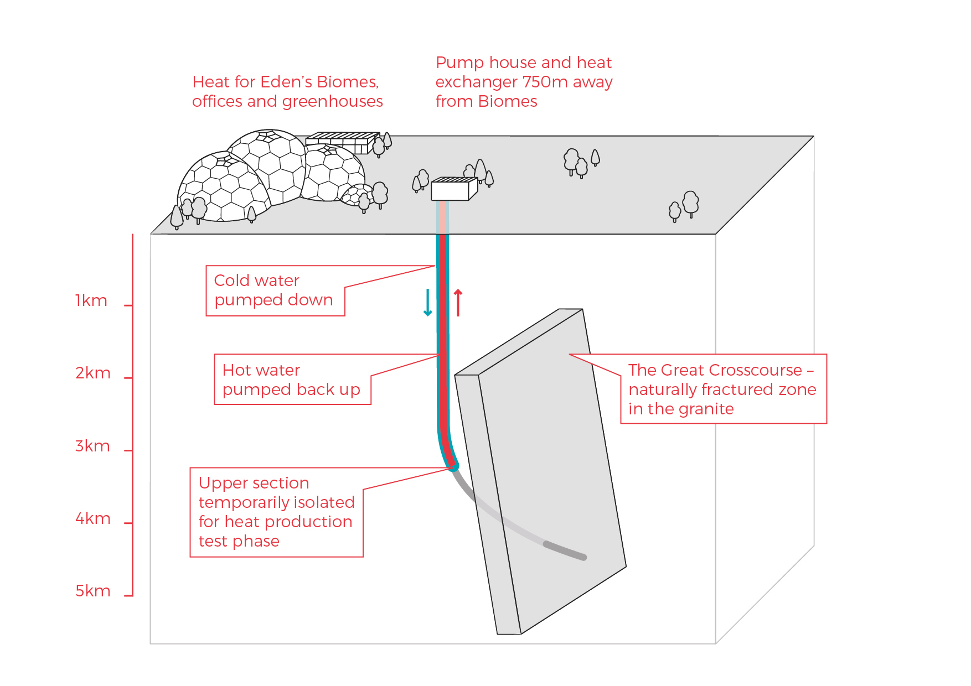
Phase 1 of the deep geothermal concept at the Eden Project

3.1 Background

Eden Geothermal Limited is a special purpose vehicle which was set up to develop the geothermal project at the Eden site. The project combines the famous Eden Project site with EGS Energy Ltd’s and BESTEC (UK) Ltd’s technical expertise and experience in the geothermal sector.

EGS Energy Ltd is a UK private limited company, incorporated in 2008 and established by Roy Baria and Guy Macpherson Grant to develop deep geothermal energy solutions in the UK. BESTEC (UK) Ltd is a UK private limited company incorporated in June 2012 and established by Jörg Baumgärtner to perform deep geothermal work in the UK in cooperation with BESTEC GmbH, an established specialist company in geothermal project development. Eden Project Limited is a wholly owned subsidiary of the Eden Trust, a registered charity in the UK, and runs the world famous Eden Project in Cornwall.

Eden Geothermal Limited has been allocated funding from the European Regional Development Fund and from Cornwall Council, together with private investment match funding, to undertake the first phase as an Industrial Research Project.

3.2 Location and Site Layout

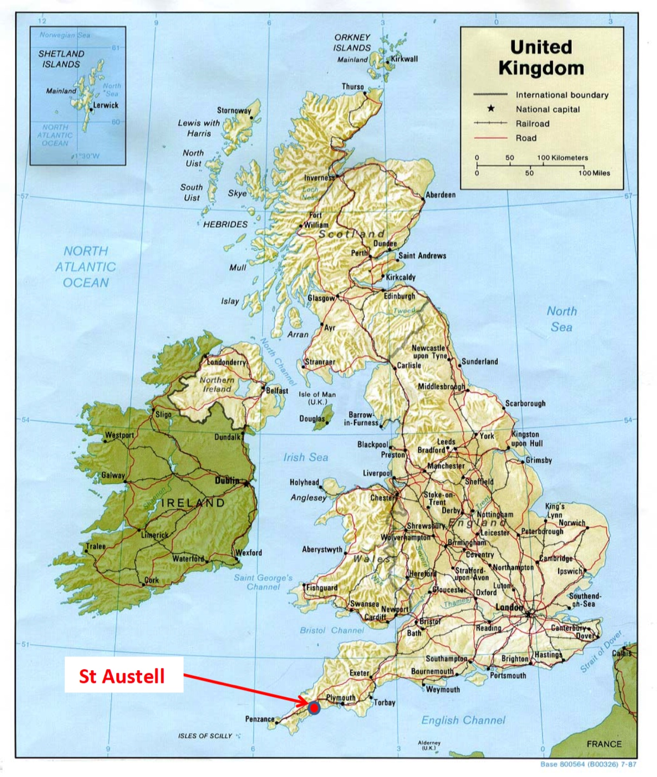
The Eden Project is located about 2 - 3 km north-east of the town of St Austell in the southern part of Cornwall.
Map of the UK showing the site of the Eden Project near St Austell

Access by car/van
The main route into Cornwall is via the M5 motorway to Exeter and either the A30 or the A38 trunk roads through Cornwall. The majority of the A30 is dual carriageway. The Eden Project is signposted from the A30.
The Eden Project is well connected by road, either (i) from the A30, via the A391; (ii) from Truro by the A390 (westbound); or (iii) from Plymouth by the A38 and A390 (eastbound). The road distance from Plymouth to St Austell is 26 miles or 42 km.
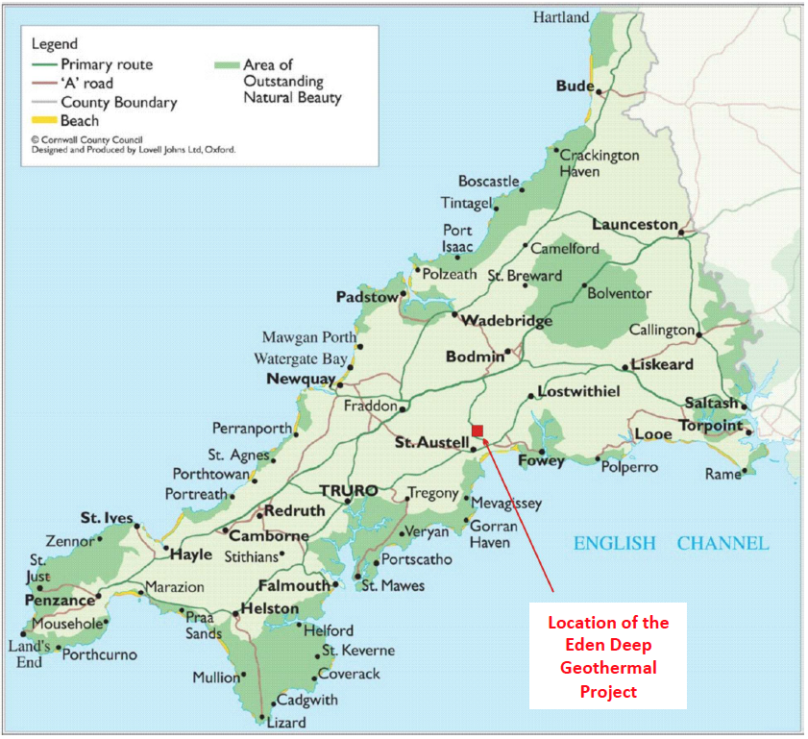
Location of the Eden Project in Cornwall
Access by truck/HGV
The recommended transport route for HGVs to and from the Eden Project is either:
- from the Innis Downs junction on the A30, taking the A391 through Bugle, Stenalees and Carluddon and onto the Eden Project; or
- from the Victoria Interchange on the A30, taking the B3274 through Roche and Trezaise to Stenalees, then the A391 to Carluddon and onto the Eden Project.
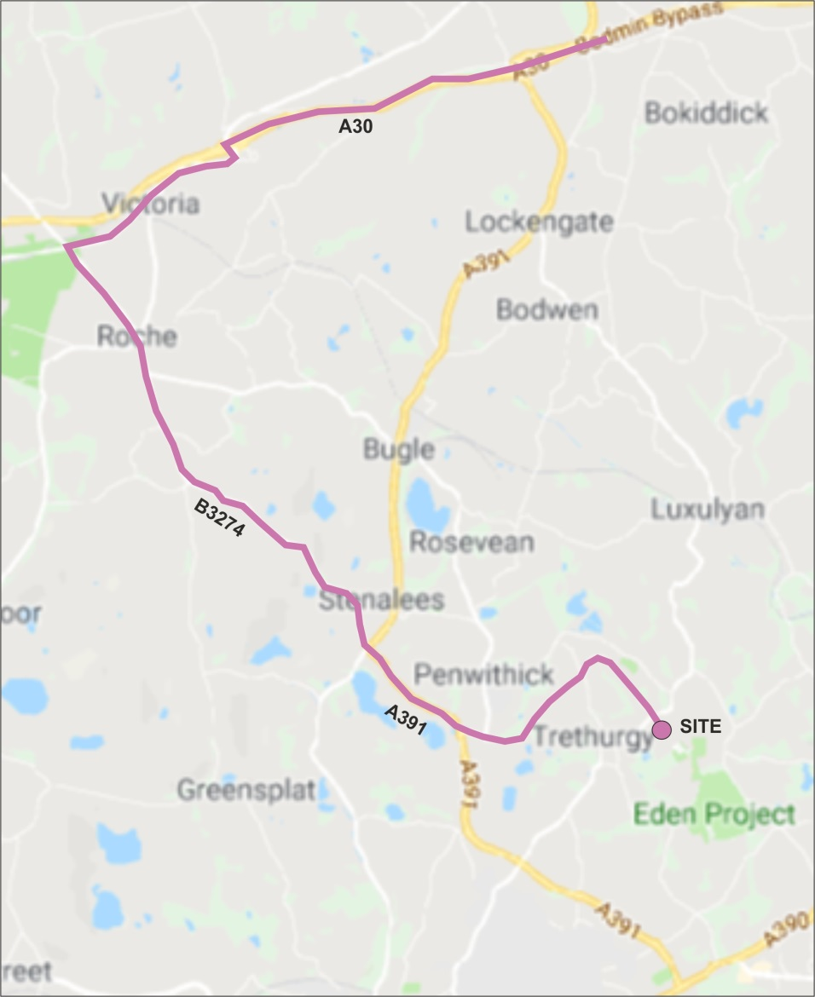
HGV road route to the Eden Project

Access from mainland Europe by boat to Plymouth:
Brittany Ferries maintains a route from Roscoff in Brittany, France to Plymouth (approximately 6 - 8 hrs sailing time).

PART C: TECHNICAL REQUIREMENTS AND SPECIFICATIONS

4 Technical Requirements

Eden Geothermal Ltd invites tenders for the supply of casing materials for Phase 1 of the Eden Geothermal Project. The technical requirements are set out in Sections 4.1 to 4.5 together with the information in Schedule 3.

4.1 Specifications and Standards
The detailed specifications and standards for the casing materials to be supplied are set out in Schedule 3, 3b Table 1.

4.2 Delivery Terms
Delivery terms are DDP (Delivered Duty Paid - as stated in Incoterms 2020). Materials must be delivered to the drilling site, at the Eden Project, Bodelva, Par, Cornwall, United Kingdom PL24 2SG by 30th November 2020.

4.3 Financial Terms
All prices will be fixed prices, exclusive of VAT, inclusive of all other taxes and duties.

4.4 Listing of Geothermal Casing Material to be supplied

The parts to be supplied are set out in Schedule 3, 3c Table 2. The casing materials are divided into four packages. You may make your submission for all four packages, or any combination of those packages.

PART D: RETURN OF TENDER

5 Tender Completion Documentation

This Section provides information to help Tenderers prepare their tenders. Applicants are advised to read all the documentation carefully to ensure that they are familiar with the nature and extent of their obligations should their tender be accepted.
The Applicant must complete and return all relevant documents as part of their Tender response:
- Company Information – Schedules 1a – 1g
- Declarations – Schedule 2
- Technical submission – Schedule 3
- Commercial submission – Schedule 4

Schedules 1, 2 and 3 may be submitted jointly but Schedule 4 must be submitted separately.

It is the responsibility of the Applicant to inform EGL of any matter that may affect the Applicant’s qualification. All Applicants must complete Schedules 1, 2, 3 and 4.

Applicants must ensure that all questions are completed in full, in English, and in the format requested. Failure to do so may result in the submission being disqualified. Applicants are expected to supply all required information, or clearly state the reason for being unable to do so. Where the question does not apply, please state clearly ‘N/A’. Where the answer is a statement of fact, it must be accurate. It is the Applicant’s responsibility to ensure that EGL is not misled.

Any appropriate supporting documents (e.g. product catalogues, technical specifications and sheets, independent test certificates/reports, brochures etc. as requested in Schedule 3) should be included as additional information. Please supply them as an Appendix. They should be numbered clearly and listed as part of your declaration. PDF is the only acceptable file format. All additional documents provided by the Applicant must refer to a specific item or requirement within the ITT and be easily identifiable.

Should the Applicant wish to propose a variation from the specification please ensure that this is clearly identified where appropriate in the response. The variation needs to be accompanied by a thorough explanation.

5.1 Company Information
5.1.1 Company Details
The Applicant must complete the details required in Schedule 1a. Where the Applicant is a consortium or partnership bidder, Schedule 1a must be completed by each member of the consortium or partnership.
5.1.2 Financial Matters
The Applicant is required to provide the information requested in Schedule 1b. In the case of a consortium or partnership bid, all members of the consortium or partnership should complete this information. This section may be used, in conjunction with credit reference agency checks if necessary, to gain a basic indication of the financial stability of the Applicant. The determination of the appropriate risk level will be proportionate and relevant to the size, value and nature of the specific contract being tendered. EGL reserves the right to undertake further independent financial checks, if it feels it important to do so. Financial responsibility cannot be shared. Consortium or partnership bids must state one of the members of the partnership as the Lead Applicant, which will be the financially responsible party.

5.1.3 Legal Matters, Disputes and Conflicts
The Applicant must complete answers to all the questions in Schedule 1c and 1d.

5.1.4 Warranties/Insurance/Supply
For any Applicant to be successful, adequate proof of warranties/insurance will be required. The minimum levels are indicated in Schedule 1f. The Applicant must also confirm that they can meet the delivery terms. The Applicant must complete Schedule 1f with the relevant information and confirm that the details entered are correct.

5.1.5 Declaration
The Applicant (or each partner or member organisation in the case of a consortium bid) must complete the Declaration in Schedule 2.

5.2 Technical Submission
EGL’s requirements for this contract are set out in Part C Technical Requirements and Specifications, together with Schedule 3, which sets out more detailed information.

The Applicant’s submission should take into account all relevant factors contained within this information, although EGL does not accept any responsibility for the accuracy or completeness of this information.

The Applicant must complete Schedule 3, providing evidence to demonstrate the expertise and experience of the lead Applicant and any proposed partners or sub-contractors in relation to this contract.

5.3 Commercial Submission
The Applicant is required to complete and return Schedule 4, which will provide a detailed price structure for the items to be supplied. All prices will be:
- Fixed.
- Quoted in pounds sterling.
- Exclusive of VAT. Where applicable, EGL will pay any VAT incurred at the prevailing rate (currently 20%). If the VAT rate changes, EGL will pay any VAT incurred at the new rate. It is the responsibility of the Applicant to check their VAT position with HMRC before submitting a bid.
- Inclusive of other taxes and duties (ie anti-dumping custom fees) and delivery to the Eden Geothermal site (Incoterms 2020 DDP, Eden Project, PL24 2SG, United Kingdom) by 30th November 2020.

5.4 Confidential / Commercially Sensitive Information
Please outline in Schedule 5 any items that the Lead Organisation or its partners consider to be genuinely Confidential and/or Commercially Sensitive which should not be disclosed in respect of your Tender.

PART E: TENDER EVALUATION

6 Evaluation Process

This Section specifies the criteria to be used to determine the successful applicant and the requirements for the tenderer’s qualification to perform the contract.

All applicants must prepare separate technical and commercial bid documents.

Technical and commercial bids must be received by Eden Geothermal Ltd
in separate PDF files and hard copy documents, each quoting the tender number in the title.

All bids will be impartially evaluated against the same criteria by an ‘Evaluation Panel’ on behalf of Eden Geothermal Limited.

The evaluation process will be conducted in a manner that ensures tenders are evaluated fairly to ascertain the most technically and economically advantageous tender. Each tender submission will be evaluated only on the information that is provided by the Applicant. Tenders may be rejected if the information asked for in the ITT and Specification is not given at the time of tendering.

Technical documents and bids will be restricted to the members of the Evaluation Panel, which has full power to make decisions on behalf of Eden Geothermal Limited. The evaluation will be carried out by the Evaluation Panel in distinct sections, with weightings applied where appropriate:

Title | Evaluation Method
Company Information (Schedule 1) | Pass / Fail
Declarations (Schedule 2) | Pass / Fail
Technical Criteria (Schedule 3) | Weightings set out below
Commercial Criteria (Schedule 4) | Weightings set out below

6.1 Company Information

The Company Information will be evaluated first and Applicants will be required to pass this stage before their Tenders are evaluated on the basis of their technical and commercial submission.

The four packages set out in Schedules 3 and 4 will be individually scored using the following weightings:-

Overall Score Weighting | Package  A | Package  B | Package  C | Package D
Technical Score | 50% | 50% | 50% | 50%
Commercial Score | 50% | 50% | 50% | 50%

Six criteria will be used to evaluate Applicants, each being scored on a pass or fail basis. Applicants must pass all criteria to proceed to the remainder of the evaluation. The criteria are:
  - Company Information
  - Economic and Financial Standing
  - Grounds for Mandatory Exclusion
  - Other Grounds for Exclusion
  - Equality and Diversity
  - Warranties, Insurance and Supply
  - Company Experience / Previous Contracts

The Company will be evaluated as follows:-

- Schedules 1a and 1b will be reviewed separately. The review of the Applicant’s submission will only proceed to the remainder of Schedule 1 and Schedule 2 where the reviewer deems that the Applicant has passed these sections.

- Schedule 1c sets out the Grounds for Mandatory Exclusion. EGL will also exclude any Applicant who answers ‘Yes’ in any of the situations in Schedule 1d. This includes evidence of convictions relating to specific criminal offences including, but not limited to, bribery, corruption, conspiracy, terrorism, fraud and money laundering, or if you have been the subject of a binding legal decision which found a breach of legal obligations to pay tax or social security obligations (except where this is disproportionate, e.g. only minor amounts involved).

If the Applicant is made up of a Lead Organisation and other organisations who have jointly entered into a consortium, joint venture or other contracting arrangement, each of the organisations must pass all the criteria in order for the Tender to proceed to the remainder of the evaluation.

6.2 Technical Evaluation
Only Applicants that have passed the evaluation of Company Information will have their technical bids evaluated by the Evaluation Panel.
The technical submission should demonstrate the Applicant’s expertise, experience and capability to supply the goods and materials in accordance with the technical requirements and specifications set out in Part C.
For the materials being procured, applicants are asked to provide: product catalogues; technical specifications, sheets and certificates as stated in Schedule 3, 3b Table 1. These should be returned with your technical submission and listed in the table provided in Schedule 3. (You may add more rows if necessary.)
The 50% available for technical score for each package set out in Schedule 3 will be allocated using the weightings set out below:-

Technical Score Weighting | Package A | Package B | Package C | Package D
The certified technical casing material properties (ID, collapse, burst, yield) in comparison to the target design figures as indicated in Schedule 3, 3c. | 100% | 100% | 100% | 100%

The quality of the technical submission will be scored in accordance with the Scoring Matrix shown below:
5 Excellent Extremely good demonstration of relevant ability, understanding, experience, skills, resources and quality measures required to provide the services, with full evidence provided to support this.
4 Good Above average demonstration of the relevant ability, understanding, experience, skills, resource and quality measures required to provide the services, with a majority of evidence provided to support this.
3 Acceptable Satisfactory demonstration of the relevant ability, understanding, experience, skills, resources and quality measures required to provide the services, with some evidence to support this.
2 Minor Reservations Some reservations regarding the relevant ability, understanding, experience, skills, resources or quality measures required to provide the services, with little or no evidence to support this.
1 Major Reservations Serious reservations regarding the relevant ability, understanding, experience, skills, resources or quality measures required to provide the services, with no evidence to support this.
0 Unacceptable Non-compliance and/or insufficient information provided to demonstrate that there is the ability, understanding, experience, skills, resource and quality measures required to provide the services.

6.3 Commercial Evaluation
The Commercial Evaluation will be carried out for all submissions that that have been included in the Technical Evaluation Schedule 3. Commercial submissions from those who failed to pass Schedules 1 and 2 will be destroyed unopened.

Commercial offers will be judged by taking the tendered summarised cost for all packages as set out in Schedule 4. Where EGL believes that the tendered costs have been prepared on an inconsistent basis with the other tenders, which creates an unfair advantage to the tenderer’s offer, EGL will request that further information is provided to enable the Commercial valuation to be carried out on a fair basis.

The median price of all the tender prices will be calculated and this will be judged to equal 50% of the available commercial marks. The individual tenders will then be awarded points above and below the average percentage relative to their tender price. The maximum points will be awarded for offers which are less than or equal to half the median, and nil points will be awarded for offers which are more than or equal to double the median value.

6.4 Total Score
The final ‘Total Score’ will be calculated by converting the Technical Evaluation score and the Commercial Evaluation score into a percentage which is then combined according to the weighting stated in the sections above. The selected Applicant will be the one with the highest total score. EGL will then evaluate the individual packages, comparing the results aginst the combined submissions selected above. Where the total score for the individual packages evaluated separately is greater than the total score for the selected combined submission above then the individual packages will be selected.

The Evaluation Panel will have the authority to send out a Letter of Intent to the proposed awardee / awardees, which should state that a contract will be awarded.

6.5 Clarification
During the evaluation process, EGL may need to seek clarification on aspects of an Applicant’s submission. If required, EGL will contact the Applicant using the contact details provided. Clarification may require further submission or supplementation or clarification to complete the relevant information or documentation within an appropriate time limit. The purpose of any such clarification will be only to provide EGL with the information required to evaluate and score the submission; it will not be an opportunity for the Applicant to improve or substantially change the information that has already been submitted.

6.6 Award and Notification
Once EGL has completed the evaluation and has identified the successful tenderer(s), EGL will inform the winning Applicant(s) in writing by email of the ’award decision’.

The unsuccessful Applicants will be informed in writing of the fact at the same time after the closing of the evaluation procedure. EGL will offer feedback to every Bidder submitting an unsuccessful proposal.

Ten days after the adjudication the contract will be awarded.

PART F: CONDITIONS

7 Conditions

7.1 Confidentiality and Freedom of Information
This document is proprietary to EGL and the information contained herein is confidential.

EGL confirms that it will keep confidential and will not disclose to any third parties any information obtained from a named Applicant contact, other than to the EU Managing Authority, to its funders, and under EGL’s commitment to meeting its responsibilities under the Freedom of Information Act (FOI) 2000 or the Environmental Information Regulations (EIR) 2004. All information submitted to EGL may need to be disclosed in response to a request under these regulations.

The Applicant must treat all information supplied to it by EGL in confidence and must not disclose it to third parties other than to obtain sureties or quotations for submitting its response as part of the tendering process.

The Applicant must identify any parts of its tender submission which it designates as confidential and would not want published; such information may include technical or trade secrets or other confidential information in Schedule 5. The Applicant should explain (in broad terms) what harm may result from disclosure if a request is received, and the time period applicable to that sensitivity. However, the Applicant should be aware that, even where information has been categorised as being commercially sensitive, EGL may still be required to disclose it under the FOI or EIR if a request is received.

Without prejudice to EGL’s obligation to disclose information in accordance with the FOI or EIR, EGL shall, acting reasonably, at its absolute discretion and notwithstanding any other provision in this Tender or otherwise seek to apply the commercial interests exemption to the information/documents listed in this Schedule.

7.2 Language
The completed tender and all accompanying documents must be in English.

7.3 Applicable Law
Any contract concluded as a result of this ITT will be governed by the law of England & Wales.

7.4 Additional costs
Once the contract has been awarded EGL will not pay any additional costs incurred which are not reflected in the tender submission.

7.5 Costs
Unless otherwise stated in this ITT, all costs associated with taking part in this process remain the Applicant’s responsibility. The Applicant will not be entitled to claim from EGL any costs or expenses which may have been incurred in preparing the tender, whether or not the tender is successful. EGL will not return any part of the completed tender.

7.6 Right to cancel or vary the process
EGL reserves the right to cancel or withdraw from the tendering process at any stage. Cancellation of the procurement process (at any-time) under any circumstances will not render Eden Geothermal Ltd liable for any costs or expenses incurred by bidders during the procurement process.

7.7 Inducements
Offering an inducement of any kind in relation to obtaining this or any other contract with EGL will disqualify the Applicant from being considered and may constitute a criminal offence.

7.8 Disclaimer
The issue of the information and the tender does not commit Eden Geothermal Ltd to award any contract pursuant to the bid process or enter into a contractual relationship with any provider of the service. Nothing in the tender or in any other communications made between Eden Geothermal Ltd or its agents and any other party, or any part thereof, shall be taken as constituting a contract, agreement or representation between Eden Geothermal Ltd and any other party (save for a formal award of contract made in writing by or on behalf of Eden Geothermal Ltd).

While the information in this ITT and supporting documents has been prepared in good faith by EGL, it may not be comprehensive, and nor has it been independently verified. Neither EGL nor their advisors, nor their respective directors, officers, members, partners, employees, other staff or agents:

- makes any representation or warranty (express or implied) as to the accuracy, reasonableness or completeness of this ITT; or
- accepts any responsibility for the information contained in the ITT or for the accuracy or completeness of that information; or
- shall be liable for any loss or damage (other than in respect of fraudulent misrepresentation) arising as a result of relying on such information or any subsequent communication.

SCHEDULES

Schedule 1a - Company Details

Applicant details |  | Answer
Full name of the Applicant completing the ITT
Trading Name (if different)
Registered company address
Registered company number
Registered VAT number (if applicable)
Name of immediate parent company
Name of ultimate parent company
Type of company (please tick relevant boxes) |  | Public limited company
 |  | Limited company
 |  | Limited liability partnership
 |  | Other partnership
 |  | Sole trader
 |  | Other
 |  | Small medium enterprise
Contact details
Name
Position
Postal address
Country
Phone number
Email

Schedule 1b - Economic and Financial Standing

 | Enclosed | Not Applicable
(a) Please enclose copies of the business’ audited accounts of the past two years, to include:
- Balance Sheet
- Profit and Loss Account
- Full notes to the Accounts
- Director’s Report
- Auditor’s Report

 | Yes | No
(b) Has there been any event since the last audited accounts that could affect the going concern status of the company?

Schedule 1c - Grounds for Mandatory Exclusion

Within the past five years, has your organisation (or any member of your proposed consortium, if applicable), Directors or partner or any other person who has powers of representation, decision or control been convicted of any of the following offences? Please indicate your answer by marking ‘X’ in the relevant box.

 | Yes | No
(a) conspiracy within the meaning of section 1 or 1A of the Criminal Law Act 1977 or article 9 or 9A of the Criminal Attempts and Conspiracy (Northern Ireland) Order 1983 where that conspiracy relates to participation in a criminal organisation as defined in Article 2 of Council Framework Decision 2008/841/JHA on the fight against organised crime;
(b) corruption within the meaning of section 1(2) of the Public Bodies Corrupt Practices Act 1889 or section 1 of the Prevention of Corruption Act 1906;
(c) the common law offence of bribery;
(d) bribery within the meaning of sections 1, 2 or 6 of the Bribery Act 2010; or section 113 of the Representation of the People Act 1983;
(e) any of the following offences, where the offence relates to fraud affecting the European Communities’ financial interests as defined by Article 1 of the Convention on the protection of the financial interests of the European Communities:
(i) the offence of cheating the Revenue;
(ii) the offence of conspiracy to defraud;
(iii) fraud or theft within the meaning of the Theft Act 1968, the Theft Act (Northern Ireland) 1969, the Theft Act 1978 or the Theft (Northern Ireland) Order 1978;
(iv) fraudulent trading within the meaning of section 458 of the Companies Act 1985, article 451 of the Companies (Northern Ireland) Order 1986 or section 993 of the Companies Act 2006;
(v) fraudulent evasion within the meaning of section 170 of the Customs and Excise Management Act 1979 or section 72 of the Value Added Tax Act 1994;
(vi) an offence in connection with taxation in the European Union within the meaning of section 71 of the Criminal Justice Act 1993;
(vii) destroying, defacing or concealing of documents or procuring the execution of a valuable security within the meaning of section 20 of the Theft Act 1968 or section 19 of the Theft Act (Northern Ireland) 1969;
(viii) fraud within the meaning of section 2, 3 or 4 of the Fraud Act 2006; or
(ix) the possession of articles for use in frauds within the meaning of section 6 of the Fraud Act 2006, or the making, adapting, supplying or offering to supply articles for use in frauds within the meaning of section 7 of that Act;
(f) any offence listed in (i) in section 41 of the Counter Terrorism Act 2008; or (ii) in Schedule 2 to that Act where the court has determined that there is a terrorist connection;
(g) any offence under sections 44 to 46 of the Serious Crime Act 2007 which relates to an offence covered by subparagraph (f);
(h) money laundering within the meaning of sections 340(11) and 415 of the Proceeds of Crime Act 2002;
(i) an offence in connection with the proceeds of criminal conduct within the meaning of section 93A, 93B or 93C of the Criminal Justice Act 1988 or article 45, 46 or 47 of the Proceeds of Crime (Northern Ireland) Order 1996;
(j) an offence under section 4 of the Asylum and Immigration (Treatment of Claimants etc.) Act 2004;
(k) an offence under section 59A of the Sexual Offences Act 2003;
(l) an offence under section 71 of the Coroners and Justice Act 2009
(m) an offence in connection with the proceeds of drug trafficking within the meaning of section 49, 50 or 51 of the Drug Trafficking Act 1994; or
(n) any other offence within the meaning of Article 57(1) of the Public Contracts Directive—
(i) as defined by the law of any jurisdiction outside England and Wales and Northern Ireland; or
(ii) created, after the day on which these Regulations were made, in the law of England and Wales or Northern Ireland.
(o) Non-payment of taxes - has it been established by a judicial or administrative decision having final and binding effect in accordance with the legal provisions of any part of the United Kingdom or the legal provisions of the country in which your organisation is established (if outside the UK), that your organisation is in breach of obligations related to the payment of tax or social security contributions?

Schedule 1d - Other Grounds for Exclusion

Within the past three years, please indicate if any of the following situations have applied, or currently apply, to your organisation (or any member of your proposed consortium, if applicable). Please indicate your answer by marking ‘X’ in the relevant box.

 | Yes | No
(a) your organisation has violated applicable obligations referred to in regulation 56 (2) of the Public Contracts Regulations 2015 in the fields of environmental, social and labour law established by EU law, national law, collective agreements or by the international environmental, social and labour law provisions listed in Annex X to the Public Contracts Directive as amended from time to time;
(b) your organisation is bankrupt or is the subject of insolvency or winding-up proceedings, where your assets are being administered by a liquidator or by the court, where it is in an arrangement with creditors, where its business activities are suspended or it is in any analogous situation arising from a similar procedure under the laws and regulations of any State;
(c) your organisation has entered into agreements with other economic operators aimed at distorting competition;
(d) your organisation has a Conflict of Interest (CoI) within the meaning of regulation 24 of the Public Contracts Regulations 2015 that cannot be effectively remedied by other, less intrusive, measures; (*)
(e) the prior involvement of your organisation in the preparation of the procurement procedure has resulted in a distortion of competition, as referred to in regulation 41, that cannot be remedied by other, less intrusive, measures;
(f) your organisation has shown significant or persistent deficiencies in the performance of a substantive requirement under a prior public contract, a prior contract with a contracting entity, or a prior concession contract, which led to early termination of that prior contract, damages or other comparable sanctions;
(g) your organisation has negligently provided misleading information that may have a material influence on decisions concerning exclusion, selection or award.
(h) your organisation has committed an offence under the Modern Slavery Act 2015.

(*) Conflicts of interest
EGL may exclude the Applicant if there is a conflict of interest which cannot be effectively remedied. The concept of a conflict of interest includes any situation where relevant staff members have, directly or indirectly, a financial, economic or other personal interest which might be perceived to compromise their impartiality and independence in the context of the procurement procedure. Where there is any indication that a conflict of interest exists or may arise then it is the responsibility of the Applicant to inform EGL, detailing the conflict in a separate Appendix. Provided that it has been carried out in a transparent manner, routine pre-market engagement carried out by EGL should not represent a conflict of interest for the Applicant.

If you have answered ‘Yes’ to any of the above question, please use a separate Appendix to provide further details.

Schedule 1e - Equality and Diversity

The Lead Organisation and all other organisations must confirm that their organisation complies with its legal obligations under European law relating to the following:-

Item | Confirm Yes / No
- Race
- Sexual Orientation
- Gender Reassignment
- Disability
- Age
- Religion or Belief
- Sex
- Marriage & Civil Partnership
- Pregnancy & Maternity

Schedule 1f – Warranties, Insurance and Supply

Insurance
Product Warranties | Seller shall fully warrant the material supplied against defects in material and workmanship for a period of 12 months after receipt of delivery, not to exceed 18 months after shipment, whichever occurs first. In the event of a warrantable failure during the specified period, as mutually agreed upon by Buyer and Seller, after inspection, Seller shall repair or replace the suspect material or its component at its sole expense. The term “sole expense”, however, specifically excludes drilling rig charges, loss of revenue, consulting fees, and other such consequential damages. Repaired / replaced material or its component must be fully warranted for a further 12 months.
Insurance | The Seller is to be responsible for ensuring that the material is delivered, received and unloaded in good working order, and is fit for purpose. As outlined in Part C, section 4.2: any Goods in Transit insurance is to be at the Seller’s own expense.
Standards | Enclosed | Not applicable
Please enclose evidence/valid copy certificates of the following:
- Quality Assurance (QA)

- API SPEC 5CT/5L latest edition.

- Material and mill certification. Mill must have a valid API licence.

- Evidence of independent API inspection at the mill or at supplier’s yard.
Supply | Yes | No
Delivery in line with the required latest date of 30th November 2020 can be met for all packages tendered

Schedule 1g – Relevant Experience and Contract Examples

Please provide details of up to three contracts, in any combination from either the public or private sector; that are relevant to EGL’s requirement. Contracts should have been performed during the past three years.
The named contact provided should be able to provide written evidence to confirm the accuracy of the information provided below.
Consortia bids should provide relevant examples of where the consortium has delivered similar requirements. If this is not possible (e.g. the consortium is newly formed or a Special Purpose Vehicle is to be created for this contract) then three separate examples should be provided between the principal member(s) of the proposed consortium or Special Purpose Vehicle (three examples are not required from each member).
Where the Supplier is a Special Purpose Vehicle, or a managing agent not intending to be the main provider of the supplies or services, the information requested should be provided in respect of the main intended provider(s) or sub-contractor(s) who will deliver the contract.

If you cannot provide at least one example see ii below.

Relevant experience and contract examples will be evaluated on a 5 level score as in Part E, Tender Evaluation, 6.6 Technical Evaluation – Technical Score Weighting. A score of 3 is required to pass to the technical evaluation stage.

The following details should be provided for each contract:
Name of customer organisation
Point of contact in customer organisation
Position in the organisation
E-mail address
Description of Contract and technical specification – max 500 words
Contract start date
Contract completion date
Estimated Contract Value

i Where you intend to sub-contract a proportion of the contract, please demonstrate how you have previously maintained healthy supply chains with your sub-contractor(s).
Evidence should include, but is not limited to details of your supply chain management tracking systems to ensure performance of the contract and including prompt payment or membership of the UK Prompt Payment Code (or equivalent schemes in other countries).

ii If you cannot provide at least one contract example, in no more than 500 words please provide an explanation for this eg your organisation is a new start-up, or you have provided services in the past but not under a contract.

Schedule 2 - Declarations

I/We understand that the information provided in this document and any supporting information provided by us will be relied upon and taken to be true and accurate. Should it subsequently be determined that any information supplied by us was inaccurate, I/we understand and accept that Eden Geothermal Limited reserves the right to exclude our offer to supply (if still under evaluation) or if the Contract has been awarded and the information that was inaccurately supplied had a significant influence on the award, that Eden Geothermal Limited shall be at liberty to terminate the Contract.

I/We understand that Eden Geothermal Limited is not bound to accept the lowest price or any tender that may be received.

Name of organisation
Name of person applying on behalf of organisation
Signature
Title / position of person
Date
Contact telephone
Contact e-mail
Address and post code
Registered office if different from above
Organisation VAT number (if applicable)

Schedule 3 – Technical Submission

3a Product Specifications and Standards

Please use the tables in Sections 3b and 3c below to give technical specification on your products and / or list other documents submitted in support of your bid, e.g.: product catalogues; technical specification sheets/drawings; independent test certificates and/or reports. You should number each document and list the document title and type, and clearly link it to an item, or range of items, in this ITT. You may add more rows to the table if necessary.

3b Technical Submission ‘Specifications and Standards’

Specifications and Standards – Table 1 | Yes / No or Comment
- All casing material must be unused, seamless casing manufactured in accordance with API 5CT/5L latest edition.
- All casing material must come with material and mill certification. Mill must have a valid API license.
- An independent API Inspection at the mill or at supplier’s yard is required.

3c Technical Submission ‘Listing of Material to be Supplied’

Please fill in the relevant technical data of the casing material quoted (green boxes)

Listing of Material to be Supplied – Table 2
Target design figures
Casing size | Quality | Weight | Length | Range | Coupling | ID | Rating |  | Body Yield  Strength
 |  |  |  |  |  |  | Collapse | Burst
(in) |  | (lbs/ft) | (m) |  |  | (in) | (bar) | (bar) | (ton)
Package A Surface
20” | K-55 | 94 | 260 | R3 | BTC *) | 19.124 | 36 | 145 | 672
 |  |  |  |  | *)
20” | K-55 | 106,5 | 95 | R3 | BTC *) | 19.000 | 53 | 166 | 764
 |  |  |  |  | *)
*) BTC or alternatively Big Omega (only complete 20” string)
Package B Intermediate
13⅜” | L-80 | 61 | 950 | R3 | BTC | 12.515 | 115 | 310 | 634
13⅜” | L-80 | 68 | 360 | R3 | BTC | 12.415 | 156 | 346 | 705
13⅜” | L-80 | 72 | 330 | R3 | BTC | 12.347*) | 184 | 371 | 754
 |  |  |  |  |  | *)
*) special drift 12.25” !
Target design figures
Casing size | Quality | Weight | Length | Range | Coupling | ID | Rating |  | Body Yield Strength
 |  |  |  |  |  |  | Collapse | Burst
(in) |  | (lbs/ft) | (m) |  |  | (in) | (bar) | (bar) | (ton)
Package C Production
9⅝” | L-80 | 40 | 1480 | R3 | BTC | 8.835 | 213 | 396 | 415
9⅝” | L-80 | 40 or 43.5 or 47 | *)15 - 20 m  3 pcs | R1 | BTC | 8.835 | 213 | 396 | 415
9⅝” | L-80 | 43,5 | 530 | R3 | BTC | 8.755 | 263 | 436 | 456
9⅝” | L-80 | 47 | 860 | R3 | BTC | 8.681 | 328 | 473 | 493
*) compensating joints
Package D Production Special Casing
9⅝” | HC-L80 *) | 47 | 1350 | R3 | BTC | 8.681 | 489 | 473 | 493
*) or similar material with comparable or better properties, no P110 accepted

We confirm that:

- We have inspected this Tender Document and accompanying information relating to the Eden Geothermal Ltd Tender and hereby offer to supply and deliver the casing material listed in 3c above, to the standard and specifications set out in 3b above and Part C of this ITT document ‘Technical Requirements and Specifications’.

- The Technical Submission is accurate to the best of our knowledge.

Name of Organisation
Name of Person Signing
Capacity in which Signed
Signature
Date

Schedule 4 - Commercial Submission

The Applicant may choose to supply one or all of the packages listed below.
Please note this Schedule is to be returned in a separate document.

We have inspected this Tender Document and accompanying information relating to the Eden Geothermal Ltd Tender and hereby offer to supply and deliver casing materials as set out in Schedule 3 to your entire satisfaction for the following lump sum prices set out for each package and by the date set out below.
Please fill in the relevant commercial data of the casing material quoted (yellow boxes)
Description | Casing size | Quality | Weight | Length | Range | Coupling | Price /m | Section Price
 | (in) |  | (lbs/ft) | (m) |  |  | UK £ | UK £
Package A Surface
Specify coupling | 20” | K-55 | 94 | 260 | R3
Specify coupling | 20” | K-55 | 106,5 | 95 | R3
Total Price for Package A for 20” casing section – (GBP) - (exc other charges)
Other Charges (DDP Eden Project, PL24 2SG, UK)
Total Price (GBP)

Description | Casing size | Quality | Weight | Length | Range | Coupling | Price /m | Section Price
 | (in) |  | (lbs/ft) | (m) |  |  | UK £ | UK £
Package B Intermediate
 | 13⅜” | L-80 | 61 | 950 | R3 | BTC
 | 13⅜” | L-80 | 68 | 360 | R3 | BTC
Special drift | 13⅜” | L-80 | 72 | 330 | R3 | BTC
Total Price for Package B for 13 3/8” casing section – (GBP) - (exc other charges)
Other Charges (DDP Eden Project, PL24 2SG, UK)
Total Price (GBP)
Package C Production
 | 9⅝” | L-80 | 40 | 1480 | R3 | BTC
 | 9⅝” | L-80 | 40 or 43.5 or 47 | 15 – 20 m 3 pcs | R1 | BTC
 | 9⅝” | L-80 | 43,5 | 530 | R3 | BTC
 | 9⅝” | L-80 | 47 | 860 | R3 | BTC
Total Price for Package C for 9 5/8” casing section - (GBP) - (exc other charges)
Other Charges (DDP Eden Project, PL24 2SG, UK)
Total Price (GBP)
Package D Production Special Casing
Specify quality | 9⅝” |  | 47 | 1350 | R3 | BTC
Total Price for Package D for 9 5/8” special production casing – (GBP) - (exc other charges)
Other Charges (DDP Eden Project, PL24 2SG, UK)
Total Price (GBP

Combined Supply of Packages A, B, C and D
Total Price for Package A (exc other charges)
Total Price for Package B (exc other charges)
Total Price for Package C (exc other charges)
Total Price for Package D (exc other charges)
Other Charges (DDP Eden Project, PL24 2SG, UK)
Total £UK

Date of Supply for all packages

The above prices shall include allowances for the general obligations, management obligations and project requirements as defined in Part C of this document. The above price shall include for all reasonable disbursements but should exclude VAT (if applicable).

We confirm that:
- The Commercial Submission is accurate to the best of our knowledge.
- We understand that you do not bind yourselves to accept the lowest or any tender.
- We accept the contract conditions for this contract and this tender remains open for acceptance for 90 days.
Name of Organisation
Name of Person
Signing
Capacity in which signed
Signature
Date

Schedule 5 - Commercially Sensitive Information

Eden Geothermal Limited may be obliged to disclose information in or relating to this Tender following a request for information under the FOIA or EIR. Please outline in the table below items that you consider to be genuinely Confidential and/or Commercially Sensitive which should not be disclosed in respect of your Tender (see Section 7.1)

Information | Reference / page | Reason for non-  disclosure | Duration of confidentiality

This schedule will be kept with the Tender documents for consideration should a request for information under the Freedom of Information Act 2000 or Environmental Information Regulations 2004 be received. This document will be destroyed in line with the retention and destruction policy of Eden Geothermal Limited.

