Eden Geothermal Limited
The Eden Project
Bodelva
Par
PL24 2SG

Tel: +44 (0)1726 806541
E: tenders@edengeothermal.com

Date: 5th August 2020

INVITATION TO TENDER
Dear Sir/Madam

Project | Eden Geothermal Project
Tender Name | Supply of Drill Bits for Geothermal Development
Tender reference | EGL-ITT-CO40

You are invited to submit a competitive tender for the supply of drill bits for a project co-funded by the European Regional Development Fund.

Please submit your proposal in full no later than:
17th September 2020 at 16:00 hours

Except under exceptional circumstances, no extension of time and date by which the tender must be submitted will be granted. Late submissions will not be accepted.

Any query in connection with this tender or the invitation to tender shall be submitted in writing to the mailbox by:
27th August 2020 at 12.00 noon
by email: tenders@edengeothermal.com

We look forward to receiving your submission.

Yours faithfully

Augusta Grand
Executive Director
Invitation to Tender:

Supply of drill bits for geothermal development

Project | Eden Geothermal Project
Tender reference | EGL-ITT-CO40
Revision | Ver 2.0
Release Date | 5th August 2020
Issuer | Eden Geothermal Limited (“EGL”)
Supplier Response Date | 17th September 2020 at 16.00

Contents

 | PART A: INSTRUCTIONS TO TENDERERS
1 | Instructions for Completion | 5
1.1 | Submission Details | 5
1.2 | Enquiries and Tender Queries | 6
1.3 | Format of Tender Submission | 6
1.4 | Project Description | 7
1.5 | Outline of Requirements | 7
1.6 | Validity Period | 7
1.7 | Form of Contract / Order | 7
2 | Timetable | 9
 | PART B: PROJECT DESCRIPTION
3 | The Project | 10
3.1 | Background | 11
3.2 | Location and Site Layout | 12
 | PART C: TECHNICAL REQUIREMENTS AND SPECIFICATIONS
4 | Technical Requirements | 15
4.1 | Specifications and Standards | 15
4.2 | Delivery Terms | 18
4.3 | Financial Terms | 18
4.4 | Listing of Geothermal Drill Bits to be supplied | 18
 | PART D: RETURN OF TENDER
5 | Tender Completion Documentation | 19
5.1 | Company Information | 20
5.2 | Technical Submission | 20
5.3 | Commercial Submission | 21
5.4 | Confidential / Commercially Sensitive Information | 21
 | PART E: TENDER EVALUATION
6 | Evaluation Process | 22
6.1 | Company Information | 22
6.2 | Technical Evaluation | 23
6.3 | Commercial Evaluation | 25

6.4 | Total Score | 25
6.5 | Clarification | 25
6.6 | Award and Notification | 25
 | PART F: CONDITIONS
7 | Conditions | 27
7.1 | Confidentiality and Freedom of Information | 27
7.2 | Language | 27
7.3 | Applicable Law | 27
7.4 | Additional costs | 28
7.5 | Costs | 28
7.6 | Right to cancel or vary the process | 28
7.7 | Inducements | 28
7.8 | Disclaimer | 28
 | SCHEDULES
Schedule 1a | Company Details | 29
Schedule 1b | Economic and Financial Standing | 30
Schedule 1c | Grounds for Mandatory Exclusion | 31
Schedule 1d | Other Grounds for Exclusion | 33
Schedule 1e | Equality and Diversity | 35
Schedule 1f | Warranties, Insurance and Supply | 36
Schedule 1g | Relevant Experience and Contract Examples | 37
Schedule 2 | Declarations | 39
Schedule 3 | Technical Submission | 40
Schedule 3a | Product Specifications and Standards | 40
Schedule 3b | Technical Submission ‘Specifications and Standards’ – Table 1 | 40
Schedule 3c | Field Support | 43
Schedule 3d | Technical Submission ‘Listing of Material to be supplied’ – Table 2 | 44
Schedule 4 | Commercial Submission | 48
Schedule 5 | Commercially Sensitive Information | 53
 | APPENDICES
Appendix A | Geology | 54
Appendix B | EGL Supplier Terms and Conditions | 57

PART A: INSTRUCTIONS TO TENDERERS

1 Instructions for Completion

1.1 Submission Details
Eden Geothermal Limited is issuing this Invitation to Tender (ITT) for the supply of drill bits for the purposes of deep geothermal development at the Eden Project in Cornwall, PL23 2SG, UK.

The Applicant will be required to submit a written proposal as part of the response, in the form set out. Applicants must submit their tenders as two separate sets of documents, to ensure separation of technical and commercial bids.

- Document set one: Company Information (including responses to Schedule 1), Declarations (Schedule 2), and Technical Submission (including response to Schedule 3); sent separately from
- Document set two: Commercial submission (Schedule 4)

The Applicant should submit both an electronic AND a hard copy of these documents:
- A signed electronic copy of the two sets of documents should be sent by email, quoting the contract title EGL-ITT-C040. Electronic submisisons should include any relevant appendices and be in PDF or read-only format. Electronic tenders should be submitted to tenders@edengeothermal.com and must be received into the mailbox by the deadline of 17th September 2020 at 16.00 hours. EGL recommends a maximum attachment file size of 20MB; tenderers may send their submission as several emails – provided Schedule 4/Commercial Submission is sent separately from other parts of the tender.
- A signed hard copy of the two sets of documents, inclusive of any relevant appendices, must be posted/sent by 17th September 2020 at 16:00 hours. EGL will require proof of posting/courier in the form of postmark or sender’s receipt to verify submission by the deadline stated. Envelopes and packages should be marked with the contract reference EGL-ITT-C040 and must bear no reference to the tenderer by name; franking machines which automatically print the company’s name should not be used. Hard copy tenders should be submitted to:
The Authorised Officer, Eden Geothermal Limited, Foundation Building, Eden Project, Bodelva, Par, Cornwall PL24 2SG, UK.

Emailed tenders will be received up to the time and date stated. Hard copy tenders will be inspected to ensure that they have been sent by the date and time stated. Any tenders received before the due date will be retained unopened until then. It is the responsibility of the tenderer to ensure that their email copy tender is delivered, and their hard copy tender is sent, not later than the appointed time. EGL reserves the right to not consider any tenders submitted after the deadline, in which event late bids will not be accepted.

Applicants may request extensions to this date with a valid reason, which may be accepted at the discretion of the Evaluation Panel of Eden Geothermal Limited. All other Applicants will be notified of any extension that is granted.

Applicants are advised that Eden Geothermal Ltd is not bound to accept the lowest price submitted, and will not reimburse any expense incurred by Applicants during the tendering process.

Any information relating to Eden Geothermal Ltd and supplied by Eden Geothermal Ltd in relation to this project shall be retained by the Applicant in strictest confidence.

1.2 Enquiries and Tender Queries
Please register your interest by emailing the address below, quoting the tender reference number EGL-ITT-C040.

Send all enquiries by email, by the deadline stated at Section 2, quoting the contract title printed at the front of this document (EGL-ITT-C040) to:

tenders@edengeothermal.com

Bidders shall provide a single point of contact in their organisation. Eden Geothermal Ltd shall not be responsible for contacting the bidder through any route other than the nominated contact. The bidder must therefore undertake to notify Eden Geothermal Ltd of any changes relating to the point of contact.

Applicants are advised that, where Eden Geothermal Ltd considers appropriate, a copy of any such enquiries will be distributed to all Applicants along with the response, although the original Applicant’s identity will remain confidential. Applicants will only receive the response if they have registered their interest.

1.3 Format of Tender Submission
Applicants must provide the following:
- Company Information – Schedules 1a to 1g inclusive
- Declarations – Schedule 2
- Technical submission – Schedule 3
- Commercial submission – Schedule 4

1.4 Project Description
There is a full desciption of the project in Section 3.

1.5 Outline of Requirements
Drill bits of the specification set out in Schedule 3, 3c Table 1 are required, to be supplied and delivered to the Eden Geothermal Project.

The parts to be supplied are set out in Schedule 3, 3d Table 2.

The drill bits will be delivered to Eden Geothermal Limited at Bodelva, Par, Cornwall PL24 2SG, by 23rd December 2020.

Background information to the Eden Geothermal Project is included in Part B, and the full technical specification and requirements for the drill bits are set out in Part C.

1.6 Validity Period
Tenders must remain valid for acceptance for a period of 90 days from the Tender Return Date.

1.7 Form of Contract / Order
The contract / order will be based on Eden Geothermal Ltd’s terms and conditions in £ Sterling.

In order to secure the most competitive prices, EGL are able to offer two options for payment terms:-

Option 1
- Drill bits used invoiced monthly, using the prices from Schedule 4, upon the receipt of the Seller’s invoice.

Option 2 - Payments will be split into two parts:
- Deposit payment amounting to 25% of the total value set out in Schedule 4, upon signing the contract and receipt of the Seller’s invoice.

- Drill bits used invoiced monthly, using the prices from Schedule 4, upon the receipt of the Seller’s invoice, deducting the relevant portion of the deposit previously paid. Any remaining deposit will be deducted from the final invoice.

Prices for each option should be clearly set out in Schedule 4.

EGL holds to right to reject any deliveries that do not meet the specifications as set out by the applicant in their submission.

2 Timetable

This procurement will follow a clear, structured and transparent process at all times, to ensure that all Applicants are treated equally. The key dates for this procurement (timetable) are as follows:

Process | Date
Issue of Tender | 5th August 2020
Closing date for clarification questions | 27th August 2020 at 12.00 noon
Tender return date | 17th September 2020 at 16.00
Notify successful tenderer | 24th September 2020
Notify unsuccessful tenderers | 24th September 2020
Expected contract award | 5th October 2020
Expected contract start date | 6th October 2020
Contract completion date | 23rd December 2020
Expected drilling start | January 2021

Date set for the receipt of bids at Eden Geothermal Ltd: 17th September 2020 at 16.00.

PART B: PROJECT DESCRIPTION

3 The Project

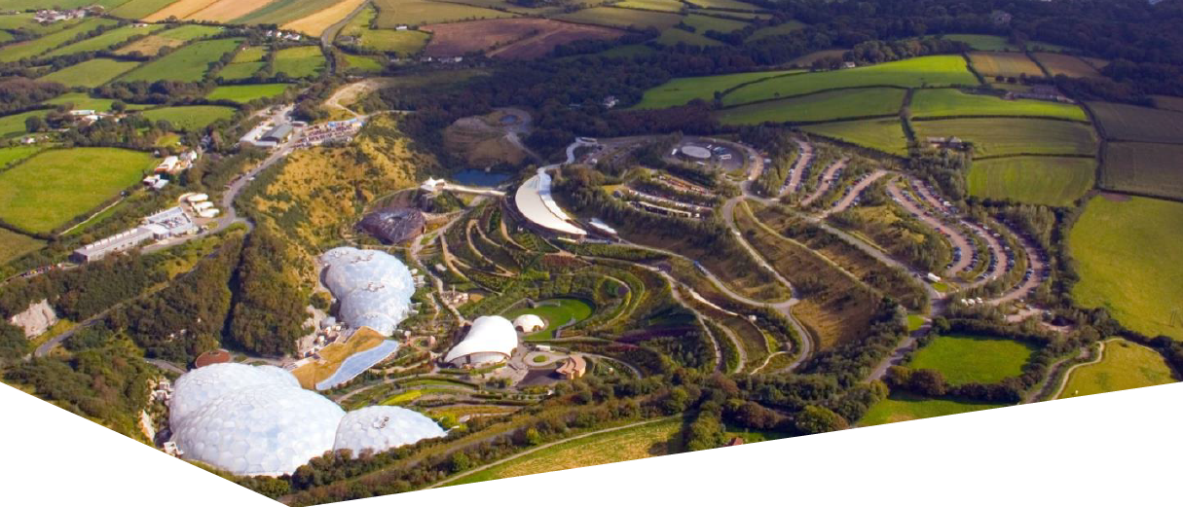
The Eden Geothermal Project is being run by Eden Geothermal Ltd (EGL), which is an SPV set-up to manage and implement the development of a deep geothermal energy plant at the Eden Project, Bodelva, Par, Cornwall PL24 2SG. Funding is in place and planning permission has been obtained.
The ultimate aim of EGL is to develop a two well deep geothermal system that will produce both direct heat and power, some of which will provide direct supply to the Eden Project, with the remainder being exported. This 3-year Project forms the first stage of this development and is co-financed by the European Regional Development Fund, Cornwall Council and private investment.

The Eden Geothermal plant will be made up of two boreholes, a production and an injection well, both drilled approximately to 4.5 km vertical depth in a known fault into the granite beneath Eden. The temperature at that depth is expected to be in the range of 170 - 190°C. Superheated water produced from this depth through the first well will be used to generate electricity and provide heat, and then, being cooled off, will be returned to the fault via an injection borehole.

With an anticipated gross electric capacity of around 7 MW_{e} and the ability to generate around 90% of the time, the Eden Geothermal Plant could produce enough electricity to supply the Eden Project and around four to five thousand households, as well as heating for the biomes and green houses at the Eden Project - and potentially some district or industrial heating.
The project will comprise (i) the construction of a suitably sized drilling site; (ii) the drilling of one well to a nominal depth of 4,500 metres; and (iii) the testing and heat production demonstration from this well. It is anticipated that the drilling of the first deep well will commence in Q4 2020, subject to procurement, and that the project will be completed by December 2022. Based on the success of this project, it will form the precursor to the next stage of development for a two well deep geothermal heat and power plant.

The project will be completed in two independent project phases. The first well and the associated test programme represent a self-contained project phase with an emphasis on exploration. This first stage is a 40 months project comprising (i) finalisation of design; (ii) site preparation & installation of infrastructure; (iii) drilling the first deep well; (iv) well/fault permeability testing; and (v) heat demonstration over a period of 12 months to satisfy ERDF outputs.

A successful first phase will pave the way for the drilling of a second well and the construction of a combined heat and power plant.
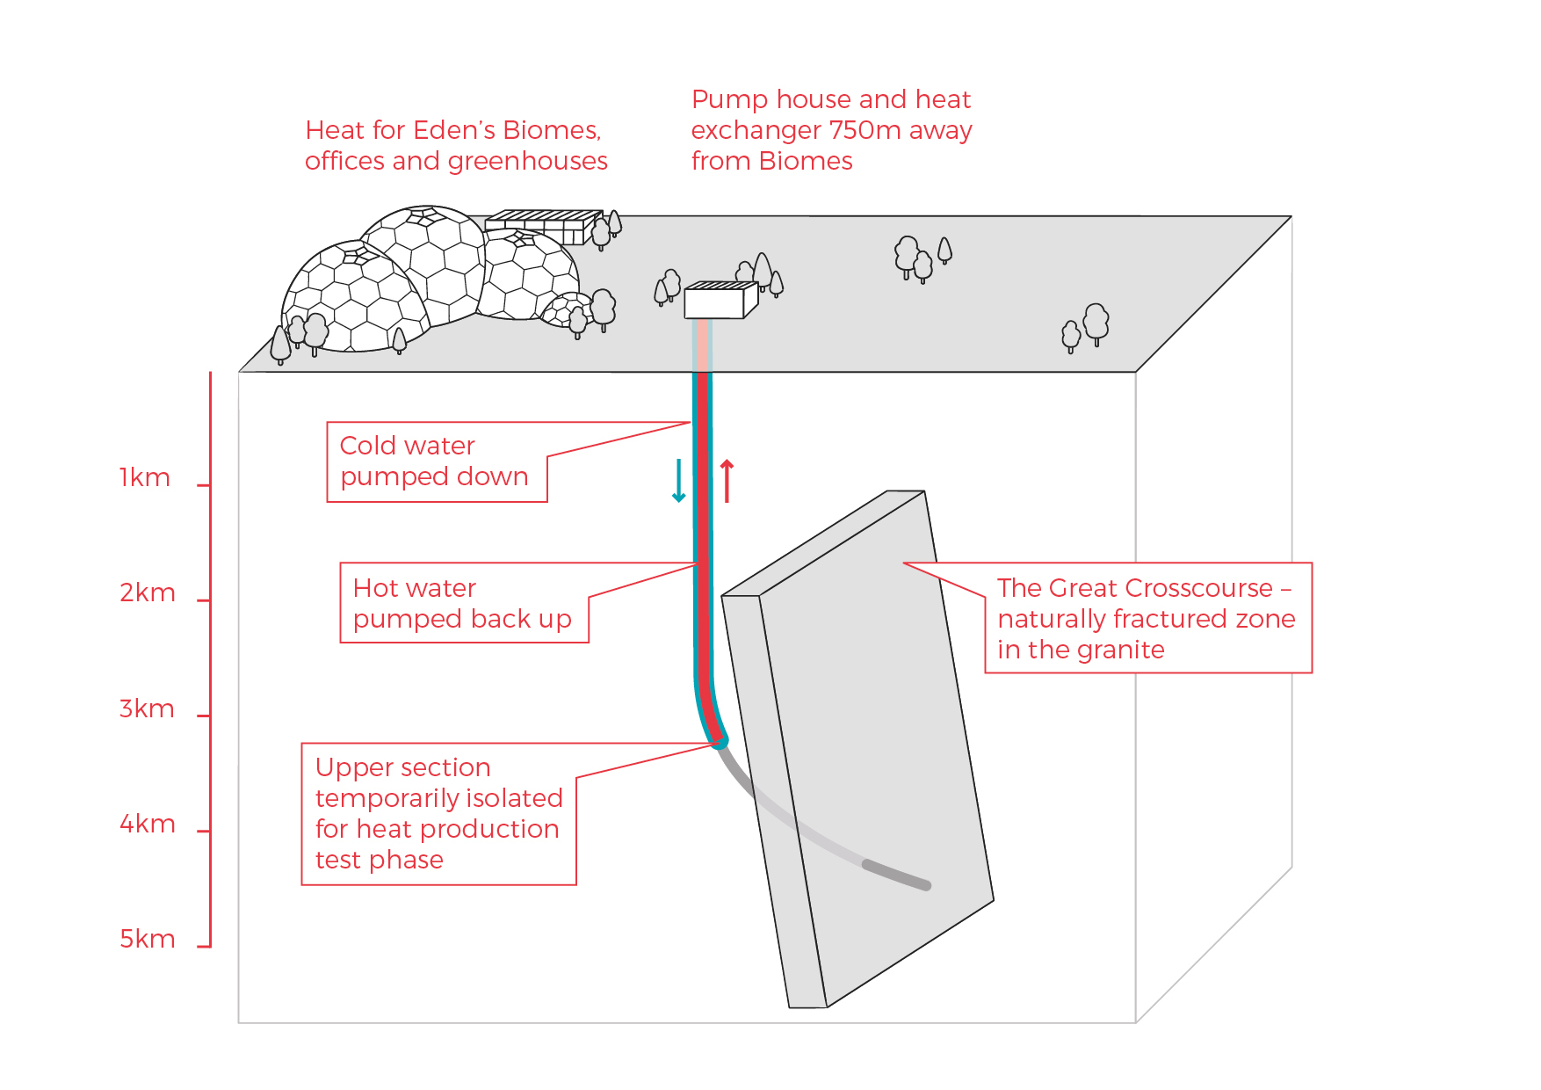
Phase 1 of the deep geothermal concept at the Eden Project

3.1 Background

Eden Geothermal Limited is a special purpose vehicle which was set up to develop the geothermal project at the Eden site. The project combines the famous Eden Project site with EGS Energy Ltd’s and BESTEC (UK) Ltd’s technical expertise and experience in the geothermal sector.

EGS Energy Ltd is a UK private limited company, incorporated in 2008 and established by Roy Baria and Guy Macpherson Grant to develop deep geothermal energy solutions in the UK. BESTEC (UK) Ltd is a UK private limited company incorporated in June 2012 and established by Jörg Baumgärtner to perform deep geothermal work in the UK in cooperation with BESTEC GmbH, an established specialist company in geothermal project development. Eden Project Limited is a wholly owned subsidiary of the Eden Trust, a registered charity in the UK, and runs the world famous Eden Project in Cornwall.

Eden Geothermal Limited has been allocated funding from the European Regional Development Fund and from Cornwall Council, together with private investment match funding, to undertake the first phase as an Industrial Research Project.

3.2 Location and Site Layout

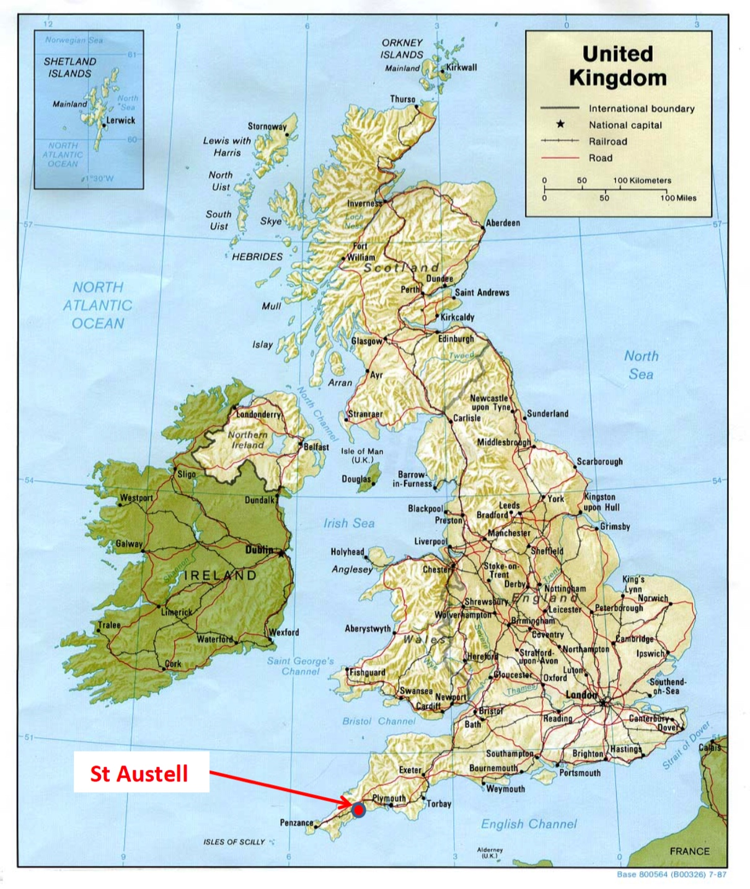
The Eden Project is located about 2 - 3 km north-east of the town of St Austell in the southern part of Cornwall.
Map of the UK showing the site of the Eden Project near St Austell

Access by car/van
The main route into Cornwall is via the M5 motorway to Exeter and either the A30 or the A38 trunk roads through Cornwall. The majority of the A30 is dual carriageway. The Eden Project is signposted from the A30.
The Eden Project is well connected by road, either (i) from the A30, via the A391; (ii) from Truro by the A390 (westbound); or (iii) from Plymouth by the A38 and A390 (eastbound). The road distance from Plymouth to St Austell is 26 miles or 42 km.
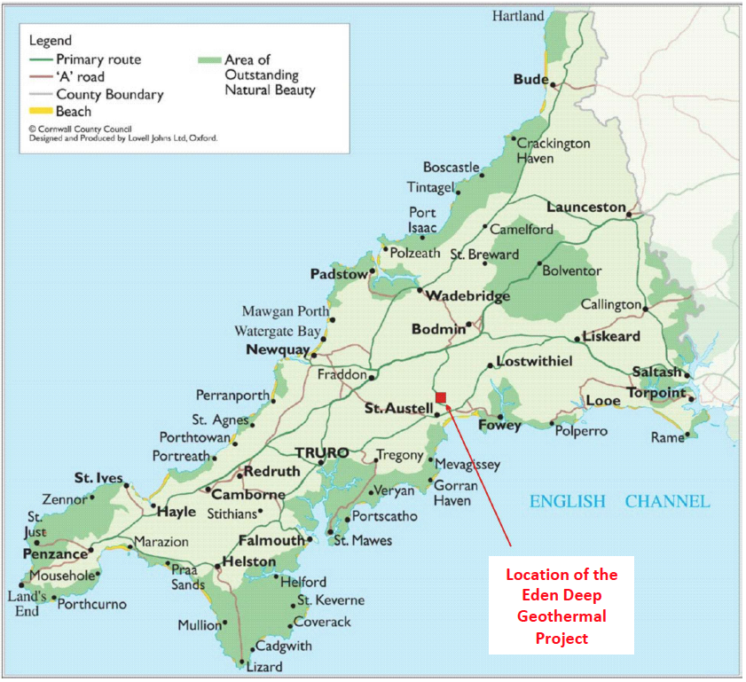
Location of the Eden Project in Cornwall
Access by truck/HGV
The recommended transport route for HGVs to and from the Eden Project is either:
- from the Innis Downs junction on the A30, taking the A391 through Bugle, Stenalees and Carluddon and onto the Eden Project; or
- from the Victoria Interchange on the A30, taking the B3274 through Roche and Trezaise to Stenalees, then the A391 to Carluddon and onto the Eden Project.
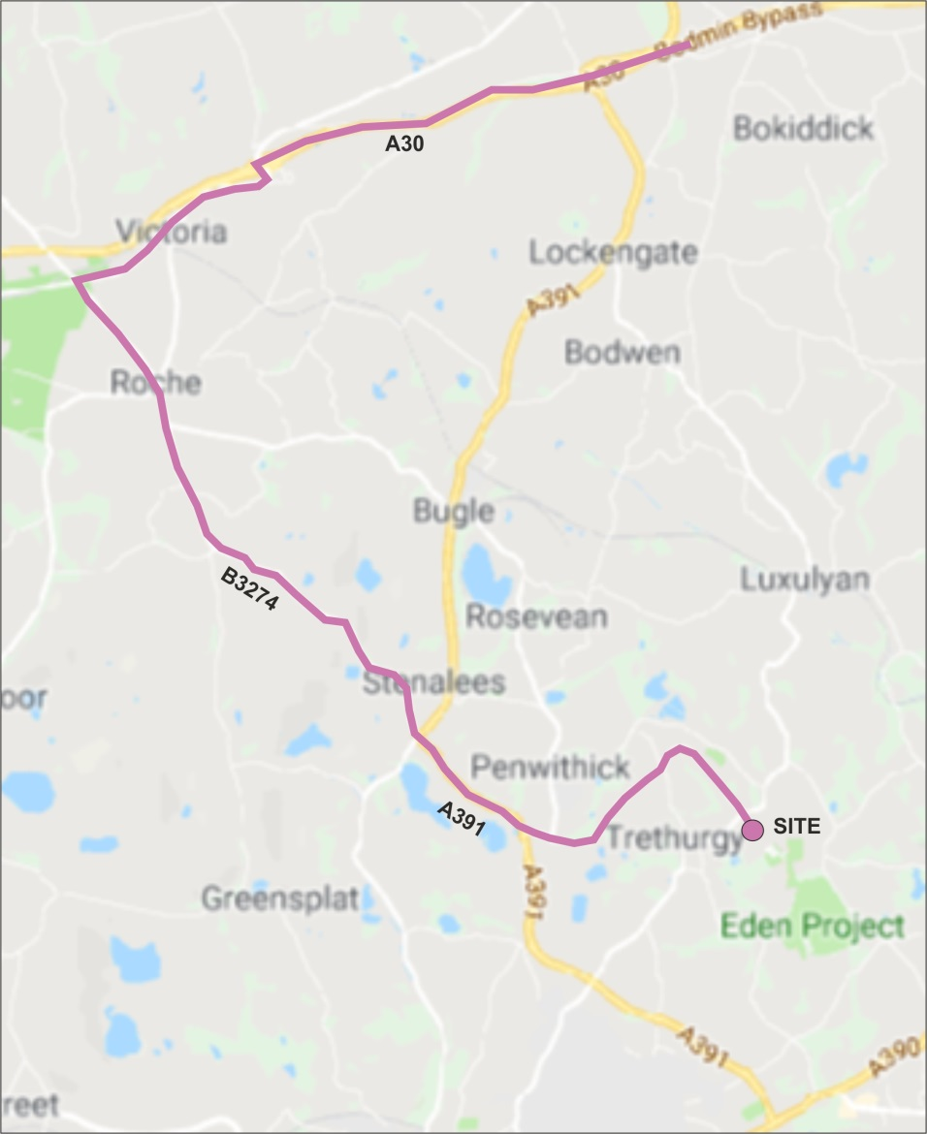
HGV road route to the Eden Project

Access from mainland Europe by boat to Plymouth:
Brittany Ferries maintains a route from Roscoff in Brittany, France to Plymouth (approximately 6 - 8 hrs sailing time).

PART C: TECHNICAL REQUIREMENTS AND SPECIFICATIONS

4 Technical Requirements

Eden Geothermal Ltd invites tenders for the supply of drill bits for Phase 1 of the Eden Geothermal Project. The technical requirements are set out in Section 4 together with the information in Schedule 3.

4.1 Specifications and Standards

The Drilling Programme is detailed below, and detailed specifications and standards for the drill bits to be supplied are set out in Schedule 3, Table 1.

4.1.1 Drilling Programme
The entire work program, including mobilisation and demobilisation of the drilling rig is estimated to take 6 – 7 months, with the drilling program taking approximately 150 days from spud to completion.

The well is designed as a directional well aiming at a major fault structure known as the Great Crosscourse.

It is the aim of our well planning to keep the well trajectory as smooth as possible to minimise drag and torque in the granitic formation (no mud cake).

The well trajectory is planned using a KOP at 1700 m TVD and a very moderate initial build. The EOB of the first well section is at around 4,150 m MD or 4,000 m TVD, just ahead of the first well target. At this depth the well inclination is expected to be around 35°.

If the first target is passed with no indication of the fault, drilling will be continued gradually raising the inclination to 40°. The second target at 4,800 m TVD is crossed at a well length of 5,160 m MD. If the fault is intersected at this depth, drilling will continue for another about 100 m in order to create a rat hole. The expected maximum length of the well is therefore 5,260 m.

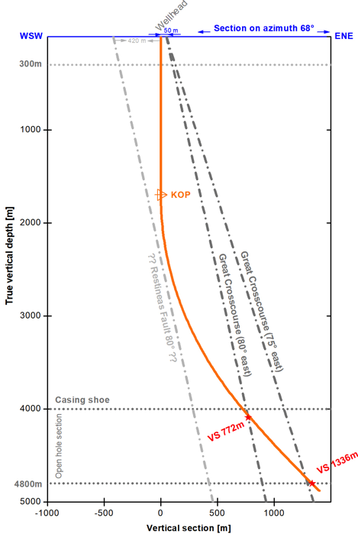

Figure 1: Detailed vertical section view at N68° azimuth. Shown are the fault lines for 80° and 75° inclination as well as the suggested well trajectory.

4.1.2 Geology
The well will be drilled in granite from near surface to bottom. The granite in the vicinity of the site is a medium to coarse grained biotite granite. The main component of the granite is quartz (~34%), alkali-feldspar (~32%), plagioclase (~22%), biotite (~6%), muscovite mica (~4%) and primary tourmaline (1%) and other minerals (1%). With depth there is likely to be changes in grain size and mineral composition.
Figure XX: Detailed vertical section view at N68° azimuth. Shown are the fault lines for 80° and 75° inclination as well as the suggested well trajectory.
Also refer to Appendix A.
4.1.3 Temperature
Figure 2: Draft wellbore schematic of the well Eden EG-1
Heat flow values on or close to the Cornish granite are typically 120 mW/m², whereas away from the granite the values are approximately 60 mW/m². The modelling indicates the geothermal gradient in the vicinity of the Eden Project to be 35 - 40 °C/km. This equates to a rock temperature of approximately 90 °C at a depth of 2,000 m; approximately 160 °C at 4,000 m (casing shoe); and 170 – 180 °C at a depth of 4,500 m (target zone).
A recent paper produced by the British Geological Survey has identified that temperatures of 220 °C may exist in the St Austell Granite at a depth of 5,000 m.

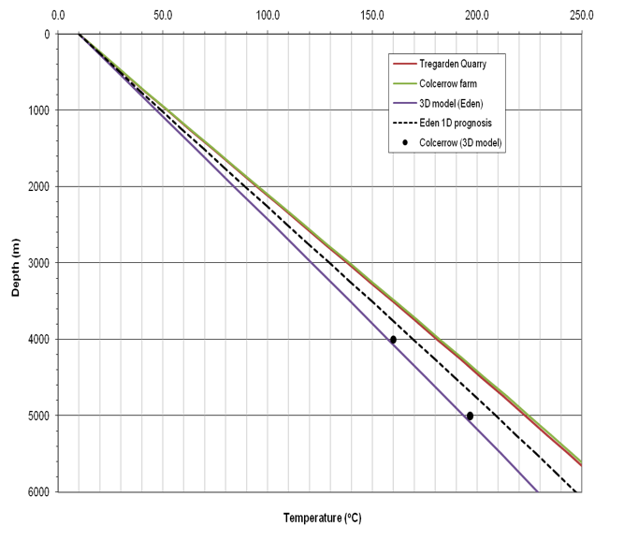

Figure 3: Anticipated geothermal gradient
Ref.: Eden EGS Development Reservoir Scoping Report, prepared by EGS Energy Limited, March 2011.

4.2 Delivery Terms
Delivery terms are DDP (Delivered Duty Paid - as stated in Incoterms 2020). Materials must be delivered to the drilling site, at the Eden Project, Bodelva, Par, Cornwall, United Kingdom PL24 2SG by 23rd December 2020.

4.3 Financial Terms
All prices will be fixed prices, exclusive of VAT, inclusive of all other taxes and duties.

4.4 Listing of Geothermal Drill Bits to be supplied

The parts to be supplied are set out in Schedule 3, 3d Table 2.

PART D: RETURN OF TENDER

5 Tender Completion Documentation

This Section provides information to help Tenderers prepare their tenders. Applicants are advised to read all the documentation carefully to ensure that they are familiar with the nature and extent of their obligations should their tender be accepted.
The Applicant must complete and return all relevant documents as part of their Tender response:
- Company Information – Schedules 1a – 1g
- Declarations – Schedule 2
- Technical submission – Schedule 3
- Commercial submission – Schedule 4

Schedules 1, 2 and 3 may be submitted jointly but Schedule 4 must be submitted separately.

It is the responsibility of the Applicant to inform EGL of any matter that may affect the Applicant’s qualification. All Applicants must complete Schedules 1, 2, 3 and 4.

Applicants must ensure that all questions are completed in full, in English, and in the format requested. Failure to do so may result in the submission being disqualified. Applicants are expected to supply all required information, or clearly state the reason for being unable to do so. Where the question does not apply, please state clearly ‘N/A’. Where the answer is a statement of fact, it must be accurate. It is the Applicant’s responsibility to ensure that EGL is not misled.

Any appropriate supporting documents (e.g. product catalogues, technical specifications and sheets, independent test certificates/reports, brochures etc. as requested in Schedule 3) should be included as additional information. Please supply them as an Appendix. They should be numbered clearly and listed as part of your declaration. PDF is the only acceptable file format. All additional documents provided by the Applicant must refer to a specific item or requirement within the ITT and be easily identifiable.

Should the Applicant wish to propose a variation from the specification please ensure that this is clearly identified where appropriate in the response. The variation needs to be accompanied by a thorough explanation.

5.1 Company Information
5.1.1 Company Details
The Applicant must complete the details required in Schedule 1a. Where the Applicant is a consortium or partnership bidder, Schedule 1a must be completed by each member of the consortium or partnership.

5.1.2 Financial Matters
The Applicant is required to provide the information requested in Schedule 1b. In the case of a consortium or partnership bid, all members of the consortium or partnership should complete this information. This section may be used, in conjunction with credit reference agency checks if necessary, to gain a basic indication of the financial stability of the Applicant. The determination of the appropriate risk level will be proportionate and relevant to the size, value and nature of the specific contract being tendered. For this contract, EGL will wish to see Capital and Reserves in excess of 100,000 GBP. Where the company does not have the required level of reserves, we will accept parent company or personal guarantees to the same value. EGL reserves the right to undertake further independent financial checks, if it feels it important to do so. Financial responsibility cannot be shared. Consortium or partnership bids must state one of the members of the partnership as the Lead Applicant, which will be the financially responsible party.

5.1.3 Legal Matters, Disputes and Conflicts
The Applicant must complete answers to all the questions in Schedule 1c and 1d.

5.1.4 Warranties/Insurance/Supply
For any Applicant to be successful, adequate proof of warranties/insurance will be required. The minimum levels are indicated in Schedule 1f. The Applicant must also confirm that they can meet the delivery terms. The Applicant must complete Schedule 1f with the relevant information and confirm that the details entered are correct.

5.1.5 Company Experience
The Applicant should provide details in Schedule 1g of up to three contracts which demonstrate the expertise and experience of the lead Applicant and any proposed partners or sub-contractors in relation to EGL’s requirements. References should be available for these contracts if possible.

5.1.6 Declaration
The Applicant (or each partner or member organisation in the case of a consortium bid) must complete the Declaration in Schedule 2.

5.2 Technical Submission
EGL’s requirements for this contract are set out in Part C Technical Requirements and Specifications, together with Schedule 3, which sets out more detailed information.

The Applicant’s submission should take into account all relevant factors contained within this information, although EGL does not accept any responsibility for the accuracy or completeness of this information. Applicants must submit their bid based on the technical requirements described in Part C.

The Applicant must complete Schedule 3, providing evidence to demonstrate:

- Expertise of personnel and experience of directional drilling in granite (drilling length in granite should exceed 500 m). ‘Hole size’, rate of penetration achieved, total meters per ‘bit’ and ‘hours per bit’ achieved should be presented with examples and data to be used to evaluate the quality of the bits proposed.

- EGL is going to be drilling in mostly unknown terrain and the drill bit performance will be tracked continuously. We expect the drill bit provider to support EGL with constructive suggestions for drill bit selection. Please indicate what field support would be available to EGL and if you have regional experts how often they would visit the project, and the operator’s representative to discuss improvement in the operation.

- The drill bit features proposed need to be adequate to allow for safe directional drilling in granite in these hole sizes. Consequently, the bits need to be equipped with sufficient gauge and leg protection, high temperature seals (below 3,000 m depth) and the bits need to be hard-faced for motor drilling. Your description of the technical features proposed/quoted for will be evaluated.

5.3 Commercial Submission
The Applicant is required to complete and return Schedule 4, which will provide a detailed price structure for the items to be supplied. All prices will be:
- Fixed.
- Quoted in pounds sterling.
- Exclusive of VAT. Where applicable, EGL will pay any VAT incurred at the prevailing rate (currently 20%). If the VAT rate changes, EGL will pay any VAT incurred at the new rate. It is the responsibility of the Applicant to check their VAT position with HMRC before submitting a bid.
- Inclusive of other taxes and duties (ie anti-dumping custom fees) and delivery to the Eden Geothermal site (Incoterms 2020 DDP, Eden Project, PL24 2SG, United Kingdom) by 23rd December 2020.

Note: All drill bits shall be ordered on consignment.

5.4 Confidential / Commercially Sensitive Information
Please outline in Schedule 5 any items that the Lead Organisation or its partners consider to be genuinely Confidential and/or Commercially Sensitive which should not be disclosed in respect of your Tender.

PART E: TENDER EVALUATION

6 Evaluation Process

This Section specifies the criteria to be used to determine the successful applicant and the requirements for the tenderer’s qualification to perform the contract.

All applicants must prepare separate technical and commercial bid documents.

Technical and commercial bids must be received by Eden Geothermal Ltd
in separate PDF files and hard copy documents, each quoting the tender number in the title.

All bids will be impartially evaluated against the same criteria by an ‘Evaluation Panel’ on behalf of Eden Geothermal Limited.

The evaluation process will be conducted in a manner that ensures tenders are evaluated fairly to ascertain the most technically and economically advantageous tender. Each tender submission will be evaluated only on the information that is provided by the Applicant. Tenders may be rejected if the information asked for in the ITT and Specification is not given at the time of tendering.

Technical documents and bids will be restricted to the members of the Evaluation Panel, which has full power to make decisions on behalf of Eden Geothermal Limited. The evaluation will be carried out by the Evaluation Panel in distinct sections, with weightings applied where appropriate:

Title | Evaluation Method
Company Information (Schedule 1) | Pass / Fail
Declarations (Schedule 2) | Pass / Fail
Technical Criteria (Schedule 3) | 65% - Weightings set out below
Commercial Criteria (Schedule 4) | 35% - Weightings set out below

6.1 Company Information

The Company Information will be evaluated first and Applicants will be required to pass this stage before their Tenders are evaluated on the basis of their technical and commercial submission.

Seven criteria will be used to evaluate Applicants, each being scored on a pass or fail basis. Applicants must pass all criteria to proceed to the remainder of the evaluation. The criteria are:
  - Company Information
  - Economic and Financial Standing
  - Grounds for Mandatory Exclusion
  - Other Grounds for Exclusion
  - Equality and Diversity
  - Warranties, Insurance and Supply
  - Company Experience / Previous Contracts

The Company will be evaluated as follows:-

- Schedules 1a and 1b will be reviewed alongside Schedule 1g. The review of the Applicant’s submission will only proceed to the remainder of Schedule 1 and Schedule 2 where the reviewer deems that the Applicant has passed these sections.

- Schedule 1c sets out the Grounds for Mandatory Exclusion. EGL will also exclude any Applicant who answers ‘Yes’ in any of the situations in Schedule 1d. This includes evidence of convictions relating to specific criminal offences including, but not limited to, bribery, corruption, conspiracy, terrorism, fraud and money laundering, or if you have been the subject of a binding legal decision which found a breach of legal obligations to pay tax or social security obligations (except where this is disproportionate, e.g. only minor amounts involved).

- EGL stresses the importance of Schedule 1g. Please be aware that a minimum score of 4 is required to proceed to the remainder of Schedule 1 and Schedule 2.

If the Applicant is made up of a Lead Organisation and other organisations who have jointly entered into a consortium, joint venture or other contracting arrangement, each of the organisations must pass all the criteria in order for the Tender to proceed to the remainder of the evaluation.

6.2 Technical Evaluation
Only Applicants that have passed the evaluation of Company Information, Relevant Experience and Contract Examples will have their technical bids evaluated by the Evaluation Panel.
The technical submission should demonstrate the Applicant’s expertise, experience and capability to supply the goods and materials in accordance with the technical requirements and specifications set out in Part C and Schedule 3.
For the materials being procured, applicants are asked to provide: product catalogues; technical specifications, sheets and certificates as stated in Schedule 3, Table 1. These should be returned with your technical submission and listed in the table provided in Schedule 3. (You may add more rows if necessary.)
The 65% available for technical score set out in Schedule 3 will be allocated using the weighting set out below:-

Technical Score Weighting | % of Total Marks
Performance of Drill Bits (particularly 12 ¼“ and 8 ½“) in Granite, or other crystaline rock of similar composition (please specify)  - Rate of penetration achieved  - With motor  - In rotary mode alone  - Total meters per bit; and  - Hours per bit | 39%
Drill Bit features for 12 ¼ “ and 8 ½ “ hole sizes  - Sufficient gauge and leg protection  - High temperature seals (below 3,000 m depth; and  - Hard-faced for motor drilling | 13%
Field Support  - What levels of field support would be available | 13%
Total Marks | 65%

The quality of the technical submission will be scored in accordance with the Scoring Matrix shown below:
5 Excellent Extremely good demonstration of relevant ability, understanding, experience, skills, resources and quality measures required to provide the services, with full evidence provided to support this.
4 Good Above average demonstration of the relevant ability, understanding, experience, skills, resource and quality measures required to provide the services, with a majority of evidence provided to support this.
3 Acceptable Satisfactory demonstration of the relevant ability, understanding, experience, skills, resources and quality measures required to provide the services, with some evidence to support this.
2 Minor Reservations Some reservations regarding the relevant ability, understanding, experience, skills, resources or quality measures required to provide the services, with little or no evidence to support this.
1 Major Reservations Serious reservations regarding the relevant ability, understanding, experience, skills, resources or quality measures required to provide the services, with no evidence to support this.
0 Unacceptable Non-compliance and/or insufficient information provided to demonstrate that there is the ability, understanding, experience, skills, resource and quality measures required to provide the services.

6.3 Commercial Evaluation
The Commercial Evaluation will be carried out for all submissions that that have been included in the Technical Evaluation Schedule 3. Commercial submissions from those who failed to pass Schedules 1 and 2 will be destroyed unopened.

Commercial offers will be judged by taking the tendered summarised cost as set out in Schedule 4. Where EGL believes that the tendered costs have been prepared on an inconsistent basis with the other tenders, which creates an unfair advantage to the tenderer’s offer, EGL will request that further information is provided to enable the Commercial valuation to be carried out on a fair basis.

The median price of all the tender prices will be calculated and this will be judged to equal 50% of the available commercial marks. The individual tenders will then be awarded points above and below the average percentage relative to their tender price. The maximum points will be awarded for offers which are less than or equal to half the median, and nil points will be awarded for offers which are more than or equal to double the median value.

6.4 Total Score
The final ‘Total Score’ will be calculated by converting the Technical Evaluation score and the Commercial Evaluation score into a percentage which is then combined according to the weighting stated in the sections above. The selected Applicant will be the one with the highest total score.

The Evaluation Panel will have the authority to send out a Letter of Intent to the proposed awardee / awardees, which should state that a contract will be awarded.

6.5 Clarification
During the evaluation process, EGL may need to seek clarification on aspects of an Applicant’s submission. If required, EGL will contact the Applicant using the contact details provided. Clarification may require further submission or supplementation or clarification to complete the relevant information or documentation within an appropriate time limit. The purpose of any such clarification will be only to provide EGL with the information required to evaluate and score the submission; it will not be an opportunity for the Applicant to improve or substantially change the information that has already been submitted.

6.6 Award and Notification
Once EGL has completed the evaluation and has identified the successful tenderer(s), EGL will inform the winning Applicant(s) in writing by email of the ’award decision’.

The unsuccessful Applicants will be informed in writing of the fact at the same time after the closing of the evaluation procedure. EGL will offer feedback to every Bidder submitting an unsuccessful proposal.

Ten days after the adjudication the contract will be awarded.

PART F: CONDITIONS

7 Conditions

7.1 Confidentiality and Freedom of Information
This document is proprietary to EGL and the information contained herein is confidential.

EGL confirms that it will keep confidential and will not disclose to any third parties any information obtained from a named Applicant contact, other than to the EU Managing Authority, to its funders, and under EGL’s commitment to meeting its responsibilities under the Freedom of Information Act (FOI) 2000 or the Environmental Information Regulations (EIR) 2004. All information submitted to EGL may need to be disclosed in response to a request under these regulations.

The Applicant must treat all information supplied to it by EGL in confidence and must not disclose it to third parties other than to obtain sureties or quotations for submitting its response as part of the tendering process.

The Applicant must identify any parts of its tender submission which it designates as confidential and would not want published; such information may include technical or trade secrets or other confidential information in Schedule 5. The Applicant should explain (in broad terms) what harm may result from disclosure if a request is received, and the time period applicable to that sensitivity. However, the Applicant should be aware that, even where information has been categorised as being commercially sensitive, EGL may still be required to disclose it under the FOI or EIR if a request is received.

Without prejudice to EGL’s obligation to disclose information in accordance with the FOI or EIR, EGL shall, acting reasonably, at its absolute discretion and notwithstanding any other provision in this Tender or otherwise seek to apply the commercial interests exemption to the information/documents listed in this Schedule.

7.2 Language
The completed tender and all accompanying documents must be in English.

7.3 Applicable Law
Any contract concluded as a result of this ITT will be governed by the law of England & Wales.

7.4 Additional costs
Once the contract has been awarded EGL will not pay any additional costs incurred which are not reflected in the tender submission.

7.5 Costs
Unless otherwise stated in this ITT, all costs associated with taking part in this process remain the Applicant’s responsibility. The Applicant will not be entitled to claim from EGL any costs or expenses which may have been incurred in preparing the tender, whether or not the tender is successful. EGL will not return any part of the completed tender.

7.6 Right to cancel or vary the process
EGL reserves the right to cancel or withdraw from the tendering process at any stage. Cancellation of the procurement process (at any-time) under any circumstances will not render Eden Geothermal Ltd liable for any costs or expenses incurred by bidders during the procurement process.

7.7 Inducements
Offering an inducement of any kind in relation to obtaining this or any other contract with EGL will disqualify the Applicant from being considered and may constitute a criminal offence.

7.8 Disclaimer
The issue of the information and the tender does not commit Eden Geothermal Ltd to award any contract pursuant to the bid process or enter into a contractual relationship with any provider of the service. Nothing in the tender or in any other communications made between Eden Geothermal Ltd or its agents and any other party, or any part thereof, shall be taken as constituting a contract, agreement or representation between Eden Geothermal Ltd and any other party (save for a formal award of contract made in writing by or on behalf of Eden Geothermal Ltd).

While the information in this ITT and supporting documents has been prepared in good faith by EGL, it may not be comprehensive, and nor has it been independently verified. Neither EGL nor their advisors, nor their respective directors, officers, members, partners, employees, other staff or agents:

- makes any representation or warranty (express or implied) as to the accuracy, reasonableness or completeness of this ITT; or
- accepts any responsibility for the information contained in the ITT or for the accuracy or completeness of that information; or
- shall be liable for any loss or damage (other than in respect of fraudulent misrepresentation) arising as a result of relying on such information or any subsequent communication.

SCHEDULES

Schedule 1a - Company Details

Applicant details |  | Answer
Full name of the Applicant completing the ITT
Trading Name (if different)
Registered company address
Registered company number
Registered VAT number (if applicable)
Name of immediate parent company
Name of ultimate parent company
Type of company (please tick relevant boxes) |  | Public limited company
 |  | Limited company
 |  | Limited liability partnership
 |  | Other partnership
 |  | Sole trader
 |  | Other
 |  | Small medium enterprise
Contact details
Name
Position
Postal address
Country
Phone number
Email

Schedule 1b - Economic and Financial Standing

 | Enclosed | Not Applicable
(a) Please state the name and title of the person in your business responsible for financial matters.

(b) Please enclose copies of the business’ audited accounts of the past two years, to include:
- Balance Sheet
- Profit and Loss Account
- Full notes to the Accounts
- Director’s Report
- Auditor’s Report

(c) If the accounts submitted for section (b) above are for an accounting year ended more than 10 months ago, please confirm that the business is still trading and provide the latest summary of management accounts.

(d) Please confirm that we may obtain references from your bankers and provide their name and address.
 | Yes | No
(e) Has there been any event since the last audited accounts that could affect the going concern status of the company?

Note: EGL will wish to see evidence of Capital and Reserves in excess of 100,000 GBP for this contract. Where the company does not have the required level of reserves, we will accept parent company or personal guarantees to the same value.

Schedule 1c - Grounds for Mandatory Exclusion

Within the past five years, has your organisation (or any member of your proposed consortium, if applicable), Directors or partner or any other person who has powers of representation, decision or control been convicted of any of the following offences? Please indicate your answer by marking ‘X’ in the relevant box.

 | Yes | No
(a) conspiracy within the meaning of section 1 or 1A of the Criminal Law Act 1977 or article 9 or 9A of the Criminal Attempts and Conspiracy (Northern Ireland) Order 1983 where that conspiracy relates to participation in a criminal organisation as defined in Article 2 of Council Framework Decision 2008/841/JHA on the fight against organised crime;
(b) corruption within the meaning of section 1(2) of the Public Bodies Corrupt Practices Act 1889 or section 1 of the Prevention of Corruption Act 1906;
(c) the common law offence of bribery;
(d) bribery within the meaning of sections 1, 2 or 6 of the Bribery Act 2010; or section 113 of the Representation of the People Act 1983;
(e) any of the following offences, where the offence relates to fraud affecting the European Communities’ financial interests as defined by Article 1 of the Convention on the protection of the financial interests of the European Communities:
(i) the offence of cheating the Revenue;
(ii) the offence of conspiracy to defraud;
(iii) fraud or theft within the meaning of the Theft Act 1968, the Theft Act (Northern Ireland) 1969, the Theft Act 1978 or the Theft (Northern Ireland) Order 1978;
(iv) fraudulent trading within the meaning of section 458 of the Companies Act 1985, article 451 of the Companies (Northern Ireland) Order 1986 or section 993 of the Companies Act 2006;
(v) fraudulent evasion within the meaning of section 170 of the Customs and Excise Management Act 1979 or section 72 of the Value Added Tax Act 1994;
(vi) an offence in connection with taxation in the European Union within the meaning of section 71 of the Criminal Justice Act 1993;
(vii) destroying, defacing or concealing of documents or procuring the execution of a valuable security within the meaning of section 20 of the Theft Act 1968 or section 19 of the Theft Act (Northern Ireland) 1969;
(viii) fraud within the meaning of section 2, 3 or 4 of the Fraud Act 2006; or
(ix) the possession of articles for use in frauds within the meaning of section 6 of the Fraud Act 2006, or the making, adapting, supplying or offering to supply articles for use in frauds within the meaning of section 7 of that Act;
(f) any offence listed in (i) in section 41 of the Counter Terrorism Act 2008; or (ii) in Schedule 2 to that Act where the court has determined that there is a terrorist connection;
(g) any offence under sections 44 to 46 of the Serious Crime Act 2007 which relates to an offence covered by subparagraph (f);
(h) money laundering within the meaning of sections 340(11) and 415 of the Proceeds of Crime Act 2002;
(i) an offence in connection with the proceeds of criminal conduct within the meaning of section 93A, 93B or 93C of the Criminal Justice Act 1988 or article 45, 46 or 47 of the Proceeds of Crime (Northern Ireland) Order 1996;
(j) an offence under section 4 of the Asylum and Immigration (Treatment of Claimants etc.) Act 2004;
(k) an offence under section 59A of the Sexual Offences Act 2003;
(l) an offence under section 71 of the Coroners and Justice Act 2009
(m) an offence in connection with the proceeds of drug trafficking within the meaning of section 49, 50 or 51 of the Drug Trafficking Act 1994; or
(n) any other offence within the meaning of Article 57(1) of the Public Contracts Directive—
(i) as defined by the law of any jurisdiction outside England and Wales and Northern Ireland; or
(ii) created, after the day on which these Regulations were made, in the law of England and Wales or Northern Ireland.
(o) Non-payment of taxes - has it been established by a judicial or administrative decision having final and binding effect in accordance with the legal provisions of any part of the United Kingdom or the legal provisions of the country in which your organisation is established (if outside the UK), that your organisation is in breach of obligations related to the payment of tax or social security contributions?

Schedule 1d - Other Grounds for Exclusion

Within the past three years, please indicate if any of the following situations have applied, or currently apply, to your organisation (or any member of your proposed consortium, if applicable). Please indicate your answer by marking ‘X’ in the relevant box.

 | Yes | No
(a) your organisation has violated applicable obligations referred to in regulation 56 (2) of the Public Contracts Regulations 2015 in the fields of environmental, social and labour law established by EU law, national law, collective agreements or by the international environmental, social and labour law provisions listed in Annex X to the Public Contracts Directive as amended from time to time;
(b) your organisation is bankrupt or is the subject of insolvency or winding-up proceedings, where your assets are being administered by a liquidator or by the court, where it is in an arrangement with creditors, where its business activities are suspended or it is in any analogous situation arising from a similar procedure under the laws and regulations of any State;
(c) your organisation has entered into agreements with other economic operators aimed at distorting competition;
(d) your organisation has a Conflict of Interest (CoI) within the meaning of regulation 24 of the Public Contracts Regulations 2015 that cannot be effectively remedied by other, less intrusive, measures; (*)
(e) the prior involvement of your organisation in the preparation of the procurement procedure has resulted in a distortion of competition, as referred to in regulation 41, that cannot be remedied by other, less intrusive, measures;
(f) your organisation has shown significant or persistent deficiencies in the performance of a substantive requirement under a prior public contract, a prior contract with a contracting entity, or a prior concession contract, which led to early termination of that prior contract, damages or other comparable sanctions;
(g) your organisation has negligently provided misleading information that may have a material influence on decisions concerning exclusion, selection or award.
(h) your organisation has committed an offence under the Modern Slavery Act 2015.

(*) Conflicts of interest
EGL may exclude the Applicant if there is a conflict of interest which cannot be effectively remedied. The concept of a conflict of interest includes any situation where relevant staff members have, directly or indirectly, a financial, economic or other personal interest which might be perceived to compromise their impartiality and independence in the context of the procurement procedure.

Where there is any indication that a conflict of interest exists or may arise then it is the responsibility of the Applicant to inform EGL, detailing the conflict in a separate Appendix. Provided that it has been carried out in a transparent manner, routine pre-market engagement carried out by EGL should not represent a conflict of interest for the Applicant.

If you have answered ‘Yes’ to any of the above question, please use a separate Appendix to provide further details.

Schedule 1e - Equality and Diversity

The Lead Organisation and all other organisations must confirm that their organisation complies with its legal obligations under European law relating to the following:-

Item | Confirm Yes / No
- Race
- Sexual Orientation
- Gender Reassignment
- Disability
- Age
- Religion or Belief
- Sex
- Marriage & Civil Partnership
- Pregnancy & Maternity

Schedule 1f – Warranties, Insurance and Supply

Insurance
Product Warranties | Seller shall fully warrant the material supplied against defects in material and workmanship for a period of 12 months after receipt of delivery, not to exceed 18 months after shipment, whichever occurs first. In the event of a warrantable failure during the specified period, as mutually agreed upon by Buyer and Seller, after inspection, Seller shall repair or replace the suspect material or its component at its sole expense. The term “sole expense”, however, specifically excludes drilling rig charges, loss of revenue, consulting fees, and other such consequential damages. Repaired / replaced material or its component must be fully warranted for a further 12 months.
Insurance | The Seller is to be responsible for ensuring that the material is delivered, received and unloaded in good working order, and is fit for purpose. As outlined in Part C, section 4.2: any Goods in Transit insurance is to be at the Seller’s own expense.
Standards | Enclosed | Not applicable
Please enclose evidence/valid copy certificates of the following:
- Quality Assurance (QA) Certificates are required

- Tolerances and threads according to API-7-1, drill bits must conform to IADC code.
Supply | Yes | No
Delivery in line with the required latest date of 23rd December 2020

Schedule 1g – Relevant Experience and Contract Examples

Please provide details of up to three contracts, in any combination from either the public or private sector; that are relevant to EGL’s requirement ie drilling in granite. Contracts should have been performed during the past three years.

The named contact provided should be able to provide written evidence to confirm the accuracy of the information provided below.
Consortia bids should provide relevant examples of where the consortium has delivered similar requirements. If this is not possible (e.g. the consortium is newly formed or a Special Purpose Vehicle is to be created for this contract) then three separate examples should be provided between the principal member(s) of the proposed consortium or Special Purpose Vehicle (three examples are not required from each member).
Where the Supplier is a Special Purpose Vehicle, or a managing agent not intending to be the main provider of the supplies or services, the information requested should be provided in respect of the main intended provider(s) or sub-contractor(s) who will deliver the contract.

If you cannot provide at least one example see ii below.

Relevant experience and contract examples will be evaluated on a 0 to 5 basis as in Part E, Tender Evaluation, 6.2 Technical Evaluation – Technical Score Weighting. A minimum score of 4 is required to pass to the technical evaluation stage.

The following details should be provided for each contract:
Name of customer organisation
Point of contact in customer organisation
Position in the organisation
E-mail address
Description of Contract and technical specification – max 500 words
Contract start date
Contract completion date
Estimated Contract Value

Where you intend to sub-contract a proportion of the contract, please demonstrate how you have previously maintained healthy supply chains with your sub-contractor(s).
Evidence should include, but is not limited to details of your supply chain management tracking systems to ensure performance of the contract and including prompt payment or membership of the UK Prompt Payment Code (or equivalent schemes in other countries).

If you cannot provide at least one contract example, in no more than 500 words please provide an explanation for this eg your organisation is a new start-up, or you have provided services in the past but not under a contract.

Schedule 2 - Declarations

I/We understand that the information provided in this document and any supporting information provided by us will be relied upon and taken to be true and accurate. Should it subsequently be determined that any information supplied by us was inaccurate, I/we understand and accept that Eden Geothermal Limited reserves the right to exclude our offer to supply (if still under evaluation) or if the Contract has been awarded and the information that was inaccurately supplied had a significant influence on the award, that Eden Geothermal Limited shall be at liberty to terminate the Contract.

I/We understand that Eden Geothermal Limited is not bound to accept the lowest price or any tender that may be received.

Name of organisation
Name of person applying on behalf of organisation
Signature
Title / position of person
Date
Contact telephone
Contact e-mail
Address and post code
Registered office if different from above
Organisation VAT number (if applicable)

Schedule 3 – Technical Submission

Evaluation Criteria

There are three technical evaluation criteria:
- Performance of drill bits in granite
- Drill bit features for 12 ¼” and 8 ½ “ hole sizes; and
- Field Support

Each category will be evaluated in line with the scoring criteria set out in Section 6.

Important note: ERDF procurement regulations prevent us from scoring ‘Company Experience’ within the technical evaluation. With this in mind, we ask tenderers to pay particular attention to the ‘Personnel’ and ‘Methodology’ categories of this technical submission (Schedule 3).

3a Product Specifications and Standards

Please use the tables in Sections 3c and 3d below to give technical specification on your products performance and features and / or list other documents submitted in support of your bid, e.g.: product catalogues; technical specification sheets/drawings; independent test certificates, reports and/or data detailing performance of drill bits in granite, and drill bit features in 12 ¼” and 8 ½” hole sizes.

You should number each document and list the document title and type, and clearly link it to an item, or range of items, in this ITT. You may add more rows to the table if necessary, but no more than 10 pages.

3b Technical Submission ‘Specifications and Standards’

Summarised below is a preliminary bit programme. During the course of the drilling operations this programme can be adapted to meet the requirements of the project. The full length of the wellbore is drilled in crystalline rock. The specific bit requirements are addressed below.

Note: The bit manufacturer may make recommendations for alternative drill bits based upon experience in previous wells in similar formations. Any additional bit types recommended should be offered on consignment basis with pricing set out in Schedule 4.

Table 1
If the tenderer on the basis of proven records has made successful use of other bit types in the same type of formation (granite) and wants to promote such bit types for the EG-1 well, EGL welcomes these suggestions and is prepared to integrate them into the drill bit programme for the EG-1 well.
Additional bit types recommended shall also be made available on consignment.
Section 1
26" HOLE (0 - 300 meters) | This section consists of kaolinized weathered granite (200 m ??) and sound granite - and will be drilled with one to two bits. If sound granite is encountered an insert bit may be required.
Drilling technique: | Vertical, with motor and MWD assembly !
Temperature (static) @ 300 m: | Expected: < 30° C
Expected requirements: | 1 – 26” IADC Code 115 bit (top section)  2 – 26" IADC Code 547 bits (optional granite, one spare)  Note: EGL’s preference is to rent these drill bits on a price per meter drilled.  2 sets of 18-18-18-18 nozzles  1 set of 20-20-20-20 nozzles for backup  26" bit breaker  Nozzle wrench
Section 2
17 1/2" HOLE (300 - 1,500 meters) | This section still consists of crystalline rock - granite. The well will be kept near vertical in this section. Most likely 6 to 7 bits will be required. The bits will be designed for high penetration rates will have to be hard faced for motor drilling. Gauge wear protection will be required.
Drilling technique: | Vertical, with motor and MWD assembly !
Temperature (static) @ 1,500 m: | Expected: < 70° C
Expected requirements: | 2 – 17 1/2" IADC Code 547 bit  5 – 17 1/2" IADC Code 637 bit  7 sets of 18-18-18-18 nozzles  2 sets of 20-20-20-20 nozzles for backup  17 1/2" bit breaker  Nozzle wrench

Section 3
12 1/4" HOLE (1,500 - 4,000 meters (MD)) | This section consists of crystalline rock – granite “too”. Most likely 15 to 18 bits will be required. The bits will be designed for high penetration rates. Starting at approximately 1,700 m the well will be directionally drilled using a mud motor assembly. A better protected gauge and seal area will be required due to the abrasive formation. High temperature seals will be required. The leg protection feature will also be required on all bits and the bits will have to be hard faced for motor drilling.
Drilling technique: | Directional, with motor and MWD assembly !  At 4,000 m about 33º inclination expected.
Temperature (static) @ 4,000 m (MD): | Expected: about 160° C
Expected requirements: | 7 – 12 ¼" IADC Code 627  7 – 12 ¼" IADC Code 637  4 – 12 ¼” IADC Code 737  20-20-20 nozzles in each bit  2 sets of 20-20-20 nozzles for backup  12 1/4" bit breaker  Nozzle wrench
Section 4
8 1/2" HOLE (4,000 - 5,260 meters (MD)) | This section consists of crystalline rock – granite. Most likely 7 to 10 bits will be required. The bits will be designed for high penetration rates. The well is still being drilled directionally using a mud motor assembly. A better protected gauge and seal area will be required due to the abrasive formation. High temperature seals will be required. The leg protection feature will also be required on all bits and the bits will have to be hard faced for motor drilling.
Drilling technique: | Directional, with motor and MWD assembly !  TD about 40º inclination expected.  Temperature (static) @ 4,350 m (MD):  Expected: about 170° C
Temperature (static) @ 5,260 m (MD): | Expected: about 200° C
Expected requirements: | 4 – 8 1/2" IADC Code 627  6 – 8 1/2" IADC Code 637  18-18-18 nozzles in each bit  2 sets – 16-16-16 nozzles for backup  8 1/2" bit breaker  Nozzle wrench

Note: We are open for discussions with the bit manufacturers on experience in previous wells in similar formations. Additional bit types recommended should be offered and made available on consignment if required.

3c Field Support

Please provide details of personnel experience including stock and field support available, naming the person in charge including a full CV outlining individuals with job titles and, for each, a detailed outline of qualifications and background/expertise/experience/skills relevant to this contract, either in their current role or prior.

Each person’s profile should be no more than 2 sides of A4 in length, but should provide enough detail to enable us to evaluate their expertise. Where possible/relevant, you may wish to highlight their direct or transferable experience in relation to the following:
- Skills and expertise of personnel, and demonstration of directional drilling in granite (drilling length in granite should exceed 500 m) providing 3-5 referees of prior experiences.
- EGL is going to be drilling in mostly unknown terrain and the drill bit performance will be tracked continuously. We expect the drill bit provider to be skilled and knowledgeable and to support EGL with constructive suggestions for drill bit selection. Please indicate what field support would be available to EGL and if you have regional experts how often they would visit the project and the operator’s representative, to discuss improvement in the operation.

The individuals proposed should be shown in an organogram, to be submitted with this Schedule, and should be dedicated to this contract if you are successful.

3d Technical Submission ‘Listing of Material to be Supplied’

Please fill in the relevant technical data of the drill bits quoted (green boxes)

Listing of Material to be Supplied – Table 2

Hole size | Item | IADC Code | Units | Suggested Bit Features Description | Suggested Bearing Description
26” | Drill bit  (rental or purchase) | 547 | 1 piece
 | Back-up drill bit  (rental or purchase) | 547 | 1 piece
 | Drill bit  (rental or purchase) | 115 | 1 piece
 | Optionally recommended drill bit
 | Nozzles | 18-18-18-18 | 2 sets
 | Back-up nozzles | 20-20-20-20 | 1 set
 | Alt. Nozzles
 | Bit Breaker | 26” | 1 piece
 | Nozzle Wrench | 26” | 1 piece

Hole size | Item | IADC Code | Units | Suggested Bit Features Description | Suggested Bearing Description
17 ½ “ | Drill bit | 547 | 2 pieces
 | Drill bit | 637 | 5 pieces
 | Optionally recommended drill bit
 | Nozzles | 18-18-18-18 | 7 sets
 | Back-up nozzles | 20-20-20-20 | 2 sets
 | Alt Nozzles
 | Bit Breaker | 17 ½ “ | 1 piece
 | Nozzle Wrench | 17 ½ “ | 1 piece
12 ¼ “ | Drill bit | 627 | 7 pieces
 | Drill bit | 637 | 7 pieces
 | Drill bit | 737 | 4 pieces
 | Optionally recommended drill bit
 | Nozzles | 20-20-20 | 18 sets
 | Back-up nozzles | 20-20-20 | 2 sets
 | Alt. Nozzles
 | Bit Breaker | 12 ¼ “ | 1 piece
 | Nozzle Wrench | 12 ¼ “ | 1 piece

Hole size | Item | IADC Code | Units | Suggested Bit Features Description | Suggested Bearing Description
8 ½ “ | Drill bit | 627 | 4 pieces
 | Drill bit | 637 | 6 pieces
 | Optionally recommended drill bit
 | Nozzles | 18-18-18 | 10 sets
 | Back-up nozzles | 16-16-16 | 2 sets
 | Alt. Nozzles
 | Bit Breaker | 8 ½ “ | 1 piece
 | Nozzle Wrench | 8 ½ “ | 1 piece

We confirm that:

- We have inspected this Tender Document and accompanying information relating to the Eden Geothermal Ltd Tender and hereby offer to supply and deliver the drill bits listed in 3d above, to the standard and specifications set out in 3b above and Part C of this ITT document ‘Technical Requirements and Specifications’.

- The Technical Submission is accurate to the best of our knowledge.

Name of Organisation
Name of Person Signing
Capacity in which Signed
Signature
Date

Schedule 4 - Commercial Submission

Please note this Schedule is to be returned in a separate document.

We have inspected this Tender Document and accompanying information relating to the Eden Geothermal Ltd Tender and hereby offer to supply and deliver drill bits as set out in Schedule 3 to your entire satisfaction by the date required, and as set out below.
Additional drill bits with proven records in the same formations can be added.
Please fill in the relevant commercial data of the drill bits quoted (blue boxes)
Hole Size | Item | Description / IADC Code | Number / Unit | Unit £ | Total Price £  (for evaluation)
In this section you may submit a quote based upon a choice of options, either rental prices for the 26” drill bits (3 lines), or for purchase prices (3 lines). Alternatively you may submit quotes for both options.
26” | Drill bit – Rental (base total price on 150m) (see note above) | 547 | 1 piece | £ / m | £
 | Back-up drill bit – Rental (base total price on 150m) (see note above) | 547 | 1 piece | £ / m | £
 | Drill bit – Rental (base total price on 150m) (see note above) | 115 | 1 piece | £ per m | £
 | Drill bit – Purchase (see note above) | 547 | 1 piece | £ | £
 | Back-up drill bit – Purchase (see note above) | 547 | 1 piece | £ | £
 | Drill bit - Purchase (see note above) | 115 | 1 piece | £ | £
 | Optionally recommended drill bit |  |  | £ | N/A

Hole Size | Item | Description / IADC Code | Number / Unit | Unit £ | Total Price £
26” | Nozzles | 18-18-18-18 | 2 sets | £ | £
 | Back-up nozzles | 20-20-20-20 | 1 set | £ | £
 | Alt. Nozzles |  |  | £ | N/A
 | Bit Breaker | 26” | 1 piece | £ | £
 | Nozzle Wrench | 26” | 1 piece | £ | £
 | Left blank for you to fill in with your recommendations |  |  |  | N/A
 | Left blank for you to fill in with your recommendations |  |  |  | N/A
17 ½ “ | Drill bit | 547 | 2 pieces | £ | £
 | Drill bit | 637 | 5 pieces | £ | £
 | Optionally recommended drill bit |  |  | £ | N/A
 | Nozzles | 18-18-18-18 | 7 sets | £ | £
 | Nozzles back-up | 20-20-20-20 | 2 sets | £ | £
 | Alt. Nozzles |  |  |  | N/A
 | Bit Breaker | 17 ½ “ | 1 piece | £ | £
 | Nozzle Wrench | 17 ½ “ | 1 piece | £ | £
 | Left blank for you to fill in with your recommendations |  |  |  | N/A
 | Left blank for you to fill in with your recommendations |  |  |  | N/A
12 ¼ “ | Drill bit | 627 | 7 pieces | £ | £
 | Drill bit | 637 | 7 pieces | £ | £
 | Drill bit | 737 | 4 pieces | £ | £
 | Optionally recommended drill bit |  |  | £ | N/A
 | Nozzles | 20-20-20 | 18 sets | £ | £
 | Nozzles back-up | 20-20-20 | 2 sets |  | £
 | Alt. Nozzles |  |  |  | N/A

Hole Size | Item | Description / IADC Code | Number / Unit | Unit £ | Total Price £
12 ¼ “ | Bit Breaker | 12 ¼ “ | 1 piece | £ | £
 | Nozzle Wrench | 12 ¼ “ | I piece | £ | £
 | Left blank for you to fill in with your recommendations |  |  |  | N/A
 | Left blank for you to fill in with your recommendations |  |  |  | N/A
8 ½ “ | Drill bit | 627 | 4 pieces | £ | £
 | Drill bit | 637 | 6 pieces | £ | £
 | Optionally recommended drill bit |  |  | £ | N/A
 | Nozzles | 18-18-18 | 10 sets | £ | £
 | Nozzles back-up | 16-16-16 | 2 sets | £ | £
 | Alt. Nozzles |  |  |  | N/A
 | Bit Breaker | 8 ½ “ | 1 piece | £ | £
 | Nozzle Wrench | 8 ½ “ | 1 piece | £ | £
 | Left blank for you to fill in with your recommendations |  |  |  | N/A
 | Left blank for you to fill in with your recommendations |  |  |  | N/A
Option 1 Monthly Invoicing (see Part A, 1.7)
Total Price for Package |  |  |  |  | £
Transportation |  |  | To rig site |  | £
 |  |  | From rig site |  | £
Any other charges (DDP Eden Project, PL24 2SG, UK) |  |  |  |  | £
Total £ UK |  |  |  |  | £
Date of Supply for package

Option 2 Deposit 25% plus Monthly Invoicing (see Part A, 1.7)
Total Price for Package |  | £
Transportation | To rig site | £
 | From rig site | £
Any other charges (DDP Eden Project, PL24 2SG, UK) |  | £
Total £ UK |  | £
Date of Supply for package

Terms and Conditions
    - All bits and nozzles shall be supplied on a consignment basis. The drill bits and nozzles shall be invoiced and paid according to consumption. Items not used will not be invoiced.
    - The 26” bits can be supplied on a rental basis (price per meter drilled, preferred option).
    - All prices are fixed prices for the duration of this order.
    - Regular inspections (at intervals to be agreed) by both parties to record both consumption of used bits, together with any unused bits on site.
    - The above prices shall include allowances for the general obligations, management obligations and project requirements as defined in Part C of this document. The above price shall include for all reasonable disbursements but should exclude VAT (if applicable).

We confirm that:
- The Commercial Submission is accurate to the best of our knowledge.
- We understand that you do not bind yourselves to accept the lowest or any tender.
- We accept the contract conditions for this contract and this tender remains open for acceptance for 90 days.
Name of Organisation
Name of Person
Signing
Capacity in which signed
Signature
Date

Schedule 5 - Commercially Sensitive Information

Eden Geothermal Limited may be obliged to disclose information in or relating to this Tender following a request for information under the FOIA or EIR. Please outline in the table below items that you consider to be genuinely Confidential and/or Commercially Sensitive which should not be disclosed in respect of your Tender (see Section 7.1)

Information | Reference / page | Reason for non-  disclosure | Duration of confidentiality

This schedule will be kept with the Tender documents for consideration should a request for information under the Freedom of Information Act 2000 or Environmental Information Regulations 2004 be received. This document will be destroyed in line with the retention and destruction policy of Eden Geothermal Limited.

Appendix A - Geology

The drilling site at the Eden Project is located on the southeast flank of the St Austell granite mass, which forms part of the Cornubian Batholith that runs under the spine of Cornwall. The St Austell Granite comprises lithium-mica granite in the west, mecoarse-grained biotite granite in the east and in the vicinity of the site is medium to coarse grained (megacrystic) biotite granite. The depth of the batholith has not been confirmed, but based on gravity modelling and processing of seismic reflection data, the base of the St Austell Granite in the vicinity of the site is inferred to lie at a depth > 7,000 m.

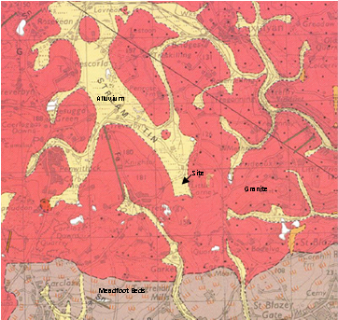  Eden Project geothermal site | 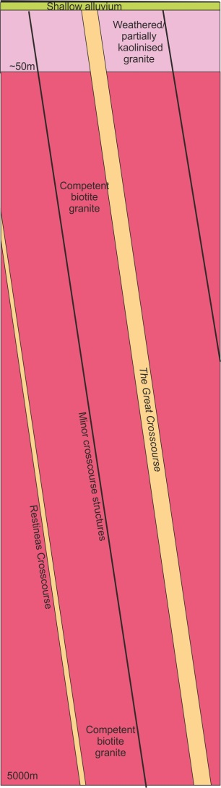
Geological plan, with The Great Crosscourse superimposed, and an inferred section

From the Geological Survey of Great Britain, (1:50,000 Geological Map of Bodmin, Sheet 347) the site is shown to be underlain (in sequence) by alluvium comprising silty clays, sands, gravels and peat overlying the St Austell Granite.

The granite in the vicinity of the site is medium to coarse grained (megacrystic) biotite granite. The granite is expected to contain feldspar megacrysts (15 - 20 mm size) in a coarse-grained matrix of alkali feldspar, plagioclase, biotite, quartz and white mica. The main component of the granite, from near surface data, at the Eden Project is quartz (~ 34 %), alkali-feldspar (~ 32 %), plagioclase (~ 22 %), biotite (~ 6 %), muscovite mica (~ 4 %) and primary tourmaline (1 %) and other minerals (1 %). With depth there are likely to be changes in grain size and mineral composition, perhaps with the granite becoming finer grained with depth. Surface mapping in the wider region shows variations in the composition of the granites which probably reflect a multi-phase intrusion history.

The Eden Project is centred in a former china clay pit. A characteristic of the St Austell Granite is the extensive ‘kaolinisation’ that occurs, principally in the lithium-mica granite to the west, which is less prevalent in the biotite granite. Kaolinisation is the alteration and degradation of the granite comprising a process of hydrolysis accompanied by removal of alkalis and silica. Ground investigations to a depth of 50m have proven highly weathered (kaolinised – Grade V) and saturated granite between surface and a depth of 25 m beneath the drill site. The formation is expected to become more competent below this depth, but further zones of weathering beneath this are likely.

The groundwater aquifer appears to be in hydraulic connection with the overlying superficial deposits, with groundwater levels at the site recorded between 2 and 4m below ground level.

Several types of veins containing varying assemblages of quartz, tourmaline and other minerals occur in the St Austell Granite, of which greisen bordered quartz-tourmaline veins are the most common type. The veins, often 1 - 2 m in width, occur in clusters, usually parallel to subparallel, with a dominant ENE - WSW strike and steeply dipping between 60 - 90°. Dip directions towards the north seem to be slightly more common than those to the south. Some relatively minor deposits of metalliferous minerals, chiefly iron and tin, have been mined underground to shallow depth only. The nearest recorded mine is a shallow tin working approximately 500 m to the south of the site.

It is suggested that the main kaolin deposits may be associated with near vertical faults (locally named crosscourses) that strike through the granite in a NNW - SSE direction. These crosscourses are likely to have formed the fluid pathways for the downward migration of meteoric water and subsequent granite alteration. Some of the crosscourses are historic wrench faults, several 10s of metres wide, whereas many of the minor crosscourses are only 1 to 2 metres in width with a relatively short length. It is anticipated that such structures will extend to great depth and will form the target zone for the development of the EGS ‘reservoir’ at a depth of 4 to 5 km.

The compressive strength of the granite varies from location to location and is dependent on a number of geological factors, such as modal composition, degree of weathering and density. The uniaxial compressive strength of the granite at the Rosemanowes site (at a depth of 2.0 - 2.5 km) was found to be 135 MPa. A recent study has shown values for Grade 2 St Austell Granite (with a density of 2,640 kg/m³) of 120 - 180 MPa; for Grade 3 granite (density of 2,450 kg/m³) of 40 - 60 MPa; and for Grade 4 granite (with a density of 2,200 kg/m³) of 10 - 20 MPa. However, the unconfined compressive strength values of 257 MPa were found in fine-grained granite at Geevor Mine, near Land’s End.

Temperature and Stress Regime

Heat flow values on or close to the Cornish granite are typically 120 mW/m², whereas away from the granite the values are approximately 60 mW/m². The modelling indicates the geothermal gradient in the vicinity of the Eden Project to be 35 - 40°C/km. This equates to a rock temperature of approximately 90°C at a depth of 2,000 m (TVD); approximately 160°C at 4,000 m (casing shoe); and 170 - 190°C at a depth of 4,500 m (target zone).

Evidence has shown that deep wells in the Cornish granite are exposed to hydrostatic conditions, with no zones of overpressure. Typical hydrostatic gradients for water lie in the range of 1.00 - 1.15 g/cm3 (0.433 - 0.500 psi/ft). At shallow depth the fracture gradient (the pressure required to induce fractures in rock at a given depth) relates to the vertical stress, but below a depth of approximately 300 m it is governed by the components of in-situ horizontal stress. Stress measurements in the 2,500 m deep geothermal wells at the former Hot Dry Rock Project, situated approximately 30 km to the southwest of Eden, and at other shallower sites in Cornwall, provide data that enables prediction of the in-situ stress regime at a depth of 5 km with a relative degree of confidence. It is anticipated that the granite will be fractured at depth and that the fluid encountered within the granite could be saline.

Target Structure

The target for the first well is a NNW-SSE coursing fault, named The Great Crosscourse, within the southeast periphery of the exposed St Austell Granite mass. This type of large crosscourse structure is a major wrench fault with a strike length of several 10s of kilometres, traversing the granite pluton. There is considerable uncertainty about the precise location and characteristics of The Great Crosscourse at a target depth of 4,500 m. The main structure is likely to be characterised by ramifying networks of intense microfractures and quartz veins. The fault zone is likely to contain a number of discrete and complex fault planes with splay faults some of which may be oriented at a low or even high angle to the main fault zone trend. The dip angle of the fault is expected to be near vertical, i.e. about 80 - 85° down to the ENE. The width of the fault is not well recorded; at one location the main structure is recorded to be ~ 45 meters wide. Generally fault structures of this type can comprise a zone of disturbed ground >100 meters wide, but this zonal width is likely to become narrower with increasing depth.

Observations and mapping of joints and strucutres from wells up to 2500 m depth at the Rosemanowes site showed that major faults/structures were dipping around 80° east.

Appendix B - EGL Supplier Terms and Conditions

Taken together with Part C, and Schedules 3 and 4 as submitted by the successful bidder, these Terms and Conditions will form the contract between EGL and the chosen Contractor.

- Definitions

Term | Meaning
Eden Geothermal / EGL / We / Us / Our | Eden Geothermal Limited (Company No. 10216419)
Supplier / You / Your | the person, firm or company to whom the Purchase Order is addressed
Goods or Services | the materials and/or services described in the Purchase Order
Purchase Order | the Purchase Order placed by Eden Geothermal Ltd on the Supplier for the purchase of the Goods or Services
Contract | the contract for the sale and purchase of Goods and/or services
Purchase Order amendment / variation | our authorised Purchase Order amendment or series of Order amendments each having precedence over any earlier amendment

- The Contract

This Purchase Order constitutes the EGL’s offer to the Supplier and shall become a binding Contract on the terms and conditions set out below upon acceptance by the Supplier by commencing performance of the Contract.

In many cases there will be a separate written contract between EGL and the Supplier signed by both parties which will govern the terms of supply. Where such a contract exists then EGL’s Purchase Order will support that contract and the terms and conditions in that agreement will take precedence.

Representations made by the Supplier in arriving at the contract may form part of the contract. Formal representations may take the form of a tender or quote. Less formal representation may come from details supplied in a letter or email giving information on product quality, durability, performance, lead times etc. It is the duty of the supplier to inform EGL if any of the circumstances change.

All other terms and conditions of Contract are excluded and all these general conditions shall apply to the Contract unless modified with EGL’s prior written consent.

Where you believe that there is an error in the Purchase Order you must ask EGL to correct the Purchase Order before the goods or services are supplied.

- Price

The agreed price for each item is specified in the Purchase Order. Such prices which will not be subject to fluctuation irrespective of the time of delivery of the Goods or Services.

The Purchase Order must show any applicable charges for packaging, storage, insurance, delivery, installation and commissioning.

All prices will be shown on the Purchase Order excluding VAT, and in Sterling (£GBP) unless otherwise agreed by EGL.

- Quality and Description

The Goods or Services shall:
- conform in every respect with the provisions of the Contract;
- be capable of all standards of performance specified in the Contract;
- be fit for any purpose made known to you expressly or by implication and in this respect we rely on Your skill and judgement;
- be new (unless otherwise specified on the Purchase Order) and be of sound materials and skilled and careful workmanship;
- correspond with their description of any samples, patterns, drawing, plans and specifications referred to in the Contract;
- be of satisfactory quality;
- comply with any current legislation.

Unless specifically required under the Contract, there shall be no asbestos content in the Goods.

- Purchase Order Amendments/Variations

EGL will have the right, before delivery, to amend or vary the Contract in writing, if this Purchase Order amendment/variation will cause a change to the price or delivery date then you must suspend performance of the Contract and notify EGL without delay, and notify EGL of the new price and delivery date. Following our receiving such notice you must allow us at least 10 working days to consider any new price and delivery date. The Purchase Order amendment/variation shall only take effect when EGL’s authorised Officer accepts in writing the new price and delivery date within the period you stipulate. If EGL’s authorised Officer fails to confirm the Purchase Order amendment/variation within the period you stipulate, then performance of the Contract shall immediately resume as though the said Purchase Order amendment/variation had not been issued (except that we will still exercise our right of cancellation in accordance with Condition 5).

- Work on our Premises

If the Contract involved any works or services that you perform on our Premises then the following conditions shall apply:
- You shall ensure that you and your employees, your sub-contractors and their employees and any other person associated with you, will adhere in every respect to the obligations imposed on you by current safety legislation. EGL’s Health and Safety Policy is available upon request;
- You shall ensure that you and your employees, your sub-contractors and their employees are adequately trained and qualified for the work being carried out;
- You shall ensure that you and your employees, your sub-contractors and their employees and any other person associated with you will comply with any regulations that we may notify to You in writing;
- You shall ensure that there is the minimum amount of disruption to our business;
- You shall ensure that if any damage is sustained to our Premises as a result of your performance of the Contract then you will forthwith reinstate the damaged part or parts of the premises to their previous condition or offer reasonable compensation. Such reinstatement is to be subject to our final approval;
- You shall ensure that you have all appropriate insurances in place such as Employer’s Liability and Public Liability.

- Progress and Inspection

You shall at your expense provide any programme of manufacture and delivery that we may reasonably require. You shall notify us without delay in writing if your progress falls behind or may fall behind any of these programmes.

We shall have the right to check progress at your works, or at the works of subcontractors, at all reasonable times, to inspect and reject Goods that do not comply with the Contract. Your sub-contracts shall reserve such right for us.

Any inspection or approval shall not relieve you from your obligations under this Contract.

- Safety

You shall observe all legal requirements of the United Kingdom, European Union and relevant international agreements in relation to health, safety and the environment and in particular to the marking of hazardous Goods, the provision of data sheets for hazardous materials and all provisions relating to food.

- Delivery

The goods shall be properly packed, secured and despatched at your expense to arrive in good condition at the time or times and the place or places specified in the Contract.

If you or your carrier delivers any Goods at the wrong time or to the wrong place then we may deduct from the price any resulting costs of storage or transport.

- Late Delivery

If the Goods or Services or any part of them are not delivered by the time or times specified in the Contract then we may by written notice cancel any undelivered balance of the Goods. We may also return for full credit at your expense any Goods that in our opinion cannot be utilised owing to this cancellation.

In the case of services, we may have the work performed by alternative means and any additional costs reasonably so incurred shall be at your expense. This shall not affect any other rights that we have.

- Acceptance

We shall have the right to reject the Goods in whole or in part whether or not paid for in full or in part within a reasonable time of delivery if they do not conform to the requirements of this Contract. It is agreed that we may exercise the right of rejection notwithstanding any provision contained in the Sale of Goods Act 1979, Section 11 or Section 15A or Section 30 (Subsections (2A) and (2B)) or Section 35. We shall give you a reasonable opportunity replace the Goods with new Goods, that conform with this Contract, after which time we shall be entitled to cancel the Purchase Order and purchase the nearest equivalent Goods elsewhere. In the event of cancellation under this condition you shall promptly repay any moneys paid under the Contract without any retention or offset whatsoever.

You must collect all rejected Goods within a reasonable time of rejection or we shall return them to you at your risk and expense.

- Packages not returnable
Unless otherwise stated in the Contract, all packages shall be non-returnable. If the Contract states that the package is returnable, you must give us full disposal instructions before the time of delivery. The packaging must be clearly marked to show to whom it belongs. You must pay the cost of all carriage and handling for the return of the packaging. We shall not be liable for any package lost or damaged in transit.

- Our Right of Cancellation

In addition to EGL’s other rights of cancellation under this Contract, we may cancel the Purchase Order and any Purchase Order amendment/variation thereto at any time by sending you a notice of termination. You will comply with any instructions that we may issue with regard to the Goods.

If you submit a termination claim then we will pay you the cost of any commitments, liabilities or expenditure that in our reasonable opinion were consequences of this Contract at the time of termination. The total of all payments made or due to you under this Contract, including termination payment shall not exceed the price. If you fail to submit a termination claim within 3 months of the date of our notice of termination then we shall have no further liability under the Contract.

- Property and Risk

You shall bear all risks of loss or damage to the Goods until they have been delivered and shall insure accordingly.

Ownership of the Goods shall pass to us:
- When the goods have been delivered but without prejudice to our right of rejection under this Contract, and
- If we make any advance or stage payment, at the time such payment is made, in which case you must as soon as possible mark the Goods as our property.

- Invoicing and Credits

Your invoice must quote the full Purchase Order number and be addressed to the Company:
Eden Geothermal Ltd,
Bodelva,
Par,
Cornwall, PL24 2SG.
The invoice should display full details of the goods or services invoiced including quantities supplied and unit prices.

Where goods or services ordered are not all supplied at the same time it will be appropriate to have more than one invoice covering the Purchase Order.

You will be asked to issue a credit note in a number of circumstances, including;
- An invoice includes items not on a Purchase Order;
- The prices on the invoice do not agree to the Purchase Order;
- Goods have been returned;
- Goods or Services have not been supplied:
- Goods or Services are of inferior quality or damaged.

- Payment
Unless stated otherwise in the Contract we shall pay you on or about one month following the date of the invoice.

You will supply a statement of outstanding invoices on a monthly basis to enable us to ensure that our payments are complete.

We shall not be held responsible for delays in payment caused by your failure to comply with our invoicing instructions. Any credit notes that are due must be supplied before payments will be made.

In some cases EGL may agree to make interim or deposit payments to the supplier in the terms of the Contract. Any such payments made in advance of the supply of Goods shall be returned forthwith if the Contract is terminated for any reason other than by our default or in accordance with Condition 5.

- Right of Set Off

Whenever under the Contract any sums of money shall be recoverable from or payable by you, they may be deducted from any sums then due or which at any later time may become due to you under this Contract or under any other Contract You may have with us.

- Your Warranty

It is expressly agreed between us that:
- You shall promptly make good at your expense any defect in the Goods that we discover under proper usage during the first 12 months of actual use or 18 months from the date of acceptance by us whichever period shall expire first. Such defects may arise from your faulty design, your erroneous instructions as to use or inadequate or faulty materials or poor workmanship or any other breach of your obligations whether in this Contract or at law.
- Repairs or replacement will be covered by the above warranty but for a period of 12 months from acceptance by us.
- You will ensure that compatible spares are available to facilitate repairs (where applicable) for a period of at least 10 years from the date of delivery of the goods.

- Indemnity and Insurance

  - You shall indemnify us against all loss, actions, costs, claims, demands, expenses and liabilities whatsoever (if any) which we may incur either at common law or by statute in respect of personal injury to or death of any person or in respect of any loss or destruction of or damage to property (other than a result of any defaults or neglect of ourselves or of any person for whom we are responsible) which shall have incurred in connection with any work executed by you under this Contract or shall be alleged to be attributable to some defect in the Goods.
  - This Purchase Order is given on the condition that (without prejudice to the generality of Condition 19(a)) you will indemnify against all loss, costs, claims, demands, expenses and liabilities whatsoever (if any) which we may incur either at common law or by statute (other than as a result of any default or neglect of ourselves or of any person for whom we are responsible) in respect of personal injury to or death of any of your or our employees, agents, sub-contractors or other representatives while on our premises whether or not such persons are (at the time such personal injury or death are caused) acting in the course of their employment
  - You will indemnify us against all loss, costs, expenses and liabilities caused to us whether directly as a result of the action, claim or demand of any third party by reason of any breach by you of these conditions or of any terms or obligations on Your part implied by the Sale of Goods Act 1979, by the supply of Goods and Services Act 1982 or by any other statute or statutory provision relevant to the Contract or to Goods or work covered thereby. This indemnity shall not be prejudiced or waived by any exercise of our rights under Condition
  - You shall hold satisfactory insurance cover with a reputable insurer to fulfil your insurance obligations for the duration of this Contract including public liability insurance cover of at least £2m. You shall effect insurance against all those risks arising from your indemnity in Conditions 19(c). Satisfactory evidence of such insurance and payment of current premiums shall be shown to us upon request.

- Assignment and Sub-letting

The Contract shall not be assigned by you nor sub-let as a whole.

You shall not sub-let any part of the Contract without our written consent, but we shall not refuse such consent unreasonably. The restriction contained in this condition shall not apply to sub-contracts for materials for minor details or for any part of which the makers are named in the Contract.

You shall be responsible all work done and Goods supplied by all subcontractors.

- Articles on loan

All tools, materials, drawings, specifications and other equipment and data (“the Articles”) loaned by us to you in connection with the Contract shall remain always our property and be surrendered to us upon demand in good and serviceable condition (fair wear and tear allowed) and are to be used by you solely for the purpose of completing the Contract.
You agree that no copy of the articles will be made without the consent in writing of our authorised officer.

Until you return all the articles to us they shall be at your risk and insured by you at your expense against the risk of loss, theft or damage. Any loss of or damage to such articles shall be made good by you at your expense.

All scrap arising from the supply of such articles must be disposed of at our discretion and all proceeds of sales such as scrap must promptly be paid to us in full.

- Data Protection

Any information derived from our property or otherwise communicated to you in connection with the Contract shall be kept secret and confidential and shall not without the consent in writing of our authorised officer, be published or disclosed to any third party, or made use of by you except for the purpose of implementing the Contract.

- Ownership of Results

If the Contract involves design and/or development work:
  - All rights in the results of work arising out of or deriving from this Contract, including interventions, designs, copyright and knowledge shall be our property and we shall have the sole right to determine whether any letters patent, registered design, trademark and other protection shall be sought.
  - You shall promptly communicate to us all such results and shall if requested and at our expense do all acts and things necessary to enable us or our nominee to obtain letters patent, registered designs and other protection for such results in all territories and to assign the same to us or our nominee.
  - You shall ensure that all technical information (including computer programmes and programming information) arising out of or deriving from this Contract is held in strict confidence except for any such information that becomes public other than by breach of this Contract.

- Infringement of Intellectual Property Rights

With the exception of Goods made to our design or instructions, you warrant that neither the Goods nor our use of them will infringe any patent registered design trade mark copyright or other protected right and undertake to indemnify us against all actions claims demands costs charges and expenses arising from or incurred by reason of any infringement or alleged infringement of any such right.

- Integrity

We are committed to acting professionally, fairly and with integrity in all our business dealings and relationships wherever we operate. We take a zero-tolerance approach to bribery and corruption and are committed to implementing and enforcing effective systems to counter bribery.

We will award contracts to suppliers based upon our assessment of quality, price, sustainability and any other factors that we deem appropriate. In many cases our procedures will need to follow procurement regulations laid down by the UK Government or the European Commission. We will not accept facilitation payments or "kickbacks" of any kind, or allow bid rigging of any kind.

You may only make a gift or offer hospitality to the company, staff or agents if the specific conditions set out as acceptable in the EGL Anti-Corruption and Bribery Policy are met. Payments of cash or cash equivalents are not acceptable.

In the event of any breach of this Condition, we shall, without prejudice to any other rights we may possess, be at liberty forthwith to terminate this and any other Contract and to recover from you any loss or damage resulting from such termination.
Our Anti-Corruption and Bribery Policy is available upon request.

- Non Observance of Condition

If you breach or fail to observe any provision of this Contract we may give you written notice of such breach or non-observance and you shall have 28 days from receipt of the notice in which to rectify the breach or non-observance. Should you fail to rectify the breach or non-observance, then we shall have the right to give you written notice terminating the contract with immediate effect.

- Waiver

A failure at any time to enforce any provision of the Contract shall in no way affect the right at a later date to require complete performance of the Contract; nor shall the waiver of the break of any provision be taken or held to be a waiver of any subsequent breach of the provision or be a waiver of the provision itself.

- Matters Beyond Control

If either party is delayed or prevented from performing its obligations under this Contract by circumstances beyond the reasonable control of either party (including without limitation any form of Government intervention, strikes and lock-outs relevant to the Purchase Order or breakdown of plant) such performance shall be suspended, and if it cannot be completed within a reasonable time after the due date as specified in the Purchase Order then the Contract may be cancelled by either party.

We shall pay to you such sum as may be fair and reasonable in all the circumstances of the case in respect of work performed by you under the Purchase Order prior to cancellation but only in respect of work performed by you under the Purchase Order prior to cancellation but only in respect of work for which we have received full benefit as originally contemplated in the Contract.

This provision can only have effect if it is called into operation by the party wishing to rely on it giving written notice to the other to that effect.

- Your Insolvency

If you suffer the making of Interim Order or a petition is presented or an Order is made for you to become insolvent or you make an arrangement with your creditors or have an administrator or an administrative receiver or a receiver and manager appointed of the whole or any part of your undertaking property or assets or a petition is presented or an order is made or a resolution is passed or analogous proceedings are taken for you to be wound up (save for the purpose of reconstruction or amalgamation without insolvency and previously approved in writing by us) or any distress or execution is levied upon any of your Goods or property, we may, without replacing or reducing any other of our rights, terminate the Contract with immediate effect by written notice to you or any person in whom the Contract may have become vested.

- Notice

All notices and communications required to be sent by you or us in this contract shall be made in writing and sent by first class mail and if sent to you sent to your registered or head office, and if sent to us sent to the Finance Director, Eden Geothermal Ltd, Eden Project, Bodelva, Par, Cornwall, PL24 2SG and shall be deemed to have reached the party to whom it is addressed on the next business day following the date of posting.

- Amendment
No addition, alteration or substitution of these conditions will bind us or form part of the Contract unless and until accepted in writing by our authorised officer.

- Law

This Contract shall be subject to English Law and the parties submit to the non-exclusive jurisdiction of the English Courts.

- Eden Geothermal Policy Documents
Upon request we will supply our policy documents which include:
- Procurement Policy
- Sustainability Policy
- Health and Safety Policy
- Anti-Corruption and Bribery Policy

- General
If at any time one or more of the Clauses (or any paragraph, sub paragraph or any part thereof) is held to be or becomes void or otherwise unenforceable for any reason under any applicable law, the same shall be deemed omitted from these conditions and the validity and/or enforceability of the remaining provisions of these Clauses shall not as a result of such deemed omission in any way be affected or impaired.

The Terms and clauses contained in these Conditions together with such other terms as are expressly incorporated in them by reference or otherwise agreed in writing by you and us shall together constitute the entire agreement between you and us relating to the purchase of the Goods and Services and there shall be deemed to be incorporated and merged in such agreement any and all statements, representations promises, undertakings and warranties by or on behalf of and the parties of whatsoever nature and when so ever made.

Nothing in this clause shall, however, operate to limit or exclude any liability for fraud.

