Eden Geothermal Limited
The Eden Project
Bodelva
Par
PL24 2SG

Tel: +44 (0)1726 806545
E: tenders@edengeothermal.com

Date: 1st October 2020

INVITATION TO TENDER
Dear Sir/Madam

Project | Eden Geothermal Project
Tender Name | Directional Drilling Services and Rental Items for Drilling a Geothermal Well
Tender reference | EGL-ITT-C047

You are invited to submit a competitive tender for directional drilling services for a project co-funded by the European Regional Development Fund.

Please submit your proposal in full no later than:
Monday 9th November 2020 at 16:00 hours

Except under exceptional circumstances, no extension of time and date by which the tender must be submitted will be granted. Late submissions will not be accepted.

Any query in connection with this tender or the invitation to tender shall be submitted in writing (by email) to tenders@edengeothermal.com by:

Tuesday 27th October 2020 at 12:00 hours

We look forward to receiving your submission.

Yours faithfully

Augusta Grand
Executive Director

This page is intentionally blank

Invitation to Tender:

Directional Drilling Services and Rental Items for Drilling a Geothermal Well

Project | Eden Geothermal Project
Tender reference | EGL-ITT-C047
Revision | Ver 2.0
Release Date | 1st October 2020
Issuer | Eden Geothermal Limited (“EGL”)
Supplier Response Date | 9th November 2020 at 16.00

Contents

PART A: INSTRUCTIONS TO TENDERERS

1 Instructions for Completion | 6
1.1 Submission Details | 6
1.2 Enquiries and Tender Queries | 7
1.3 Format of Tender Submission | 7
1.4 Project Description | 7
1.5 Outline of Requirements | 8
1.6 Validity Period | 8
1.7 Form of Contract | 8
1.8 Financial Terms | 8
2 Timetable | 9
PART B: PROJECT DESCRIPTION

3 The Project | 10
3.1 Background | 11
3.2 Location | 12
PART C: TECHNICAL REQUIREMENTS AND SPECIFICATIONS

4 Technical Requirements | 14
4.1 Technical Directional Programme and Drill String Elements | 14
PART D: RETURN OF TENDER  5 Tender Completion Documentation | 16
5.1 Company Information | 17
5.2 Technical Submission | 18
5.3 Commercial Submission | 19
5.4 Commercially Sensitive Information | 19
PART E: EVALUATION PROCESS  6 Evaluation Process | 20
6.1 Company Information | 21
6.2 Technical Evaluation  6.3 Commercial Evaluation  6.4 Total Score  6.5 Clarification  6.6 Award and Notification | 21  22  23  23  23

Contents continued
PART F: CONDITIONS
7 Conditions | 24
7.1 Confidentiality and Freedom of Information | 24
7.2 Language | 24
7.3 Applicable Law | 24
7.4 Additional Costs | 24
7.5 Costs | 25
7.6 Right to Cancel or Vary the Process | 25
7.7 Inducements | 25
7.8 Disclaimer | 25
PART G: SCHEDULES (TENDER SUBMISSION TEMPLATES)
Schedule 1a: Company Information  Schedule 1b: Economic and Financial Standing | 26  27
Schedule 1c: Legal Matters and Disputes | 28
Schedule 1d: Grounds for Mandatory Exclusion | 29
Schedule 1e: Other Grounds for Exclusion | 31
Schedule 1f: Insurance Cover | 33
Schedule 1g: Equality and Diversity | 34
Schedule 1h: Health and Safety | 35
Schedule 1i: Quality Assurance, Environmental Management Systems and Corporate and Social Responsibility | 36
Schedule 1j: Company Experience | 37
Schedule 2: Declarations | 39
Schedule 3: Technical Submission Form | 40
Schedule 4: Commercial Submission Form | 48
Schedule 5: Commercially Sensitive Information | 59
APPENDICES
Appendix A: Site Regulations  Appendix B: Well Summary EG-1  Appendix C: Drilling Design and Programme  Appendix D: Geology  Appendix E: Drilling Site Plan | 60  61  62  70  73
Appendix F: EGL Contract Terms and Conditions | 74

PART A: INSTRUCTIONS TO TENDERERS

1 Instructions for Completion

1.1 Submission Details
Eden Geothermal Limited is issuing this Invitation to Tender (ITT) for directional drilling services and rental items during geothermal drilling at the Eden Project in Cornwall, PL24 2SG, UK.

The Applicant will be required to submit a written proposal as part of the response, in the form set out. Applicants must submit their tenders as two separate sets of documents, to ensure separation of technical and commercial bids.

- Document set one: Company Information (Schedules 1a – 1j), Declaration (Schedule 2), and Technical Submission (Schedule 3); sent separately from
- Document set two: Commercial Submission (Schedule 4).

The Applicant should submit a signed electronic copy of the two sets of documents by email, quoting the contract title EGL-ITT-C047. Submissions should include any relevant appendices and be in PDF or read-only format. Tenders should be submitted to tenders@edengeothermal.com and must be received into the mailbox by the deadline of Monday 9th November 2020 at 16.00 hours. EGL recommends a maximum attachment file size of 20MB; tenderers may send their submission as several emails – provided Schedule 4/Commercial Submission is sent separately from other parts of the tender.
Emailed tenders will be received up to the time and date stated. Any tenders received before the due date will be retained unopened until then. It is the responsibility of the tenderer to ensure that their email copy tender is delivered not later than the appointed time. EGL reserves the right to not consider any tenders submitted after the deadline, in which event late bids will not be accepted.

In light of current UK government recommendations on working from home during the Covid-19 pandemic, EGL has suspended the requirement for hard copy tenders to be posted. Email only submissions are being accepted for this ITT.

Applicants may request extensions to submission deadlines with a valid reason, which may be accepted at the discretion of the Evaluation Panel of Eden Geothermal Limited. All other Applicants will be notified of any extension that is granted.

Applicants are advised that Eden Geothermal Ltd is not bound to accept the lowest price submitted, and will not reimburse any expense incurred by Applicants during the tendering process.

Any information relating to Eden Geothermal Ltd and supplied by Eden Geothermal Ltd in relation to this project shall be retained by the Applicant in strictest confidence.

1.2 Enquiries and Tender Queries
Please register your interest by emailing the address below, quoting the tender reference number EGL-ITT-C047.

Send all enquiries by email, by the deadline stated at Section 2, quoting the tender reference printed at the front of this document (EGL-ITT-C047) to:

tenders@edengeothermal.com

Bidders shall provide a single point of contact in their organisation. Eden Geothermal Ltd shall not be responsible for contacting the bidder through any route other than the nominated contact. The bidder must therefore undertake to notify Eden Geothermal Ltd of any changes relating to the point of contact.

Applicants are advised that, where Eden Geothermal Ltd considers appropriate, a copy of any such enquiries will be distributed to all Applicants along with the response, although the original Applicant’s identity will remain confidential. Applicants will only receive the response if they have registered their interest.

1.3 Format of Tender Submission
Applicants must provide the following:
- Company Information – Schedules 1a to 1j inclusive
- Declarations – Schedule 2
- Technical submission – Schedule 3
- Commercial submission – Schedule 4 (submitted separately)

1.4 Project Description
There is a description of the project in Section 3, with additional technical background information in Appendices B-E.

1.5 Outline of Requirements
The directional drilling contractor selected will be required to perform directional drilling services and provide rental items during drilling operations.

The detailed description and scope of directional drilling services to be supplied is set out in Part C. The directional drilling services have been divided into four sections, referring to the well sections. EGL will only consider submissions that cover all four sections.

Please note:
      - All relevant HSE documents and certificates should be provided by the bidder with the tender response.
- The bidder must demonstrate their ability to perform directional drilling operations on large land rigs (> 300 tons). Satisfactory references for at least three operations will be required to pass Schedule 1j and to proceed to full technical and commercial evaluation (Schedules 3 and 4).
- At the Eden Geothermal site, drilling will be almost solely in granite. The bidder will need to demonstrate their ability to directionally drill in granite or similar crystalline rock, with an emphasis on drilling in hot wells. Satisfactory references for at least three operations will be required to pass Schedule 1j and to proceed to full technical and commercial evaluation (Schedules 3 and 4).

The detailed description and scope of directional drilling services to be provided is set out in Part C.

1.6 Validity Period
Tenders must remain valid for acceptance for a period of 90 days from the Tender Return Date.

1.7 Form of Contract
The contract between EGL and the successful bidder will be LOGIC, General Conditions of Contract For Services On and Off Shore, Edition 4, February 2019, a copy of which are attached as Appendix F, together with the following parts of this document:
- Part C (Technical Requirements and Specifications)
- Schedules 3 and 4 as submitted by the successful bidder

1.8 Financial Terms
All prices will be fixed, exclusive of VAT and inclusive of all other taxes and duties.

2 Timetable

This procurement will follow a clear, structured and transparent process at all times, to ensure that all Applicants are treated equally. The key dates for this procurement (timetable) are as follows:

Process | Date
Issue of Tender | Thursday 1st October 2020
Closing date for clarification questions | 12:00 hours Tuesday 27th October 2020
EGL to respond to clarification questions | Monday 2nd November 2020
Tender return date | 16:00 hours Monday 9th November 2020
Award decision communicated to the winning tenderer | Monday 30th November 2020
Notify unsuccessful tenderers | Monday 30th November 2020
Expected contract award date | Friday 11th December 2020
Expected contract start date | Friday 18th December 2020
Expected programme start | February 2021
Expected contract completion date | June 2021

Date set for the receipt of bids at Eden Geothermal Ltd: Monday 9th November 2020 at 16:00.

PART B: PROJECT DESCRIPTION

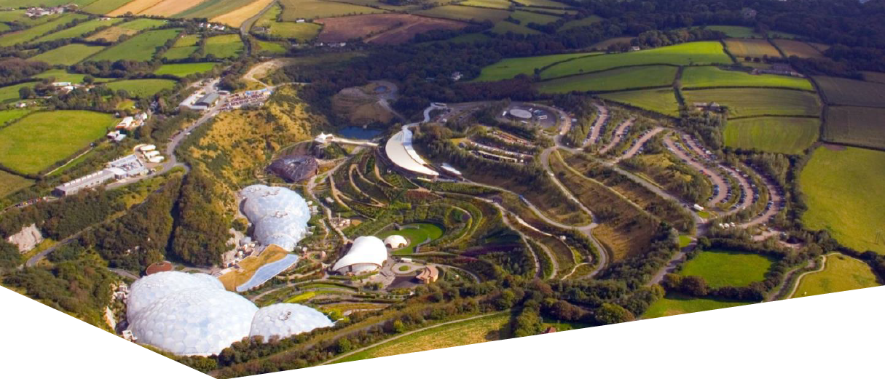
3 The Project

The Eden Geothermal Project is run by Eden Geothermal Ltd (EGL), an SPV set-up to manage and implement the development of a deep geothermal energy plant at the Eden Project, Cornwall PL24 2SG. Funding is in place and planning permission has been obtained.
The ultimate aim of EGL is to develop a two-well deep geothermal system that will produce both direct heat and power, some of which will provide direct supply to the Eden Project, with the remainder being exported.

This will be achieved by drilling two boreholes - a production and an injection well - to a vertical depth of approximately 4500 m and into a known fault into the granite beneath Eden. The temperature at that depth is expected to be in the range of 170 - 190°C. Superheated water brought to surface in the production well will be used to generate electricity and provide heat, and then, being cooled off, will be returned to the fault via the injection well.

With an anticipated gross electric capacity of around 7 MW_{e} and the ability to generate around 90% of the time, the Eden Geothermal Plant could produce enough electricity to supply the Eden Project and around four to five thousand households, as well as heating for the biomes and greenhouses at the Eden Project - and potentially some district or industrial heating.

The project will be completed in two independent project phases. The first well and the associated test programme represent a self-contained project phase (co-financed by the European Regional Development Fund, Cornwall Council and private investment) with an emphasis on exploration. This project stage comprises (i) finalisation of design; (ii) site preparation & installation of infrastructure; (iii) drilling the first deep well; (iv) well/fault permeability testing; and (v) heat demonstration over a period of 12 months to satisfy ERDF outputs. This project phase is the focus of this Invitation to Tender for directional drilling services and rental items.

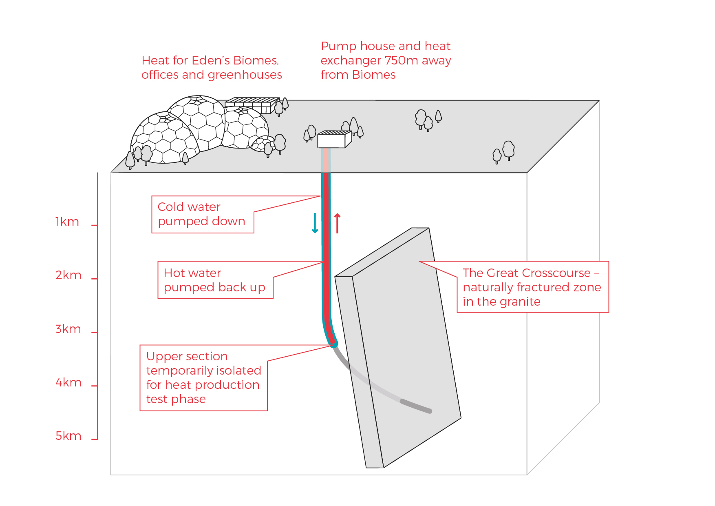
Phase 1 of Eden Geothermal Project

A successful first phase will pave the way for the drilling of a second well and the construction of the combined heat and power plant.

More detailed technical background to the project is available in Appendices B-E.

3.1 Background

Eden Geothermal Limited is a special purpose vehicle set up to develop the geothermal project at the Eden site. The project combines the famous Eden Project site with EGS Energy Ltd’s and BESTEC (UK) Ltd’s technical expertise and experience in the geothermal sector.

EGS Energy Ltd is a UK private limited company, incorporated in 2008 and established by Roy Baria and Guy Macpherson Grant to develop deep geothermal energy solutions in the UK. BESTEC (UK) Ltd is a UK private limited company incorporated in June 2012 and established by Jörg Baumgärtner to perform deep geothermal work in the UK in cooperation with BESTEC GmbH, an established specialist company in geothermal project development. Eden Project Limited is a wholly owned subsidiary of the Eden Trust, a registered charity in the UK, and runs the world famous Eden Project in Cornwall.

Eden Geothermal Limited has been allocated funding from the European Regional Development Fund and from Cornwall Council, together with private investment match funding, to undertake the first phase as an Industrial Research Project.

3.2 Location

The Eden Project is located approximately 2 - 3 km north-east of the town of St Austell in the southern part of Cornwall.

Access from mainland Europe by ferry:
Brittany Ferries maintains a route from Roscoff in Brittany, France to Plymouth (approximately 6 - 8 hrs sailing time).

Access by plane:
Newquay International Airport is located approximately 30 km from the Eden Project, around half an hour by car, via the A3059, A39, A30 and A391.

Access by train from London:
From Paddington Station, First Great Western runs trains to Cornwall which stop at all the principal stations throughout Cornwall including St Austell and Par.
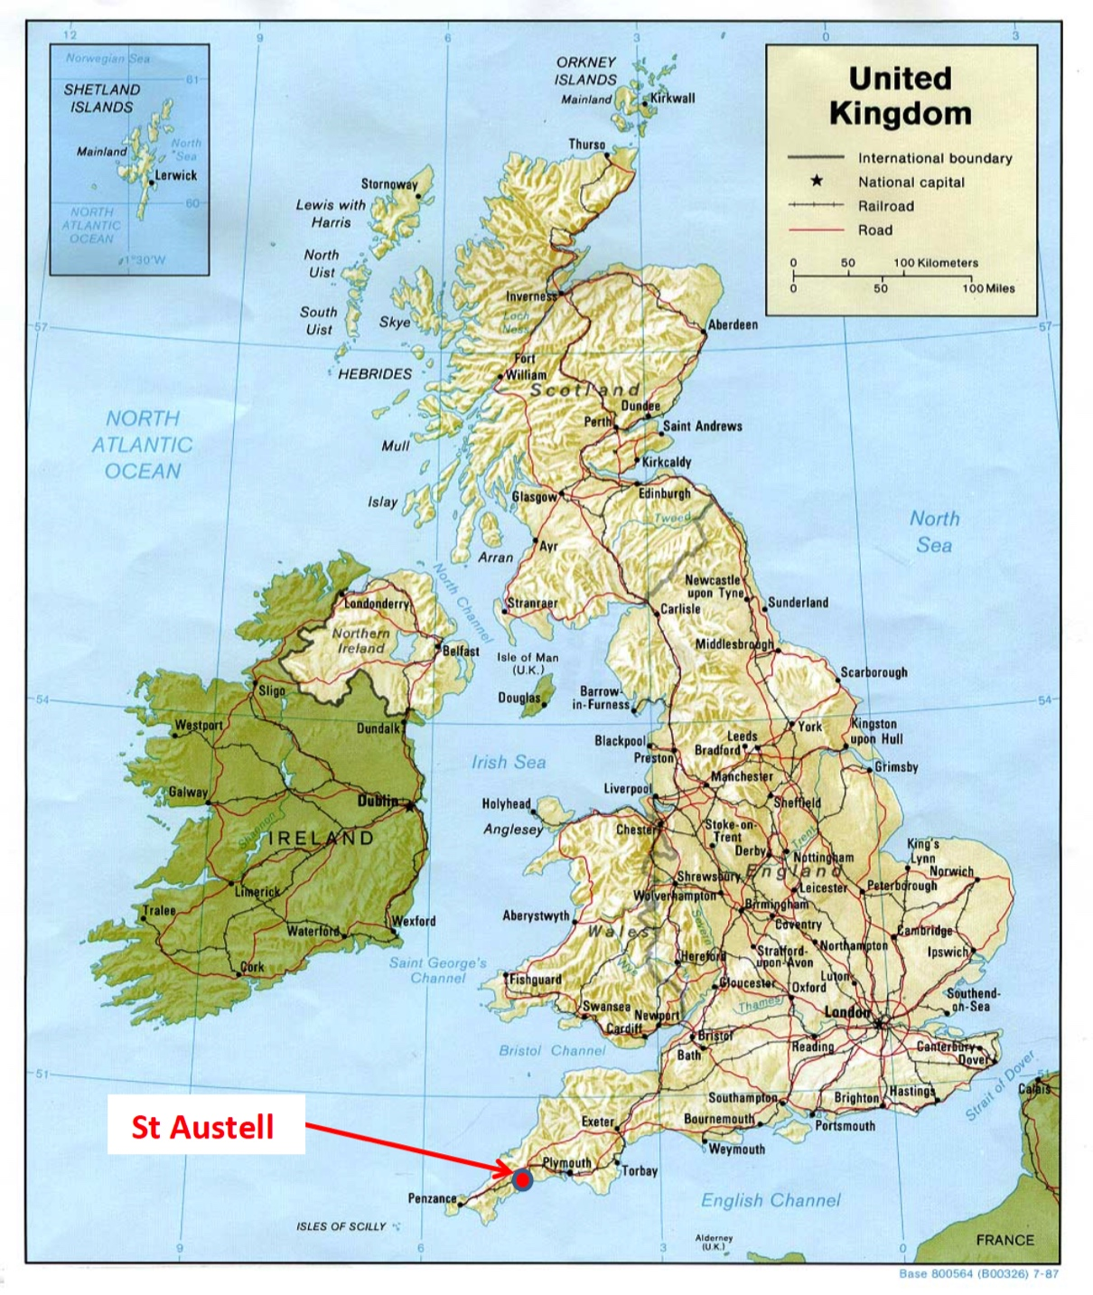

Access by car/van
The main route into Cornwall is via the M5 motorway to Exeter and either the A30 or the A38 trunk roads through Cornwall. The majority of the A30 is dual carriageway. The Eden Project is signposted from the A30.

The Eden Project is well connected by road, either (i) from the A30, via the A391; (ii) from Truro by the A390 (westbound); or (iii) from Plymouth by the A38 and A390 (eastbound). The road distance from Plymouth to St Austell is 26 miles or 42 km.

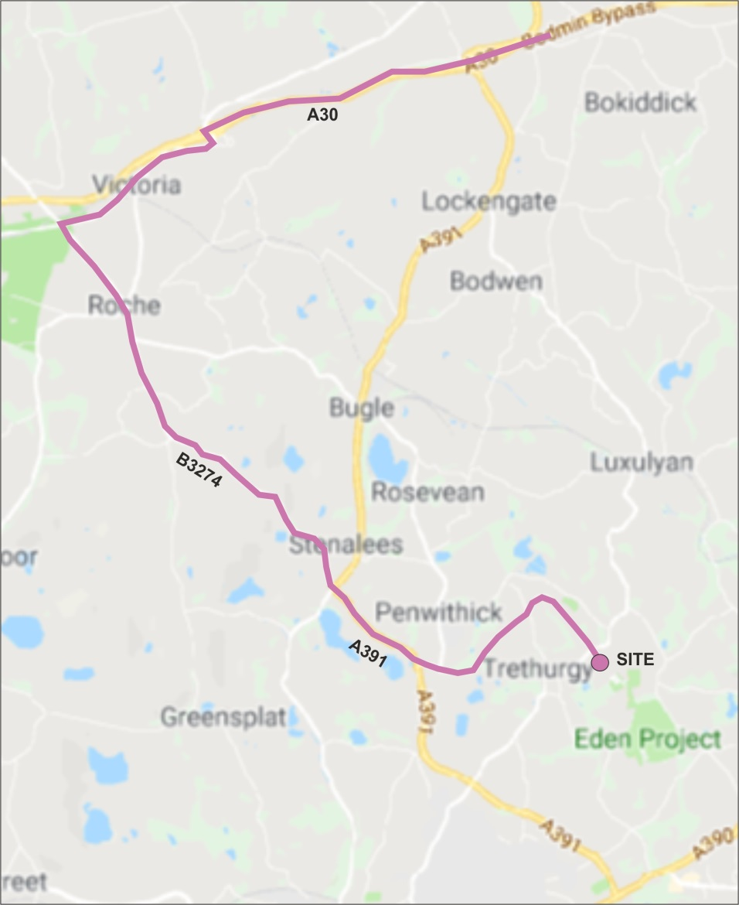
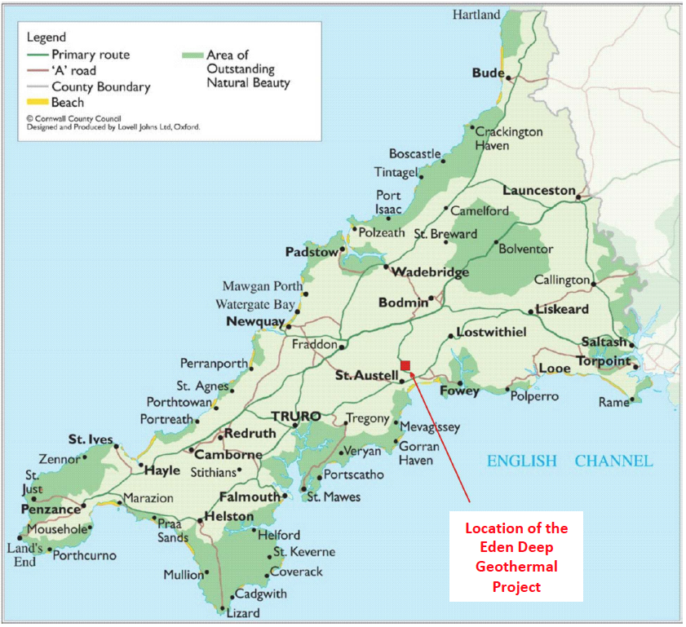

Access by truck/HGV
The recommended transport route for HGVs to and from the Eden Project is either:
- From the Innis Downs junction on the A30, taking the A391 through Bugle, Stenalees and Carluddon and onto the Eden Project; or
- From the Victoria Interchange on the A30, taking the B3274 through Roche and Trezaise to Stenalees, then the A391 to Carluddon and onto the Eden Project.

PART C: TECHNICAL REQUIREMENTS / SPECIFICATIONS

4 Technical Requirements
Eden Geothermal Ltd invites tenders for providing directional drilling services and rental items during drilling for Phase 1 of the Eden Geothermal Project. EGL’s requirements are set out in detail in the sections below. These should be read in conjunction with Schedule 3. The drilling design is provided in the Appendix C.

4.1 Technical Directional Programme and Drill String Elements

Section 1: 26" hole to +/- 300 m MD (vertical)

The 26" hole section will comprise 5 1/2" 24.7 lbs./ft. premium class drill pipe in S135. The BHA for this section of the hole will consist of:

- a downhole drilling motor (*), MWD telemetry and non-magnetic drill collar,
- a 9 ¹/₂" float sub with float,
- 24” (23 3/4”) stabilizer,
- 9 ¹/₂" shock tool,
- 9 ¹/₂" drill collars,
- 8” drill collars,
- 5 ¹/₂" HWDP,
- cross-overs and subs as required.

*) based on experience from a previous well in this formation. MWD for verticality.

Section 2: 17 ¹/₂" hole to 1,500 m MD (vertical)

The 17 ¹/₂" hole section will require 5 ¹/₂" 24.7 lbs./ft. premium class drill pipe in S135. The BHA for this section of hole will consist of:

- a downhole drilling motor, MWD (directional assembly) and non-magnetic drill collar
- a (8”) 8 ¹/₄" float sub with float,
- (8”) 8 ¹/₄" shock tool,
- (8”) 8 ¹/₄" drill collars,
- (8”) 8 ¹/₄” drilling jar,
- 6 ¹/₂” drill collars,
- ¹/₂" HWDP,
- 16 ³/₄" stabilizer or stab ring,
- cross-overs and subs as required.

According to availability and spares, the 9 ¹/₂" drill collars and the shock tool may be used too in this section as long as suitable stabilizers can be located in the correct size.

Section 3: 12 ¹/₄" hole to 4,000 m MD (directional, about 3,870 mTVD)

The 12 ¹/₄" hole section will require 5 ¹/₂" 24.7 lbs./ft. premium class drill pipe in S135. The BHA for this section of the hole will consist of:

- a downhole drilling motor, MWD (directional assembly) and non-magnetic drill collar,
- a (8”) 8 ¹/₄" float sub with float,
- (8”) 8 ¹/₄" drill collars,
- (8”) 8 ¹/₄” drilling jar,
- 5 ¹/₂" HWDP,
- at a minimum one 12” stabiliser or stab-ring,
- cross-overs and subs as required.

Section 4: 8 ¹/₂" hole to max. 5,260 m MD (about 4,880 m TVD)

The 8 ¹/₂" hole section will require a combination of 5" 19.5 lbs./ft. and 5 ¹/₂" 24.7 lbs./ft. drill pipe in S135. Inside the 8 ¹/₂” hole we recommend to use only 5” DP in order to allow for sufficient clearance around the tool joints. The up drag in the well will most likely be in the order of 30 to 50 tons by 5,000 m. The BHA for this section of the hole will consist of:

- a downhole drilling motor, MWD (directional assembly) and non-magnetic drill collar,
- a 6 ¾” (6 ⁵/₈”) float sub with float,
- 6 ¹/₂" drill collars,
- 6 ¹/₂" drilling jar,
- 8" stabilisers,
- 5" HWDP,
- cross-overs and subs as required.

If drag and torque become a problem in the lower intervals, the 6 ¹/₂" drill collars will be reduced accordingly and the drilling weight will be compensated with additional 5" HWDP.

PART D: RETURN OF TENDER

5 Tender Completion Documentation

This Section provides information to help Tenderers prepare their tenders. Applicants are advised to read all the documentation carefully to ensure that they are familiar with the nature and extent of their obligations should their tender be accepted.

The Applicant must complete and return all relevant documents as part of their Tender response. The tender return templates are contained in Part G:
- Company Information – Schedules 1a to 1j inclusive
- Declarations – Schedule 2
- Technical submission - Schedule 3
- Commercial submission – Schedule 4 (to be submitted separately).

Schedules 1, 2 and 3 may be submitted jointly but Schedule 4 must be submitted as a separate document.

It is the responsibility of the Applicant to inform EGL of any matter that may affect the Applicant’s qualification.

All Applicants must complete Schedules 1, 2, 3 and 4. Applicants must ensure that all questions are completed in full, in English, and in the format requested. Failure to do so may result in the submission being disqualified. Applicants are expected to supply all required information, or clearly state the reason for being unable to do so. Where the question does not apply, please state clearly ‘N/A’. Where the answer is a statement of fact, it must be accurate. It is the Applicant’s responsibility to ensure that EGL is not misled.

Any appropriate supporting documents (e.g.; maps, brochures, organisation charts, etc.) should be included as additional information. Please supply them as an Appendix. They should be numbered clearly and listed as part of your declaration. PDF is the only acceptable electronic file format. Any additional documents provided by the Applicant must refer to a specific item within the ITT and be easily identifiable as the answer to a particular question or set of questions.

Should the Applicant wish to propose a deviation from the specification, please ensure that this is clearly identified in the response where appropriate.

5.1 Company Information
5.1.1 Company Details
The Applicant must complete the details required in Schedule 1a. Where the Applicant is a consortium or partnership bidder, Schedule 1a must be completed by each member of the consortium or partnership.

5.1.2 Financial Matters
The Applicant is required to provide the information requested in Schedule 1b. In the case of a consortium or partnership bid, all members of the consortium or partnership should complete this information. This section may be used, in conjunction with credit reference agency checks if necessary, to gain a basic indication of the financial stability of the Applicant. The determination of the appropriate risk level will be proportionate and relevant to the size, value and nature of the specific contract being tendered. For this contract, EGL will wish to see Capital and Reserves in excess of 50,000 GBP. Where the company does not have the required level of reserves, we will accept parent company or personal guarantees to the same value. EGL reserves the right to undertake further independent financial checks, if it feels it important to do so. Financial responsibility cannot be shared. Consortium or partnership bids must state one of the members of the partnership as the Lead Applicant, which will be the financially responsible party.

5.1.3 Legal Matters, Disputes and Conflicts
EGL is obliged to consider certain legal and conflict matters that could affect the ability of the Lead Applicant, or its partners, to deliver the services required for this contract. Some of these matters would lead to a mandatory exclusion. The Lead Organisation and its partner organisations must complete answers to all the questions in Schedule 1c, 1d and 1e.

If the answer to any of the questions is ‘yes’, please provide full details and the steps taken as a consequence.

5.1.4 Insurances
For any Applicant to be successful, adequate insurance cover will be required. The minimum levels are indicated in Schedule 1f. The Lead Organisation, and any partners or consortium members, must complete Schedule 1f with the relevant information and confirm that the details entered are correct. If the Applicant does not currently have the required level of insurance, please confirm that it will have the cover required should it be awarded the contract. If the policy held is in the aggregate, the remaining cover must exceed the minimum requirements shown.

5.1.5 Equality and Diversity
The Lead Organisation must complete Schedule 1g confirming that their organisation and any partner or sub-contract organisation complies with its legal obligations under European law relating to equality and diversity.

5.1.6 Health &, Safety, Quality Assurance and Environment
The Applicant must supply a copy of all relevant Health and Safety, Environmental Management and Quality Assurance policies as requested in Schedules 1h & i. In the case of a consortium or partnership bid, the Health and Safety, Quality Assurance and Environment policies of the lead Applicant shall be submitted with the proposal and shall prevail.

5.1.7 Company Experience
The Applicant should provide details in Schedule 1j of up to three contracts which demonstrate the expertise and experience of the lead Applicant and any proposed partners or sub-contractors in relation to EGL’s requirements. References should be available for these contracts if possible.

5.1.8 Declaration
The Applicant (or each partner or member organisation in the case of a consortium bid) must complete the Declaration in Schedule 2.

5.2 Technical Submission
The detailed technical requirements for the contract are set out in Part C. The Applicant’s submission should take into account all relevant factors contained within this information, although EGL does not accept any responsibility for the accuracy or completeness of this information. Applicants must submit their bid based on the technical requirements described in Part C.

The Applicant must complete Schedule 3. Evidence should be provided to demonstrate:

- The experience, knowledge and skills of named personnel relevant to EGL’s requirements. In particular, the bidder should outline their personnel’s ability to perform directional drilling operations on large land rigs (> 300 tons) and their expertise in drilling operations in granite or similar crystalline rock, with an emphasis on high temperature environments.
- An appropriate methodology and approach, suitable for EGL’s requirements as set out in Part 4 and Schedule 3 of this document. This should include: a description of all equipment to be used; an explanation of what support will be provided in case of technical failure; details or training for personnel; any other information which the Applicant feels is relevant.

5.3 Commercial Submission
The Applicant is required to provide a total price for the contract (based on a programme of 150 days’ drilling) and a detailed price structure and breakdown for the services to be provided. On award of the tender, the breakdown and prices at Schedule 4 will, together with Part C of this document and the bidder’s Technical Submission at Schedule 3 and EGL’s Terms and Conditions, be the contract between EGL and the successful bidder. All prices will be quoted in pounds sterling and should exclude VAT. If some prices are only estimated at this stage, please make it clear which these are (excluding VAT).

Where applicable, EGL will pay any VAT incurred at the prevailing rate (currently 20%). If the VAT rate changes, EGL will pay any VAT incurred at the new rate. It is the responsibility of the Applicant to check their VAT position with HMRC before submitting a bid.

5.4 Commercially Sensitive Information
Please outline in Schedule 5 any items that the Lead Organisation or its partners consider to be genuinely Confidential and/or Commercially Sensitive and which should not be disclosed in respect of your Tender.

PART E: TENDER EVALUATION

6 Evaluation Process

This Section specifies the criteria to be used to determine the successful applicant and the requirements for the tenderer’s qualification to perform the contract.

All applicants must prepare separate technical and commercial bid documents.

Technical and commercial bids must be received by Eden Geothermal Ltd
in separate PDF files (email submission only), each quoting the tender number in the title.

All bids will be impartially evaluated against the same criteria by an ‘Evaluation Panel’ on behalf of Eden Geothermal Limited.

The evaluation process will be conducted in a manner that ensures tenders are evaluated fairly to ascertain the most technically and economically advantageous tender. Each tender submission will be evaluated only on the information that is provided by the Applicant. Tenders may be rejected if the information asked for in the ITT and Specification is not given at the time of tendering.

Technical documents and bids will be restricted to the members of the Evaluation Panel, which has full power to make decisions on behalf of Eden Geothermal Limited. The evaluation will be carried out by the Evaluation Panel in distinct sections, with weightings applied where appropriate:

Title | Evaluation Method
Company Information (Schedule 1) | Pass / Fail
Declarations (Schedule 2) | Pass / Fail
Technical Criteria (Schedule 3) | 50%
Commercial Criteria (Schedule 4) | 50%

6.1 Company Information

The Company Information will be evaluated first and Applicants will be required to pass this stage before their Tenders are evaluated on the basis of their technical and commercial submission.

Ten criteria will be used to evaluate tenders, each being scored on a pass or fail basis. Applicants must pass all criteria to proceed to the remainder of the evaluation. The criteria are:
  - Company Information – Schedule 1a
  - Economic and Financial Standing – Schedule 1b
  - Legal Matters – Schedule 1c
  - Grounds for Mandatory Exclusion – Schedule 1d
  - Other Grounds for Exclusion – Schedule 1e
  - Insurance – Schedule 1f
  - Equality and Diversity – Schedule 1g
  - Health & Safety – Schedule 1h
  - Quality Assurance and Environmental Management Systems – Schedule 1i
  - Company Experience – Schedule 1j

The Company will be evaluated as follows:

Schedules 1a and 1b will be reviewed separately. The review of the Applicant’s submission will only proceed to the remainder of Schedule 1 and Schedule 2 where the reviewer deems that the Applicant has passed these sections.

EGL will exclude any Applicant who answers ‘Yes’ in any of the situations in Schedule 1d, and may also exclude any Applicant who answers ‘Yes’ in any of the situations in Schedule 1e.

If the Applicant is made up of a Lead Organisation and other organisations who have jointly entered into a consortium, joint venture or other contracting arrangement, each of the organisations must pass all the criteria in order for the Tender to proceed to the remainder of the evaluation.

6.2 Technical Evaluation
Only Applicants that have passed the evaluation of Company Information will have their technical bids evaluated by the Evaluation Panel.
The technical submission should demonstrate the Applicant’s expertise and capability to provide directional drilling services in accordance with the technical requirements and specifications set out in Part C and Schedule 3.
The quality of the technical submission will be scored in accordance with the Scoring Matrix shown below:

5 Excellent Extremely good demonstration of relevant ability, understanding, experience, skills, resources and quality measures required to provide the services, with full evidence provided to support this.
4 Good Above average demonstration of the relevant ability, understanding, experience, skills, resource and quality measures required to provide the services, with a majority of evidence provided to support this.
3 Acceptable Satisfactory demonstration of the relevant ability, understanding, experience, skills, resources and quality measures required to provide the services, with some evidence to support this.
2 Minor Reservations Some reservations regarding the relevant ability, understanding, experience, skills, resources or quality measures required to provide the services, with little or no evidence to support this.
1 Major Reservations Serious reservations regarding the relevant ability, understanding, experience, skills, resources or quality measures required to provide the services, with no evidence to support this.
0 Unacceptable Non-compliance and/or insufficient information provided to demonstrate that there is the ability, understanding, experience, skills, resource and quality measures required to provide the services.

6.3 Commercial Evaluation
The Commercial Evaluation will be carried out for all submissions that have been included in the Technical Evaluation (Schedule 3). Commercial submissions from those who failed to pass Schedules 1 and 2 will be destroyed unopened.
The commercial offer will be judged by reference to the tendered total price. The median price of all the tender prices will be calculated and this will be judged to equal 50% of the available commercial marks. Points will be awarded or deducted from this median score in proportion to the amount that the tender price is lower than or exceeds the median price. The maximum points will be awarded for offers which are less than or equal to half the median, and nil points will be awarded for offers which are more than or equal to double the median value.
Where EGL believes that the tendered prices have been prepared on an inconsistent basis with the other tenders, which creates an unfair advantage to the tenderer’s offer, EGL will request that further information is provided to enable the Commercial evaluation to be carried out on a fair basis.

6.4 Total Score
The final ‘Total Score’ will be calculated by converting the Technical Evaluation score and the Commercial Evaluation score into percentages, which are then combined according to the weighting stated in the table in Section 4. The selected Applicant will be the one with the highest Total Score and this will be the award decision.

The Evaluation Panel will have the authority to send out a Letter of Intent to the proposed awardee, which should state that a contract will be awarded.

6.5 Clarification
During the evaluation process, EGL may need to seek clarification on aspects of an Applicant’s submission. If required, EGL will contact the Applicant using the contact details provided. Clarification may require further submission or supplementation or clarification to complete the relevant information or documentation within an appropriate time limit. The purpose of any such clarification will be only to provide EGL with the information required to evaluate and score the submission; it will not be an opportunity for the Applicant to improve or substantially change the information that has already been submitted.

6.6 Award and Notification
Once EGL has completed the evaluation and has identified the successful tenderer(s), EGL will inform the winning Applicant(s) in writing by email of the ’award decision’.

The unsuccessful Applicants will be informed in writing of the fact at the same time after the closing of the evaluation procedure. EGL will offer feedback to every Bidder submitting an unsuccessful proposal.

Ten days after the adjudication the contract will be awarded.

PART F: CONDITIONS

7 Conditions

7.1 Confidentiality and Freedom of Information
This document is proprietary to EGL and the information contained herein is confidential.

EGL confirms that it will keep confidential and will not disclose to any third parties any information obtained from a named Applicant contact, other than to the EU Managing Authority, to its funders, and under EGL’s commitment to meeting its responsibilities under the Freedom of Information Act (FOI) 2000 or the Environmental Information Regulations (EIR) 2004. All information submitted to EGL may need to be disclosed in response to a request under these regulations.

The Applicant must treat all information supplied to it by EGL in confidence and must not disclose it to third parties other than to obtain sureties or quotations for submitting its response as part of the tendering process.

The Applicant must identify any parts of its tender submission which it designates as confidential and would not want published; such information may include technical or trade secrets or other confidential information in Schedule 5. The Applicant should explain (in broad terms) what harm may result from disclosure if a request is received, and the time period applicable to that sensitivity. However, the Applicant should be aware that, even where information has been categorised as being commercially sensitive, EGL may still be required to disclose it under the FOI or EIR if a request is received.

Without prejudice to EGL’s obligation to disclose information in accordance with the FOI or EIR, EGL shall, acting reasonably, at its absolute discretion and notwithstanding any other provision in this Tender or otherwise seek to apply the commercial interests exemption to the information/documents listed in this Schedule.

7.2 Language
The completed tender and all accompanying documents must be in English.

7.3 Applicable Law
Any contract concluded as a result of this ITT will be governed by the law of England & Wales.

7.4 Additional costs
Once the contract has been awarded EGL will not pay any additional costs incurred which are not reflected in the tender submission.

7.5 Costs
Unless otherwise stated in this ITT, all costs associated with taking part in this process remain the Applicant’s responsibility. The Applicant will not be entitled to claim from EGL any costs or expenses which may have been incurred in preparing the tender, whether or not the tender is successful. EGL will not return any part of the completed tender.

7.6 Right to cancel or vary the process
EGL reserves the right to cancel or withdraw from the tendering process at any stage. Cancellation of the procurement process (at any-time) under any circumstances will not render Eden Geothermal Ltd liable for any costs or expenses incurred by bidders during the procurement process.

7.7 Inducements
Offering an inducement of any kind in relation to obtaining this or any other contract with EGL will disqualify the Applicant from being considered and may constitute a criminal offence.

7.8 Disclaimer
The issue of the information and the tender does not commit Eden Geothermal Ltd to award any contract pursuant to the bid process or enter into a contractual relationship with any provider of the service. Nothing in the tender or in any other communications made between Eden Geothermal Ltd or its agents and any other party, or any part thereof, shall be taken as constituting a contract, agreement or representation between Eden Geothermal Ltd and any other party (save for a formal award of contract made in writing by or on behalf of Eden Geothermal Ltd).

While the information in this ITT and supporting documents has been prepared in good faith by EGL, it may not be comprehensive, and nor has it been independently verified. Neither EGL nor their advisors, nor their respective directors, officers, members, partners, employees, other staff or agents:

- makes any representation or warranty (express or implied) as to the accuracy, reasonableness or completeness of this ITT; or
- accepts any responsibility for the information contained in the ITT or for the accuracy or completeness of that information; or
- shall be liable for any loss or damage (other than in respect of fraudulent misrepresentation) arising as a result of relying on such information or any subsequent communication.

PART G: SCHEDULES / TENDER SUBMISSION TEMPLATES

Schedule 1a - Company Details. To be completed by each consortium member.
Applicant details |  | Answer
Full name of the Applicant completing the ITT
Trading name (if different)
Registered company address
Registered company number
Name of immediate parent company
Name of ultimate parent company
Type of company (please tick relevant boxes) |  | Public limited company
 |  | Limited company
 |  | Limited liability partnership
 |  | Other partnership
 |  | Sole trader
 |  | Other
 |  | Small or medium enterprise
Tendering model (please tick relevant box) |  | Bidding as a Prime Contractor and will deliver 100% of the key contract deliverables
 |  | Bidding as a Prime Contractor and will use third parties to deliver some of the services
 |  | Bidding as Prime Contractor but will operate as a Managing Agent and will use third parties to deliver all of the services
 |  | Other (please specify)
Contact details
Name
Position
Postal address
Country
Phone number
Email

Schedule 1b - Economic and Financial Standing

 | Enclosed | Not Applicable
(a) Please state the name and title of the person in your business responsible for financial matters.
(b) Please enclose copies of the business’ audited accounts of the past two years, to include:
- Balance Sheet
- Profit and Loss Account
- Full notes to the Accounts
- Director’s Report
- Auditor’s Report

(c) If the accounts submitted for section (b) above are for an accounting year ended more than 10 months ago, please confirm that the business is still trading and provide the latest summary of management accounts.

 | Yes | No
(d) Has there been any event since the last audited accounts that could affect the going concern status of the company?
If yes please provide details.
(e) Please confirm that we may obtain references from your bankers and provide their name and address.
(f) VAT Registration number (if applicable).

Note: EGL will wish to see evidence of Capital and Reserves in excess of 50,000 GBP for this contract. Where the company does not have the required level of reserves, we will accept parent company or personal guarantees to the same value.

Schedule 1c - Legal Matters and Disputes
Has the Applicant, or any of its proposed partners, in the last three years: | Yes/no If yes, please provide details including details of any unresolved disputes, or outstanding claims or litigation.
- been prosecuted or had any Court judgements awarded against it?
(b) had penalties, default notices or liquidated damages awarded against it?
(c) been in breach of any contract, had a contract terminated or not had a contract renewed due to a failure to meet its obligations?
(d) been prosecuted for breaking any UK or EU, or equivalent national legislation relating to the environment or Health and Safety?
(e) had any notice served upon it by an environmental regulator or authority?
(f) had any finding of unlawful discrimination made against it by any court of law or industrial or employment tribunal?
(g) been the subject of a formal investigation on grounds of alleged unlawful discrimination?
(h) been convicted for failure to prevent corruption or bribery under section 7 of the Bribery Act 2010?
(i) been the subject of any health / safety on-the-job citations, violations or demands from any employees?

EGL will decide whether an answer ‘Yes’ to any of the questions listed above and its consequential details constitutes an acceptable risk. Where the Applicant (including the Lead Organisation and all other organisations) answers ‘No’ to all of the above the Applicant will pass.

Schedule 1d - Grounds for Mandatory Exclusion

Within the past five years, has your organisation (or any member of your proposed consortium, if applicable), Directors or partner or any other person who has powers of representation, decision or control been convicted of any of the following offences? Please indicate your answer by marking ‘X’ in the relevant box.

 | Yes | No
(a) conspiracy within the meaning of section 1 or 1A of the Criminal Law Act 1977 or article 9 or 9A of the Criminal Attempts and Conspiracy (Northern Ireland) Order 1983 where that conspiracy relates to participation in a criminal organisation as defined in Article 2 of Council Framework Decision 2008/841/JHA on the fight against organised crime;
(b) corruption within the meaning of section 1(2) of the Public Bodies Corrupt Practices Act 1889 or section 1 of the Prevention of Corruption Act 1906;
(c) the common law offence of bribery;
(d) bribery within the meaning of sections 1, 2 or 6 of the Bribery Act 2010; or section 113 of the Representation of the People Act 1983;
(e) any of the following offences, where the offence relates to fraud affecting the European Communities’ financial interests as defined by Article 1 of the Convention on the protection of the financial interests of the European Communities:
(i) the offence of cheating the Revenue;
(ii) the offence of conspiracy to defraud;
(iii) fraud or theft within the meaning of the Theft Act 1968, the Theft Act (Northern Ireland) 1969, the Theft Act 1978 or the Theft (Northern Ireland) Order 1978;
(iv) fraudulent trading within the meaning of section 458 of the Companies Act 1985, article 451 of the Companies (Northern Ireland) Order 1986 or section 993 of the Companies Act 2006;
(v) fraudulent evasion within the meaning of section 170 of the Customs and Excise Management Act 1979 or section 72 of the Value Added Tax Act 1994;
(vi) an offence in connection with taxation in the European Union within the meaning of section 71 of the Criminal Justice Act 1993;
(vii) destroying, defacing or concealing of documents or procuring the execution of a valuable security within the meaning of section 20 of the Theft Act 1968 or section 19 of the Theft Act (Northern Ireland) 1969;
(viii) fraud within the meaning of section 2, 3 or 4 of the Fraud Act 2006; or
(ix) the possession of articles for use in frauds within the meaning of section 6 of the Fraud Act 2006, or the making, adapting, supplying or offering to supply articles for use in frauds within the meaning of section 7 of that Act;
(x) disproportionate history of personnel and technical safety violations
(f) any offence listed in (i) in section 41 of the Counter Terrorism Act 2008; or (ii) in Schedule 2 to that Act where the court has determined that there is a terrorist connection;
(g) any offence under sections 44 to 46 of the Serious Crime Act 2007 which relates to an offence covered by subparagraph (f);
(h) money laundering within the meaning of sections 340(11) and 415 of the Proceeds of Crime Act 2002;
(i) an offence in connection with the proceeds of criminal conduct within the meaning of section 93A, 93B or 93C of the Criminal Justice Act 1988 or article 45, 46 or 47 of the Proceeds of Crime (Northern Ireland) Order 1996;
(j) an offence under section 4 of the Asylum and Immigration (Treatment of Claimants etc.) Act 2004;
(k) an offence under section 59A of the Sexual Offences Act 2003;
(l) an offence under section 71 of the Coroners and Justice Act 2009;
(m) an offence in connection with the proceeds of drug trafficking within the meaning of section 49, 50 or 51 of the Drug Trafficking Act 1994; or
(n) any other offence within the meaning of Article 57(1) of the Public Contracts Directive—
(i) as defined by the law of any jurisdiction outside England and Wales and Northern Ireland; or
(ii) created, after the day on which these Regulations were made, in the law of England and Wales or Northern Ireland.
(o) Any breach of obligations related to the deduction of tax or social security from any employee or contractor, or to its obligation for payment of any tax or social security contributions that has been established by a judicial or administrative decision having final and binding effect in accordance with the legal provisions of any part of the United Kingdom or the legal provisions of the country in which your organisation is established (if outside the UK).

Schedule 1e - Other Grounds for Exclusion

Within the past three years, please indicate if any of the following situations have applied, or currently apply, to your organisation (or any member of your proposed consortium, if applicable). Please indicate your answer by marking ‘X’ in the relevant box.
 | Yes | No
(a) your organisation has violated applicable obligations referred to in regulation 56 (2) of the Public Contracts Regulations 2015 in the fields of environmental, social and labour law established by EU law, national law, collective agreements or by the international environmental, social and labour law provisions listed in Annex X to the Public Contracts Directive as amended from time to time;
(b) your organisation is bankrupt or is the subject of insolvency or winding-up proceedings, where your assets are being administered by a liquidator or by the court, where it is in an arrangement with creditors, where its business activities are suspended or it is in any analogous situation arising from a similar procedure under the laws and regulations of any State;
(c) your organisation is guilty of grave professional misconduct, which renders its integrity questionable;
(d) your organisation has entered into agreements with other economic operators aimed at distorting competition;
(e) your organisation has a Conflict of Interest (CoI) within the meaning of regulation 24 of the Public Contracts Regulations 2015 that cannot be effectively remedied by other, less intrusive, measures; (*)
(f) the prior involvement of your organisation in the preparation of the procurement procedure has resulted in a distortion of competition, as referred to in regulation 41, that cannot be remedied by other, less intrusive, measures;
(g) your organisation has shown significant or persistent deficiencies in the performance of a substantive requirement under a prior public contract, a prior contract with a contracting entity, or a prior concession contract, which led to early termination of that prior contract, damages or other comparable sanctions;
(h) your organisation has negligently provided misleading information that may have a material influence on decisions concerning exclusion, selection or award.
(i) your organisation has committed an offence under the Modern Slavery Act 2015.

(*) Conflicts of interest – see next page
* Conflicts of Interest: EGL may exclude the Applicant if there is a conflict of interest which cannot be effectively remedied. The concept of a conflict of interest includes any situation where relevant staff members have, directly or indirectly, a financial, economic or other personal interest which might be perceived to compromise their impartiality and independence in the context of the procurement procedure. Where there is any indication that a conflict of interest exists or may arise then it is the responsibility of the Applicant to inform EGL, detailing the conflict in a separate Appendix. Provided that it has been carried out in a transparent manner, routine pre-market engagement carried out by EGL should not represent a conflict of interest for the Applicant.

If you have answered ‘Yes’ to any of the above question, please use a separate Appendix to provide further details.

Schedule 1f - Insurance Cover

Insurance
Employer’s Liability (minimum £5m cover)
Employers' Liability insurance shall cover all employees engaged in the performance of the Contractor's services.
Insurer
Policy Number
Amount of cover £
Renewal Date
Public Liability (minimum £5m cover)
General Third Party Liability insurance for any incident or series of incidents covering the operations of the Contractor and its Sub-Contractors in the performance of the Contract.
Insurer
Policy Number
Amount of cover £
Renewal Date
The policy shall include, but not be limited to, coverage of (i) damage to third party property, (ii) bodily and personal injury (iii) premises and operations, (iv) independent contractors, (v) completed operations, (vi) contractual liability (or their equivalents).

Schedule 1g - Equality and Diversity

The Lead Organisation and all other organisations must confirm that their organisation complies with its legal obligations under European law relating to the following:

Item | Confirm Yes / No
a) Race
b) Sexual Orientation
c) Gender Reassignment
d) Disability
e) Age
f) Religion or Belief
g) Sex
h) Marriage & Civil Partnership
i) Pregnancy & Maternity

In order to pass this criterion, all organisations must answer ‘yes’ to all items.

Schedule 1h - Health and Safety

This section should be filled out by the lead Applicant on behalf of partners/other consortium members. The lead Applicant’s policies should be provided and shall prevail for all partners/consortium members.

 | Enclosed | Not Applicable
(a) State the total number of Employees
(b) Please enclose a signed copy of your Health and Safety Policy indicating when it was last reviewed and by whose authority it was published.
 | None | Enclosed
(c) Please provide evidence of all RIDDOR (the Reporting of Injuries, Diseases and Dangerous Occurrences Regulations 1999) reportable events for the last three years. This should include a system for reviewing all incidents, and recording the action taken as a result.
(d) Please enclose details of prosecutions or notices served on your company under the Health and Safety at Work Act 1974, or other health and safety legislation, in the last five years and the action which you have taken to remedy matters subject to enforcement action.

Schedule 1i - Quality Assurance, Environmental Management and Corporate Social Responsibility

This section should be filled out by each partner or member of proposed consortium, where applicable.

(a) Name of Director, Partner or persons responsible for the implementation of the company’s Environmental and Quality Assurance Policies.
 | Enclosed | Not Applicable
(b) Have you acquired any recognised Quality Assurance accreditation relevant to this contract? If yes, please provide details.

If no accreditation is held, please attach an outline of your Quality Assurance Policy or, if you have no policy, give reasons why.
(c) Please provide details of any Environmental Management System certification that your company holds, e.g. ISO 14001 or equivalent standard which is pending. Please include a copy of any certificate.

If no accreditation is held, please attach an outline of your Environmental Policy or, if you have no policy, give reasons why.

(d) Please enclose a copy of your Corporate Social Responsibility Policy, or other equivalent policy document (if available)

Schedule 1j - Company Experience

Using the table below, please provide details of three contracts, from the past five years, in any combination from either the public or private sector, that are relevant to EGL’s requirements for this tender. Contracts may include grant-funded work.

Where possible, bidders should outline experience performing directional drilling operations on large land rigs (> 300 tons) and in directional drilling operations in granite or similar crystalline rock, with an emphasis on drilling in a high-temperature environment. The named contact provided should be able to provide written evidence to confirm the accuracy of the information provided below. If you attach information for the ‘Description of Contract’ section, please specify ‘attached’ in the relevant box and clearly label/reference the supporting material.
Consortium bids should provide relevant examples of where the consortium has delivered similar requirements. If this is not possible (e.g. the consortium is newly formed or a Special Purpose Vehicle is to be created for this contract) then three separate examples should be provided between the principal member(s) of the proposed consortium or Special Purpose Vehicle (three examples are not required from each member).
Where the Supplier is a Special Purpose Vehicle, or a managing agent not intending to be the main provider of the supplies or services, the information requested should be provided in respect of the main intended provider(s) or sub-contractor(s) who will deliver the contract.

 | Contract 1 | Contract 2 | Contract 3
Name of customer organisation
Point of contact in the organisation
Position in the organisation
E-mail address
Description of contract (max 300 words)
Contract Start date
Contract completion date
Estimated contract value
Subcontracting
Where you intend to sub-contract a proportion of the contract, please demonstrate how you have previously maintained healthy supply chains with your sub-contractor(s).

Evidence should include, but is not limited to, details of your supply chain management tracking systems to ensure performance of the contract and including prompt payment or membership of the UK Prompt Payment Code (or equivalent schemes in other countries).

Schedule 2 - Declarations

I/We understand that the information provided in this document and any supporting information provided by us will be relied upon and taken to be true and accurate. Should it subsequently be determined that any information supplied by us was inaccurate, I/we understand and accept that Eden Geothermal Limited reserves the right to exclude our offer to supply (if still under evaluation) or if the Contract has been awarded and the information that was inaccurately supplied had a significant influence on the award, that Eden Geothermal Limited shall be at liberty to terminate the Contract.

I/We understand that Eden Geothermal Limited is not bound to accept the lowest price or any tender that may be received.

Name of organisation
Name of person applying on behalf of organisation
Signature
Title / position of person
Date
Contact telephone
Contact e-mail
Address and post code
Registered office if different from above
Organisation VAT number (if applicable)

Schedule 3 – Technical Submission

Evaluation Criteria
There are 2 technical evaluation criteria:
- Personnel
- Methodology and Approach
Each category will be evaluated in line with the scoring criteria set out in Section 6.2.

Important note: ERDF procurement regulations prevent us from scoring ‘Company Experience’ within the technical evaluation. With this in mind, we ask tenderers to pay particular attention to the ‘Personnel’ and ‘Methodology and Approach’ categories of this technical submission (Schedule 3).

Category 1: Personnel (25% of total marks)
Please provide details of a maximum of 8 named individuals with job titles and, for each, a detailed outline of qualifications and background/expertise/experience/skills relevant to this contract, either in their current role or prior.

Each person’s profile should be no more than 2 sides of A4 in length, but should provide enough detail to enable us to evaluate their expertise. Where possible/relevant, you may wish to highlight their direct or transferable experience in relation to the following:

The individuals proposed should be shown in an organogram, to be submitted with this Schedule, and should be dedicated to this contract if you are successful.

Where subcontractors will be undertaking a significant proportion of the work, you may wish to include key subcontractor personnel.

As part of the maximum eight profiles, we would like to receive personnel information relating to the following roles. It is acknowledged that the roles given below may overlap and/or that individuals may fulfil more than one role.
- Directional driller
- MWD engineer

Please list the profiles provided in the table on the next page.

Category 2: Methodology and Approach (25% of total marks)
Please provide an outline of your proposed approach to EGL’s programme.

Please explain your approach as fully as possible within a maximum of 4 sides of A4. Your outline should cover the following:

- A full description of all service equipment and software to be used (data sheets)
- What kind of support is offered in case of technical failure
- How your technical personnel are trained
- Any other information you feel is relevant

If relevant/appropriate, you may provide additional information as an appendix to this category. Please list any supporting information in the table below.

Technical Proposal for Directional Services and Rental Items

The Tenderer is expected to supply all equipment, material and personnel listed below with exception of such material noted as „supplied by drilling contractor”.

Section 1: 26" hole to +/- 300 m MD (vertical)

Hole size: 26”
Length: 300 m
Trajectory: Vertical
Geology: Granite at various degrees of kaolinisation
Drilling: 8 days
Mob/demob: 1 x

BHA (section 1) as planned
Item | Type | Quantity | Technical Proposal  (confirm or highlight deviations)
Float Sub and Float | 9 ½” incl. Back-up | 1 + 1
Shock Tool | 9 ½” | 1
Steerable System | Standard Motor (9 ½”, 9 ⁵/₈” or similar) incl. Back-up | 1 + 1
 | MWD Telemetry and Directional Non-Magnetic Collar incl. Back-up | 1 + 1 ea
Drill Collars | 9 ½”, 8” | Supplied by Drilling Contractor
Integral Blade Stabiliser | 24” or 23 ¾” | 1
HWDP | 5 ½” | up to 10
Cross-overs and subs |  | as required
Additional Services & Charges | Stab/NMDC/Sub Inspection | 1
 | Motor Service | 1
 | Mob/Demob Equipment | 1

Personnel (section 1) as planned
Item | Type | Quantity | Technical Proposal  (confirm or highlight deviations)
Directional Driller | On site (24 hrs coverage) | 2 persons*
MWD Engineer | On site (24 hrs coverage) | 2 persons*
Additional Charges | Mob/Demob of 4 persons | 1
 | Subsistence each Day | 4

*Alternative personnel configurations can be proposed, personnel is demobilized during casing running and cementing

Section 2: 17 ¹/₂" hole to 1,500 m MD (vertical)

Hole size: 17 ½”
Length: 1200 m
Trajectory: Vertical
Geology: Granite
Drilling: 27 days
Mob/demob: 2 x

BHA (section 2) as planned
Item | Type | Quantity | Technical Proposal  (confirm or highlight deviations)
Float Sub and Float | 8”, 8 ¼” or 9 ½” incl. Back-up | 1 + 1
Shock Tool | 8” or 8 ¼” or 9 ½” | 1
Steerable System | Standard Motor (9 ½” , 9 ⁵/₈” or similar) incl. Back-up | 1 +1
 | MWD Telemetry and Directional Non-Magnetic Collar incl. Back-up | 1 +1 ea
Drilling Jar | 8” or 8 ¼” incl. Back-up | 1 + 1
Drill Collars | 8” or 8 ¼” incl. Cross-over | Supplied by Drilling Contractor
Stabiliser or Stab Ring | 16 ¾” | 1
HWDP | 5 ½” | up to 10
Cross-over and subs |  | as required
Additional Services / Charges | Stab/NMDC/Sub Inspection | 1
 | Motor Service | 2
 | Mob/Demob Equipment | 1

Personnel (section 2) as planned
Item | Type | Quantity | Technical Proposal  (confirm or highlight deviations)
Directional Driller | On site (24 hrs coverage) | 2 persons*
MWD engineer | On site (24 hrs coverage) | 2 persons*
Additional Charges | Mob/Demob of 4 Persons | 2
 | Subsistence each Day | 4

*Alternative personnel configurations can be proposed

Section 3: 12 ¹/₄" hole to 4,000 m MD (directional, about 3,870 m TVD)

Hole size: 12 ¼”
Length: 2500 m
Trajectory: Directional
Geology: Granite
Drilling: 51 days
Mob/demob: 4 x

BHA (section 3) as planned
Item | Type | Quantity | Technical Proposal  (confirm or highlight deviations)
Float sub and float | 8” or 8 ¼” incl. Back-up | 1 + 1
Steerable System | Standard Motor  (9 ½” , 9 ⁵/₈” or similar) incl. Back-up | 1 + 1
 | MWD Telemetry and Directional Non-Magnetic Collar incl. Back-up | 1 + 1 ea
Drill Collars | 8” or 8 ¼” incl. Cross-over | Supplied by Drilling Contractor
Drilling Jar | 8” or 8 ¼” incl. Back-up | 1 + 1
Stabiliser or Stab Ring | 12” | 1 (2)
HWDP | 5 ½” | up to 12
Cross-overs and subs |  | as required
Additional Services / Charges | Stab/NMDC/Sub Inspection | 2
 | Motor Service | 2
 | Mob/Demob Equipment | 2

Personnel (section 3) as planned
Item | Type | Quantity | Technical Proposal  (confirm or highlight deviations)
Directional Driller | On site (24 hrs coverage) | 2 persons*
MWD engineer | On site (24 hrs coverage) | 2 persons*
Additional Charges | Mob/Demob of 4 Persons | 4
 | Subsistence each Day | 4

*Alternative personnel configurations can be proposed

Section 4: 8 ¹/₂" hole to max. 5,260 m MD (directional, about 4,880 m TVD)

Hole size: 8 ½”
Length: max. 1260 m
Trajectory: Directional
Geology: Granite
Drilling: 27 days
Mob/demob: 2 x

BHA (section 4) as planned
Item | Type | Quantity | Technical Proposal  (confirm or highlight deviations)
Float Sub and Float | 6 ¾” or 6 ⁵/₈” incl. Back-up | 1 + 1
Steerable System | Standard Motor (6 ³/₄” or similar) incl. Back-up | 1 + 1
 | MWD Telemetry and Directional Non-Magnetic Collar incl. Back-up | 1 + 1 ea
Drill Collars | 6 ½” incl. Cross-over | Supplied by Drilling Contractor
Drilling Jar | 6 ¹/₂” incl. Back-up | 1 + 1
Stabiliser or Stab Ring | 8” | 2
HWDP | 5” | Up to 10, additional 10 supplied by Drilling Contractor

Cross-overs and subs |  | as required
Additional Services / Charges | Stab/NMDC/Sub Inspection | 1
 | Motor Service | 1
 | Mob/Demob Equipment | 1

Personnel (section 4) as planned
Item | Type | Quantity | Technical Proposal  (confirm or highlight deviations)
Directional Driller | On site (24 hrs coverage) | 2 persons*
MWD engineer | On site (24 hrs coverage) | 2 persons*
Additional Charges | Mob/Demob of 4 Persons | 2
 | Subsistence each Day | 4

*Alternative personnel configurations can be proposed
Submission of Supporting Information
Please clearly label/reference any supporting information submitted in conjunction with this Schedule and list all documents using the table below. In addition to the document reference/name, you should clearly mark the category under which it is to be considered (1 – Personnel; 2 – Methodolgy and Approach) and, if appropriate/necessary, provide a brief explanation of why you have included it. You may add more rows if necessary.

Document Reference | Evaluation Category | Relevance/reason for inclusion

Declaration

We confirm that:
- We have inspected this Tender Document and accompanying information relating to the Eden Geothermal Ltd Tender and hereby offer to provide the services as set out in Part C (Section 4) of this document.
- The Technical Submission is accurate to the best of our knowledge.

Name of Organisation

Name of Person Signing

Capacity in which Signed

Signature

Date

Schedule 4 - Commercial Submission (Please note this Schedule is to be returned in a separate document).

Instructions

Please complete all bid tables below in UK Pounds Sterling (GBP). All prices should be exclusive of VAT.

There are 5 sections for bidders to complete:
- Package A

Detailed prices for directional drilling services, comprising;
- A table for itemized personnel costs; and
- Pricing subdivided into 4 well sections of which each is covering the operating charges for the equipment, additional services and charges for personnel. The tables for evaluation are based upon the provisional technical proposal provided for each section under Schedule 3, with a provisional programme of 113 days of drilling with 3 interruptions for casing running and cementing. At the start of each section is a summary of the key assumptions that you should follow when completing the tables provided.

2. Package B

Detailed price breakdown for LIH insurance and damage beyond repair values. The package is equally subdivided into 4 sections referring to the well sections.

3. Package C

Detailed price breakdown for itemized equipment (rental prices and prices for LIH insurance).

4. Total Price for Evaluation

This is a summary of the price totals arising from Package A,

Your total price should not include standby charges, optional items or prices for LIH insurance.

5. Declaration.

Specific Terms
      - Equipment rental charges apply when the equipment is at the Eden drill site and under the direction of the Operator or his Supervisor.
      - Operating Charges shall apply per day or part there when the motor or tool is below the rotary table.
      - Prices are inclusive of routine maintenance and repair of normal wear and tear.
      - Standby charges during drilling operations apply when the equipment is at the Eden rig site in operational condition but not below the rotary table. No stand-by charges apply during casing running, cementing and wellhead modification operations as contractor is contracted for the full drilling operation.
      - All equipment charges include back-up. During operating periods always 2 motors and 2 MWDs have to be on location.
      - No Motor/MWD equipment standby shall apply for back-up equipment on location while one Motor/MWD is operating.
      - Equipment rates are fully inclusive inspection, certification and repair for refurbishment of reasonable wear and tear. Abnormal wear and tear on any equipment shall be charged at repair cost + 5%.
      - Maintenance and service charges are for normal wear and tear.
      - Any equipment not returned at the end of the job, whether lost, lost in hole or damaged beyond repair will be charged to the Operator.
      - Personnel costs include all costs for meals and lodging while the personnel are engaged at the Eden drill site.
      - All prices are firm prices for the duration of this job.

1. Package A: Price Breakdown for Directional Drilling Services

Itemized Personnel Costs:

Itemized Costs Personnel (ex. VAT)
Item | Description | Quantity | Price £
1 | Directional Driller - operating | 24 hrs coverage/1 person
2 | Directional Driller - stand-by | 24 hrs/1 person
3 | MWD Engineer - operating | 24 hrs coverage/1 person
4 | MWD Engineer - stand-by | 24 hrs/1 person
5 | Mob/Demob | 1 Person
6 | Subsistence | Per Person per day

Section 1

Hole size: 26”
Length: 300 m
Trajectory: Vertical
Geology: Granite at various degrees of kaolinisation
Drilling: 8 days
Casing running & cementing: 5 days

Itemized Charges/Equipment (ex. VAT)
Item | Description | Quantity | Price £
1 | Operating as per proposed Equipment Package (section 1) | 1 day
2 | Stand-by as per proposed Equipment Package (section 1) | 1 day

Operating Charges & Additional Services and Charges for Equipment (ex. VAT)
Item | Description | Quantity | Price £
3 | Operating as per proposed Equipment Package (section 1) | 8 days
4 | Stab/NMDC/Sub Inspection | 1
5 | Motor Service | 1
6 | Mob/Demob Equipment | 1
7 | Additional Charges, if applicable
Total Equipment Price for lines 4 to 7 (exc VAT) |  |  | £

Operating Charges/Personnel (ex. VAT)
Item | Description | Quantity | Price £
8 | Directional Drillers - operating –  (2 persons for 8 days) | 16 shifts
9 | MWD Engineers - operating –  (2 persons for 8 days) | 16 shifts
10 | Mob/Demob Personnel | 4*
11 | Subsistence  (4 persons for 8 days) | 32
Total Personnel Price for lines 8 to 11 (exc VAT) |  |  | £
* we are assuming the personnel is demobilised while running the surface casing

Subtotal of all Prices during Drilling Section 1 (ex. VAT)
Equipment from summary above | £
Personnel from summary above | £
Total Price for Section 1 (exc VAT) | £

Section 2

Hole size: 17 ½”
Length: 1200 m
Trajectory: Vertical
Geology: Granite
Drilling: 27 days
Casing running & cementing: 8 days

Itemized Charges/Equipment (ex. VAT)
Item | Description | Quantity | Price £
12 | Operating as per proposed Equipment Package (section 2) | 1 day
13 | Stand-by as per proposed Equipment Package (section 2) | 1 day

Operating Charges & Additional Services and Charges for Equipment (ex. VAT)
Item | Description | Quantity | Price £
14 | Operating as per proposed Equipment Package (section 2) | 27 days
15 | Stab/NMDC/Sub Inspection | 1
16 | Motor Service | 2
17 | Mob/Demob Equipment | 1
18 | Additional Charges, if applicable
Total Equipment Price for lines 14 to 18 (exc VAT) |  |  | £

Operating Charges/Personnel (ex. VAT)
Item | Description | Quantity | Price £
19 | Directional Drillers – operating –  (2 persons for 27 days) | 54 shifts
20 | MWD Engineers – operating –  (2 persons for 27 days) | 54 shifts
21 | Mob/Demob Personnel | 8*
22 | Subsistence  (4 persons for 27 days) | 108
Total Personnel Price for lines 19 to 22 (exc VAT) |  |  | £
* we are assuming one additional crew change (of 4 persons)

Subtotal of all Prices during Drilling Section 2 (ex. VAT)
Equipment from summary above | £
Personnel from summary above | £
Total Price for Section 2 (exc VAT) | £

Section 3

Hole size: 12 ¼”
Length: 2500 m
Trajectory: Directional
Geology: Granite
Drilling: 51 days
Casing running & cementing: 10 days

Itemized Charges/Equipment (ex. VAT)
Item | Description | Quantity | Price £
23 | Operating as per proposed Equipment Package (section 3) | 1 day
24 | Stand-by as per proposed Equipment Package (section 3) | 1 day

Operating Charges/Additional Services and Charges for Equipment (ex. VAT)
Item | Description | Quantity | Price £
25 | Operating as per proposed Equipment Package (section 3) | 51 days
26 | Stab/NMDC/Sub Inspection | 2
27 | Motor Service | 2
28 | Mob/Demob Equipment | 2
29 | Additional Charges, if applicable
Total Equipment Price for lines 25 to 29 (exc VAT) |  |  | £

Operating Charges/Personnel (ex. VAT)
Item | Description | Quantity | Price £
30 | Directional Drillers - operating –  (2 persons for 51 days) | 102 shifts
31 | MWD Engineers - operating –  (2 persons for 51 days) | 102 shifts
32 | Mob/Demob Personnel | 16*
33 | Subsistence  (4 persons for 51 days) | 204
Total Personnel Price for lines 30 to 33 (exc VAT) |  |  | £
* we are assuming 4 work periods (of 4 persons)

Subtotal of all Prices during Drilling Section 3 (ex. VAT)
Equipment from summary above | £
Personnel from summary above | £
Total Price for Section 3 (exc VAT) | £

Section 4

Hole size: 8 ½”
Length: max. 1260 m
Trajectory: Directional
Geology: Granite
Drilling: 27 days
Casing running & cementing: -

Itemized Charges/Equipment (ex. VAT)
Item | Description | Quantity | Price £
34 | Operating as per proposed Equipment Package (section 4) | 1 day
35 | Stand-by as per proposed Equipment Package (section 4) | 1 day

Operating Charges/Additional Services and Charges for Equipment (ex. VAT)
Item | Description | Quantity | Price £
36 | Operating as per proposed Equipment Package (section 4) | 27 days
37 | Stab/NMDC/Sub Inspection | 1
38 | Motor Service | 1
39 | Mob/Demob Equipment | 1
40 | Additional Charges, if applicable
Total Equipment Price for lines 36 to 40 (exc VAT) |  |  | £

Operating Charges/Personnel (ex. VAT)
Item | Description | Quantity | Price £
41 | Directional Drillers  (2 persons for 27 days) | 54 shifts
42 | MWD Engineers  (2 persons for 27 days) | 54 shifts
43 | Mob/Demob Personnel | 8*
44 | Subsistence  (4 persons for 27 days) | 108
Total Personnel Price for lines 41 to 44 (exc VAT) |  |  | £
* we are assuming one crew change (of 4 persons)

Subtotal of all Prices during Drilling Section 4 (ex. VAT)
Equipment from summary above | £
Personnel from summary above | £
Total Price for Section 4 (exc VAT) | £

Summary of Sections 1 to 4

Summary of Price for Evaluation for Package A (ex. VAT)
Total for Section 1 from above | £
Total for Section 2 from above | £
Total for Section 3 from above | £
Total for Section 4 from above | £
Total Price for Package A (exc VAT) | £

2. Package B: Price Breakdown for Lost in Hole/Damages beyond Repair Values

Section 1

LIH – Hole Size 26” (ex. VAT)
Description | Type | Price £
Float Sub and Float | 9 ½”
Shock Tool | 9 ½”
Steerable System | Standard Motor (9 ½”, 9 ⁵/₈” or similar)
 | MWD Telemetry and Directional Non-Magnetic Collar
Integral Blade Stabiliser | 24” or 23 ¾”
Cross-overs, subs
HWDP | 5 ½” up to 10 jts
Total Price for LIH Value Section 1 (exc VAT) |  | £

Section 2

LIH – Hole Size 17 ½” (ex. VAT)
Description | Type | Price £
Float Sub and Float | 8” or 8 ¼”
Shock Tool | 8” or 8 ¼”
Steerable System | Standard Motor (9 ½”, 9 ⁵/₈” or similar)
 | MWD Telemetry and Directional Non-magnetic Collar
Drilling Jar | 8” or 8 ¼”
Stabiliser or Stab Ring | 16 ¾”
Cross-overs, subs
HWDP | 5 ½” up to 10 jts
Total Price for LIH Value Section 2 (exc VAT) |  | £

Section 3

LIH – Hole Size 12 ¼” (ex. VAT)
Description | Type | Price £
Float Sub and Float | 8” or 8 ¼”
Steerable System | Standard Motor (9 ½”, 9 ⁵/₈” or similar)
 | MWD Telemetry and Directional Non-Magnetic Collar
Drilling Jar | 8” or 8 ¼”
Stabiliser or Stab Ring | 12”
Cross overs, subs
HWDP | 5 ½” up to 12 jts
Total Price for LIH Value Section 3 (exc VAT) |  | £

Section 4

LIH – Hole Size 8 ½” (ex. VAT)
Description | Type | Price £
Float Sub and Float | 6 ¾” or 6 ⁵/₈”
Steerable System | Standard Motor (6 ¾”)
 | MWD Telemetry and Directional Non-Magnetic Collar
Drilling Jar | 6 ^{1/}₂”
Stabiliser or Stab Ring | 8”
Cross over
HWDP | Up to 5” jts
Total Price for LIH Value Section 4 (exc VAT) |  | £

- Package C: Price Breakdown for itemized Equipment and Rental Prices

Charges/Possible Additional Rental Items (ex. VAT)
Item | Hole Size  / Size | Description | Price/day  Price £ | LIH  Price £
Steel Stabilisers
1.1 | 26", 17 ½” | 9 ½” OD IBS Steel String Stabiliser
1.2 | 26", 17 ½” | 9 ½” OD IBS Steel NB Stabiliser
1.3 | 12 ¼” | 8" OD IBS Steel String Stabiliser
1.4 | 12 ¼” | 8" OD IBS Steel NB Stabiliser BFF
1.5 | 8 ½” | 6 ½” OD IBS Steel String Stabiliser
1.6 | 8 ½” | 6 ½” OD IBS Steel NB Stabiliser
Non-Magnetic Stabilisers
2.1 | 12 ¼” | 9 ½” OD IBS NM String Stabiliser
2.2 | 12 ¼” | 8" OD IBS NM String Stabiliser
2.3 | 8 ½” | 6 ½” OD IBS NM String Stabiliser
Steel Drill Collars
3.1 | 9 ½” | 30 ft Steel Drill Collar
3.2 | 9 ½” | 15 ft Short Steel Drill Collar
3.3 | 8" | 15 ft Short Steel Drill Collar
3.4 | 6 ½” | 15 ft Short Steel Drill Collar
Non-Magnetic Drill Collars
4.1 | 9 ½” | 30 ft NM Drill Collar
4.2 | 9 ½” | 15 ft Short NM Drill Collar
4.3 | 8" | 30 ft NM Drill Collar
4.4 | 8" | 15 ft Short NM Drill Collar
4.5 | 6 ½” | 30 ft NM Drill Collar
Steel Spiral Stabilisers
5.1 | 9 ½” | 30 ft Steel Spiral Drill Collar
Non-Magnetic Spiral Drill Collars
6.1 | 9 ½” | 30 ft NM Spiral Drill Collar
6.2 | 8" | 30 ft NM Spiral Drill Collar
6.3 | 6 ½” | 30 ft NM Spiral Drill Collar
Steel Crossover Sub
7.1 | 9 ½” | Steel Crossover Sub c/w any connections
7.2 | 8" | Steel Crossover Sub c/w any connections
7.3 | 6 ½” | Steel Crossover Sub c/w any connections
Non-Magnetic Crossover Sub
8.1 | 9 ½” | NM Crossover Sub c/w any connections
8.2 | 8" | NM Crossover Sub c/w any connections
8.3 | 6 ½” | NM Crossover Sub c/w any connections
Steel Drop Ball Circulating Sub
9.1 | 9 ½” | Steel Drop Ball Circulating Sub c/w connections
9.2 | 8" | Steel Drop Ball Circulating Sub c/w connections
9.3 | 6 ½” | Steel Drop Ball Circulating Sub c/w connections
 |  | Steel Drop Ball Circulating Sub c/w connections
Steel Float Sub
10.1 | 9 ½” | Steel Float Sub c/w connections
10.2 | 8" | Steel Float Sub c/w connections
10.3 | 6 ½” | Steel Float Sub c/w connections

- Total Price for Evaluation
We have inspected this Tender Document EGL-ITT-C047 and hereby offer to provide the services set out in the Technical Requirements (Part C; Section 4), to your entire satisfaction, for the prices set out in this Schedule 4.

The total price for evaluation purposes below is based upon the parameters set out in Part C and the Programme times specified. The total costs in the tables above do not include standby, lost in hole or optional items.

Description | Total Price £
Total price for Directional Drilling Services in Package A | £
Lost in Hole costs in Package B | N/a
Equipment and Rental Prices in Package C | N/a
Total Price for Evaluation (exc VAT) | £

- Declaration

We confirm that:
- The Commercial Submission is accurate to the best of our knowledge.
- We understand that you do not bind yourselves to accept the lowest or any tender.
- We accept the contract conditions for this contract and this tender remains open for acceptance for 90 days.
Name of Organisation
Name of Person
Signing
Capacity in which signed
Signature
Date

Schedule 5 - Commercially Sensitive Information

Eden Geothermal Limited may be obliged to disclose information in or relating to this Tender following a request for information under the FOIA or EIR. Please outline in the table below items that you consider to be genuinely Confidential and/or Commercially Sensitive which should not be disclosed in respect of your Tender (see Section 7.1)

Information | Reference / page | Reason for non-  disclosure | Duration of confidentiality

This schedule will be kept with the Tender documents for consideration should a request for information under the Freedom of Information Act 2000 or Environmental Information Regulations 2004 be received. This document will be destroyed in line with the retention and destruction policy of Eden Geothermal Limited.

APPENDICES

APPENDIX A – Site Regulations

The first well drilling programme will be carried out under the Borehole Sites and Operations Regulations (BSOR), 1995 and under the relevant sections of the Offshore Installations and Wells (Design and Construction) Regulations, 1996. These regulations identify the health and safety requirements that need to be followed during the drilling programme. Other relevant regulations include:
Construction (Health, Safety and Welfare) Regulations – 1996
Offshore Installations and Wells (Design and Construction) Regulations – 1996
Clean Neighbourhood and Environment Act – 2005
Contaminated Land Regulations – 2006
Control of Major Accident Hazards Regulations – 1999
Control of Pollution (Oil Storage) Regulations – 2001
Control of Substances Hazardous to Health Regulations – 2002
Controlled Waste Regulations – 1992
Environmental Noise Regulations – 2006
Environmental Protection Act – 1990
Environmental Protection (Duty of Care) Regulations – 1991
Groundwater Regulations – 2009
Hazardous Waste Regulations – 2005
Health and Safety at Work Act – 1974 (and any subsequent amendents)
Lifting Operations and Lifting Equipment Regulations - 1998
Management of Health and Safety at Work Regulations – 1999
Personal Protective Equipment Regulations – 2002
Pollution Prevention and Control Regulations – 2000
Provision and Use of Work Equipment Regulations – 1998
Reporting of Injuries Diseases and Dangerous Occurrence Regulations – 1995
Site Waste Management Plan Regulations – 2008
Waste Management Licensing Regulations – 1994
Water Resources Act – 1991/amended 2009
Workplace (Health, Safety and Welfare) Regulations – 1992

APPENDIX B – Well Summary EG-1

 | Item
1 | Well location | Eden Project, Bodelva, Par, Cornwall UK
2 | Well name | EG-1
3 | Expected well total depth | Nominal 4,700 m MD [4,500 m TVD BGL]
4 | Co-ordinate location | 204399E 055652N [British National Grid]  (elevation ~130 ma OD)
5 | Well classification | Geothermal
6 | Borehole type | Directional
7 | Well completion | Barefoot, allowing hydraulic injection/production tests
8 | Expected open hole length | Maximum 1,000 m
9 | Geology | Biotite – lithium granite with kaolonised sections
10 | Target structure | The Great Crosscourse - steeply inclined fault structure striking NNW - SSE
11 | Est. reservoir pressure | Hydrostatic (0.43psi/ft.) 9 726 m-2 kg s-2
12 | Est. BH temperature | ~ 170 - 190°C
+13 | Expected formation fluids | Saline water
14 | Expected hydrology | Low porosity/fracture permeability
15 | Estimated spud date | January 2021
16 | Anticipated duration | 150 days (excluding rig mob/demob)

APPENDIX C – Drilling Design and Programme

Objective of Well EG-1

The EG-1 well will have to serve multiple purposes:

- A geological exploration well targeting the Great Crosscourse fault system at a depth of about 4.1 – 4.8 km (TVD) to evaluate its hydraulic properties.
- Within the ERDF programme it will initially serve as a well for a single deep borehole heat exchanger.
- In a second stage, provided the hydraulic properties of the Great Crosscourse fault system turn out to be promising (as expected), it will become one well of a geothermal doublet system utilised for power and heat production. However, at the current of the project, it cannot be determined if the well would be used as a production or or injection well.

The total depth of the first well will be based on drilling through the target structure and allowing a 50 to 100 m of ‘rat hole’ beyond this. The drilling will be followed by hydraulic testing on this well to provide data about the hydrogeological conditions at target depth. This will provide essential verification about the technical and commercial viability of the proposed system.

Basis of well design

The appropriate method to drill a deviated geothermal well in fractured crystalline rock to a depth of about 4,500 m (TVD) is considered to be the conventional rotary mud drilling technology.
The well as planned will comprise five sections (see Table C1 and Figure C1). During the drilling programme, each section will be cased apart from the 8 ½” section, which will be open hole, unless wellbore stability requires a perforated liner. The casing design will allow for thermal stresses across the temperature range from ambient temperature at surface to the maximum allowed production temperature.

Table C1: Well design

Section | Hole size | Casing size | Depth [m] MD | Description
0 | 34-36" | 30" | ca. 40 | conductor
1 | 26" | 20" | 300 | surface casing
2 | 17 ½" | 13 ⅜" | ~1,500 | intermediate casing
3 | 12 ¼" | 9 ⅝" | ~ 4,000 | production casing
4 | 8 ½" | (7") | 4,000-max ca. 5,260 | open hole

The 30” conductor will be installed by a boring machine prior to mobilising the rig.

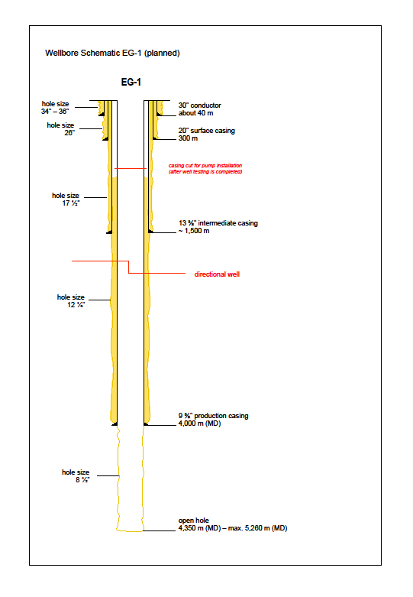

Figure C1: Well schematic

The well trajectory is planned using a KOP at 1700 m TVD, a very moderate initial build rate of 0.43°/30 m and a KO and EOB azimuth of N 68° (fault dip direction). The KOP was chosen at 1700 m in order to minimise the risk to cross or even be forced to kick-off in or near the possible Restineas Fault (fig. C2).

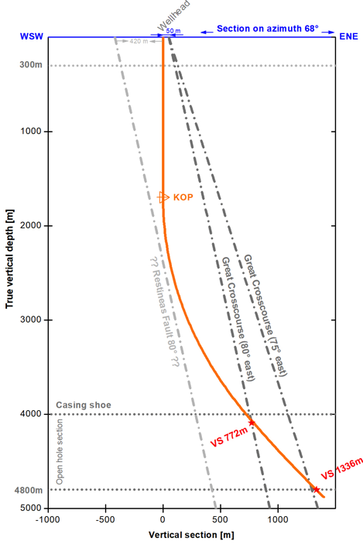

Figure C2: VS view N68° illustrating the structural setting and the EG-1 trajectory

The EOB of the first well section is at around 4,150 m MD or 4,000 m TVD, just ahead of the first well target. At this depth the well inclination is 35°.

If the first target is passed with no indication of the fault, drilling will be continued gradually raising the inclination to 40°. The second target at 4,800 m TVD is crossed at a well length of 5,160 m MD. If the fault is intersected at this depth, drilling will continue for another about 100 m in order to create a rat hole. The expected maximum length of the well is therefore 5,260 m.

Directional Control

For drilling in granite, it is essential that large dog-leg severity (DLS) is avoided. A DLS > 1.5°/30m in granite would result in high drag and torque. Wellbore trajectory, including verticality, shall be controlled during the whole operation as follows:

Depth (m) MD | 0 - 1,700 | 1,700 - 4,150 | 4,150 - ~5,260
Inclination | vertical, inclination < 5° | Angle build at 0.43°/30 m to 35° | tangent section, slight angle building at 0.13°/30 m to 40°

Formation tendency may exist that causes the well to deviate in a certain direction. The top 800 meters of the wellbore will need to be as vertical as possible (~1°) to accommodate the later installation of a line-shaft pump (the OD of a typical geothermal line-shaft pump is ~12¼”, which means that it has to be set within the 13 ⅜” casing). The remaining vertical section of the well from 800 m to the kick-off depth of 1,700 m will be maintained as vertical as possible (< 5°) to minimise problems with torque and drag. Also, the verticality of this section has implications for the subsequent drilling of a possible second well, given the close proximity between the wellheads (10 m edge to edge) and the risk of collision.

Consequently, the EG-1 well will require directional drilling assemblies along the whole well consisting of downhole drilling motors, stabilizers and MWD systems in order to properly control the well direction.

We anticipate drilling also the 26” well section using a motor/MWD assembly. Experience from previous wells shows that this may help to considerably accelerate the progress with such a large bit in hard rock and it will also help to reduce – near surface – vibrations and thus minimize the noise emission from the rig.

During the 8 ¹/₂" drilling, if heavy or full mud losses are encountered while crossing the fractured/ faulted zones, it may be required to lay down the directional assembly to reduce the risk of losing the valuable tools in the well. At this point, it would then be required to pick up a rotary assembly to continue drilling to total depth.

Drilling programme

- Mobilise and rig up drilling rig over well centre. Prepare spud mud.
- Drill 26" vertical hole to 300 m with motor, shock absorber and MWD
- Set 20" casing and cement to surface using inner string cementing technique.
- After cement is set, cut off 20” casing to near cellar floor and install 20 ³/₄" 3,000 psi SOW casing head. Test the weld to 3,000 psi. Install 20 ³/₄" 3,000 psi temporary spacer spools and. nipple up 20 ¾” 3,000 psi annular BOP and hook up to flow line. Test BOP.
- Drill 17 ¹/₂" vertical hole to 1,500 m with motor and MWD.
- Log well (cement volume) and make any other scientific measurements required.
- Run 13 ³/₈" casing to bottom, cement casing with weight reduced cement to surface.
- After the cement is set, release casing, set slips. Remove 20 ¾” 3,000 psi annular BOP and 20 ¾” 3,000 psi spacer spools, cut off 13 ³/₈" casing. Install 20 ¾” 3,000 psi spacer spool, DSA, 13 ⁵/₈” 5,000 psi mud cross with hook up for kill and choke line and nipple up 13 ⁵/₈" 10.000 psi BOP stack and test.
- Drill 12 ¹/₄" vertical hole from 1,500 to 1,700 m with motor and MWD.
- Kick-off @ 1,700 m and directionally drill 12¹/₄" hole to 4,000 m (MD) with gradual angle build using motor and MWD
- Log well (cement volume) and perform all required scientific measurements.
- Run 4,000 m of 9 ⁵/₈" casing. Then cement the 9 ⁵/₈" casing from 4,000 m to at least 1,400 m depth (above 13 ³/₈” casing shoe) in 2 stages with weight-reduced cement.
- Drill 8 ½” deviated well (install mud cooling system as required), either:
- Drill directionally to about 4,350 m MD, (about 4,160 m TVD). Maximum inclination will be in the order of 35°; or
- If no indication for the fault can be found at/near the first target, continue to drill 8 ¹/₂" directionally to about 5,260 m MD, (about 4,880 m TVD) Maximum inclination will be in the order of 40°. TD well at/near 5260 m MD.
- Circulate well clean, replace mud by water, log well and make any other scientific
measurements required.
- Perform hydraulic tests which will include water injection and production testing.
- Lay down drill pipe and drill collars. Clean mud tanks and release rig.
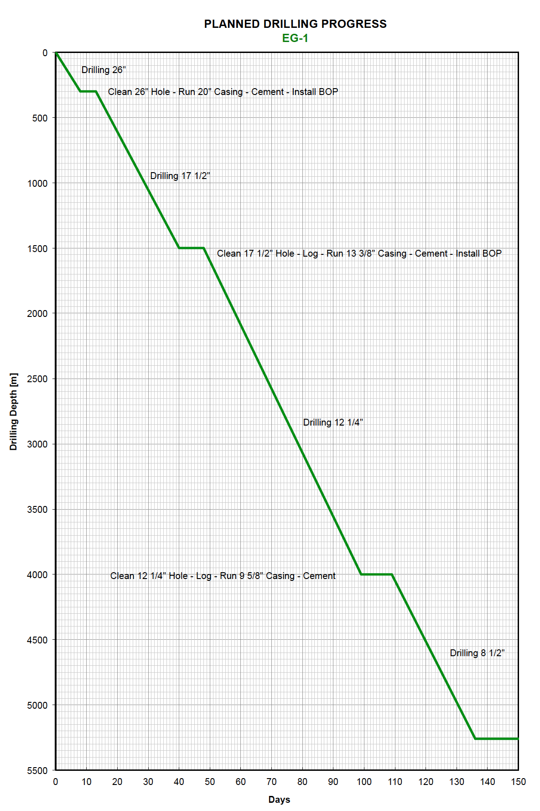
Figure C3: Estimate of drill time for the well EG-1 to a max. depth of 5,260 m (MD)

Drilling Fluids

Water based drilling muds will be used at all times, unless, due to the need to ensure the safety and stability of the well, it is not reasonably practicable to do so. The precise materials to be used in the drilling muds, for example the polymers, have not yet been finalised. The drilling muds will not include barite or chloride additives, unless barite has to be used as a last resort as a weighting agent. In the event that troubled clay formations are drilled, 3-7% of KCl may be added.

The drilling fluids programme has been outlined by wellbore section as follows:

26” section | A viscous fluid (spud mud) will be required in this section of the well to adequately transport drill cuttings to the surface. A flocculated bentonite drilling fluid should be inexpensive, environmentally safe and adequate to do the job. Spud mud normally consists of some 40 to 60 kg/m³ bentonite in fresh water. The pH should be maintained at 9 to 10 with caustic soda.
17½” section | The fluid for this section is likely to be a polymer drilling fluid. If clays (kaolin) are encountered, KCl can be added to the system. The same fluid used on the 26” section will be diluted with fresh water and “broken over” to a polymer mud. Chemicals, which function as protective colloids in the drilling mud, will be added. PH values should be maintained in the 9 to 10 range for corrosion resistance.
12¼” section | This section of the well will continue with a polymer based drilling fluid. The same fluid used on the previous section will be used for the 12 ¼” hole. Corrosion inhibitors and a lubricant will have to be added to reduce torque and drag in the well below about 2,000 - 2,500 m MD (from experience). The mud density shall be maintained below 9.0 ppg, this means the solid content has to be kept low. PH values should be maintained in the 9 to 10 range for corrosion resistance.
8½” section | After the 9 5/8” casing has been run and cemented, the fluid in hole will be displaced with an HT polymer mud. Fluid is mixed with thermally stable filtration control polymers, which have been tested in the lab and proven to be non-damaging for use in the reservoir zone. Air or water-based mud coolers will have to be integrated into the mud system once the surface return mud temperature exceeds about 65° C, both for safety and mud chemistry reasons; all additives will need to be suitable for high temperature use. The mud density shall be maintained clearly below 9.0 ppg, this means the solid content has to be kept low. PH values should be maintained in the 9 to 10 range for corrosion resistance.  Corrosion inhibitors and a lubricant will have to be added in this section to reduce torque and drag in the well. This may present a disposal problem as high temperatures generally require mineral based lubricants.  If severe losses or seeps are encountered, this section may be drilled with fresh water utilizing NaCl salt for the weighting fluid if required to control fluid flows from the formation.  At TD the fluid will be removed, a wellbore clean-up will be performed and the well will be filled with inhibited fresh water (or NaCl brine if required for density).  Samples of the chippings will be collected every 5 metres and will be washed, dried and stored in sample boxes. The samples will be visually inspected.

APPENDIX D – Geology

The drilling site at the Eden Project is located on the southeast flank of the St Austell granite mass, which forms part of the Cornubian Batholith that runs under the spine of Cornwall. The St Austell Granite comprises lithium-mica granite in the west, mecoarse-grained biotite granite in the east and in the vicinity of the site is medium to coarse grained (megacrystic) biotite granite. The depth of the batholith has not been confirmed, but based on gravity modelling and processing of seismic reflection data, the base of the St Austell Granite in the vicinity of the site is inferred to lie at a depth > 7,000 m.

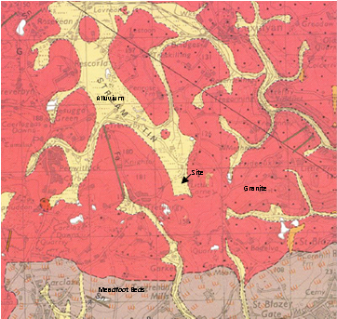  Eden Project geothermal site | 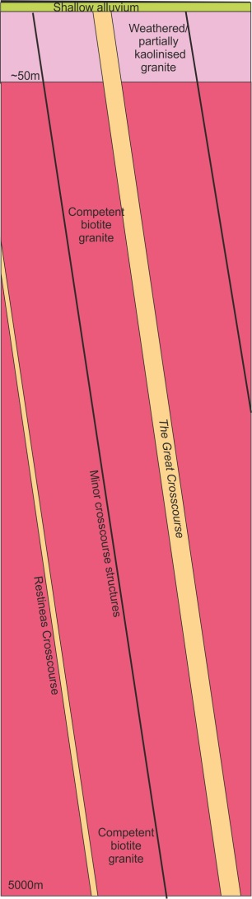
Geological plan, with The Great Crosscourse superimposed, and an inferred section

From the Geological Survey of Great Britain, (1:50,000 Geological Map of Bodmin, Sheet 347) the site is shown to be underlain (in sequence) by alluvium comprising silty clays, sands, gravels and peat overlying the St Austell Granite.

The granite in the vicinity of the site is medium to coarse grained (megacrystic) biotite granite. The granite is expected to contain feldspar megacrysts (15 - 20 mm size) in a coarse-grained matrix of alkali feldspar, plagioclase, biotite, quartz and white mica. The main component of the granite, from near surface data, at the Eden Project is quartz (~ 34 %), alkali-feldspar (~ 32 %), plagioclase (~ 22 %), biotite (~ 6 %), muscovite mica (~ 4 %) and primary tourmaline (1 %) and other minerals (1 %). With depth there are likely to be changes in grain size and mineral composition, perhaps with the granite becoming finer grained with depth. Surface mapping in the wider region shows variations in the composition of the granites which probably reflect a multi-phase intrusion history.

The Eden Project is centred in a former china clay pit. A characteristic of the St Austell Granite is the extensive ‘kaolinisation’ that occurs, principally in the lithium-mica granite to the west, which is less prevalent in the biotite granite. Kaolinisation is the alteration and degradation of the granite comprising a process of hydrolysis accompanied by removal of alkalis and silica. Ground investigations to a depth of 50m have proven highly weathered (kaolinised – Grade V) and saturated granite between surface and a depth of 25 m beneath the drill site. The formation is expected to become more competent below this depth, but further zones of weathering beneath this are likely.

The groundwater aquifer appears to be in hydraulic connection with the overlying superficial deposits, with groundwater levels at the site recorded between 2 and 4m below ground level.

Several types of veins containing varying assemblages of quartz, tourmaline and other minerals occur in the St Austell Granite, of which greisen bordered quartz-tourmaline veins are the most common type. The veins, often 1 - 2 m in width, occur in clusters, usually parallel to subparallel, with a dominant ENE - WSW strike and steeply dipping between 60 - 90°. Dip directions towards the north seem to be slightly more common than those to the south. Some relatively minor deposits of metalliferous minerals, chiefly iron and tin, have been mined underground to shallow depth only. The nearest recorded mine is a shallow tin working approximately 500 m to the south of the site.

It is suggested that the main kaolin deposits may be associated with near vertical faults (locally named crosscourses) that strike through the granite in a NNW - SSE direction. These crosscourses are likely to have formed the fluid pathways for the downward migration of meteoric water and subsequent granite alteration. Some of the crosscourses are historic wrench faults, several 10s of metres wide, whereas many of the minor crosscourses are only 1 to 2 metres in width with a relatively short length. It is anticipated that such structures will extend to great depth and will form the target zone for the development of the EGS ‘reservoir’ at a depth of 4 to 5 km.

The compressive strength of the granite varies from location to location and is dependent on a number of geological factors, such as modal composition, degree of weathering and density. The uniaxial compressive strength of the granite at the Rosemanowes site (at a depth of 2.0 - 2.5 km) was found to be 135 MPa. A recent study has shown values for Grade 2 St Austell Granite (with a density of 2,640 kg/m³) of 120 - 180 MPa; for Grade 3 granite (density of 2,450 kg/m³) of 40 - 60 MPa; and for Grade 4 granite (with a density of 2,200 kg/m³) of 10 - 20 MPa. However, the unconfined compressive strength values of 257 MPa were found in fine-grained granite at Geevor Mine, near Land’s End.

Temperature and stress regime

Heat flow values on or close to the Cornish granite are typically 120 mW/m², whereas away from the granite the values are approximately 60 mW/m². The modelling indicates the geothermal gradient in the vicinity of the Eden Project to be 35 - 40°C/km. This equates to a rock temperature of approximately 90°C at a depth of 2,000 m (TVD); approximately 160°C at 4,000 m (casing shoe); and 170 - 190°C at a depth of 4,500 m (target zone).

Evidence has shown that deep wells in the Cornish granite are exposed to hydrostatic conditions, with no zones of overpressure. Typical hydrostatic gradients for water lie in the range of 1.00 - 1.15 g/cm3 (0.433 - 0.500 psi/ft). At shallow depth the fracture gradient (the pressure required to induce fractures in rock at a given depth) relates to the vertical stress, but below a depth of approximately 300 m it is governed by the components of in-situ horizontal stress. Stress measurements in the 2,500 m deep geothermal wells at the former Hot Dry Rock Project, situated approximately 30 km to the southwest of Eden, and at other shallower sites in Cornwall, provide data that enables prediction of the in-situ stress regime at a depth of 5 km with a relative degree of confidence. It is anticipated that the granite will be fractured at depth and that the fluid encountered within the granite could be saline.

Target structure

The target for the first well is a NNW-SSE coursing fault, named The Great Crosscourse, within the southeast periphery of the exposed St Austell Granite mass. This type of large crosscourse structure is a major wrench fault with a strike length of several 10s of kilometres, traversing the granite pluton. There is considerable uncertainty about the precise location and characteristics of The Great Crosscourse at a target depth of 4,500 m. The main structure is likely to be characterised by ramifying networks of intense microfractures and quartz veins. The fault zone is likely to contain a number of discrete and complex fault planes with splay faults some of which may be oriented at a low or even high angle to the main fault zone trend. The dip angle of the fault is expected to be near vertical, i.e. about 80 - 85° down to the ENE. The width of the fault is not well recorded; at one location the main structure is recorded to be ~ 45 meters wide. Generally fault structures of this type can comprise a zone of disturbed ground >100 meters wide, but this zonal width is likely to become narrower with increasing depth.

Observations and mapping of joints and strucutres from wells up to 2500 m depth at the Rosemanowes site showed that major faults/structures were dipping around 80° east.

APPENDIX E – Plan of Drilling Site
The site is a relatively large, level area situated in the base of a shallow valley at an elevation of approximately 130 ma OD. The proposed layout of the drilling site is shown below.

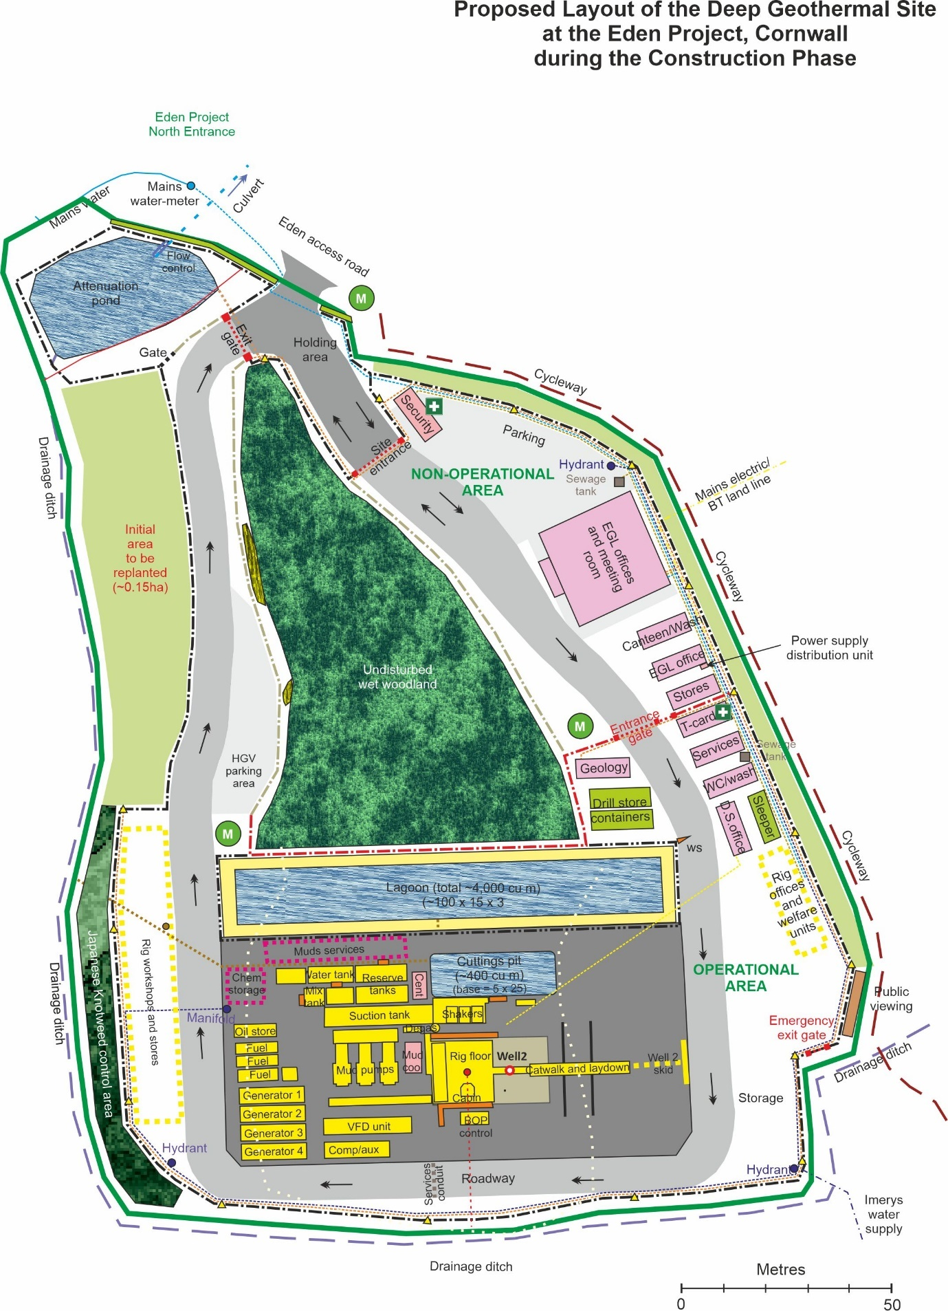

APPENDIX F – Contract terms and conditions
(LOGIC, General Conditions of Contract For Services On and Off Shore, Edition 4, February 2019)

These are the Terms and Conditions which, in conjunction with Part C of this document, and Schedules 3 and 4 of the completed tender submission, will form the contract between EGL and the successful tenderer.

See separate attachment

(The remainder of this page has been left intentionally blank)

