Eden Geothermal Limited
The Eden Project
Bodelva
Par
PL24 2SG

Tel: +44 (0)1726 806545
E: tenders@edengeothermal.com

Date: 1st October 2020

INVITATION TO TENDER
Dear Sir/Madam

Project | Eden Geothermal Project
Tender Name | Independent well examination services for a deep geothermal well
Tender reference | EGL-ITT-C058

You are invited to submit a competitive tender for independent well examination services for a project co-funded by the European Regional Development Fund.

Please submit your proposal in full no later than:
Tuesday 27th October at 16:00 hours

Except under exceptional circumstances, no extension of time and date by which the tender must be submitted will be granted. Late submissions will not be accepted.

Any query in connection with this tender or the invitation to tender shall be submitted in writing (by email) to tenders@edengeothermal.com by:

Thursday 16th October at 12.00 noon

We look forward to receiving your submission.

Yours faithfully

Augusta Grand
Executive Director

This page intentionally blank

Invitation to Tender:

Independent well examination services for a deep geothermal well

Project | Eden Geothermal Project
Tender reference | EGL-ITT-C058
Revision | Ver 1.0
Release Date | 1st October 2020
Issuer | Eden Geothermal Limited (“EGL”)
Supplier Response Date | 27th October 2020 at 16.00

Contents

PART A: INSTRUCTIONS TO TENDERERS

1 Instructions for Completion | 7
1.1 Submission Details | 7
1.2 Enquiries and Tender Queries | 8
1.3 Format of Tender Submission | 8
1.4 Project Description | 8
1.5 Outline of Requirements | 9
1.6 Validity Period | 9
1.7 Form of Contract | 9
1.8 Financial Terms | 9
2 Timetable | 10
PART B: BACKGROUND INFORMATION

3 Background Information | 11
3.1 Eden Geothermal Project  3.2 About Eden Geothermal Ltd | 11  12
PART C: EGL’s REQUIREMENTS / SCOPE OF WORK

4 EGL’s Requirements/Scope of Work | 14
4.1 Context | 14
4.2 Stage 1: Well Design | 15
4.3 Stage 2: Well Construction (Drill, Test, Complete) | 15
PART D: RETURN OF TENDER

5 Tender Completion Documentation | 17
5.1 Company Information | 18
5.2 Technical Submission | 19
5.3 Commercial Submission | 20
5.4 Confidential/Commercially Sensitive Information | 20

Contents continued

PART E: EVALUATION PROCESS
6 Evaluation Process | 21
6.1 Company Information | 22
6.2 Technical Evaluation  6.3 Commercial Evaluation  6.4 Total Score  6.5 Clarification  6.6 Award and Notification | 22  23  24  24  24

PART F: CONDITIONS
7 Conditions |  | 25
7.1 Confidentiality and Freedom of Information |  | 25
7.2 Language |  | 25
7.3 Applicable Law |  | 25
7.4 Additional Costs |  | 26
7.5 Costs |  | 26
7.6 Right to Cancel or Vary the Process |  | 26
7.7 Inducements |  | 26
7.8 Disclaimer |  | 26
PART G: SCHEDULES (TENDER SUBMISSION TEMPLATES)
Schedule 1a: Company Information  Schedule 1b: Economic and Financial Standing |  | 28  29
Schedule 1c: Legal Matters and Disputes |  | 30
Schedule 1d: Grounds for Mandatory Exclusion |  | 32
Schedule 1e: Other Grounds for Exclusion |  | 35
Schedule 1f: Insurance Cover |  | 37
Schedule 1g: Equality and Diversity |  | 38
Schedule 1h: Health and Safety |  | 39
Schedule 1i: Quality Assurance, Environmental Management Systems and Corporate and Social Responsibility |  | 40
Schedule 1j: Company Experience |  | 41
Schedule 2: Declarations |  | 44
Schedule 3: Technical Submission Form |  | 45
Schedule 4: Commercial Submission Form |  | 48
Contents continued

Schedule 5: Commercially Sensitive Information |  | 51
APPENDICES
Appendix A: Plan of Drilling Site  Appendix B: Background Technical Information |  | 52  53
Appendix C: Contract Agreement |  | 65

PART A: INSTRUCTIONS TO TENDERERS

1 Instructions for Completion

1.1 Submission Details
Eden Geothermal Limited is issuing this Invitation to Tender (ITT) for specialist independent well examination services for ‘EG-1’, the first deep geothermal well at the Eden Project, Cornwall PL24 2SG, UK.

The Applicant will be required to submit a written proposal as part of the response, in the form set out. Applicants must submit their tenders as two separate sets of documents, to ensure separation of technical and commercial bids.

- Document set one: Company Information (Schedules 1a – 1j), Declaration (Schedule 2), and Technical Submission (Schedule 3); sent separately from
- Document set two: Commercial Submission (Schedule 4).

The Applicant should send a signed electronic copy of the two sets of documents by email, quoting the contract title EGL-ITT-C058. Submisisons should include any relevant appendices and be in PDF or read-only format. Tenders should be submitted to tenders@edengeothermal.com and must be received into the mailbox by the deadline of 27th October 2020 at 16.00 hours. EGL recommends a maximum attachment file size of 20MB; tenderers may send their submission as several emails – provided Schedule 4/Commercial Submission is sent separately from other parts of the tender.
Emailed tenders will be received up to the time and date stated. Any tenders received before the due date will be retained unopened until then. It is the responsibility of the tenderer to ensure that their tender is delivered not later than the appointed time. EGL reserves the right to not consider any tenders submitted after the deadline, in which event late bids will not be accepted.

Please note that, due to current UK government guidelines on working from home during the Covid-19 pandemic, EGL has suspended its requirement to submit hard copy tenders by post. Only electronic copies submitted by email will be required.

Applicants may request extensions to submission deadlines with a valid reason, which may be accepted at the discretion of the Evaluation Panel of Eden Geothermal Limited. All other Applicants will be notified of any extension that is granted.

Applicants are advised that Eden Geothermal Ltd is not bound to accept the lowest price submitted, and will not reimburse any expense incurred by Applicants during the tendering process.

Any information relating to Eden Geothermal Ltd and supplied by Eden Geothermal Ltd in relation to this project shall be retained by the Applicant in strictest confidence.

1.2 Enquiries and Tender Queries
Please register your interest by emailing the address below, quoting the tender reference number EGL-ITT-C058.

Send all enquiries by email, by the deadline stated at Section 2, quoting the tender reference printed at the front of this document (EGL-ITT-C058) to:

tenders@edengeothermal.com

Bidders shall provide a single point of contact in their organisation. Eden Geothermal Ltd shall not be responsible for contacting the bidder through any route other than the nominated contact. The bidder must therefore undertake to notify Eden Geothermal Ltd of any changes relating to the point of contact.

Applicants are advised that, where Eden Geothermal Ltd considers appropriate, a copy of any such enquiries will be distributed to all Applicants along with the response, although the original Applicant’s identity will remain confidential. Applicants will only receive the response if they have registered their interest.

1.3 Format of Tender Submission
Applicants must provide the following:
- Company Information – Schedules 1a to 1j inclusive
- Declarations – Schedule 2
- Technical submission – Schedule 3
- Commercial submission – Schedule 4 (submitted separately)

1.4 Project Description
There is a brief description of the Eden Geothermal Project in Part B (Section 3).

1.5 Outline of Requirements
The full description and scope of services to be provided are set out in Part C.

In summary, EGL requires specialist independent and impartial well examination services for the first deep geothermal well at the Eden Project, named EG-1, in 2 stages.

At the design stage (prior to drilling commencement), the Independent Well Examiner will:
- review and assess the Basis of Design for the well, EGL’s proposed drilling programme, and well drilling and testing documentation to ensure these are fit for purpose, compliant with HSE regulations and follow industry good practice;
- produce a design stage well examination report/certificate for submission to HSE and project funders.

During the construction stage (drilling, well testing and completion) the Independent Well Examiner will:
- check that operations are carried out safely and in accordance with the accepted design and programme;
- produce a construction stage well examination report/certificate when operations are complete;
- produce fortnightly update summaries for project funders.

1.6 Validity Period
Tenders must remain valid for acceptance for a period of 90 days from the Tender Return Date.

1.7 Form of Contract
The contract between EGL and the successful bidder will EGL Terms and Conditions, a copy of which are provided as Appendix C, together with the following parts of this document:

- Part C (Technical Requirements and Specifications)
- Schedules 3 and 4 as submitted by the successful bidder.

1.8 Financial Terms
All prices will be fixed, in £ sterling, exclusive of VAT and inclusive of all other taxes and duties.

2 Timetable

This procurement will follow a clear, structured and transparent process at all times, to ensure that all Applicants are treated equally. The key dates for this procurement (timetable) are as follows:

Process | Date
Issue of Tender | Thursday 1st October 2020
Closing date for clarification questions | 12:00 hours Thursday 16th October 2020
EGL to respond to clarification questions | Tuesday 20th October 2020
Tender return date | 16:00 hrs Tuesday 27th October 2020
Award decision communicated to the winning tenderer | Monday 9th November 2020
Notify unsuccessful tenderers | Monday 9th November 2020
Expected contract award date | Tuesday 10th November 2020
Expected contract start date | Wednesday 11th November 2020
Expected drilling programme start | 15th February 2021
Expected contract completion date | 31st August

Date set for the receipt of bids at Eden Geothermal Ltd: 27th October 2020 at 16.00.

PART B: BACKGROUND INFORMATION

3 Background Information

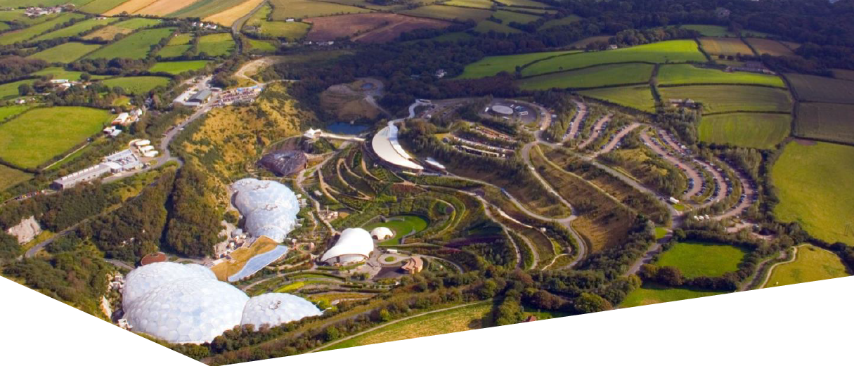
3.1 Eden Geothermal Project

The Eden Geothermal Project is run by Eden Geothermal Ltd (EGL), an SPV set-up to manage and implement the development of a deep geothermal energy plant at the Eden Project, Cornwall PL24 2SG. Funding is in place and planning permission has been obtained.
The ultimate aim of EGL is to develop a two-well deep geothermal system that will produce both direct heat and power, some of which will provide direct supply to the Eden Project, with the remainder being exported. With an anticipated gross electric capacity of around 7 MW_{e} and the ability to generate around 90% of the time, the Eden Geothermal Plant could produce enough electricity to supply the Eden Project and around four to five thousand households, as well as heating for the biomes and greenhouses at the Eden Project - and potentially some district or industrial heating.

This will be achieved by drilling two boreholes - a production and an injection well - to a vertical depth of approximately 4500m and into a known steeply inclined fault in the granite beneath Eden. The temperature at total depth is expected to be in the range of 170 - 190°C. Superheated water brought to surface in the production well will be used to generate electricity and provide heat, and then, being cooled off, will be returned to the fault via the injection well.

The project will be completed in two independent project phases. The first well and the associated test programme represent a self-contained project phase (co-financed by the European Regional Development Fund, Cornwall Council and private investment) with an emphasis on exploration. This project stage comprises (i) finalisation of design; (ii) site preparation & installation of infrastructure; (iii) drilling the first deep well; (iv) well/fault permeability testing; and (v) heat demonstration over a period of 12 months to satisfy ERDF outputs. This first project phase is the focus of this Invitation to Tender for independent well examination services.

Please see Appendix B for more technical detail relating to Phase 1 of the project, as relevant to this ITT.

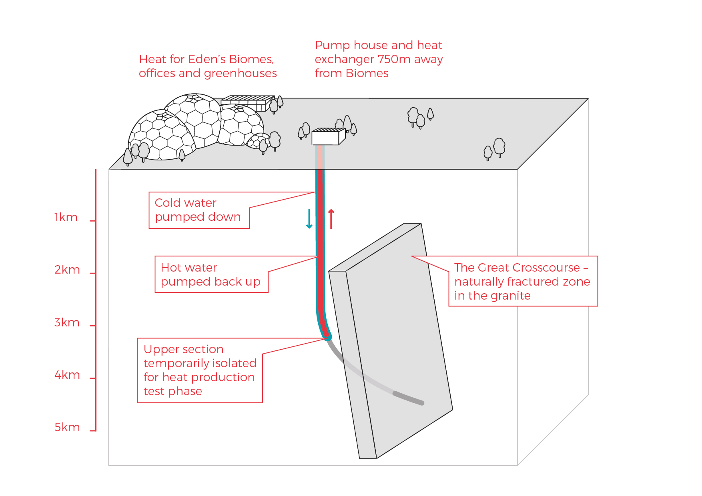
Phase 1 of Eden Geothermal Project

A successful first phase will pave the way for the drilling of a second well and the construction of the combined heat and power plant.

3.2 About Eden Geothermal Ltd

Eden Geothermal Limited is a special purpose vehicle set up to develop the geothermal project at the Eden site. The project combines the famous Eden Project site with EGS Energy Ltd’s and BESTEC (UK) Ltd’s technical expertise and experience in the geothermal sector.

EGS Energy Ltd is a UK private limited company, incorporated in 2008 and established by Roy Baria and Guy Macpherson Grant to develop deep geothermal energy solutions in the UK. BESTEC (UK) Ltd is a UK private limited company incorporated in June 2012 and established by Jörg Baumgärtner to perform deep geothermal work in the UK in cooperation with BESTEC GmbH, an established specialist company in geothermal project development. Eden Project Limited is a wholly owned subsidiary of the Eden Trust, a registered charity in the UK, and runs the world famous Eden Project in Cornwall.

Eden Geothermal Limited has been allocated funding from the European Regional Development Fund and from Cornwall Council, together with private investment match funding, to undertake the first phase as an Industrial Research Project.

More information about the Eden Geothermal Project, and about Eden Geothermal Ltd, can be found on our website: www.edengeothermal.com

PART C: EGL’s REQUIREMENTS/ SCOPE OF WORK

4 EGL’s Requirements / Scope of Work
EGL invites tenders for provision of independent well examination services for the drilling and well testing programme of Phase 1 of the Eden Geothermal Project. The drilling of the first deep well at the Eden Project is due to commence in early February 2021.

Our requirements are set out in full in the sections below, which should be read in conjunction with Schedule 3. Please refer to Appendix B for relevant technical information.

4.1 Context
A duty exists, under Regulation 13 of the Offshore Installations and Wells (Design and construction, etc) Regulations 1996, to ensure that a well is designed, modified, commissioned, constructed, equipped, operated, maintained, suspended and abandoned such that:
- so far as is reasonably practicable, there can be no unplanned escape of fluids from the well;
- risks to the health and safety of persons from it or anything in it, or in strata, to which it is connected, are as low as reasonably practicable.

An Independent Well Examiner with a high level of understanding of onshore well examination requirements in the UK, and preferably with an understanding of goethermal wells. is required for the Eden Geothermal Project. The Independent Well Examiner will ensure that the well EG-1 is designed and constructed consistent with EGL’s requirements, acceptable industry standards and sector good practice.

The well examiner must be impartial, assessing and commenting only on work done by EGL.

The results of the independent well examination programme will be used by EGL’s Drilling Manager and Drilling Supervisors, and will be submitted to the HSE and to Eden Geothermal Project funders.

The independent well examination programme will be based primarily on documents and discussions, and will be developed and provided as a two stage process.

    - Stage 1: Well Design Stage

Prior to drilling commencement, the Independent Well Examiner will be required to:
- Review the Basis of Design for the well, including (i) work programme, (ii) casing design, (iii) kick tolerance, (iv) casing setting depths, (v) cementing design, (vi) mud weights, (vii) barrier selection, installation, and testing, and (viii) well control equipment (including pressure testing philosophy for casing, BOP and wellhead). The review will take account of the anticipated conditions in the sub-surface environment (including zones that could be a source of cross flow or annulus pressure potential).
- Assess the proposed drilling programme in relation to the anticipated conditions below ground.
- Review the proposed and actual well drilling and testing documentation to ensure that the well design and operational programme are fit for purpose, comply with HSE Regulations and demonstrate industry good practice.
- Confirm that the well is designed and constructed within acceptable industry standards.
- Issue a Design Stage Well Examination Report (and certificate if required), upon completion of design stage examination. This will be submitted by EGL to the UK HSE, and to project funders, prior to the commencement of drilling operations.

The development of the well examination programme is envisaged as an iterative process, where the well examiner reviews the well design and liaises directly with the Drilling Manager, who is responsible for planning and operations.

4.3 Stage 2: Well Construction Stage (Drill, Test and Complete)

The primary aim of well examination during the construction stage, including drilling and well testing, is to independently check that the well operation is performed safely and that the well is constructed to the accepted design.

Typically, this is expected to be undertaken by checking daily operations reports for drilling, testing and completion programmes for, but not limited to:
- Casing / wellhead – rating, design, centralisation, lockdown;
- Cement – placement, slurry design, planned tops;
- Pore / fracture pressures – mud weight, leak-off tests;
- Well barriers – during removal of BOP and installing wellhead components.

The Well Examiner will also monitor management of change and any deviations or dispensations from policy or procedures, and will assess EGL’s policies for:
- Directional drilling control
- SIMOPs
- Well control and barriers
- Lost circulation
- Well testing

The Independent Well Examiner will issue a Construction Stage Well Examination Report (and certificate if required) when the construction stage is complete. This report must address any revision of the original Well Design Stage scheme.

In addition, during the construction stage, the Independent Well Examiner will produce a fortnightly update summary for Eden Geothermal Project funders. This will provide a review of progress and focus on deviations from the well plan as originally agreed, and on emerging risks.

PART D: RETURN OF TENDER

5 Tender Completion Documentation

This Section provides information to help Tenderers prepare their tenders. Applicants are advised to read all the documentation carefully to ensure that they are familiar with the nature and extent of their obligations should their tender be accepted.

The Applicant must complete and return all relevant documents as part of their Tender response. The tender return templates are contained in Part G:
- Company Information – Schedules 1a to 1j inclusive
- Declarations – Schedule 2
- Technical submission - Schedule 3
- Commercial submission – Schedule 4 (to be submitted separately).

Schedules 1, 2 and 3 may be submitted jointly but Schedule 4 must be submitted as a separate document.

It is the responsibility of the Applicant to inform EGL of any matter that may affect the Applicant’s qualification.

All Applicants must complete Schedules 1, 2, 3 and 4. Applicants must ensure that all questions are completed in full, in English, and in the format requested. Failure to do so may result in the submission being disqualified. Applicants are expected to supply all required information, or clearly state the reason for being unable to do so. Where the question does not apply, please state clearly ‘N/A’. Where the answer is a statement of fact, it must be accurate. It is the Applicant’s responsibility to ensure that EGL is not misled.

Any appropriate supporting documents (e.g.; maps, brochures, organisation charts, etc.) should be included as additional information. Please supply them as an Appendix. They should be numbered clearly and listed as part of your declaration. PDF is the only acceptable electronic file format. Any additional documents provided by the Applicant must refer to a specific item within the ITT and be easily identifiable as the answer to a particular question or set of questions.

Should the Applicant wish to propose a deviation from the specification, please ensure that this is clearly identified in the response where appropriate.

5.1 Company Information
5.1.1 Company Details
The Applicant must complete the details required in Schedule 1a. Where the Applicant is a consortium or partnership bidder, Schedule 1a must be completed by each member of the consortium or partnership.

5.1.2 Financial Matters
The Applicant is required to provide the information requested in Schedule 1b. In the case of a consortium or partnership bid, all members of the consortium or partnership should complete this information. This section may be used, in conjunction with credit reference agency checks if necessary, to gain a basic indication of the financial stability of the Applicant. The determination of the appropriate risk level will be proportionate and relevant to the size, value and nature of the specific contract being tendered. For this contract, EGL will wish to see Capital and Reserves in excess of 25,000 GBP. Where the company does not have the required level of reserves, we will accept parent company or personal guarantees to the same value. EGL reserves the right to undertake further independent financial checks, if it feels it important to do so. Financial responsibility cannot be shared. Consortium or partnership bids must state one of the members of the partnership as the Lead Applicant, which will be the financially responsible party.

5.1.3 Legal Matters, Disputes and Conflicts
EGL is obliged to consider certain legal and conflict matters that could affect the ability of the Lead Applicant, or its partners, to deliver the services required for this contract. Some of these matters would lead to a mandatory exclusion. The Lead Organisation and its partner organisations must complete answers to all the questions in Schedule 1c, 1d and 1e.

If the answer to any of the questions is ‘yes’, please provide full details and the steps taken as a consequence.

5.1.4 Insurances
For any Applicant to be successful, adequate insurance cover will be required. The minimum levels are indicated in Schedule 1f. The Lead Organisation, and any partners or consortium members, must complete Schedule 1f with the relevant information and confirm that the details entered are correct. If the Applicant does not currently have the required level of insurance, please confirm that it will have the cover required should it be awarded the contract. If the policy held is in the aggregate, the remaining cover must exceed the minimum requirements shown.

5.1.5 Equality and Diversity
The Lead Organisation must complete Schedule 1g confirming that their organisation and any partner or sub-contract organisation complies with its legal obligations under European law relating to equality and diversity.

5.1.6 Health &, Safety, Quality Assurance and Environment
The Applicant must supply a copy of all relevant Health and Safety, Environmental Management and Quality Assurance policies as requested in Schedules 1h & i. In the case of a consortium or partnership bid, the Health and Safety, Quality Assurance and Environment policies of the lead Applicant shall be submitted with the proposal and shall prevail.

5.1.7 Company Experience
The Applicant should provide details in Schedule 1j of up to three contracts which demonstrate the expertise and experience of the lead Applicant and any proposed partners or sub-contractors in relation to EGL’s requirements. References should be available for these contracts if possible.

3.18 Declaration
The Applicant (or each partner or member organisation in the case of a consortium bid) must complete the Declaration in Schedule 2.

5.2 Technical Submission
The detailed requirements and scope of work for the contract are set out in Part C.
The Applicant’s submission should take into account all relevant factors contained within the information, although EGL does not accept any responsibility for the accuracy or completeness of the information. Applicants must submit their bid based on the technical requirements described in Part C.

The Applicant must complete Schedule 3. Evidence should be provided to demonstrate:

- The experience, knowledge and skills of named personnel relevant to EGL’s requirements. (EGL can only evaluate personnel, and not the company, in this section.)
- An appropriate methodology and approach, suitable for EGL’s requirements as set out in Part C and Schedule 3 of this document.

5.3 Commercial Submission
The Applicant is required to provide the prices requested in Schedule 4, which will include daily personnel rates and other ancillary prices, and a price summary for evaluation purposes based upon the project programme period provided.

All prices will be quoted in pounds sterling and should exclude VAT. If some prices are only estimated at this stage, please make it clear which these are.

Where applicable, EGL will pay any VAT incurred at the prevailing rate (currently 20%). If the VAT rate changes, EGL will pay any VAT incurred at the new rate. It is the responsibility of the Applicant to check their VAT position with HMRC before submitting a bid.

On award of the tender, the form and content of the contract with the successful bidder is set out in Appendix C, and will include the prices set out in Schedule 4 by the successful bidder.

5.4 Commercially Sensitive Information
Please outline in Schedule 5 any items that the Lead Organisation or its partners consider to be genuinely Confidential and/or Commercially Sensitive and which should not be disclosed in respect of your Tender.

PART E: TENDER EVALUATION

6 Evaluation Process

This Section specifies the criteria to be used to determine the successful applicant and the requirements for the tenderer’s qualification to perform the contract.

All applicants must prepare separate technical and commercial bid documents.

Technical and commercial bids must be received by Eden Geothermal Ltd
in separate PDF files and hard copy documents, each quoting the tender number in the title.

All bids will be impartially evaluated against the same criteria by an ‘Evaluation Panel’ on behalf of Eden Geothermal Limited.

The evaluation process will be conducted in a manner that ensures tenders are evaluated fairly to ascertain the most technically and economically advantageous tender. Each tender submission will be evaluated only on the information that is provided by the Applicant. Tenders may be rejected if the information asked for in the ITT and Specification is not given at the time of tendering.

Technical documents and bids will be restricted to the members of the Evaluation Panel, which has full power to make decisions on behalf of Eden Geothermal Limited. The evaluation will be carried out by the Evaluation Panel in distinct sections, with weightings applied where appropriate:

Title | Evaluation Method
Company Information (Schedule 1) | Pass / Fail
Declarations (Schedule 2) | Pass / Fail
Technical Criteria (Schedule 3) | 40%
Commercial Criteria (Schedule 4) | 60%

6.1 Company Information

The Company Information will be evaluated first and Applicants will be required to pass this stage before their Tenders are evaluated on the basis of their technical and commercial submission.

Ten criteria will be used to evaluate tenders, each being scored on a pass or fail basis. Applicants must pass all criteria to proceed to the remainder of the evaluation. The criteria are:
  - Company Information – Schedule 1a
  - Economic and Financial Standing – Schedule 1b
  - Legal Matters – Schedule 1c
  - Grounds for Mandatory Exclusion – Schedule 1d
  - Other Grounds for Exclusion – Schedule 1e
  - Insurance – Schedule 1f
  - Equality and Diversity – Schedule 1g
  - Health & Safety – Schedule 1h
  - Quality Assurance and Environmental Management Systems – Schedule 1i
  - Company Experience – Schedule 1j

The Company will be evaluated as follows:

Schedules 1a and 1b will be reviewed separately. The review of the Applicant’s submission will only proceed to the remainder of Schedule 1 and Schedule 2 where the reviewer deems that the Applicant has passed these sections.

EGL will exclude any Applicant who answers ‘Yes’ in any of the situations in Schedule 1d, and may also exclude any Applicant who answers ‘Yes’ in any of the situations in Schedule 1e.

If the Applicant is made up of a Lead Organisation and other organisations who have jointly entered into a consortium, joint venture or other contracting arrangement, each of the organisations must pass all the criteria in order for the Tender to proceed to the remainder of the evaluation.

6.2 Technical Evaluation
Only Applicants that have passed the evaluation of Company Information will have their technical bids evaluated by the Evaluation Panel.
The technical submission should demonstrate the Applicant’s expertise and capability to provide independent well examination services in accordance with the technical requirements and specifications set out in Part C and Schedule 3.
The quality of the technical submission will be scored in accordance with the Scoring Matrix shown below:
5 Excellent | Extremely good demonstration of relevant ability, understanding, experience, skills, resources and quality measures required to provide the services, with full evidence provided to support this.
4 Good | Above average demonstration of the relevant ability, understanding, experience, skills, resource and quality measures required to provide the services, with a majority of evidence provided to support this.
3 Acceptable | Satisfactory demonstration of the relevant ability, understanding, experience, skills, resources and quality measures required to provide the services, with some evidence to support this.
2 Minor Reservations | Some reservations regarding the relevant ability, understanding, experience, skills, resources or quality measures required to provide the services, with little or no evidence to support this.
1 Major Reservations | Serious reservations regarding the relevant ability, understanding, experience, skills, resources or quality measures required to provide the services, with no evidence to support this.
0 Unacceptable | Non-compliance and/or insufficient information provided to demonstrate that there is the ability, understanding, experience, skills, resource and quality measures required to provide the services.

6.3 Commercial Evaluation
The Commercial Evaluation will be carried out for all submissions that that have been included in the Technical Evaluation (Schedule 3). Commercial submissions from those who failed to pass Schedules 1 and 2 will be destroyed unopened.
The commercial offer will be judged by reference to the tendered total price. The median price of all the tender prices will be calculated and this will be judged to equal 50% of the available commercial marks. Points will be awarded or deducted from this median score in proportion to the amount that the tender price is lower than or exceeds the median price. The maximum points will be awarded for offers which are less than or equal to half the median, and nil points will be awarded for offers which are more than or equal to double the median value.
Where EGL believes that the tendered prices have been prepared on an inconsistent basis with the other tenders, which creates an unfair advantage to the tenderer’s offer, EGL will request that further information is provided to enable the Commercial evaluation to be carried out on a fair basis.

6.4 Total Score
The final ‘Total Score’ will be calculated by converting the Technical Evaluation score and the Commercial Evaluation score into percentages, which are then combined according to the weighting stated in the table in Section 6. The selected Applicant will be the one with the highest Total Score and this will be the award decision.

The Evaluation Panel will have the authority to send out a Letter of Intent to the proposed awardee, which should state that a contract will be awarded.

6.5 Clarification
During the evaluation process, EGL may need to seek clarification on aspects of an Applicant’s submission. If required, EGL will contact the Applicant using the contact details provided. Clarification may require further submission or supplementation or clarification to complete the relevant information or documentation within an appropriate time limit. The purpose of any such clarification will be only to provide EGL with the information required to evaluate and score the submission; it will not be an opportunity for the Applicant to improve or substantially change the information that has already been submitted.

6.6 Award and Notification
Once EGL has completed the evaluation and has identified the successful tenderer(s), EGL will inform the winning Applicant(s) in writing by email of the ’award decision’.

The unsuccessful Applicants will be informed in writing of the fact at the same time after the closing of the evaluation procedure. EGL will offer feedback to every Bidder submitting an unsuccessful proposal.

The contract will then be awarded.

PART F: CONDITIONS

7 Conditions

7.1 Confidentiality and Freedom of Information
This document is proprietary to EGL and the information contained herein is confidential.

EGL confirms that it will keep confidential and will not disclose to any third parties any information obtained from a named Applicant contact, other than to the EU Managing Authority, to its funders, and under EGL’s commitment to meeting its responsibilities under the Freedom of Information Act (FOI) 2000 or the Environmental Information Regulations (EIR) 2004. All information submitted to EGL may need to be disclosed in response to a request under these regulations.

The Applicant must treat all information supplied to it by EGL in confidence and must not disclose it to third parties other than to obtain sureties or quotations for submitting its response as part of the tendering process.

The Applicant must identify any parts of its tender submission which it designates as confidential and would not want published; such information may include technical or trade secrets or other confidential information in Schedule 5. The Applicant should explain (in broad terms) what harm may result from disclosure if a request is received, and the time period applicable to that sensitivity. However, the Applicant should be aware that, even where information has been categorised as being commercially sensitive, EGL may still be required to disclose it under the FOI or EIR if a request is received.

Without prejudice to EGL’s obligation to disclose information in accordance with the FOI or EIR, EGL shall, acting reasonably, at its absolute discretion and notwithstanding any other provision in this Tender or otherwise seek to apply the commercial interests exemption to the information/documents listed in this Schedule.

7.2 Language
The completed tender and all accompanying documents must be in English.

7.3 Applicable Law
Any contract concluded as a result of this ITT will be governed by the law of England & Wales.

7.4 Additional costs
Once the contract has been awarded EGL will not pay any additional costs incurred which are not reflected in the tender submission.

7.5 Costs
Unless otherwise stated in this ITT, all costs associated with taking part in this process remain the Applicant’s responsibility. The Applicant will not be entitled to claim from EGL any costs or expenses which may have been incurred in preparing the tender, whether or not the tender is successful. EGL will not return any part of the completed tender.

7.6 Right to cancel or vary the process
EGL reserves the right to cancel or withdraw from the tendering process at any stage. Cancellation of the procurement process (at any-time) under any circumstances will not render Eden Geothermal Ltd liable for any costs or expenses incurred by bidders during the procurement process.

7.7 Inducements
Offering an inducement of any kind in relation to obtaining this or any other contract with EGL will disqualify the Applicant from being considered and may constitute a criminal offence.

7.8 Disclaimer
The issue of the information and the tender does not commit Eden Geothermal Ltd to award any contract pursuant to the bid process or enter into a contractual relationship with any provider of the service. Nothing in the tender or in any other communications made between Eden Geothermal Ltd or its agents and any other party, or any part thereof, shall be taken as constituting a contract, agreement or representation between Eden Geothermal Ltd and any other party (save for a formal award of contract made in writing by or on behalf of Eden Geothermal Ltd).

While the information in this ITT and supporting documents has been prepared in good faith by EGL, it may not be comprehensive, and nor has it been independently verified. Neither EGL nor their advisors, nor their respective directors, officers, members, partners, employees, other staff or agents:

- makes any representation or warranty (express or implied) as to the accuracy, reasonableness or completeness of this ITT; or
- accepts any responsibility for the information contained in the ITT or for the accuracy or completeness of that information; or
- shall be liable for any loss or damage (other than in respect of fraudulent misrepresentation) arising as a result of relying on such information or any subsequent communication.

PART G: SCHEDULES / TENDER SUBMISSION TEMPLATES

Schedule 1a - Company Details. To be completed by each consortium member.
Applicant details |  | Answer
Full name of the Applicant completing the ITT
Trading name (if different)
Registered company address
Registered company number
Name of immediate parent company
Name of ultimate parent company
Type of company (please tick relevant boxes) |  | Public limited company
 |  | Limited company
 |  | Limited liability partnership
 |  | Other partnership
 |  | Sole trader
 |  | Other
 |  | Small or medium enterprise
Tendering model (please tick relevant box) |  | Bidding as a Prime Contractor and will deliver 100% of the key contract deliverables
 |  | Bidding as a Prime Contractor and will use third parties to deliver some of the services
 |  | Bidding as Prime Contractor but will operate as a Managing Agent and will use third parties to deliver all of the services
 |  | Other (please specify)
Contact details
Name
Position
Postal address
Country
Phone number
Email

Schedule 1b - Economic and Financial Standing

 | Enclosed | Not Applicable
(a) Please enclose copies of the business’ audited accounts of the past two years, to include:
- Balance Sheet
- Profit and Loss Account
- Full notes to the Accounts
- Director’s Report
- Auditor’s Report

(b) If the accounts submitted for section (b) above are for an accounting year ended more than 10 months ago, please confirm that the business is still trading and provide the latest summary of management accounts.

 | Yes | No
(c) Has there been any event since the last audited accounts that could affect the going concern status of the company?
(d) Registered VAT number

Note: EGL will wish to see evidence of Capital and Reserves in excess of 25,000 GBP for this contract. Where the company does not have the required level of reserves, we will accept parent company or personal guarantees to the same value.

Schedule 1c - Legal Matters and Disputes
Has the Applicant, or any of its proposed partners, in the last three years: | Yes/no If yes, please provide details including details of any unresolved disputes, or outstanding claims or litigation.
- been prosecuted or had any Court judgements awarded against it?
(b) had penalties, default notices or liquidated damages awarded against it?
(c) been in breach of any contract, had a contract terminated or not had a contract renewed due to a failure to meet its obligations?
(d) been prosecuted for breaking any UK or EU, or equivalent national legislation relating to the environment or Health and Safety?
(e) had any notice served upon it by an environmental regulator or authority?
(f) had any finding of unlawful discrimination made against it by any court of law or industrial or employment tribunal?
(g) been the subject of a formal investigation on grounds of alleged unlawful discrimination?
(h) been convicted for failure to prevent corruption or bribery under section 7 of the Bribery Act 2010?
(i) been the subject of any health / safety on-the-job citations, violations or demands from any employees?

EGL will decide whether an answer ‘Yes’ to any of the questions listed above and its consequential details constitutes an acceptable risk. Where the Applicant (including the Lead Organisation and all other organisations) answers ‘No’ to all of the above the Applicant will pass.

Schedule 1d - Grounds for Mandatory Exclusion

Within the past five years, has your organisation (or any member of your proposed consortium, if applicable), Directors or partner or any other person who has powers of representation, decision or control been convicted of any of the following offences? Please indicate your answer by marking ‘X’ in the relevant box.

 | Yes | No
(a) conspiracy within the meaning of section 1 or 1A of the Criminal Law Act 1977 or article 9 or 9A of the Criminal Attempts and Conspiracy (Northern Ireland) Order 1983 where that conspiracy relates to participation in a criminal organisation as defined in Article 2 of Council Framework Decision 2008/841/JHA on the fight against organised crime;
(b) corruption within the meaning of section 1(2) of the Public Bodies Corrupt Practices Act 1889 or section 1 of the Prevention of Corruption Act 1906;
(c) the common law offence of bribery;
(d) bribery within the meaning of sections 1, 2 or 6 of the Bribery Act 2010; or section 113 of the Representation of the People Act 1983;
(e) any of the following offences, where the offence relates to fraud affecting the European Communities’ financial interests as defined by Article 1 of the Convention on the protection of the financial interests of the European Communities:
(i) the offence of cheating the Revenue;
(ii) the offence of conspiracy to defraud;
(iii) fraud or theft within the meaning of the Theft Act 1968, the Theft Act (Northern Ireland) 1969, the Theft Act 1978 or the Theft (Northern Ireland) Order 1978;
(iv) fraudulent trading within the meaning of section 458 of the Companies Act 1985, article 451 of the Companies (Northern Ireland) Order 1986 or section 993 of the Companies Act 2006;
(v) fraudulent evasion within the meaning of section 170 of the Customs and Excise Management Act 1979 or section 72 of the Value Added Tax Act 1994;
(vi) an offence in connection with taxation in the European Union within the meaning of section 71 of the Criminal Justice Act 1993;
(vii) destroying, defacing or concealing of documents or procuring the execution of a valuable security within the meaning of section 20 of the Theft Act 1968 or section 19 of the Theft Act (Northern Ireland) 1969;
(viii) fraud within the meaning of section 2, 3 or 4 of the Fraud Act 2006; or
(ix) the possession of articles for use in frauds within the meaning of section 6 of the Fraud Act 2006, or the making, adapting, supplying or offering to supply articles for use in frauds within the meaning of section 7 of that Act;
(x) disproportionate history of personnel and technical safety violations
(f) any offence listed in (i) in section 41 of the Counter Terrorism Act 2008; or (ii) in Schedule 2 to that Act where the court has determined that there is a terrorist connection;
(g) any offence under sections 44 to 46 of the Serious Crime Act 2007 which relates to an offence covered by subparagraph (f);
(h) money laundering within the meaning of sections 340(11) and 415 of the Proceeds of Crime Act 2002;
(i) an offence in connection with the proceeds of criminal conduct within the meaning of section 93A, 93B or 93C of the Criminal Justice Act 1988 or article 45, 46 or 47 of the Proceeds of Crime (Northern Ireland) Order 1996;
(j) an offence under section 4 of the Asylum and Immigration (Treatment of Claimants etc.) Act 2004;
(k) an offence under section 59A of the Sexual Offences Act 2003;
(l) an offence under section 71 of the Coroners and Justice Act 2009;
(m) an offence in connection with the proceeds of drug trafficking within the meaning of section 49, 50 or 51 of the Drug Trafficking Act 1994; or
(n) any other offence within the meaning of Article 57(1) of the Public Contracts Directive—
(i) as defined by the law of any jurisdiction outside England and Wales and Northern Ireland; or
(ii) created, after the day on which these Regulations were made, in the law of England and Wales or Northern Ireland.
(o) Any breach of obligations related to the deduction of tax or social security from any employee or contractor, or to its obligation for payment of any tax or social security contributions that has been established by a judicial or administrative decision having final and binding effect in accordance with the legal provisions of any part of the United Kingdom or the legal provisions of the country in which your organisation is established (if outside the UK).

Schedule 1e - Other Grounds for Exclusion

Within the past three years, please indicate if any of the following situations have applied, or currently apply, to your organisation (or any member of your proposed consortium, if applicable). Please indicate your answer by marking ‘X’ in the relevant box.
 | Yes | No
(a) your organisation has violated applicable obligations referred to in regulation 56 (2) of the Public Contracts Regulations 2015 in the fields of environmental, social and labour law established by EU law, national law, collective agreements or by the international environmental, social and labour law provisions listed in Annex X to the Public Contracts Directive as amended from time to time;
(b) your organisation is bankrupt or is the subject of insolvency or winding-up proceedings, where your assets are being administered by a liquidator or by the court, where it is in an arrangement with creditors, where its business activities are suspended or it is in any analogous situation arising from a similar procedure under the laws and regulations of any State;
(c) your organisation is guilty of grave professional misconduct, which renders its integrity questionable;
(d) your organisation has entered into agreements with other economic operators aimed at distorting competition;
(e) your organisation has a Conflict of Interest (CoI) within the meaning of regulation 24 of the Public Contracts Regulations 2015 that cannot be effectively remedied by other, less intrusive, measures; (*)
(f) the prior involvement of your organisation in the preparation of the procurement procedure has resulted in a distortion of competition, as referred to in regulation 41, that cannot be remedied by other, less intrusive, measures;
(g) your organisation has shown significant or persistent deficiencies in the performance of a substantive requirement under a prior public contract, a prior contract with a contracting entity, or a prior concession contract, which led to early termination of that prior contract, damages or other comparable sanctions;
(h) your organisation has negligently provided misleading information that may have a material influence on decisions concerning exclusion, selection or award.
(i) your organisation has committed an offence under the Modern Slavery Act 2015.

(*) Conflicts of interest – see next page
* Conflicts of Interest: EGL may exclude the Applicant if there is a conflict of interest which cannot be effectively remedied. The concept of a conflict of interest includes any situation where relevant staff members have, directly or indirectly, a financial, economic or other personal interest which might be perceived to compromise their impartiality and independence in the context of the procurement procedure. Where there is any indication that a conflict of interest exists or may arise then it is the responsibility of the Applicant to inform EGL, detailing the conflict in a separate Appendix. Provided that it has been carried out in a transparent manner, routine pre-market engagement carried out by EGL should not represent a conflict of interest for the Applicant.

If you have answered ‘Yes’ to any of the above question, please use a separate Appendix to provide further details.

Schedule 1f - Insurance Cover

Insurance
Employer’s Liability (minimum £5m cover)
Employers' Liability insurance shall cover all employees engaged in the performance of the Contractor's services.
Insurer
Policy Number
Amount of cover £
Renewal Date
Professional Indemnity (minimum £5m cover)
Insurer
Policy Number
Amount of cover £
Renewal Date
Public Liability (minimum £5m cover)
General Third Party Liability insurance for any incident or series of incidents covering the operations of the Contractor and its Sub-Contractors in the performance of the Contract.
Insurer
Policy Number
Amount of cover £
Renewal Date
The policy shall include, but not be limited to, coverage of (i) damage to third party property, (ii) bodily and personal injury (iii) premises and operations, (iv) independent contractors, (v) completed operations, (vi) contractual liability (or their equivalents).

Schedule 1g - Equality and Diversity

The Lead Organisation and all other organisations must confirm that their organisation complies with its legal obligations under European law relating to the following:

Item | Confirm Yes / No
a) Race
b) Sexual Orientation
c) Gender Reassignment
d) Disability
e) Age
f) Religion or Belief
g) Sex
h) Marriage & Civil Partnership
i) Pregnancy & Maternity

In order to pass this criterion, all organisations must answer ‘yes’ to all items.

Schedule 1h - Health and Safety

This section should be filled out by the lead Applicant on behalf of partners/other consortium members. The lead Applicant’s policies should be provided and shall prevail for all partners/consortium members.

 | Enclosed | Not Applicable
(a) State the total number of Employees
(b) Please enclose a signed copy of your Health and Safety Policy indicating when it was last reviewed and by whose authority it was published.
 | None | Enclosed
(c) Please provide evidence of all RIDDOR (the Reporting of Injuries, Diseases and Dangerous Occurrences Regulations 1999) reportable events for the last three years. This should include a system for reviewing all incidents, and recording the action taken as a result.
(d) Please enclose details of prosecutions or notices served on your company under the Health and Safety at Work Act 1974, or other health and safety legislation, in the last five years and the action which you have taken to remedy matters subject to enforcement action.

Schedule 1i - Quality Assurance, Environmental Management and Corporate Social Responsibility

This section should be filled out by each partner or member of proposed consortium, where applicable.

(a) Name of Director, Partner or persons responsible for the implementation of the company’s Environmental and Quality Assurance Policies.
 | Enclosed | Not Applicable
(b) Have you acquired any recognised Quality Assurance accreditation relevant to this contract? If yes, please provide details.

If no accreditation is held, please attach an outline of your Quality Assurance Policy or, if you have no policy, give reasons why.
(c) Please provide details of any Environmental Management System certification that your company holds, e.g. ISO 14001 or equivalent standard which is pending. Please include a copy of any certificate.

If no accreditation is held, please attach an outline of your Environmental Policy or, if you have no policy, give reasons why.

(d) Please enclose a copy of your Corporate Social Responsibility Policy, or other equivalent policy document (if available)

Schedule 1j - Company Experience

Using the table below, please provide details of up to three contracts, from the past five years, in any combination from either the public or private sector, that are relevant to EGL’s requirements for this tender. Contracts may include grant-funded work. Named contacts, who are able to provide written evidence to confirm the accuracy of the information provided, should be provided. If you attach information for the ‘Description of Contract’ section, please specify ‘attached’ in the relevant box and clearly label/reference the supporting material.

In order to pass Schedule 1j and progress to full technical evaluation, applicants must:
- Include evidence of providing well examination services for at least one deep onshore drilling project. Contracts should be listed in ‘Table 1j - A’ below, with any supporting information referenced in ‘Table 1j - C’ below;
- Provide evidence that the company meets or exceeds the minimum standards outlined in the Oil and Gas (UK) ‘Guidelines for Well Operators on the Competency of Well Examiners’. Please list any supporting information in ‘Table 1j - C’ below.

Consortium bids should provide relevant examples of where the consortium has delivered similar requirements. If this is not possible (e.g. the consortium is newly formed or a Special Purpose Vehicle is to be created for this contract) then three separate examples should be provided between the principal member(s) of the proposed consortium or Special Purpose Vehicle (three examples are not required from each member).
Where the Supplier is a Special Purpose Vehicle, or a managing agent not intending to be the main provider of the supplies or services, the information requested should be provided in respect of the main intended provider(s) or sub-contractor(s) who will deliver the contract.
Table 1j -A | Contract 1 | Contract 2 | Contract 3
Name of customer organization

Point of contact in the organization

Position in the organization

E-mail address

Description of contract (max 300 words)

Contract Start date

Contract completion date
Estimated contract value

Please also provide evidence of any company technical accreditations and/or membership of professional bodies relevant to EGL’s requirements for this contract.

Important note: The information given in this section will be used to assess whether the bidding company meets the minimum criteria to proceed to full technical evaluation. I.e. it will be marked on a pass/fail basis only. ERDF procurement regulations prevent us from scoring ‘Company Experience’ within the technical evaluation, and with this in mind, we ask tenderers to pay particular attention to the ‘Personnel’ and ‘Methodology and Approach’ categories of their technical submission (Schedule 3).

Subcontracting
Where you intend to sub-contract a proportion of the contract, please demonstrate how you have previously maintained healthy supply chains with your sub-contractor(s).

Evidence should include, but is not limited to, details of your supply chain management tracking systems to ensure performance of the contract and including prompt payment or membership of the UK Prompt Payment Code (or equivalent schemes in other countries).
Table 1j -B
Submission of Supporting Information
Please clearly label/reference any supporting information submitted in conjunction with Schedule 1j and list all documents using Table 1j - C below.

Table 1j - C
Document Reference | Relevance/reason for inclusion

Schedule 2 - Declarations

I/We understand that the information provided in this document and any supporting information provided by us will be relied upon and taken to be true and accurate. Should it subsequently be determined that any information supplied by us was inaccurate, I/we understand and accept that Eden Geothermal Limited reserves the right to exclude our offer to supply (if still under evaluation) or if the Contract has been awarded and the information that was inaccurately supplied had a significant influence on the award, that Eden Geothermal Limited shall be at liberty to terminate the Contract.

I/We understand that Eden Geothermal Limited is not bound to accept the lowest price or any tender that may be received.

Name of organisation
Name of person applying on behalf of organisation
Signature
Title / position of person
Date
Contact telephone
Contact e-mail
Address and post code
Registered office if different from above

Schedule 3 – Technical Submission

Evaluation Criteria
There are 2 technical (quality) evaluation criteria:
- Personnel
- Methodology and Approach
Each category will be evaluated in line with the scoring criteria set out in Section 6.2.

Important note: The information submitted under ‘Company Experience’ in Schedule 1j will be used to assess whether the bidding company meets the minimum criteria to proceed to full technical evaluation. I.e. it will be marked on a pass/fail basis only. ERDF procurement regulations prevent us from scoring ‘Company Experience’ within the technical evaluation, and with this in mind, we ask tenderers to pay particular attention to the ‘Personnel’ and ‘Methodology and Approach’ categories of this, their technical submission (Schedule 3).

Category 1: Personnel (25% of total marks)
Please provide details of the individual(s) being proposed for this contract with job titles and, for each, a detailed outline of qualifications and background/expertise/experience/skills relevant to this contract, either in their current role or prior.

Technical competence does not need to reside with a single individual and additional persons can be used to provide the full range of competencies required. A maximum of 4 individuals’ profiles may be submitted for evaluation. Each person’s profile should be no more than 4 sides of A4 in length, but should provide enough detail to enable us to evaluate their expertise.

Our evaluation will focus on:
- Breadth and depth of relevant knowledge;
- Experience – with evidence of prior contracts where possible;
- Skills and aptitudes;
- Qualifications. They personnel must meet or exceed the minimum standards outlined in the Oil and Gas (UK) ‘Guidelines for Well Operators on the Competency of Well Examiners’.

Where subcontractors will be undertaking a significant proportion of the work, you may wish to include key subcontractor personnel.

Please list the profiles provided in the table on the next page.

Category 2: Methodology and Approach (15% of total marks)
Please detail your proposed well examination scheme, explaining the methodology and approach to be taken as fully as possible within a maximum of 5 sides of A4. Your outline should include a proposed system for resolving any disputes or disagreements which may occur between the Well Operator and Well Examiner.

If relevant/appropriate, you may provide additional information as an appendix to this category. Please list any supporting information in the table overleaf.

Submission of Supporting Information
Please clearly label/reference any supporting information submitted in conjunction with this Schedule and list all documents using the table below. In addition to the document reference/name, you should clearly mark the category under which it is to be considered (1 – Personnel; 2 – Methodolgy and Approach) and, if appropriate/ necessary, provide a brief explanation of why you have included it. You may add more rows if necessary.

Document Reference | Evaluation Category | Relevance/reason for inclusion

Declaration

We confirm that:
- We have inspected this Tender Document and accompanying information relating to the Eden Geothermal Ltd Tender and hereby offer to provide the services as set out in Part C (Section 4) of this document.
- The Technical Submission is accurate to the best of our knowledge.

Name of Organisation

Name of Person Signing

Capacity in which Signed

Signature

Date

Schedule 4 - Commercial Submission

(Please note this Schedule is to be returned in a separate document).

There are 4 sections for bidders to complete:
- Stage 1 - Well Design detailed price breakdown for.
- Stage 2 - Well Construction detailed price breakdown
- Total Price for Evaluation
- Declaration.

1. Stage 1 – Well Design Stage
Please provide a fixed price based on personnel daily rates and any ancillary costs. You may add more price lines (rows) if necessary. Please refer to notes below.

Personnel Prices
Name | Job Role | Daily Rate £ | No. of days | Total Price £
Total personnel prices (exc VAT)
Other Charges
Description of charges |  | Unit Rate £ | No. of units | Total Price £
Total other charges (exc VAT)
Total of the above |  |  | Total Price £
Personnel Prices – from summary above
Other Charges – from summary above
Total Price (exc VAT)

2. Stage 2 – Well Construction Stage (Drill; Test; Complete)
Please provide daily rates for personnel and prices for any ancillary costs. For evaluation purposes only, you should complete the table below on the basis of a 150-day drilling programme and 30-day testing programme. You may add more price lines (rows) if necessary. Please refer to notes below.

Personnel Prices
Name | Job Role | Daily Rate £ | No. of days | Total Price £
Total personnel prices (exc VAT)
Other Charges
Description of charges |  | Unit Rate £ | No. of units | Total Price £
Total other charges (exc VAT)
Total of the above |  |  | Total Price £
Personnel Prices – from summary above
Other Charges – from summary above
Total Price (exc VAT)
Notes for completion of Tables above
- Currency / VAT
All prices to be shown in £ sterliing, and excluding VAT.
- Personnel
Please ensure that employee profiles are included in Schedule 3 for the key employees shown above
- Disbursements
Disbursements for travel and subsistence may be included at a single daily rate.
- Other Charges
Please ensure that sufficent description is included to give a proper understanding of the charge.
3. Total Price Breakdown for Evaluation
Please summarise the totals from the two tables above:

Total Price £
Stage 1 – Well Design Stage
Stage 2 – Well Construction Stage
Total Price for Evaluation (exc VAT)

4. Declaration
We confirm that:
- The Commercial Submission is accurate to the best of our knowledge.
- We understand that you do not bind yourselves to accept the lowest or any tender.
- We accept the contract conditions for this contract and this tender remains open for acceptance for 90 days.
- We understand that the Well construction Stage of the contract will be based upon the rates quoted above but that the number of days shown above is for illustrative purposes only

Name of Organisation
Name of Person
Signing
Capacity in which signed
Signature
Date

Schedule 5 - Commercially Sensitive Information

Eden Geothermal Limited may be obliged to disclose information in or relating to this Tender following a request for information under the FOIA or EIR. Please outline in the table below items that you consider to be genuinely Confidential and/or Commercially Sensitive which should not be disclosed in respect of your Tender (see Section 7.1)

Information | Reference / page | Reason for non-  disclosure | Duration of confidentiality

This schedule will be kept with the Tender documents for consideration should a request for information under the Freedom of Information Act 2000 or Environmental Information Regulations 2004 be received. This document will be destroyed in line with the retention and destruction policy of Eden Geothermal Limited.

APPENDICES

APPENDIX A – Plan of Drilling Site

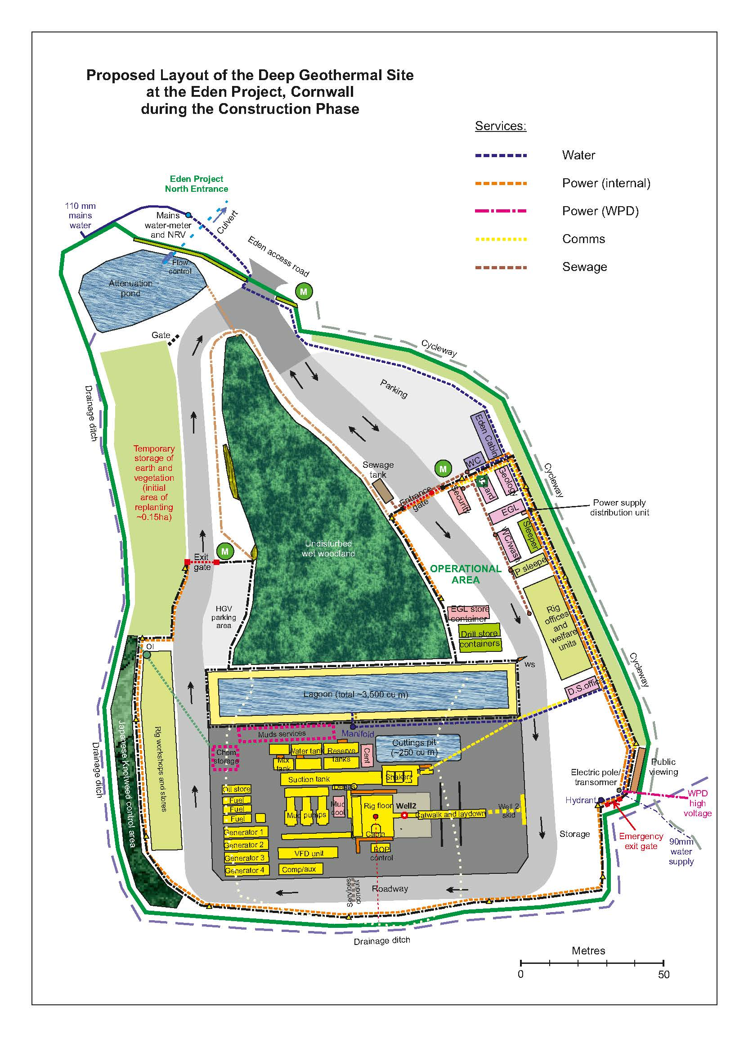

APPENDIX B – Background Technical Information

General Background
Eden Geothermal Limited is scheduled to drill the first of two deep wells as the first stage of developing a deep geothermal energy plant at the Eden Project in Cornwall. This first stage is an industrial research project majority funded by the European Union under the ERDF programme for Cornwall. The longer-term objective is to follow-up the first stage with a second well and the construction of a heat and power plant.

In Phase 1 of the project, it is planned to directionally drill an exploration well to 4,350 to 5,260 metres measured depth, intersect a naturally fractured zone in granite, and hydraulically test the well to characterize the target zone. Modelling indicates the geothermal gradient in the vicinity of the Eden Project to be 35 40°C/m. This equates to a rock temperature of approximately 90°C at a depth of 2,000 m, 160°C at 4000 m (casing shoe) and 170-180°C at a depth of 4,500 m

On completion, a series of well tests will be undertaken to establish the hydrogeological characteristics of the well and the fault zone and to assess the likely productivity prior to drilling the second well. As the first well will ultimately form one well of a geothermal doublet system, its design will have to cover all possible applications and also the possibility that the permeability of the well may have to be enhanced through cycling injection and production testing.

This is followed by the option (yet to be finalised) to temporarily deploy a co-axial system within the well to demonstrate heat production over a period of 12 months to supply the Eden Project biomes and offices.

If the thermohydraulic properties of the first well are sufficient to produce electricity and heat, a second well will be drilled to create an Enhanced Geothermal System in Phase 2 of the project.

Project Programme
The first stage of the project commenced in mid-2019 and is due to take 40 months to complete, with the drilling due to commence in February 2021:

Item | Activity | Duration Months | Cumulative Months
1 | Pre-preparation, recruitment, procurement, finalise design, tenders for main contractors | 12 | 12
3 | Site preparation/construction works | 4 | 16
4 | Drill and complete the first well | 5 | 21
5 | Well testing | 2 | 23
6 | Reporting - evaluation, reporting and dissemination | 4 | 27
7 | Deploy single-well heat system and heat main
8 | Run single well heat output | 12 | 28 - 39
9 | Final reporting and dissemination | 1 | 40

Geology
The drilling site at the Eden Project is located on the southeast flank of the St Austell granite mass, which forms part of the Cornubian Batholith that runs under the spine of Cornwall. The granite in the vicinity of the site is medium to coarse-grained (megacrystic) biotite granite. The granite is expected to contain feldspar megacrysts (15 - 20 mm size) in a coarse-grained matrix of alkali feldspar, plagioclase, biotite, quartz and white mica. The components of the granite at the Eden Project, from near surface data, are quartz (~ 34 %), alkali-feldspar (~ 32 %), plagioclase (~ 22 %), biotite (~ 6 %), muscovite mica (~ 4 %) and primary tourmaline (1 %) and other minerals (1 %). With depth there are likely to be changes in grain size and mineral composition, perhaps with the granite becoming finer grained with depth.

A characteristic of the St Austell Granite is the extensive ‘kaolinisation’ that occurs, principally in the lithium-mica granite to the west, which is less prevalent in the biotite granite. Kaolinisation is the alteration and degradation of the granite comprising a process of hydrolysis accompanied by removal of alkalis and silica. The formation is expected to become more competent below this depth, but further zones of weathering beneath this are likely.

Several types of veins containing varying assemblages of quartz, tourmaline and other minerals occur in the St Austell Granite, of which greisen bordered quartz-tourmaline veins are the most common type. The veins, often 1 to 2 m in width, occur in clusters, usually parallel to sub-parallel, with a dominant ENE - WSW strike and steeply dipping between 60 - 90°. Dip directions towards the north seem to be slightly more common than those to the south. Some relatively minor deposits of metalliferous minerals, chiefly iron and tin, have been mined underground to shallow depth only.

The target for the first well is a NNW-SSE coursing fault, named The Great Crosscourse, within the southeast periphery of the exposed St Austell Granite mass. The dip angle of the fault is expected to be near vertical, i.e. about 80° down to ENE. This type of large crosscourse structure is a major wrench fault with a strike length of several 10s of kilometers, traversing the granite pluton. The width of the fault is not well recorded; at one location the main structure is recorded to be ~ 45 m wide. The main structure is likely to be characterized by ramifying networks of intense microfractures and quartz veins. Generally, fault structures of this type can comprise a zone of disturbed ground >100 m wide, but this zonal width is likely to become narrower with increasing depth.

Modelling indicates the geothermal gradient in the vicinity of the Eden Project to be linear at 35 - 40 °C/km. This equates to a rock temperature of approximately 90 °C at a depth of 2,000 m; approximately 160 °C at 4,000 m (casing shoe); and 170 – 180 °C at a depth of 4,500 m (target zone). A recent paper produced by the British Geological Survey has identified that temperatures of 220 °C may exist in the St Austell Granite at a depth of 5,000 m.

Sub-surface conditions
Evidence from other deep wells drilled into the Cornish Granite shows that the wells are sub-hydrostatic and the formation is not found to be over-pressurised. Based on geological considerations it can be expected that the formation fluid is saline.

Trace quantities of biogenic hydrocarbons have been found in the Cornish granites, but they do not occur in any significant quantity that is likely to impact the drilling programme at Eden. Evidence to support this statement has been gained from other deep geothermal wells in the county.

Metallic mineralisation may be present within the granite, specifically within mineralised lode or fault structures that are intersected during the drilling. This may result in localised elevated levels of minerals such as arsenic.

The Cornish granite contains elevated levels of radiogenic elements, and enhanced levels of uranium mineralisation may be present in some lode or fault structures. Radon gas may be released from the produced drilling fluids in the vicinity of the flow line and shakers on the drilling rig, but this will diffuse into the atmosphere and does not present a safety risk.

Summary of Design
The appropriate method to drill a deviated geothermal well in fractured crystalline rock to a depth of about 4,500 m (TVD) is considered to be the conventional rotary mud drilling technology using tungsten carbide insert tricone roller cone bits and a water-based mud system. The well, as planned, will comprise five sections; each section will be cased apart from the 8½” section, which will be open hole, unless wellbore stability requires a perforated liner:

Section | Hole size | Casing size | Depth [m] MD | Description
1 | 34-36" | 30" | ca. 40 | conductor
2 | 26" | 20" | 300 | surface casing
3 | 17 ½" | 13 ⅜" | ~1,500 | intermediate casing
4 | 12 ¼" | 9 ⅝" | ~ 4,000 | production casing
5 | 8 ½" | (7") | 4,000-max ca. 5,260 | open hole

The well trajectory is planned using a KOP at 1700 m TVD, a very moderate initial build rate of 0.43°/30 m and a KO and EOB azimuth of N 68° (fault dip direction). The EOB of the first well section is at around 4,150 m MD or 4,000 m TVD, just ahead of the first well target. At this depth the well inclination is 35°. If the first target is passed with no indication of the fault, drilling will be continued gradually raising the inclination to 40°. During drilling of the 8½" openhole section, if heavy or full mud losses are encountered while crossing the fractured / faulted zones, it may be necessary to lay down the directional assembly to reduce the risk of losing the valuable tools in the well. At this point, it would then be required to pick up a rotary assembly to continue drilling to total depth.
Section of the well design
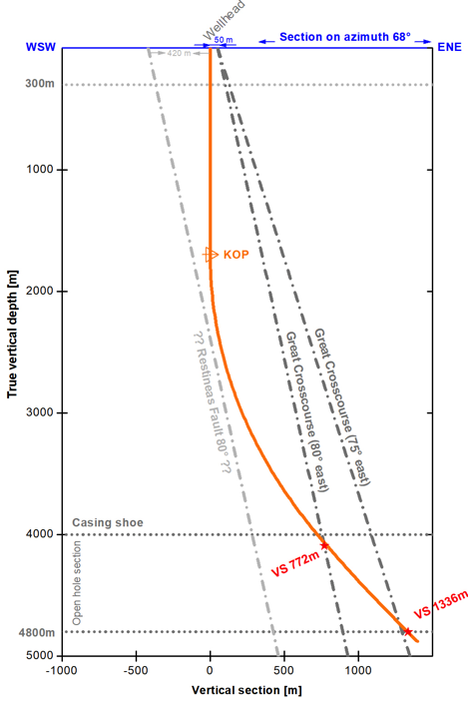
Cross-section of the well trajectory

Water based drilling muds will be used at all times, unless it is not reasonably practicable to use water-based muds due to the need to ensure the safety and stability of the well. The precise types of materials to be used in the drilling muds, for example the polymers, have not yet been finalised. The drilling muds will not include barite or chloride additives, unless barite has to be used as a last resort as a weighting agent. In the event that troubled clay formations are drilled, 3-7% of KCl may be added.
There are three main cementing operations required on the EG-1 wellbore during the wellbore construction and drilling phase, not including the 30" conductor casing. Each operation has a unique set of requirements and the precise procedures and material requirements will be modified to actual wellbore conditions after pilot testing and wellbore parameters become evident.

Although the risk from hydrocarbons and overpressurised formation is considered to be negligible, the fluid produced from the well during drilling and from subsequent testing of the well will be hot - 65°C at surface.

The well control system will be based on a conventional system used for inshore drilling in the UK. Where practical a double-barrier philosophy will be adopted, as per the requirements of BSOR 1995, throughout the drilling and well testing programmes. However, evidence from other deep wells in Cornish granite have shown that in-situ well conditions are sub-hydrostatic. The well control system will be developed in stages as the well is drilled:

Section (in) | BOP Stack Size (in) | Pressure Rating (psi) | Wellhead Installed | Pressure Rating (psi)
24” hole for 20” casing | No BOP required | N/A | Riser to flowline | N/A
17½” hole for 13⅜” casing | 20¾” BOP annular preventer | 3,000 | 20” starter head housing x 20¾” flange up | 3,000
12¼” hole for 9⅝” casing and 8½”openhole | 13⅝” BOP double ram + annular preventer | 10,000 | 20¾” x 13⅝”  flanged for packing-off 9⅝” casing | 5,000

Upon completion of drilling to TD, a 3,000 psi wellhead will be installed to enable well testing.
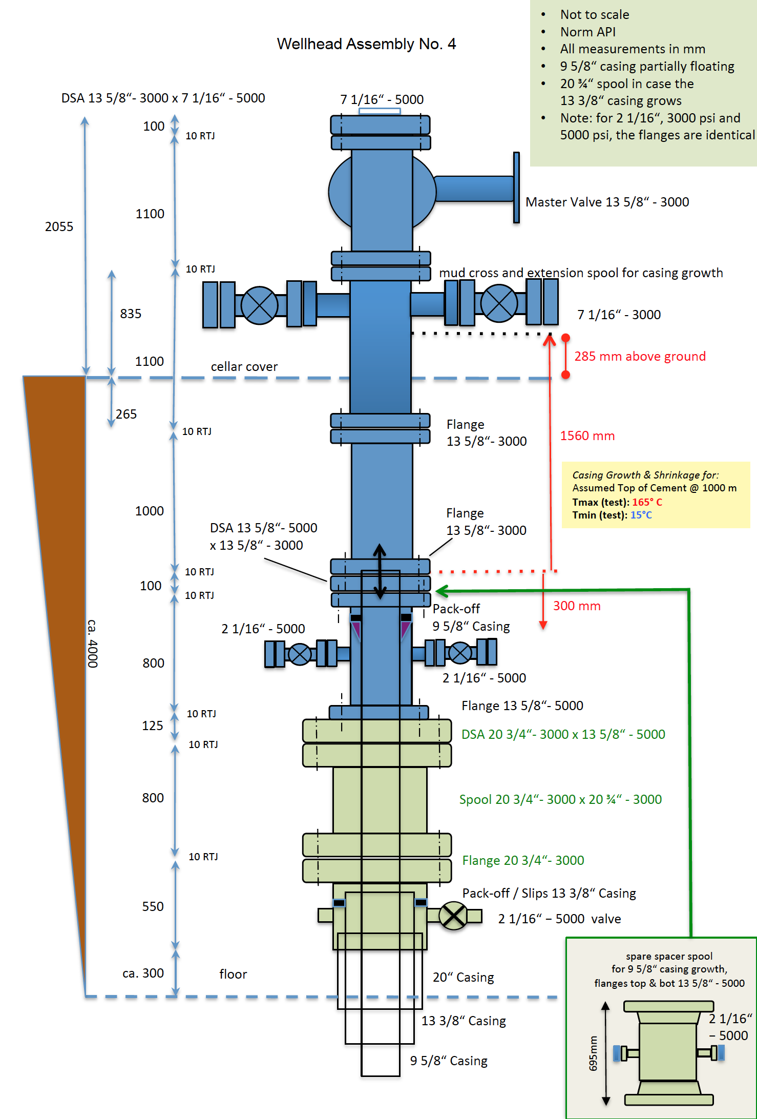
Summary of the first well
1 | Well location | Eden Project, Bodelva, Par, Cornwall UK
2 | Well name | EG-1
3 | Expected well total depth | nominal 4,350 m MD [4,160 m TVD bGL], maximum ca. 5,260 m MD respectively 4,880 m TVD
4 | Coordinate location | 204399E 055652N [British National Grid]
5 | Well classification | Geothermal
6 | Borehole type | Directional: KOP at 1,700 m, azimuth 068° at an inclination of ~35° - 40°
7 | Well completion | Barefoot, allowing hydraulic injection/production tests
8 | Expected open hole length | 350 m - 1,260 m
9 | Geology | Biotite granite with kaolonised sections
10 | Target structure | Steeply inclined fault structure striking NNW - SSE
11 | Estimated reservoir pressure | Hydrostatic
12 | Estimated BH temperature | ~ 160 – 190°C
13 | Expected formation fluids | Saline water
14 | Expected hydrology | Low porosity/ fracture permeability

Drilling Rig
It is intended to use a 450 T Bentec Eurorig, hired through a UK based drilling contractor, to drill the first well. The rig has the following specifications:

Capability | Drilling to a depth of 5,500 m using 5½” drillpipe.
Hook Load | A maximum hook load capacity of 990,000 pounds (450 metric tons).
Mast height | The height to the top of the mast is 53 m above ground level
Racking capacity | At least 5,500 m with 5" drill pipe.
Top Drive | Max. load is 450 metric tons.
Tripping Capacity | Triples.
Pumps | Triplex mud pumps capable of delivering at least 950 gpm (3600 l/min) and 3000 psi (200 bars).
Tanks | Mud tanks with a capacity of at least 180 m³, plus a reserve tank.
Mud Cooler | Mud Cooler (on request), mud temperature reduction 15 – 20°C
Fresh Water | Fresh water tanks with a capacity of 50 m³ or more.
Solid Control | Solid Control System with at least two linear / elliptical motion shakers, desander, desilter, one centrifuge and optional mud flocculation unit.
Power Supply | Electricity through generators; at least one back-up generator.
Drilling Programme
The drilling programme for the first well is due to take 150 days to complete and will be followed by 2 – 4 weeks of well testing. There are three main casing and cementing operations required on the first well during the drilling phase (not including the 30" conductor casing). The basic drilling strategy is:
- Mobilise and rig up drilling rig over well centre. Prepare spud mud.
- Drill 26" vertical hole to 300 m with motor, shock absorber and MWD.
- Set 20" casing and cement to surface using inner string cementing technique.
- After cement is set, cut off 20” casing to near cellar floor and install 20 ³/₄" 3,000 psi SOW casing head. Test the weld to 3,000 psi. Install 20³/₄" 3,000 psi temporary spacer spools and. nipple up 20¾” 3,000 psi annular BOP and hook up to flow line. Test BOP.
- Drill 17¹/₂" vertical hole to 1,500 m with motor and MWD.
- Log well (cement volume) and make any other scientific measurements required.
- Run 13³/₈" casing to bottom, cement casing with weight reduced cement to surface.
- After the cement is set, release casing, set slips. Remove 20¾” 3,000 psi annular BOP and 20¾” 3,000 psi spacer spools, cut off 13³/₈" casing. Install 20¾” 3,000 psi spacer spool, DSA, 13⁵/₈” 5,000 psi mud cross with hook up for kill and choke line and nipple up 13⁵/₈" 10.000 psi BOP stack and test.
- Drill 12¹/₄" vertical hole from 1,500 to 1,700 m with motor and MWD.
- Kick-off @ 1,700 m and directionally drill 12¹/₄" hole to 4,000 m (MD) with gradual angle build using motor and MWD
- Log well (cement volume) and perform all required scientific measurements.
- Run 4,000 m of 9⁵/₈" casing. Then cement the 9⁵/₈" casing from 4,000 m to at least 1,400 m depth (100 m above 13³/₈” casing shoe) using 2 stages with weight-reduced cement.
- Drill 8½” deviated well (install mud cooling system as required), either:
  - Drill directionally to about 4,350 m MD, (about 4,160 m TVD). Maximum inclination will be in the order of 35°; or
  - If no indication for the fault can be found at/near the first target, continue to drill 8¹/₂" directionally to about 5,260 m MD, (about 4,880 m TVD) Maximum inclination will be in the order of 40°. TD well at/near 5260 m MD.
- Circulate well clean, replace mud by water, log well and make any other scientific
measurements required.
- Perform hydraulic tests which will include water injection and production testing.
- Lay down drill pipe and drill collars. Clean mud tanks and release rig.
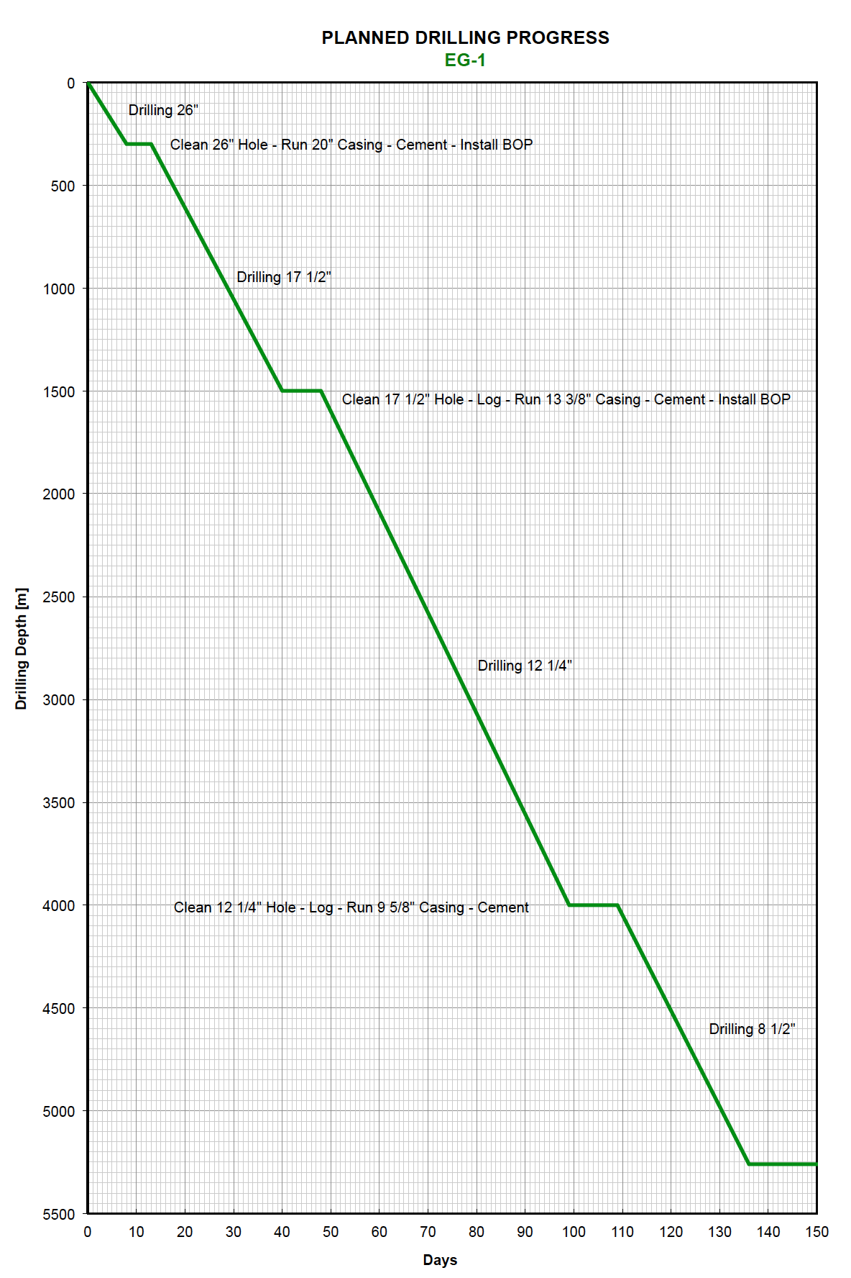
Well testing and enhancement
Once the well has been drilled to total depth, wireline geophysical logs will be run in the openhole section. Following the logging operations it is planned to trip back into the open hole and clean out the wellbore by circulation. The mud in the well will be replaced with brine at a density that keeps the well from flowing. The required density needs to be determined from the drilling and logging data. This will be followed by a short (2 – 4 week) period of well testing.

The main objectives of the well testing program are:
- determine the thermo-hydraulic properties of EG-1
- characterise the permeability/impedance of the target zone
- evaluate the spatial extent of the fracture distribution and orientation in the target zone
- characterise the flowing zones and evaluate the ‘far-field flow contribution’
- characterize reservoir fluid properties
- improve the hydraulic properties of the well by hydraulic stimulation and assess fractures induced by the well enhancement if required

An outline scope for the well testing programme has been produced, but the final programme will have to be updated and optimized after drilling is completed, and should be based on all information obtained from drilling and logging operations (mud losses/gains, temperature, geology, etc.).

It is envisaged that the well testing will progress as follows:
- A short activation test at moderate injection rate (using fresh water) will deliver a first injectivity index and help to decide whether the well can also produce sufficient amounts of fluid.
- A first production test (“production lift”) will then be performed (as long as possible) with the aim to get all relevant reservoir parameters including first formation fluid samples.
- Several step rate injection tests will be performed, to determine the injectivity (pressure drawdown vs. flowrate), compare it to the productivity and to evaluate whether the well is dominated by laminar or turbulent flow.
- If the well has improved during injection testing, production lifting can be optionally repeated at this point to verify the productivity of the well.
- If the productivity and injectivity of the well are still too low, different options for well enhancement may be considered. Techniques such as chemical treatment or thermal fracking can be used to improve the near well bore region, up to a distance of few tens of metres. The only approved method with the potential to improve the far field, up to several hundreds of metres away from the borehole, is continued hydraulic injection with associated shearing of fractures. Any well enhancement operation has to be planned very carefully because pressures on surface might easily exceed one hundred bars if no losses or only minor losses have been observed during drilling and previous tests.

Since the early 1980s, research at various sites confirmed that shearing rather than tensile fracturing is the dominant process required to gain permeability during fluid injection. Natural joints, favorably aligned with the stress regime, fail in shear. As a consequence, formations with high stress anisotropy and hence a high shear stress, are the best candidates for stimulation in low permeable rock. However, this also means that these tests will be accompanied by an increased micro-seismic activity. It must be the aim of the test supervision to adjust the test parameters such that these events cannot be felt on surface.

A seismic network system will be installed around the Eden Geothermal site. Micro-seismic monitoring helps to prevent disturbance on surface and also delivers 3-D time-resolved evidence of event location and magnitude from which the fractured rock volume can be inferred.

Long-term operation

At present it is not certain whether the first well will form the production well or the injection well of the doublet system. This will only become clear once the second well has been drilled and tested.

The long-term operation of the system will involve extracting superheated fluid from the production well, proabably with the assistance of an electric submersible pump or lin-shaft pump. This fluid will pass through a heat exchanger, which in turn provides heat for the power plant using an Organic Rankine Cycle system. The cooled water from the heat exchanger is then re-injected down the injection well.

The operation lifetime of the system is designed to be at least 25 years.

APPENDIX C - Contract Agreement

Contract Agreement for Independent Well Examination Services C058

Parties
Eden Geothermal Ltd (“EGL”), Company number 10216419, having its registered office at Eden Project, Bodelva, Par, Cornwall, UK, PL24 2SG;
and
xxxxxxxxxxxxxxxxxxxxxxxx, Company number xxxxxxx, having its registered office at xxxxxxxx and having a place of business at xxxxxxxxxxxxxxxxxxx

Contract
This agreement forms the whole contract and comprises this document together with the following:
- Appendix I – EGL’s Requirements / Scope of work
- Appendix II – Services to be Supplied and Pricing
- Appendix III – EGL Terms and Conditions
All changes to the contract will be agreed by both parties in writing.

Supply and Pricing
EGL agrees to purchase Independent Well Examination Services as listed in its Invitation to Tender EGL-ITT-C058 Independent well examination services for a deep geothermal well from xxxxxxxx, whose submission dated xxxxxx 2020 was successful, as set out in EGL’s Notification of Contract Award Decision letter dated xxxxx 2020.
For the purpose of this contract, the list of services and prices are set out in Appendix II.

For the avoidance of doubt, the total price for the Independent Well Examiner in the Commercial Submission for a 150 day drilling and 30 day well testing period were for evaluation purposes only, and the contract price will vary according to the actual period of the contract.

Terms and Conditions

The purchase will follow EGL’s Standard Terms and Conditions attached at Appendix III.
All other terms and conditions of Contract are excluded and all these general conditions shall apply to the Contract unless modified with EGL’s prior written consent.

Contract Agreement for Independent Well Examination Services C058

Xxxxxxxxxx confirms that the representations made within its Technical and Commercial Submissions received on xxxxxxxx 2020 are accurate, and understands that EGL has relied upon those representations when entering into this contract. xxxxxxxxxxx additionally confirms that it will immediately inform EGL if any of the circumstances change.
On behalf of xxxxxxxxxxxxxxxxxxxx:
Name of Person Signing
Capacity in which Signed
Signature
Date

On behalf of Eden Geothermal Ltd:
Name of Person Signing
Capacity in which Signed
Signature
Date

Contract Agreement for Independent Well Examination Services C058

Appendix I – EGL’s Requirements / Scope of work

This appendix will comprise the summary of EGL’s Requirements / Scope of Work set out in Part C of the Invitation to Tender, EGL-ITT-C058 Independent Well Examination Services.

Contract Agreement for Independent Well Examination Services C058

Appendix II – Supply and Pricing

This appendix will comprise the services to be supplied set out in Schedule 3, and the unit pricing set out in Schedule 4 of the tender submission by the successful bidder.

Contract Agreement for Independent Well Examination Services C058

Appendix III – EGL Terms and Conditions

- Definitions

Term | Meaning
Eden Geothermal / EGL / We / Us / Our | Eden Geothermal Limited (Company No. 10216419)
Supplier / You / Your | the person, firm or company to whom the Purchase Order is addressed
Goods or Services | the materials and/or services described in the Purchase Order
Purchase Order | the Purchase Order placed by Eden Geothermal Ltd on the Supplier for the purchase of the Goods or Services
Contract | the contract for the sale and purchase of Goods and/or services
Purchase Order amendment / variation | our authorised Purchase Order amendment or series of Order amendments each having precedence over any earlier amendment

- The Contract

Set out in agreement above.

- Price

The agreed price for each item is specified in the Purchase Order. Such prices which will not be subject to fluctuation irrespective of the time of delivery of the Goods or Services.

The Purchase Order must show any applicable charges for packaging, storage, insurance, delivery, installation and commissioning.

All prices will be shown on the Purchase Order excluding VAT, and in Sterling (£GBP) unless otherwise agreed by EGL.

- Quality and Description

The Goods or Services shall:
- conform in every respect with the provisions of the Contract;
- be capable of all standards of performance specified in the Contract;
- be fit for any purpose made known to you expressly or by implication and in this respect we rely on Your skill and judgement;
- be new (unless otherwise specified on the Purchase Order) and be of sound materials and skilled and careful workmanship;
- correspond with their description of any samples, patterns, drawing, plans and specifications referred to in the Contract;
- be of satisfactory quality;
- comply with any current legislation.

Unless specifically required under the Contract, there shall be no asbestos content in the Goods.

- Purchase Order Amendments/Variations

EGL will have the right, before delivery, to amend or vary the Contract in writing, if this Purchase Order amendment/variation will cause a change to the price or delivery date then you must suspend performance of the Contract and notify EGL without delay, and notify EGL of the new price and delivery date. Following our receiving such notice you must allow us at least 10 working days to consider any new price and delivery date. The Purchase Order amendment/variation shall only take effect when EGL’s authorised Officer accepts in writing the new price and delivery date within the period you stipulate. If EGL’s authorised Officer fails to confirm the Purchase Order amendment/variation within the period you stipulate, then performance of the Contract shall immediately resume as though the said Purchase Order amendment/variation had not been issued (except that we will still exercise our right of cancellation in accordance with Condition 5).

- Work on our Premises

If the Contract involved any works or services that you perform on our Premises then the following conditions shall apply:
- You shall ensure that you and your employees, your sub-contractors and their employees and any other person associated with you, will adhere in every respect to the obligations imposed on you by current safety legislation. EGL’s Health and Safety Policy is available upon request;
- You shall ensure that you and your employees, your sub-contractors and their employees are adequately trained and qualified for the work being carried out;
- You shall ensure that you and your employees, your sub-contractors and their employees and any other person associated with you will comply with any regulations that we may notify to You in writing;
- You shall ensure that there is the minimum amount of disruption to our business;
- You shall ensure that if any damage is sustained to our Premises as a result of your performance of the Contract then you will forthwith reinstate the damaged part or parts of the premises to their previous condition or offer reasonable compensation. Such reinstatement is to be subject to our final approval;
- You shall ensure that you have all appropriate insurances in place such as Employer’s Liability and Public Liability.

- Progress and Inspection

You shall at your expense provide any programme of manufacture and delivery that we may reasonably require. You shall notify us without delay in writing if your progress falls behind or may fall behind any of these programmes.
We shall have the right to check progress at your works, or at the works of subcontractors, at all reasonable times, to inspect and reject Goods that do not comply with the Contract. Your sub-contracts shall reserve such right for us.
Any inspection or approval shall not relieve you from your obligations under this Contract.

- Safety

You shall observe all legal requirements of the United Kingdom, European Union and relevant international agreements in relation to health, safety and the environment and in particular to the marking of hazardous Goods, the provision of data sheets for hazardous materials and all provisions relating to food.

- Delivery

The goods shall be properly packed, secured and despatched at your expense to arrive in good condition at the time or times and the place or places specified in the Contract.

If you or your carrier delivers any Goods at the wrong time or to the wrong place then we may deduct from the price any resulting costs of storage or transport.

- Late Delivery

If the Goods or Services or any part of them are not delivered by the time or times specified in the Contract then we may by written notice cancel any undelivered balance of the Goods. We may also return for full credit at your expense any Goods that in our opinion cannot be utilised owing to this cancellation.

In the case of services, we may have the work performed by alternative means and any additional costs reasonably so incurred shall be at your expense. This shall not affect any other rights that we have.

- Acceptance

We shall have the right to reject the Goods in whole or in part whether or not paid for in full or in part within a reasonable time of delivery if they do not conform to the requirements of this Contract. It is agreed that we may exercise the right of rejection notwithstanding any provision contained in the Sale of Goods Act 1979, Section 11 or Section 15A or Section 30 (Subsections (2A) and (2B)) or Section 35. We shall give you a reasonable opportunity replace the Goods with new Goods, that conform with this Contract, after which time we shall be entitled to cancel the Purchase Order and purchase the nearest equivalent Goods elsewhere. In the event of cancellation under this condition you shall promptly repay any moneys paid under the Contract without any retention or offset whatsoever.

You must collect all rejected Goods within a reasonable time of rejection or we shall return them to you at your risk and expense

- Packages not returnable
Unless otherwise stated in the Contract, all packages shall be non-returnable. If the Contract states that the package is returnable, you must give us full disposal instructions before the time of delivery. The packaging must be clearly marked to show to whom it belongs. You must pay the cost of all carriage and handling for the return of the packaging. We shall not be liable for any package lost or damaged in transit.

- Our Right of Cancellation

In addition to EGL’s other rights of cancellation under this Contract, we may cancel the Purchase Order and any Purchase Order amendment/variation thereto at any time by sending you a notice of termination. You will comply with any instructions that we may issue with regard to the Goods.

If you submit a termination claim then we will pay you the cost of any commitments, liabilities or expenditure that in our reasonable opinion were consequences of this Contract at the time of termination. The total of all payments made or due to you under this Contract, including termination payment shall not exceed the price. If you fail to submit a termination claim within 3 months of the date of our notice of termination then we shall have no further liability under the Contract.

- Property and Risk

You shall bear all risks of loss or damage to the Goods until they have been delivered and shall insure accordingly.

Ownership of the Goods shall pass to us:
- When the goods have been delivered but without prejudice to our right of rejection under this Contract, and
- If we make any advance or stage payment, at the time such payment is made, in which case you must as soon as possible mark the Goods as our property.

- Invoicing and Credits

Your invoice must quote the full Purchase Order number and be addressed to the Company:
Eden Geothermal Ltd,
Bodelva,
Par,
Cornwall, PL24 2SG.

The invoice should display full details of the goods or services invoiced including quantities supplied and unit prices.

Where goods or services ordered are not all supplied at the same time it will be appropriate to have more than one invoice covering the Purchase Order.

You will be asked to issue a credit note in a number of circumstances, including;
- An invoice includes items not on a Purchase Order;
- The prices on the invoice do not agree to the Purchase Order;
- Goods have been returned;
- Goods or Services have not been supplied:
- Goods or Services are of inferior quality or damaged.

- Payment
Unless stated otherwise in the Contract we shall pay you on or about one month following the date of the invoice.

You will supply a statement of outstanding invoices on a monthly basis to enable us to ensure that our payments are complete.

We shall not be held responsible for delays in payment caused by your failure to comply with our invoicing instructions. Any credit notes that are due must be supplied before payments will be made.

In some cases EGL may agree to make interim or deposit payments to the supplier in the terms of the Contract. Any such payments made in advance of the supply of Goods shall be returned forthwith if the Contract is terminated for any reason other than by our default or in accordance with Condition 5.

- Right of Set Off

Whenever under the Contract any sums of money shall be recoverable from or payable by you, they may be deducted from any sums then due or which at any later time may become due to you under this Contract or under any other Contract You may have with us.

- Your Warranty

It is expressly agreed between us that:
- You shall promptly make good at your expense any defect in the Goods that we discover under proper usage during the first 12 months of actual use or 18 months from the date of acceptance by us whichever period shall expire first. Such defects may arise from your faulty design, your erroneous instructions as to use or inadequate or faulty materials or poor workmanship or any other breach of your obligations whether in this Contract or at law.
- Repairs or replacement will be covered by the above warranty but for a period of 12 months from acceptance by us.
- You will ensure that compatible spares are available to facilitate repairs (where applicable) for a period of at least 10 years from the date of delivery of the goods.

- Indemnity and Insurance

  - You shall indemnify us against all loss, actions, costs, claims, demands, expenses and liabilities whatsoever (if any) which we may incur either at common law or by statute in respect of personal injury to or death of any person or in respect of any loss or destruction of or damage to property (other than a result of any defaults or neglect of ourselves or of any person for whom we are responsible) which shall have incurred in connection with any work executed by you under this Contract or shall be alleged to be attributable to some defect in the Goods.
  - This Purchase Order is given on the condition that (without prejudice to the generality of Condition 19(a)) you will indemnify against all loss, costs, claims, demands, expenses and liabilities whatsoever (if any) which we may incur either at common law or by statute (other than as a result of any default or neglect of ourselves or of any person for whom we are responsible) in respect of personal injury to or death of any of your or our employees, agents, sub-contractors or other representatives while on our premises whether or not such persons are (at the time such personal injury or death are caused) acting in the course of their employment
  - You will indemnify us against all loss, costs, expenses and liabilities caused to us whether directly as a result of the action, claim or demand of any third party by reason of any breach by you of these conditions or of any terms or obligations on Your part implied by the Sale of Goods Act 1979, by the supply of Goods and Services Act 1982 or by any other statute or statutory provision relevant to the Contract or to Goods or work covered thereby. This indemnity shall not be prejudiced or waived by any exercise of our rights under Condition
  - You shall hold satisfactory insurance cover with a reputable insurer to fulfil your insurance obligations for the duration of this Contract including public liability insurance cover of at least £2m. You shall effect insurance against all those risks arising from your indemnity in Conditions 19(c). Satisfactory evidence of such insurance and payment of current premiums shall be shown to us upon request.

- Assignment and Sub-letting

The Contract shall not be assigned by you nor sub-let as a whole.

You shall not sub-let any part of the Contract without our written consent, but we shall not refuse such consent unreasonably. The restriction contained in this condition shall not apply to sub-contracts for materials for minor details or for any part of which the makers are named in the Contract.

You shall be responsible all work done and Goods supplied by all subcontractors.

- Articles on loan

All tools, materials, drawings, specifications and other equipment and data (“the Articles”) loaned by us to you in connection with the Contract shall remain always our property and be surrendered to us upon demand in good and serviceable condition (fair wear and tear allowed) and are to be used by you solely for the purpose of completing the Contract.
You agree that no copy of the articles will be made without the consent in writing of our authorised officer.

Until you return all the articles to us they shall be at your risk and insured by you at your expense against the risk of loss, theft or damage. Any loss of or damage to such articles shall be made good by you at your expense.

All scrap arising from the supply of such articles must be disposed of at our discretion and all proceeds of sales such as scrap must promptly be paid to us in full.

- Data Protection

Any information derived from our property or otherwise communicated to you in connection with the Contract shall be kept secret and confidential and shall not without the consent in writing of our authorised officer, be published or disclosed to any third party, or made use of by you except for the purpose of implementing the Contract.

- Ownership of Results

If the Contract involves design and/or development work:
  - All rights in the results of work arising out of or deriving from this Contract, including interventions, designs, copyright and knowledge shall be our property and we shall have the sole right to determine whether any letters patent, registered design, trademark and other protection shall be sought.
  - You shall promptly communicate to us all such results and shall if requested and at our expense do all acts and things necessary to enable us or our nominee to obtain letters patent, registered designs and other protection for such results in all territories and to assign the same to us or our nominee.
  - You shall ensure that all technical information (including computer programmes and programming information) arising out of or deriving from this Contract is held in strict confidence except for any such information that becomes public other than by breach of this Contract.

- Infringement of Intellectual Property Rights

With the exception of Goods made to our design or instructions, you warrant that neither the Goods nor our use of them will infringe any patent registered design trade mark copyright or other protected right and undertake to indemnify us against all actions claims demands costs charges and expenses arising from or incurred by reason of any infringement or alleged infringement of any such right.

- Integrity

We are committed to acting professionally, fairly and with integrity in all our business dealings and relationships wherever we operate. We take a zero-tolerance approach to bribery and corruption and are committed to implementing and enforcing effective systems to counter bribery.

We will award contracts to suppliers based upon our assessment of quality, price, sustainability and any other factors that we deem appropriate. In many cases our procedures will need to follow procurement regulations laid down by the UK Government or the European Commission. We will not accept facilitation payments or "kickbacks" of any kind, or allow bid rigging of any kind.

You may only make a gift or offer hospitality to the company, staff or agents if the specific conditions set out as acceptable in the EGL Anti-Corruption and Bribery Policy are met. Payments of cash or cash equivalents are not acceptable.

In the event of any breach of this Condition, we shall, without prejudice to any other rights we may possess, be at liberty forthwith to terminate this and any other Contract and to recover from you any loss or damage resulting from such termination.
Our Anti-Corruption and Bribery Policy is available upon request.

- Non Observance of Condition

If you breach or fail to observe any provision of this Contract we may give you written notice of such breach or non-observance and you shall have 28 days from receipt of the notice in which to rectify the breach or non-observance. Should you fail to rectify the breach or non-observance, then we shall have the right to give you written notice terminating the contract with immediate effect.

- Waiver

A failure at any time to enforce any provision of the Contract shall in no way affect the right at a later date to require complete performance of the Contract; nor shall the waiver of the break of any provision be taken or held to be a waiver of any subsequent breach of the provision or be a waiver of the provision itself.

- Matters Beyond Control

If either party is delayed or prevented from performing its obligations under this Contract by circumstances beyond the reasonable control of either party (including without limitation any form of Government intervention, strikes and lock-outs relevant to the Purchase Order or breakdown of plant) such performance shall be suspended, and if it cannot be completed within a reasonable time after the due date as specified in the Purchase Order then the Contract may be cancelled by either party.

We shall pay to you such sum as may be fair and reasonable in all the circumstances of the case in respect of work performed by you under the Purchase Order prior to cancellation but only in respect of work performed by you under the Purchase Order prior to cancellation but only in respect of work for which we have received full benefit as originally contemplated in the Contract.

This provision can only have effect if it is called into operation by the party wishing to rely on it giving written notice to the other to that effect.

- Your Insolvency

If you suffer the making of Interim Order or a petition is presented or an Order is made for you to become insolvent or you make an arrangement with your creditors or have an administrator or an administrative receiver or a receiver and manager appointed of the whole or any part of your undertaking property or assets or a petition is presented or an order is made or a resolution is passed or analogous proceedings are taken for you to be wound up (save for the purpose of reconstruction or amalgamation without insolvency and previously approved in writing by us) or any distress or execution is levied upon any of your Goods or property, we may, without replacing or reducing any other of our rights, terminate the Contract with immediate effect by written notice to you or any person in whom the Contract may have become vested.

